MySQL Installation:

Window 32 Bit Link: <https://www.filehorse.com/download-mysql-32/>

Window 64 Bit Link: <https://www.filehorse.com/download-mysql-64/>

Step-1: Click on **mysql-installer-community-8.0.19 Link** then you will get warning Pop-up then you will select **Run** Button.

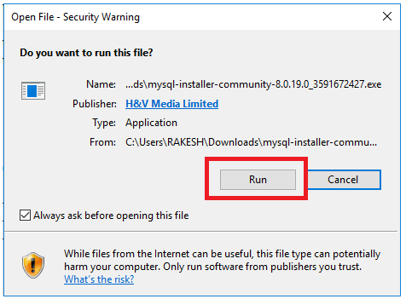

Step-2: Once Click on **Run** Button then will get Pop-Up [Do You want allow this app ] then click on **Yes** Button

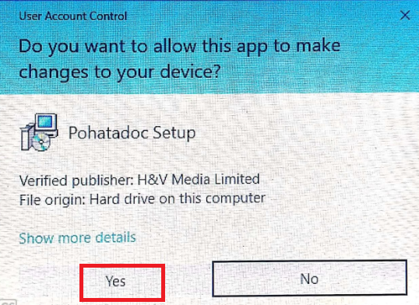

Step-3: Browse the **MySQL Downloading Directory** and click the **Next Button**

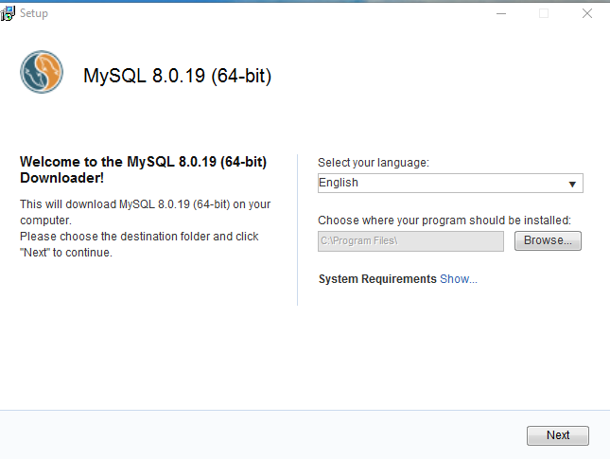

Step-4: **Downloading..........**

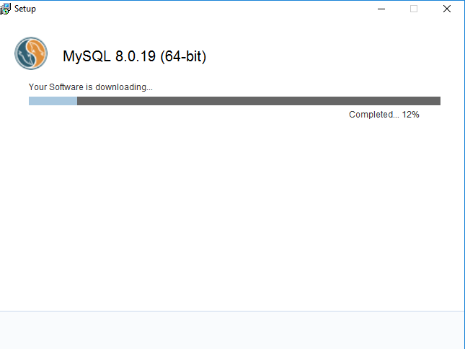

Step-5: Software Downloading has done.

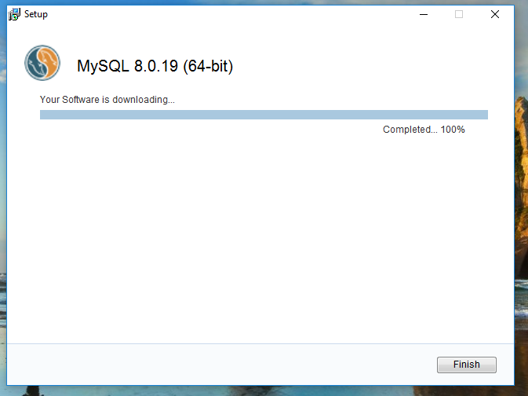

Step-6: Click On **Install Now** Button

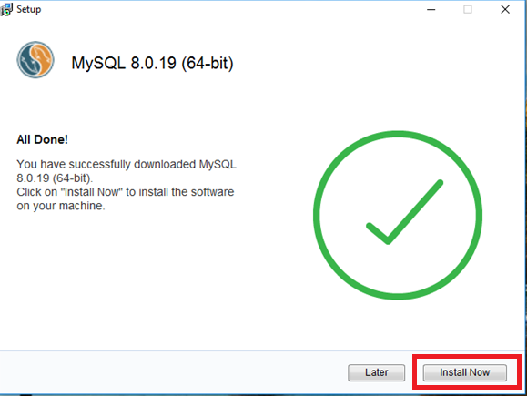

Step-7: once click on **install now** then start installing

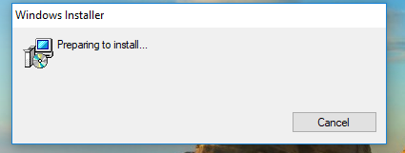

Step-8: Select **Development Default** Radio Button and click **Next** Button

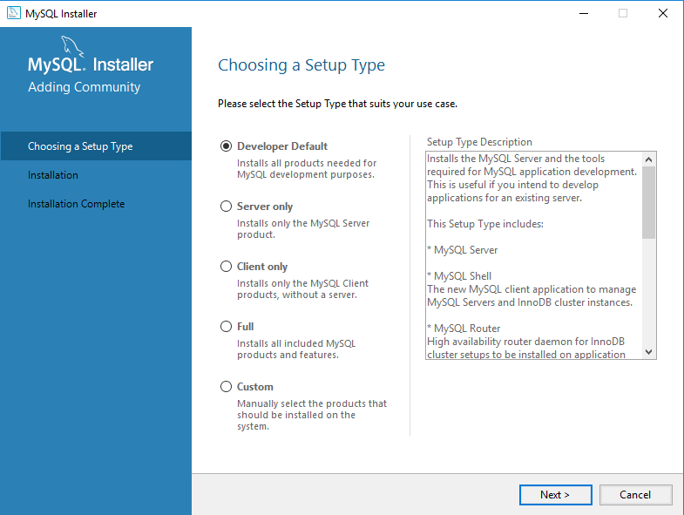

Step-9 : Mention **MySQL Installation Location** and click on **Next** Button

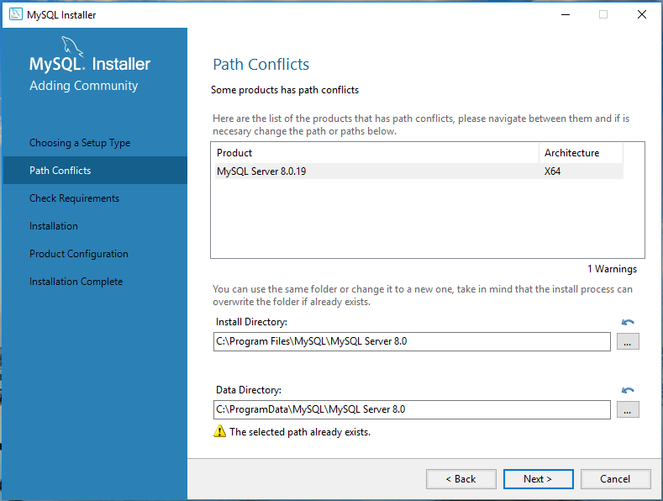

Step-10: Once you click on **Next** Button then Warning Pop-up will come and select **Yes** Button.

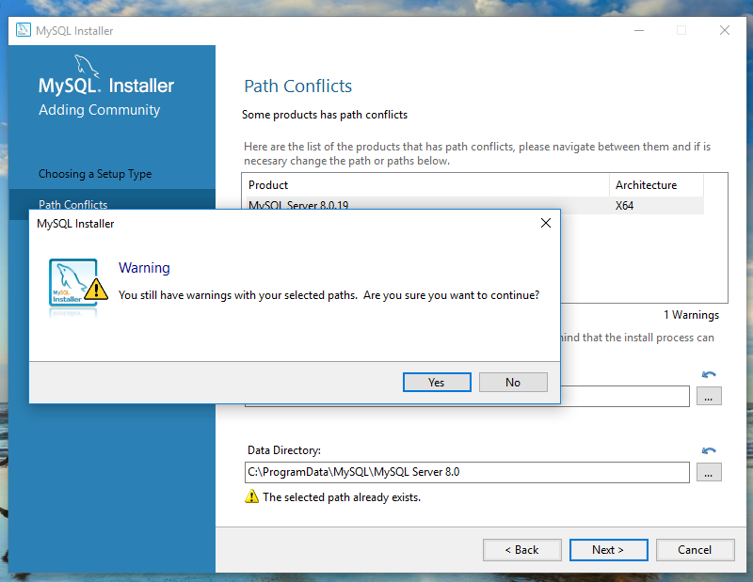

Step-11: Click on **Execute** Button

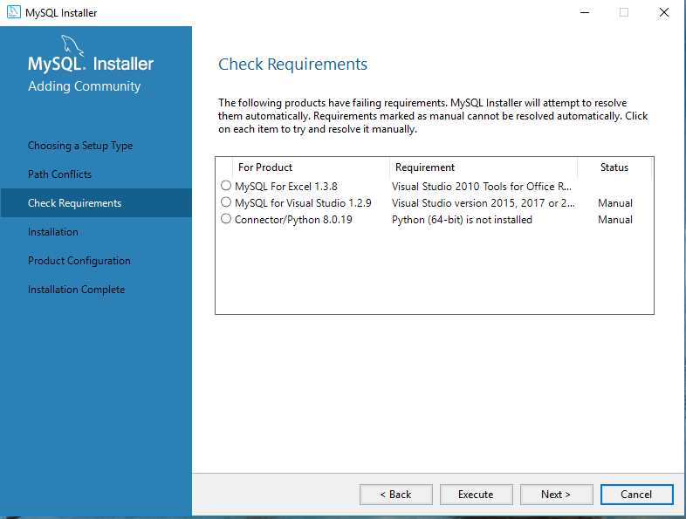

Step-11:Click on **Next** Button and you will get Warning Pop-up then select **Yes** -Button

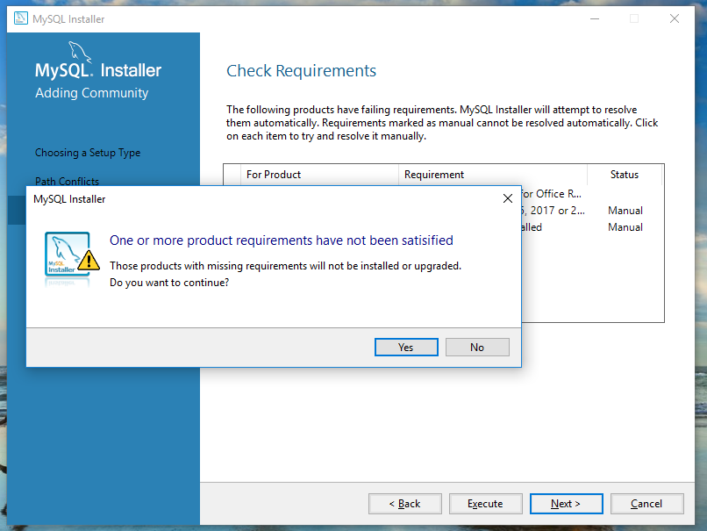

Step-12: Click On Execute Botton

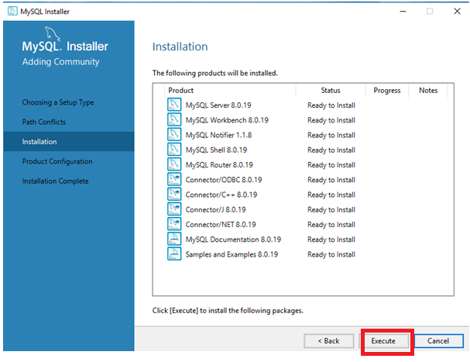

Step-13: Installation is going on........

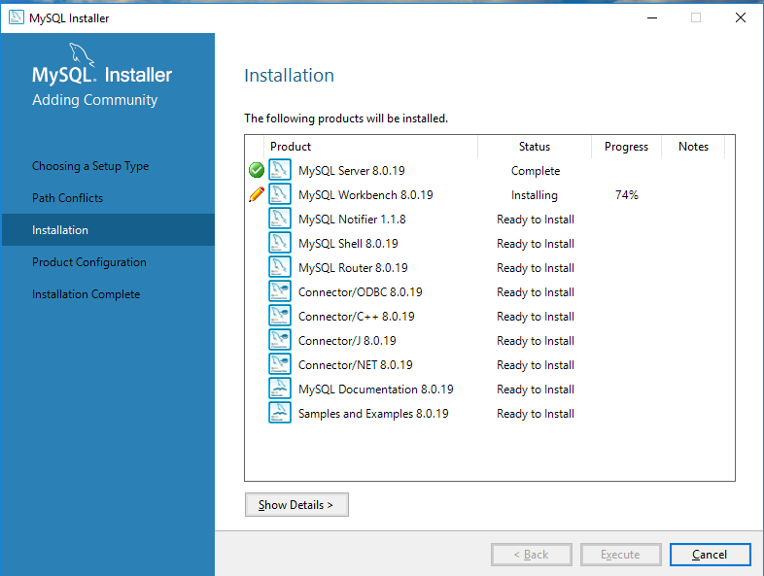

Note: Installation will take 5-10 minutes.

Step-14: Installation has Done and Click on **Next**-Button

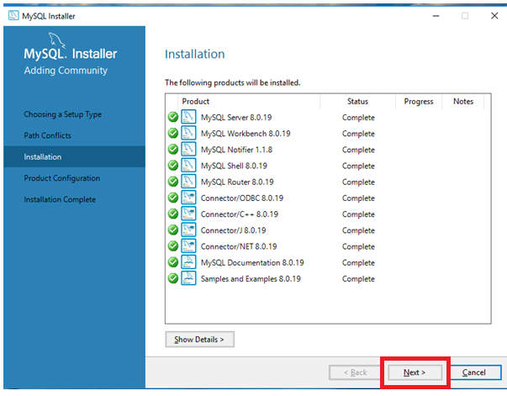

Step-15: Click on **Next** Button

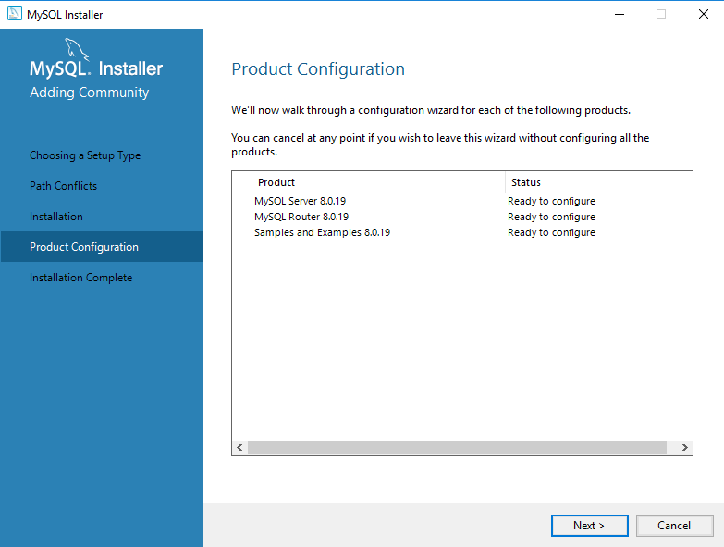

Step-16: Go With Default Option.

**Standalone MySQL Server / Classic MySQL Replication Radio Button** and click on **Next** Button

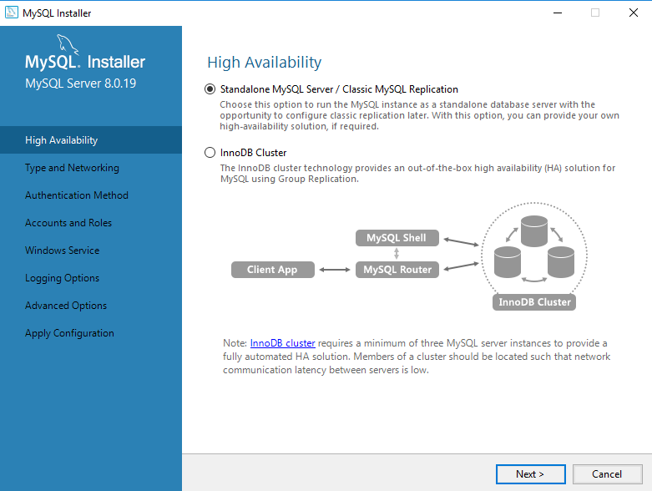

Step-17: Click on **Next** Button

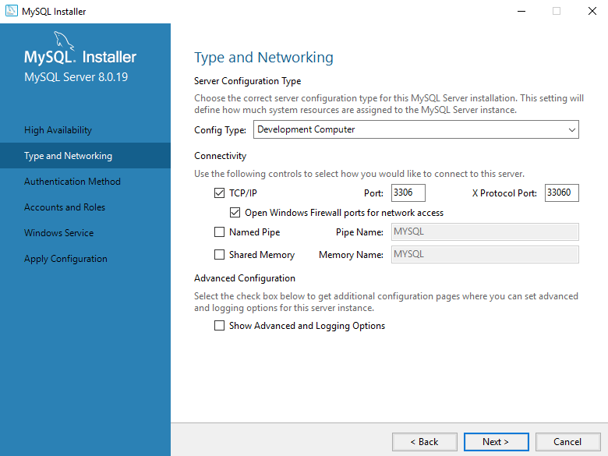

Step-18: Click On **Next** Button

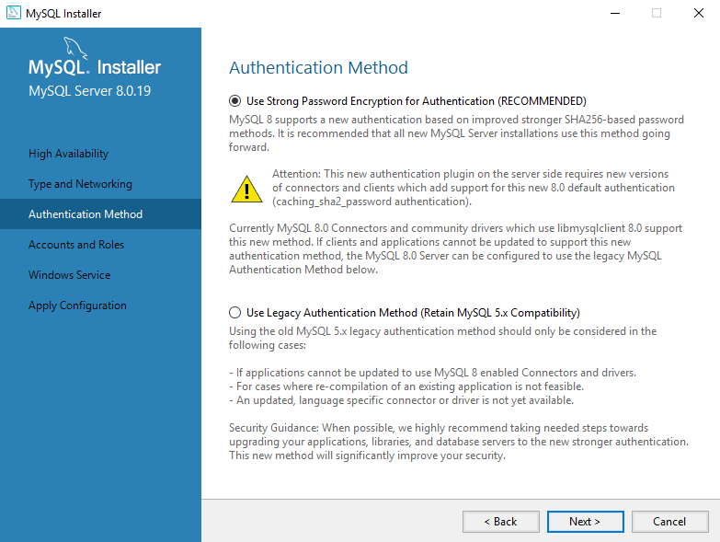

Step-19: Provide **Master Root Password** and also click on **Add User** and Provide **Password** and click on **check** Button then Password will be verified.

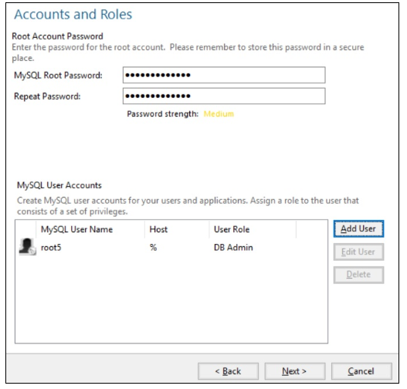

Step-20: Click on **Next** Button

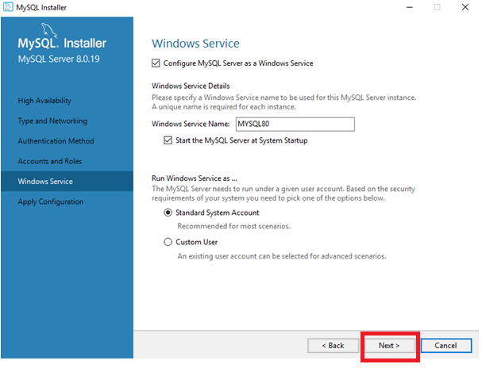

Step-21: Click On **Execute** Button

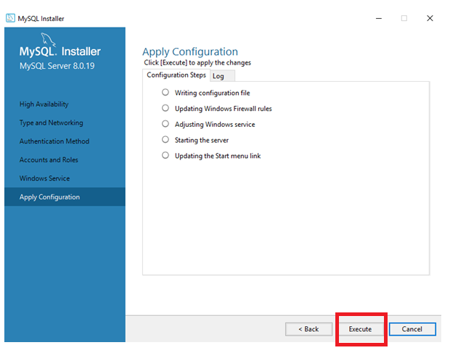

Step-22: Click On **Finish** Button.

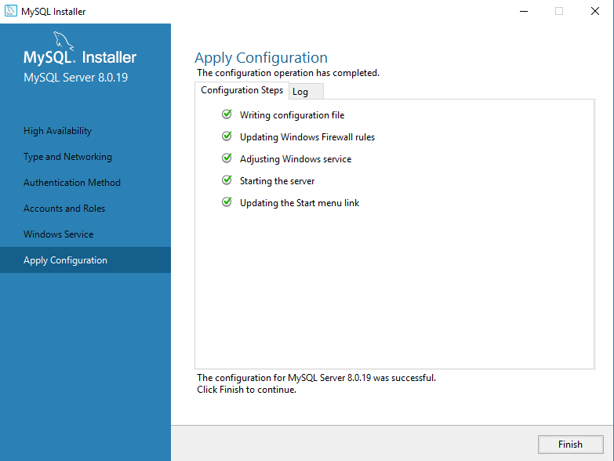

Step-23: Click On **Next** Button

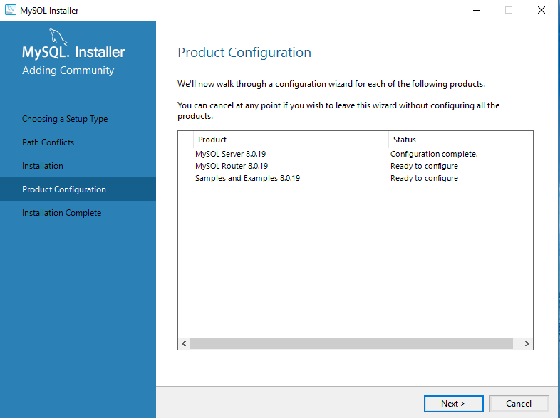

Step-24: Click On **Finish** Button

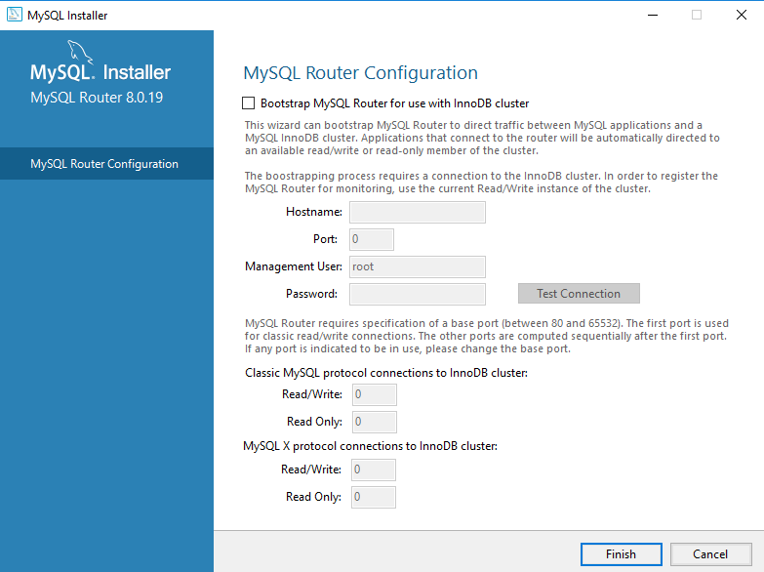

Step-25:Click On **Next** Button

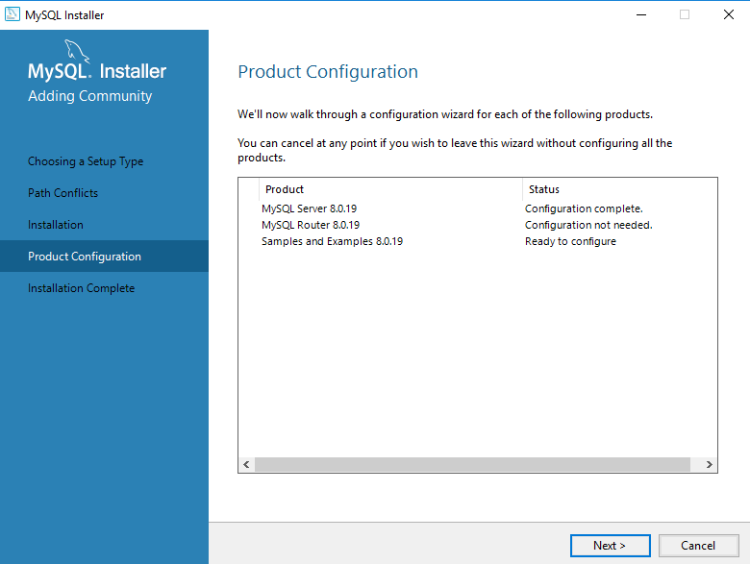

Step-26: Enter your Password and click on **check** button.

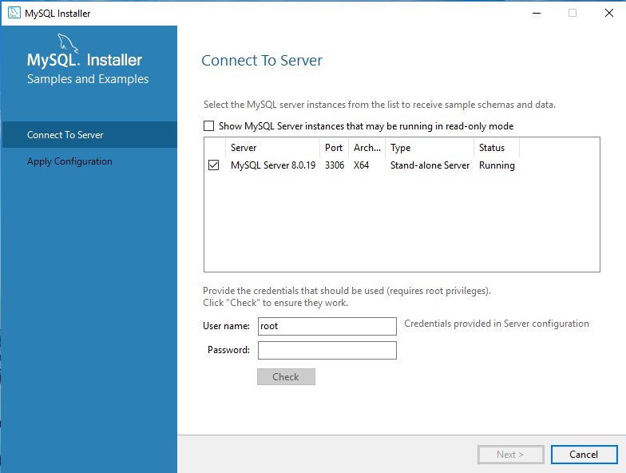

Step-27: After entering your password and click the **check**-Button then your password will be verified.

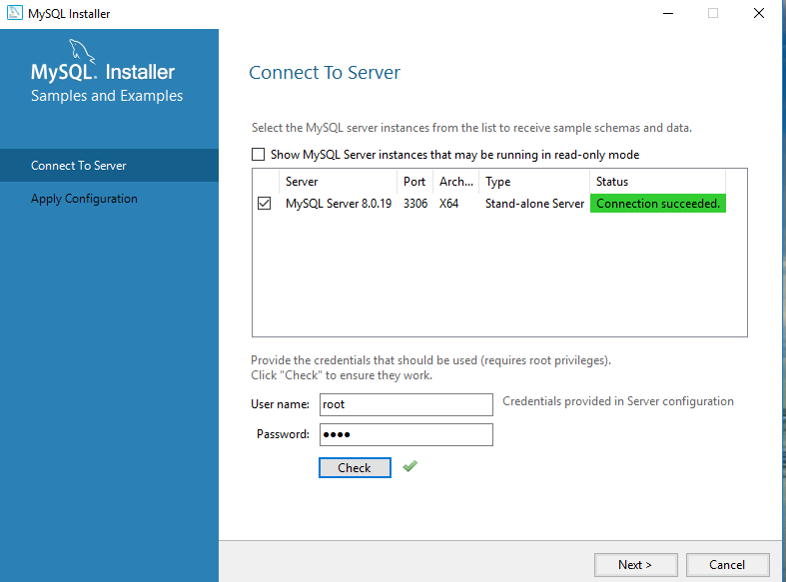

Step-28: Click on **Execute**-Button

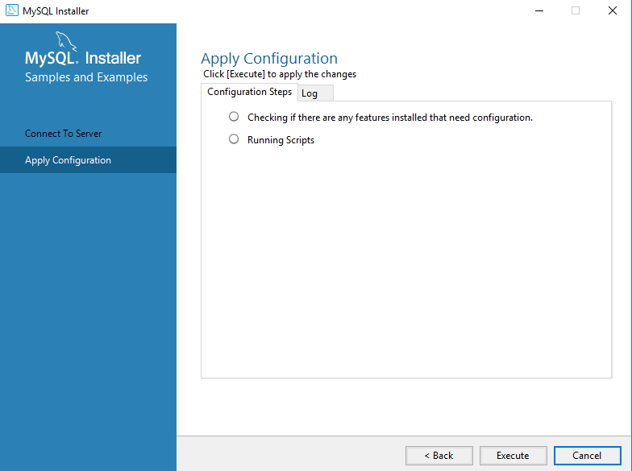

Note : Installation will take 2-3 minutes

Step-29: Once Installation has done then click on **Finish**-Button

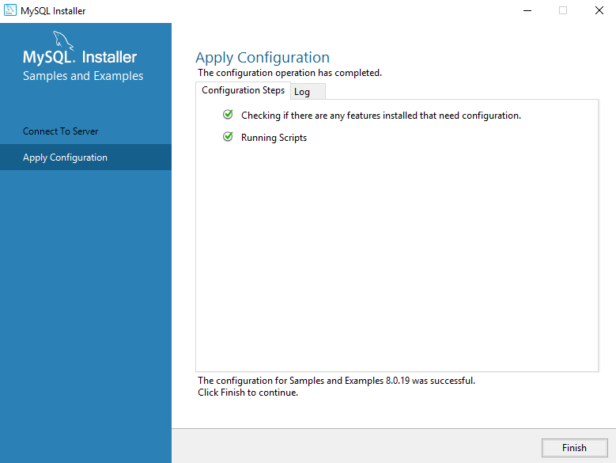

Step-30: Click On **Next** Button

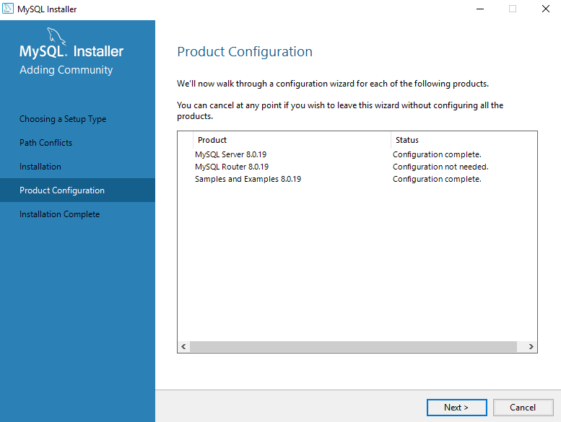

Step-31: click On **Finish** Button then installation process is done.

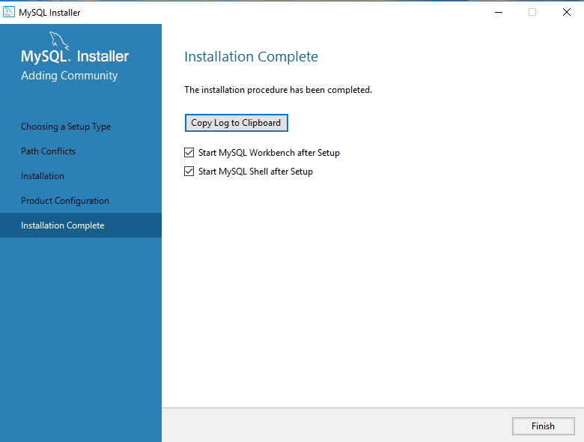

Note:

Next go to **Windows Start** and search “Mysql” word then you will find 🡺 **Mysql 8.0 Command Line Client ,** click on that below MySql prompt will come.

