**Order Supply System**

**Noun phrase:- LocalDate**Nouns: month, day year, DEFAULT_YEAR, DEFAULT_MONTH, DEFAULT_DAY (int)  
**Noun phrase:- RepeatedOrder**Nouns: period(int), endDate(LocalDate)  
**Noun phrase:- SupplyOrder**Nouns:orderID(String), customerID(String), productid(String), orderDate(LocalDate), amount(double)  
**Noun phrase:- OrderManager**Nouns: orderIDD(int), listedOrder(ArrayList<SupplyOrder>), ID(ArrayList<Integer>), id(int)  
**Noun phrase:- UserInterface**Nouns: orderManager(OrderManager)  
**Noun phrase:- FileGenerator**Nouns: alphaber(char[]) , generator(String), random(Random), Set<String>(Hash set)

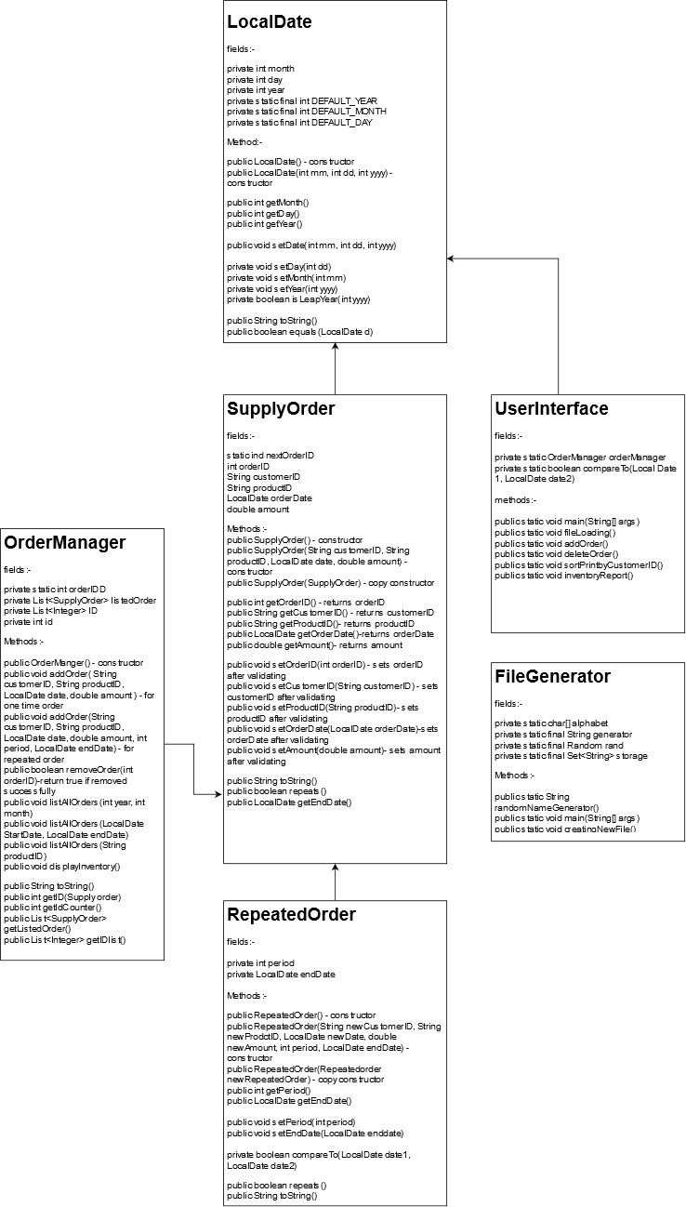

Output of the order supply system(With code)

Code snippets for user interface class(Driver Class):-

Output for UserInterface   
1) first picture is the menu where I am asking for the user input  
2) second picture is the test case where the user enter the wrong file name  
3)

