3EJ4 Lab1

Name: Rui Qiu

Student Id: 400318681

Part1:

For the NPN-BJT 2N3904 characterized, if we want to bias this device to conduct a collector current IC ≈ 1.0 mA at the lowest VCE value, answer the following questions.

Q1. (7 Points) Based on the simulated data in Steps 1.2-1.4, use the bias condition giving the closest IC value to the desired collector current, find out



(1) What are the simulated VBEon in volt and the base current IB in µA?

Ans: VBEon = 0.621V, IB = 8.79µA

(2) What is the β = IC/IB value at this IC?

Ans: 117

(3) What is the early voltage |VA| in volt?

Ans: 1000V

(4) What is the output resistance ro in kΩ?

Ans: 976 kΩ

(5) What is the transconductance gm in mS?

Ans: 41mS

(6) What is the input resistance rπ in kΩ?

Ans: 2.845 kΩ

Q2. (8 Points) Based on the measured data in Step 1.8, use the same bias condition used in Q1 (or the first reliable data if that bias condition is an outlier), find out



1. How much is the measured collector current IC in mA?

Ans: 1.8mA

1. What are the measured VBEon in volt and the base current IB in µA?

Ans: VBEon = 0.6826V, IB = 8.17µA

1. What is the β = IC/IB value at this IC?

Ans: 220

1. What is the early voltage |VA| in volt?

Ans: 180V

1. What is the output resistance ro in kΩ?

Ans: 100kΩ

1. What is the transconductance gm in mS?

Ans: 72mS

(7) What is the input resistance rπ in kΩ?  
Ans: 3.058kΩ

Part2:

For the PNP-BJT 2N3906 characterized, if we want to bias this device to conduct a collector current IC≈1.0 mA at the lowest VEC value, answer the following questions.

Q3. (7 Points) Based on the simulated data in Steps 2.2-2.4, use the bias condition giving the closest IC value to the desired collector current, find out



(1) What are the simulated VEBon in volt and the base current IB in µA?  
Ans: VEBon = 0.660V, IB = 8.40µA

(2) What is the β = IC/IB value at this IC?   
Ans: 123

(3) What is the early voltage |VA| in volt?

Ans: 133

(4) What is the output resistance ro in kΩ?  
Ans: 139kΩ

(5) What is the transconductance gm in mS?  
Ans: 41.2mS

(6) What is the input resistance rπ in kΩ?   
Ans: 2.976kΩ

Q4. (8 Points) Based on the measured data in Step 2.8, use the same bias condition used in Q3 (or the first reliable data if that bias condition is an outlier), find out



1. How much is the measured collector current IC in mA?

Ans: 0.990mA

(2) What are the measured VEBon in volt and the base current IB in µA?  
Ans: VEBon = 0.646V, IB = 3.54µA

(3) What is the β = IC/IB value at this IC?  
Ans: 280

(4) What is the early voltage |VA| in volt?   
Ans: 33V

(5) What is the output resistance ro in kΩ?  
Ans: 33.6kΩ

(6) What is the transconductance gm in mS?  
Ans: 39.6mS

(7) What is the input resistance rπ in kΩ?  
Ans: 7.066kΩ

Part3:

**Q5. (10 Points)** Express the base current IB as a function of VBB, RBB, VBEon, R3, VEE, and β  
Ans:

Solution:



**Q6. (10 Points)** Comparing the IB expression obtained in Q5 with (3), what is the difference between these two equations? For a change ∆VEE in the power supply VEE, derive equations for the resulted change in the base current ∆IB using (3) and the IB expression obtained in Q5. Show that the emitter resistor R3 reduces the change in the base current ∆IB as a result of the change ∆VEE in the power supply VEE

Ans:

The difference between these two equations is there is a following Resistance equation in Q5 if we don’t assume R3 is zero from the **Fig.7**.

Equations for the resulted change in the base current ∆IB.

Using expression (3):

Using expression (Q5):

As seen from the two expressions, if there is a change ∆VEE in the power supply, all other resistors stay constant, the emitter resistor R3(Resistor must be positive) will increase the denominator values in order to reduce the overall change of current ∆IB.

Solution: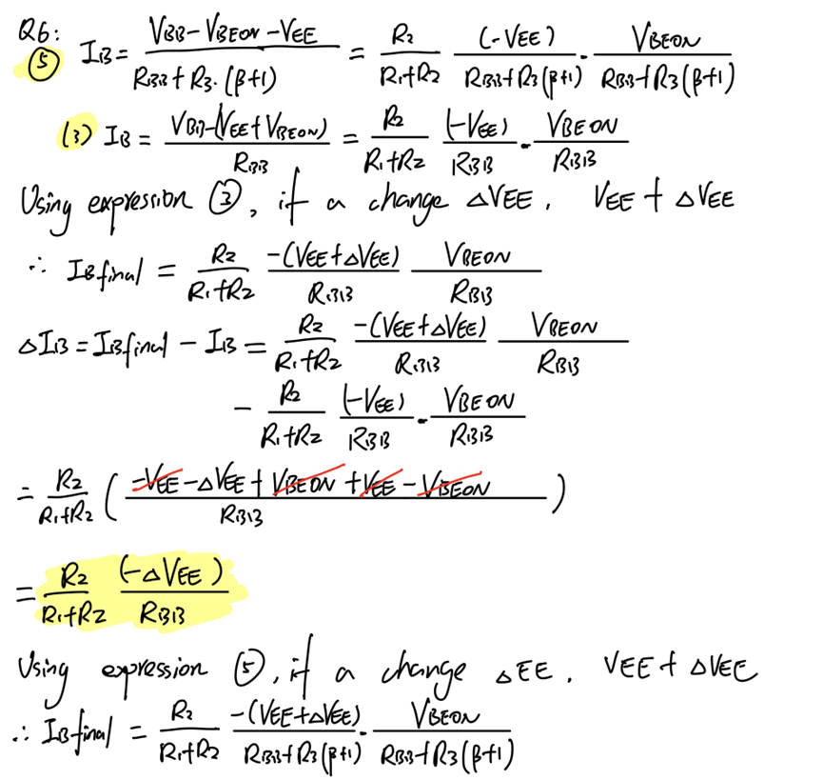

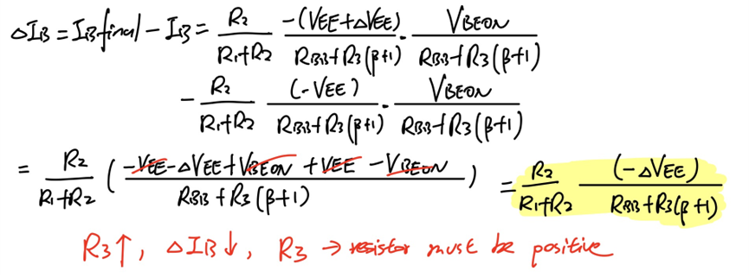

**Q7. (15 Points)** Inserting the feedback R3 at the emitter of the BJT not only stabilizes the IB but also improves (or increases) the output resistance Ro of the current sink shown in Fig. 6/Fig. 7 (i.e., *I*o is more stable when there is a change in VCE). Using a π-model for the BJT, prove that the output resistance of the current sink is .

Ans:

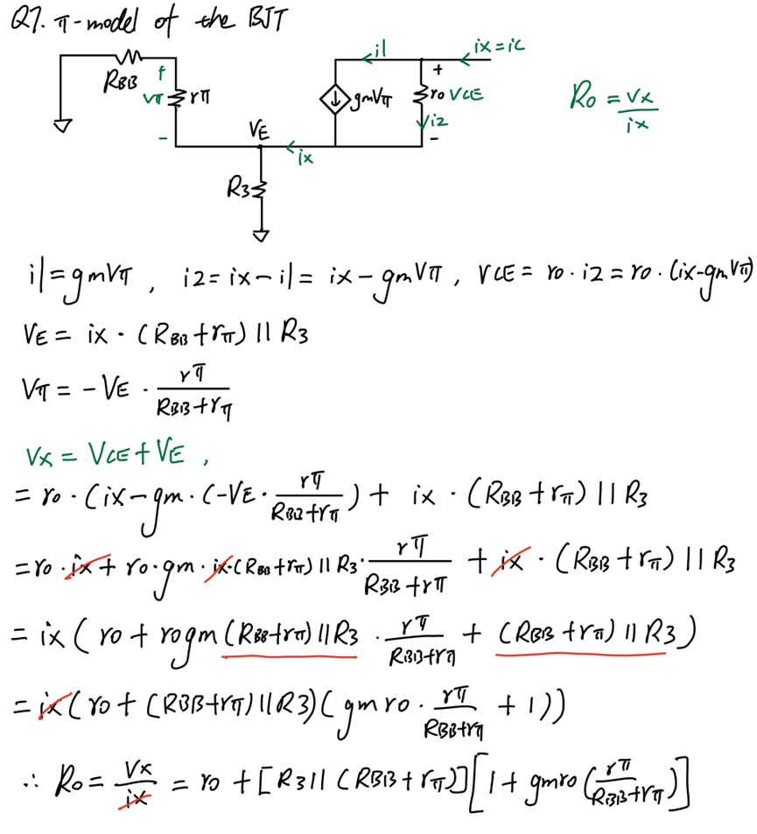

**Q8. (10 Points)** Inserting the feedback *R*3 at the emitter of the BJT improves the stabilization of the Q-point at the cost of increased *Vo,min*. What is the *Vo,min* of the constant current sink when R3≠0?

Ans:

Given *Vo,min* formula is *Vo,min* = VEE + 0.3V, this is the mimum voltage if we assume when R3 is zero.

After inserting the feedback R3, the current will flow through the R3 and generated a new voltage drop across R3, this voltage can be calculated as VR3 = IR3 * R3 by applying the Ohm’s law. Since IR3 is the current flow through the emitter, there IR3 = IE and VR3 = IE * R3.

As a result, after inserting the feedback R3, the *Vo,min* = VEE + 0.3V + VR3 = VEE + 0.3V + IE * R3.

**Q9. (15 Points)** For VEE = -5V, if we want to design a current sink with *Io* = 1.0 mA and *V*o,min=-1V using the NPN-BJT 2N3094 characterized in Q1, what is the resistance value for R3? To reduce the DC power consumption of R1 and R2, we usually choose large resistance values (in tens or hundreds of kΩ) for R1 and R2. Suppose we choose R2 = 100 kΩ, calculate R1 in kΩ. Verify the Io vs. VCC characteristics of the design by sweeping VCC from -5V to 5V with a 0.05V step and post the screenshot of the simulated Io vs. VCC characteristics.

Ans:

R3=3.67 kΩ, R1=13.09 kΩ

Io vs. VCC characteristics:

Solution:

**Q10. (10 Points)** When designing the constant current sink shown in Fig. 6, we assume that |*VCE*| ≥0.3V and Q1 works in the active region. Based on the resistance values obtained in Q9, sweep *VCC* in Fig. 6 from -5 V to +5V with a 0.05 V step and measure VE and IC to determine the |*VCE*| required for Q1 to work in the active region.

Ans:

As observed from the simulation graph, the horizontal axis is the VCC DC sweep voltage, and the vertical axis is the VE voltage. The active region is described as the horizontal line on the graph. The breakpoint observed of VE and VCC is -1.3101906V and -1V separately. Therefore, the VCE can be calculated as VCE = VCC – VE = -1V + 1.3101906V = 0.3101906≈0.31V which meets the assumption.

Circuit schematic for the Q9 and Q10:

