3EJ4 Lab3

Name: Rui Qiu

Student Id: 400318681

*Part1:*

(1)

Discuss/Justify:

(2) To ensure the circuit work as a common-collector amplifier, Vsig should in the range of -4.5V to 5.0V and the output voltage Vo should be greater in the range of -4.683226V to 4.447137V.

(3) The Vsig values results in Vo = 0V is Vsig = 0.5V.



The simulated intrinsic voltage gain Avo at low frequency is 0dB with phase -8.47E-5deg.

The measured intrinsic voltage gain Avo at low frequency is 0.8dB with phase 0deg.

*Part2:*

The most difficult one.

1. Input impedance Rin = 389.12ohm. The current gain Ai = 1.048.
2. Output impedance Ro = 1.58E+06ohm.
3. A picture:

*Part3:*

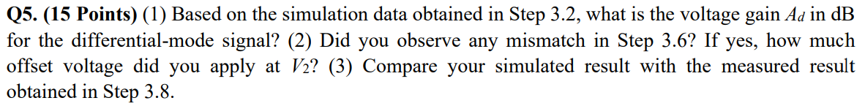

1. The voltage gain is 78.11dB.

1. Yes, the offset I applied at V2 is -0.00065V.Graphical user interface, text, application, Word

   Description automatically generated
2. The simulated result is 58.94dB and the measured result is 56.2dB which they are close enough.



The upper 3-dB frequency should around 1.54E+04 hz which will have the Vm(vo) amplitude close to 11.37861354V.





The upper 3-dB frequency is 5655555.22514252Hz from question (8) of lab2 by using the differential amplifier. The upper 3-dB frequency from Q6 is around 15400Hz. The reason of the differential amplifier with the current mirror load has a smaller f3dB is because ..



What formulas should use to find GBW?