Section 1: Multiple Choice Questions
Q1. What is the primary function of a router in a computer network?
Answer: c) Forwarding data packets between networks

Q2. What is the purpose of DNS in a computer network?
Answer: c) Converting domain names to IP addresses

Q3. Which topology uses a centralized hub or switch?
Answer: a) Star

Q4. Which protocol is used for secure file transfer?
Answer: b) FTP

🔹 Section 2: True or False
Q5. Firewall monitors and controls network traffic
✔️ True

Q6. DHCP assigns static IP addresses automatically
✔️ False
- DHCP assigns dynamic IPs, not static

Q7. VLANs divide network into logical networks
✔️ True

🔹 Section 3: Short Answers

Q8. Difference Between Hub and Switch
Feature | Hub | Switch
Data handling | Broadcast to all devices | Sends to specific device
Intelligence | Dumb device | Smart device
Speed | Slow | Fast
Security | Low | Better

Q9. Troubleshooting Network Connectivity Issues
✔️ Steps:
- Check physical connections (cables, Wi-Fi)
- Restart router/modem
- Check IP configuration (ipconfig)
- Ping test (check connectivity)
- Check DNS settings
- Disable firewall temporarily (for testing)
- Update network drivers

🔹 Section 4: Practical Application

Q10. Configure Wireless Router Security
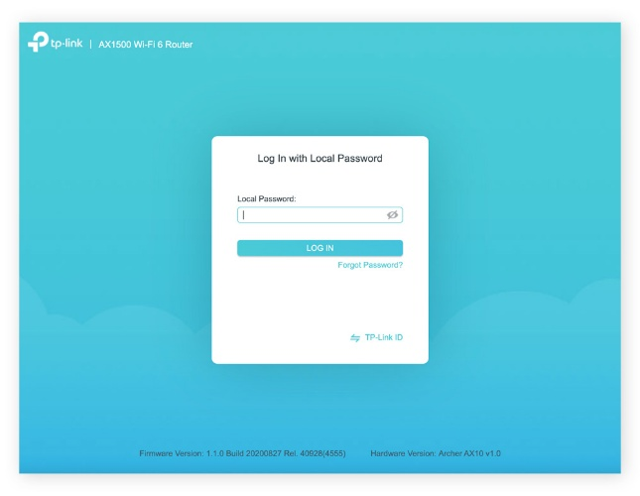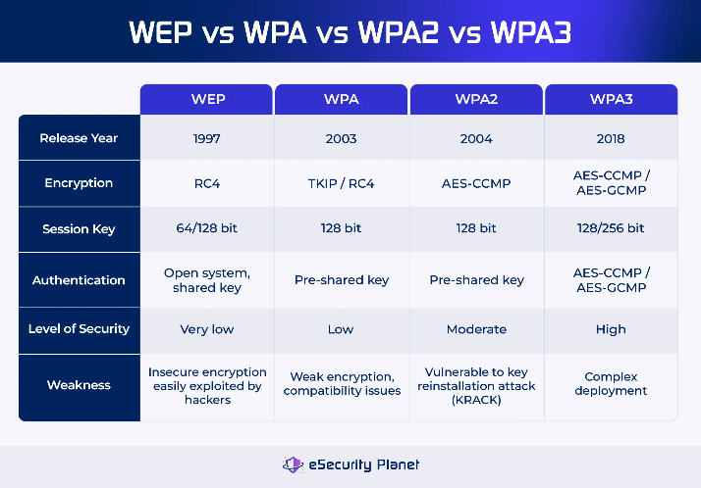

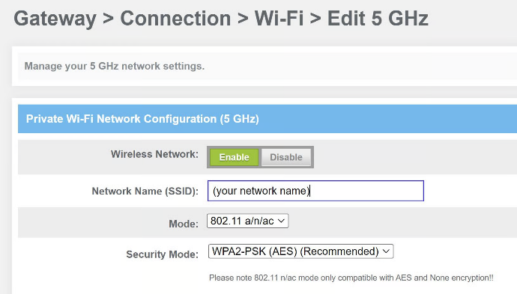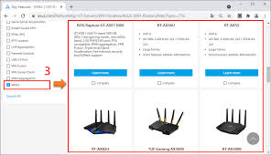
4
✔️ Steps:
- Open browser → enter router IP (e.g., 192.168.1.1)
- Login with admin credentials
- Go to Wireless Settings
- Set WPA2 or WPA3 encryption
- Change strong Wi-Fi password
- Disable WPS (security risk)
- Save settings and reboot

🔹 Section 5: Essay

Q11. Importance of Network Documentation
✔️ Why it matters:
- Helps in troubleshooting faster
- Reduces downtime
- Improves network management
- Essential for security tracking
✔️ What to document:
- Network topology diagram
- IP address details
- Device configurations
- Login credentials (secured)
- Firewall rules
- Hardware inventory

