Basic Computer Hardware
Task 1: System Information Screenshot
On your ASUS TUF A15 laptop:
Method 1
Press:
Windows + I
Go to:
System → About
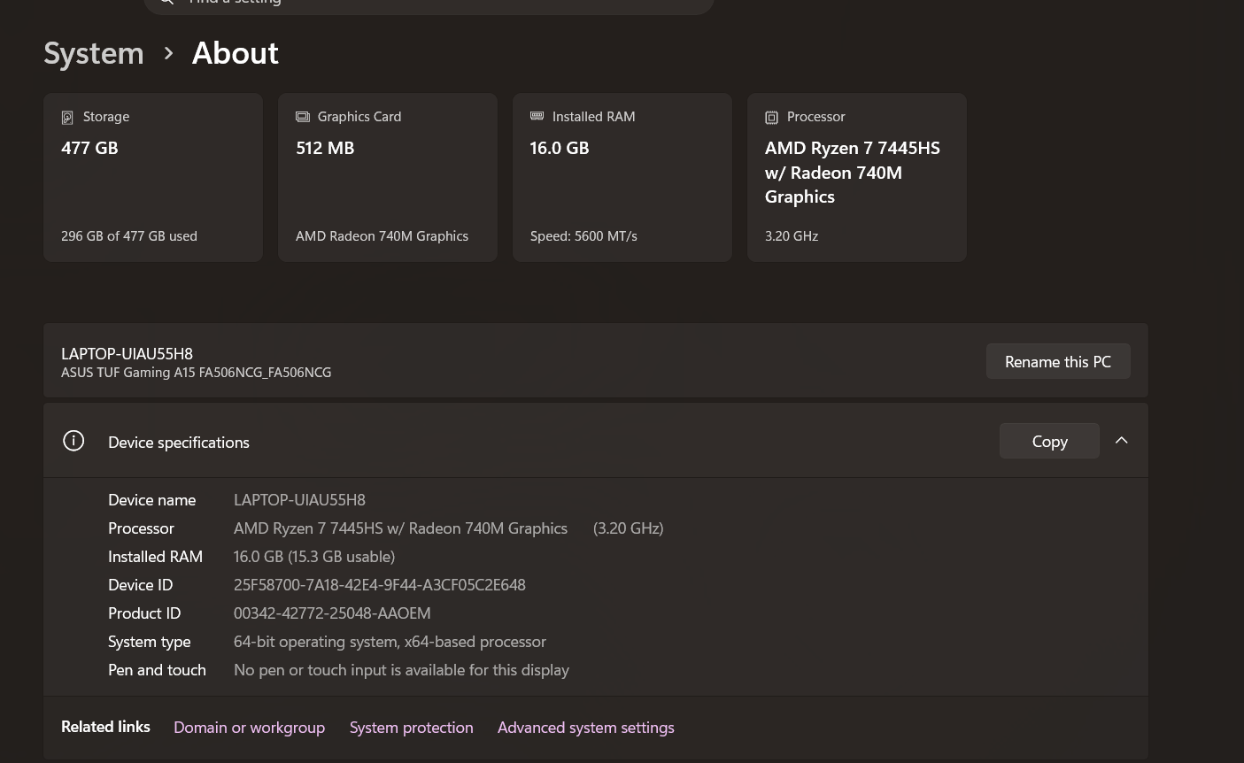

Method 2 (More Detailed)
Press:
Windows + R
Type:
msinfo32
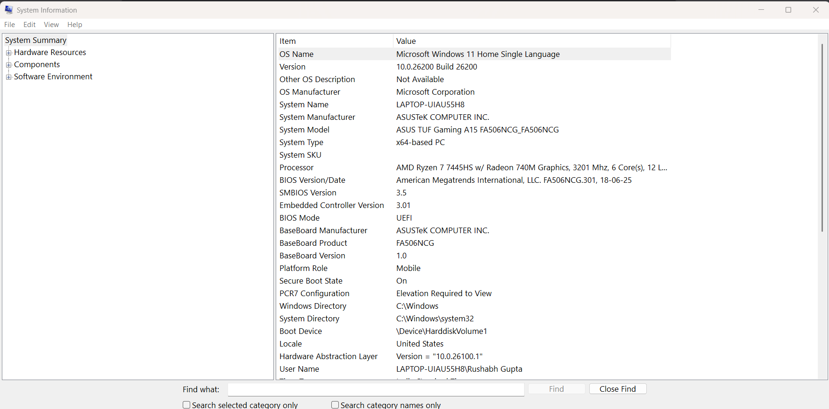

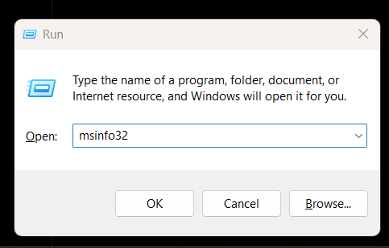
Task 2: Hardware Components Diagram
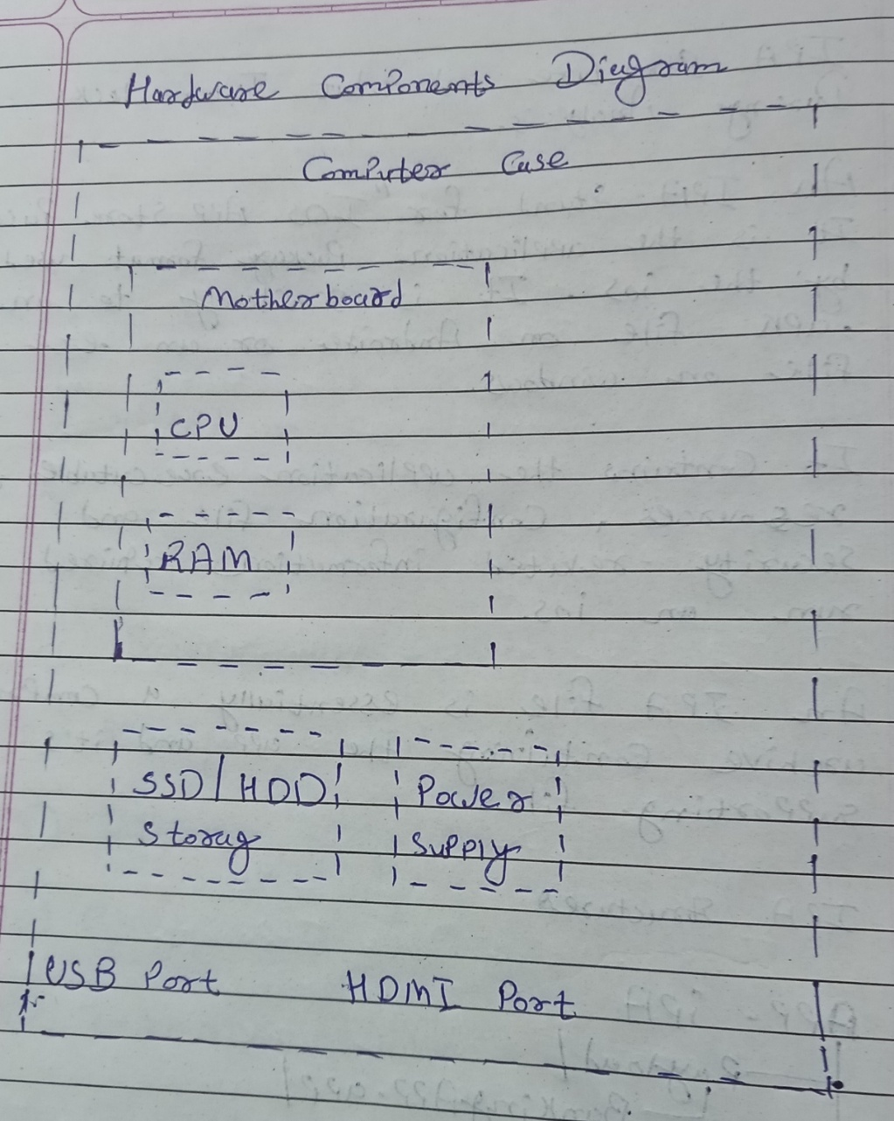
Label:
- CPU
- RAM
- Motherboard
- SSD/HDD
- Power Supply
- USB Port
- HDMI Port

Task 3: Hardware Upgrades for Gaming or Video Editing
Component | Why It Helps
RAM Upgrade | More RAM allows smoother multitasking and handling of large applications.
SSD Upgrade | Reduces boot time and speeds up software loading.
Better GPU | Improves gaming performance and video rendering speed.
Improved Cooling System | Prevents overheating and maintains performance during heavy workloads.
Faster Processor (CPU) | Improves overall system speed and processing power.
Example for Your ASUS TUF A15
You already have a good Ryzen 7 processor.
Most beneficial upgrades:
- Increase RAM to 32GB
- Install a faster NVMe SSD
- Improve cooling (cooling pad, cleaning fans)

Task 4: SSD vs HDD Comparison
Feature | SSD | HDD
Speed | Very Fast | Slower
Boot Time | 10-20 seconds | 30-60 seconds or more
Durability | No moving parts, more durable | Contains moving parts, more fragile
Which is Better for a Student?
An SSD is better for a student because:
- Faster boot times.
- Applications open quickly.
- Better overall system responsiveness.
Conclusion
For students who want fast startup times, quicker file access, and improved performance while studying, gaming, or editing videos, an SSD is the preferred storage option over an HDD.

