📘 Assignment: Introduction to Cybersecurity

🔹 Task 1: Key Cybersecurity Terms
Term | Definition
Threat | Anything that can cause harm to a system, network, or data.
Vulnerability | A weakness in a system that attackers can exploit.
Risk | The potential damage that may occur if a threat exploits a vulnerability.
Asset | Any valuable resource that needs protection, such as data, systems, or applications.
Attack Vector | The method or path used by an attacker to gain unauthorized access to a system.

🔹 Task 2: Real-World Cyberattack on an Indian Company
Incident: Tata Electronics Cyber Breach (2026)
Tata Electronics confirmed a cybersecurity incident affecting some of its systems. According to reports, a ransomware group called World Leaks allegedly obtained and published over 200,000 files (more than 630 GB of data) containing sensitive information related to customers such as Apple and Tesla. The leaked files reportedly included manufacturing documents, design specifications, emails, and other confidential records.
Summary
A cybercriminal group gained unauthorized access to Tata Electronics systems and allegedly exfiltrated confidential business data. The stolen information was later published on the dark web, creating concerns about data confidentiality and corporate security.
Analysis
Category | Example
Threat | Ransomware/Data Extortion Group (World Leaks)
Vulnerability | Unauthorized access to internal systems
Risk | Exposure of confidential business documents and customer data

🔹 Task 3: Cybersecurity Dashboard Observation
Selected Dashboard:
Kaspersky Cyberthreat Real-Time Map
Screenshot
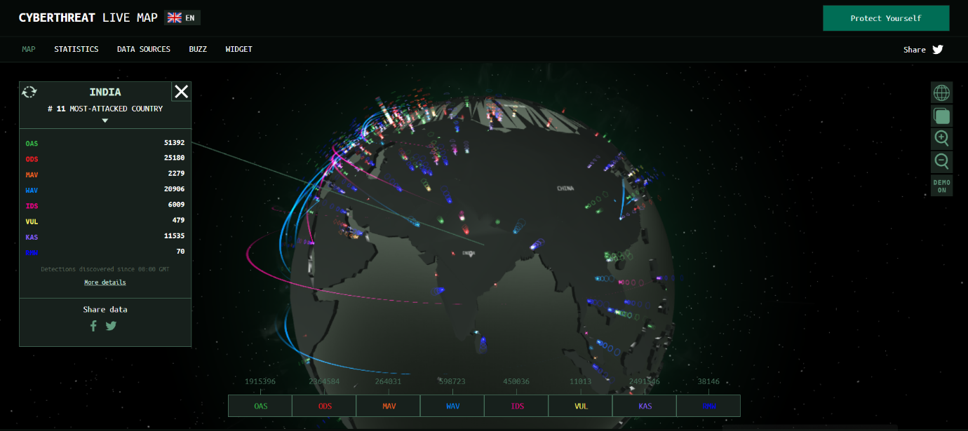
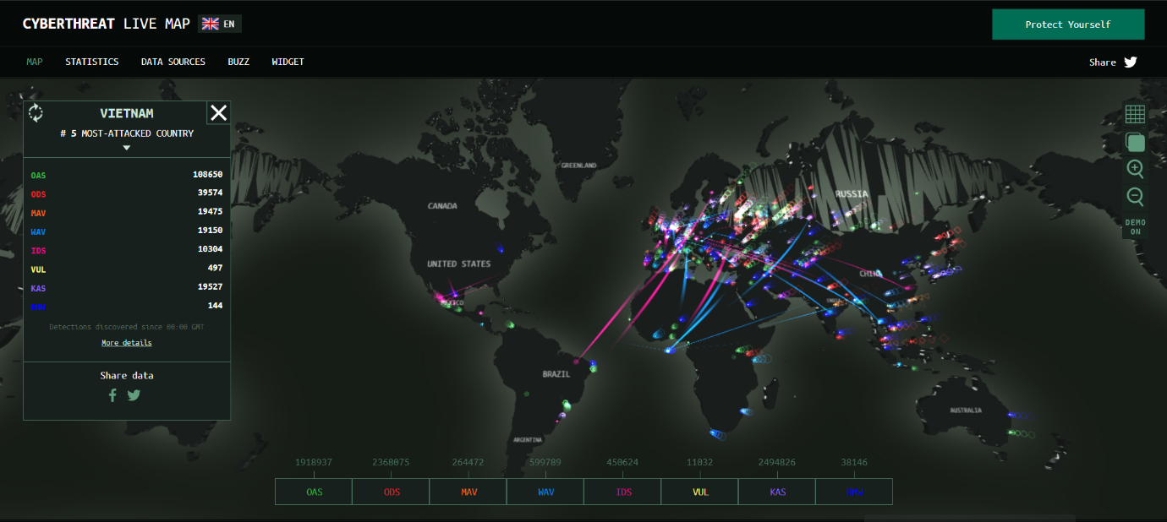

Three Types of Information Displayed
- Real-time cyberattack activity around the world.
- Number of malware detections by country.
- Statistics on web threats, infected devices, and malicious network activities.

🔹 Task 4: Simulated Phishing Email Template
Example Phishing Email
Subject: Urgent: Your Paytm Account Has Been Suspended
Dear Customer,
We detected unusual activity on your Paytm account. To prevent permanent suspension, please verify your account immediately by clicking the link below:
Verify Account:
http://paytm-security-verification-login.com
Failure to verify within 24 hours will result in account deactivation.
Thank you,
Paytm Security Team
Suspicious Elements
Suspicious Element | Why It Is Suspicious
Urgent language | Creates panic and pressure
Fake website link | Does not belong to the official Paytm domain
Threat of account suspension | Used to force quick action
Request for account verification | Attempts to steal credentials

🔹 Task 5: AI-Generated Simulated Phishing Email
Phishing Email for Fictional Food Delivery App "FoodiePal"
Subject: Important: Your FoodiePal Account Requires Verification
Hello User,
We noticed suspicious activity on your FoodiePal account. To continue using our services and avoid account suspension, please verify your account immediately by clicking the secure link below:
Verify Account:
http://foodiepal-account-security-check.com
Failure to complete verification within 12 hours may result in temporary account suspension.
Thank you,
FoodiePal Security Department

Why This Email Could Trick Users
- Uses urgency
  - Claims account suspension will occur soon.
- Appears legitimate
  - Uses a company name and professional formatting.
- Includes a fake verification link
  - Users may not notice the domain is fake.
- Creates fear
  - Threatens loss of account access.
- Requests immediate action
  - Encourages users to act without thinking carefully.

✅ Conclusion
Cybersecurity is essential for protecting digital assets, data, and users from cyber threats. Understanding threats, vulnerabilities, risks, and phishing techniques helps individuals and organizations identify attacks and strengthen their security posture. Real-world incidents such as the Tata Electronics breach demonstrate how cyberattacks can impact businesses and expose sensitive information.

