MODEL REVIEW
Model Comparison Report
Visit Risk Classification: V1 vs V2
Attribute | Value
Models | 02_risk_model_v1.ipynb and 02_risk_model_v2.ipynb
Target | risk_score: High, Low, Medium
Data | Cleaned Oracle PATIENTS, VISITS, and BILLING tables
Prepared | 29 June 2026

Decision summary. V2 Random Forest is the stronger candidate for continued development because it removes post-outcome billing predictors, improves macro-F1 and High-risk recall relative to V1 Random Forest, and produces a materially smaller model. It is not ready for clinical deployment because High-risk recall remains only 7%.

1. Executive Summary
This report compares two implementations of a three-class visit-risk classifier. V1 combines patient, visit, and billing context; V2 removes billing predictors and introduces prior-visit history. Both versions train Logistic Regression and Random Forest models against risk_score using a chronological 80/20 holdout.
- V1 Random Forest achieves the highest accuracy: 46.98%.
- V1 tuned Random Forest achieves the highest macro-F1: 33.78%.
- V2 Random Forest improves macro-F1 over V1 regular Random Forest from 30.28% to 33.54% and improves High-risk recall from 2% to 7%.
- V2 Random Forest is recommended for continued development because its feature timing is more defensible and its class balance is better, but it is not clinically deployment-ready.
Recommendation: Advance V2 Random Forest as the development baseline, then improve High-risk recall, probability calibration, and temporal validation before any operational or clinical use.

2. Problem Statement
The business objective is to classify each hospital visit as High, Low, or Medium operational and clinical risk. This is a supervised multi-class classification task with risk_score as the target. The intended value is earlier identification of resource-intensive or clinically concerning visits, supporting staffing, escalation, and care coordination decisions.
Scope caution: The current feature set includes length_of_stay_hours, so the model is suitable only when stay duration is known. A true pre-visit or admission-time model must remove or replace that field.

3. Dataset Overview
Attribute | V1 | V2
Records | 25,000 visits | 25,000 visits
Predictor features | 19 (12 numeric, 7 categorical) | 17 (12 numeric, 5 categorical)
Data sources | PATIENTS, VISITS, BILLING | PATIENTS, VISITS
Target | risk_score | risk_score
Target distribution | Low 12,470; Medium 7,496; High 5,034 | Same overall distribution
Train/Test | 20,000 / 5,000 | 20,000 / 5,000
Training period | 20 Jan 2025 - 8 Nov 2025 | 20 Jan 2025 - 8 Nov 2025
Testing period | 8 Nov 2025 - 20 Jan 2026 | 8 Nov 2025 - 20 Jan 2026
Missing values | Median numeric; most-frequent categorical | Same
Outlier handling | No explicit model-stage clipping/removal | Same

Comparison caveat: Both notebooks sort only by visit_date before splitting. Because many visits share the boundary date, database row order can change which tied records enter the test set. The observed class supports differ slightly. Future runs should sort by visit_date and visit_id for an identical, deterministic holdout.

4. Data Preprocessing
Step | V1 | V2
Numeric imputation | Median | Median
Categorical imputation | Most frequent | Most frequent
Encoding | One-hot, unknown categories ignored | Same
Scaling | StandardScaler for numeric features | Same
Class balance | class_weight='balanced' | class_weight='balanced'
Feature engineering | Visit calendar and registration-tenure features | Adds prior count, prior average LOS, days since prior visit, prior High-risk count
Feature removal | None beyond IDs/raw dates | Removes billed amount, approved amount, payment days, claim status, doctor ID, visit year

5. Models Compared
Model | Version | Key configuration
Logistic Regression | V1 | max_iter=1000; balanced class weights
Random Forest | V1 | 250 trees; unrestricted depth; min leaf=2; balanced
Tuned Random Forest | V1 | Best: 300 trees; depth=8; min leaf=3
Logistic Regression | V2 | max_iter=1000; balanced class weights
Random Forest | V2 | 300 trees; depth=12; min leaf=3; balanced

6. Evaluation Methodology
- Chronological holdout: earliest 80% for training, latest 20% for testing.
- Primary metrics: accuracy and macro-F1; class precision, recall, F1, and confusion matrices support error analysis.
- Macro-F1 is important because the target is imbalanced: Low is roughly half of all visits, while High is about one-fifth.
- ROC-AUC, precision-recall curves, calibration, and confidence intervals were not calculated in either notebook and should not be inferred.

7. Performance Metrics
Model | Accuracy | Macro-F1 | High Recall | Low Recall | Medium Recall
V1 Logistic Regression | 34.42% | 32.87% | 27% | 33% | 42%
V1 Random Forest | 46.98% | 30.28% | 2% | 82% | 19%
V1 Tuned Random Forest | 39.24% | 33.78% | 14% | 50% | 39%
V2 Logistic Regression | 33.96% | 31.23% | 17% | 31% | 50%
V2 Random Forest | 43.30% | 33.54% | 7% | 64% | 34%

V1 Random Forest maximizes total correct predictions by favoring the Low class. V2 Random Forest sacrifices 3.68 percentage points of accuracy but gains 3.26 points of macro-F1 relative to V1 Random Forest, indicating more balanced behavior.

8. Visual Comparisons
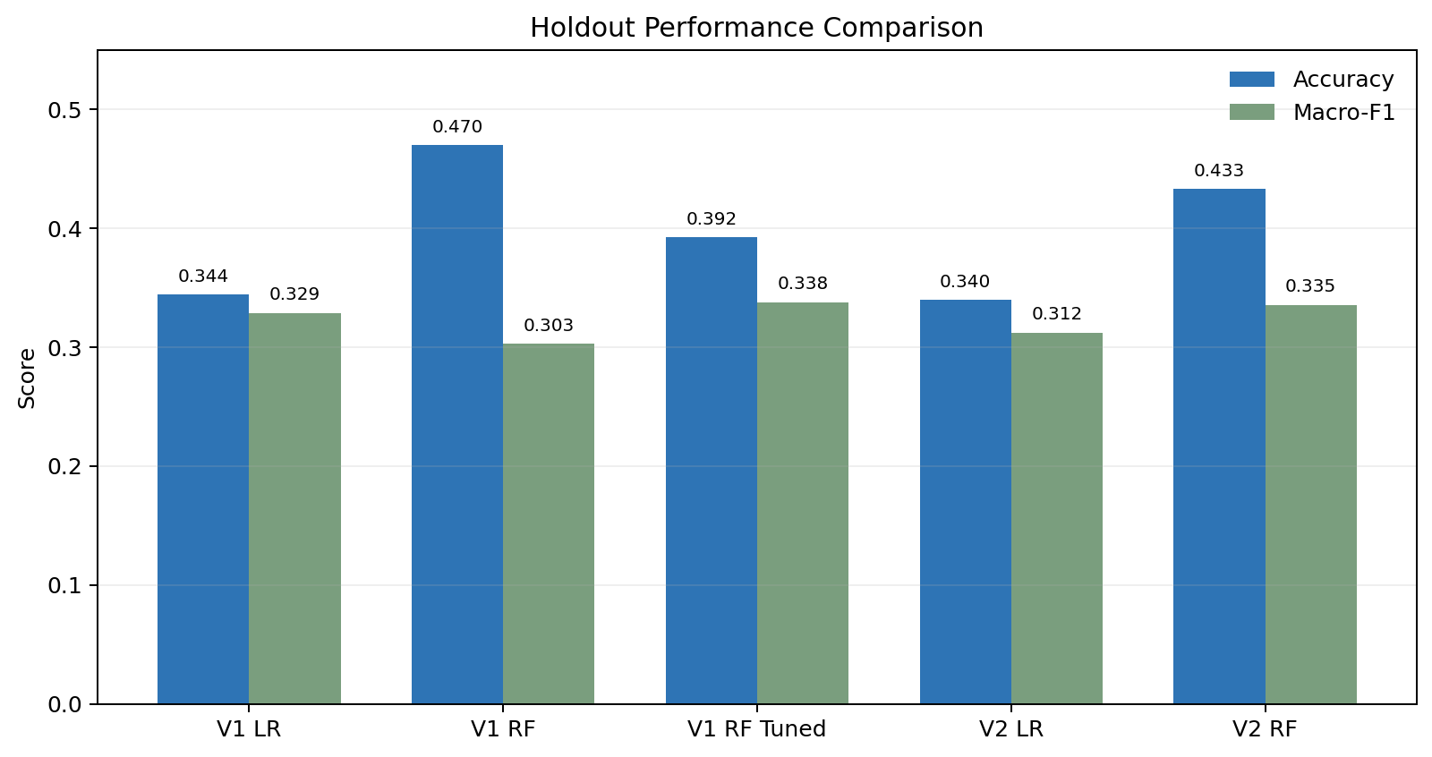
Figure 1. Holdout accuracy and macro-F1 across V1 and V2 models.
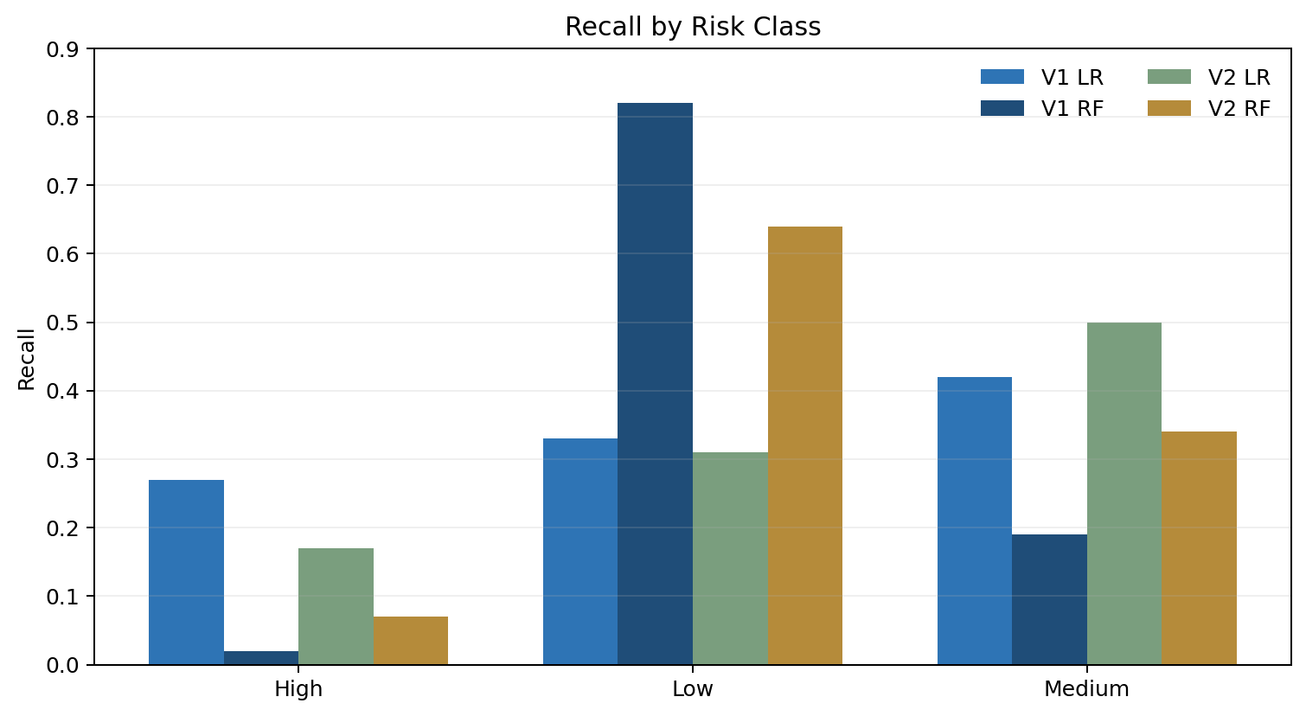
Figure 2. Recall by risk class for regular Logistic Regression and Random Forest models.
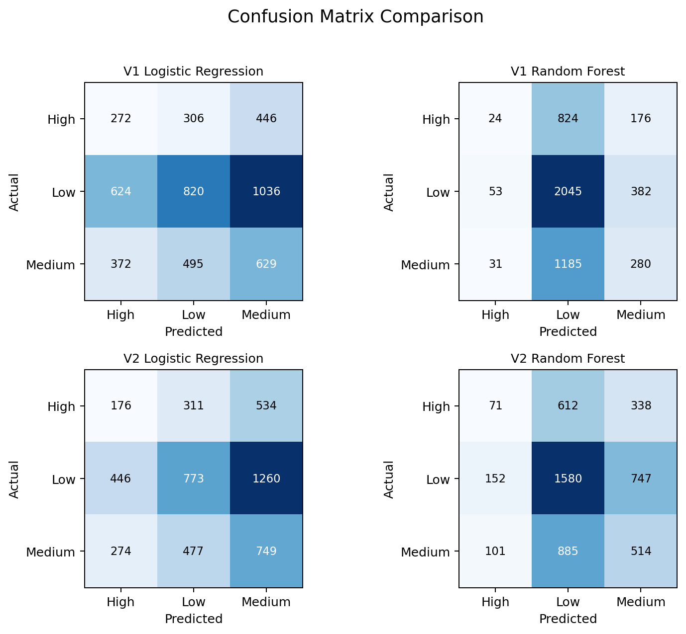
Figure 3. Confusion matrices for V1 and V2 regular models.

9. Error Analysis
The central failure mode is missed High-risk visits. V1 Random Forest identifies only 24 of 1,024 High-risk visits and classifies 824 of them as Low. V2 Random Forest identifies 71 of 1,021 High-risk visits, reducing the High-to-Low error to 612, but still misses 950 High-risk visits overall.
Error pattern | V1 Random Forest | V2 Random Forest | Interpretation
High predicted Low | 824 | 612 | V2 materially reduces the most concerning error
High correctly detected | 24 | 71 | V2 nearly triples true High detections, from a very low base
Low correctly detected | 2,045 | 1,580 | V1 accuracy advantage is driven by majority-class capture
Medium predicted Low | 1,185 | 885 | V2 is less biased toward Low

Clinical risk: A 7% High-risk recall means V2 still fails to flag approximately 93% of High-risk visits. Neither version should drive unattended clinical decisions.

10. Interpretability
Aspect | Logistic Regression | V1 Random Forest | V2 Random Forest
Global explanation | Strong through coefficients | Moderate through feature importance | History features are business-readable
Nonlinear effects | Limited | Strong | RF can model history/context interactions
Individual explanation | Possible with coefficient contributions | Requires SHAP or local explanation | SHAP not implemented
Governance | Easier to document | More complex | V2 removes outcome-timing concerns from billing fields

11. Computational Efficiency
Artifact | Observed size | Relative cost
V1 Logistic Regression | ~11 KB | Very low
V1 Random Forest | ~152 MB | Highest memory; unrestricted depth
V1 Tuned Random Forest | ~4.7 MB | Lower due to depth=8
V2 Logistic Regression | ~7 KB at creation | Very low
V2 Random Forest | ~37 MB at creation | Moderate; depth=12

The notebooks did not instrument per-model training latency, prediction latency, CPU use, or peak memory. Exact timing claims would therefore be speculative. Artifact size indicates that V2 Random Forest is substantially lighter than the unrestricted V1 Random Forest.

12. Strengths and Weaknesses

V1
- Strength: highest observed accuracy through V1 Random Forest.
- Strength: V1 Logistic Regression has the highest High-risk recall among regular models at 27%.
- Weakness: uses billed amount, approved amount, payment days, and claim status; several are unavailable at visit-risk prediction time and can create leakage or timing mismatch.
- Weakness: regular Random Forest is heavily biased toward Low risk and has only 2% High-risk recall.

V2
- Strength: removes billing predictors and adds prior patient-history features.
- Strength: improves Random Forest macro-F1 and reduces High-to-Low errors.
- Strength: smaller Random Forest artifact and constrained depth improve deployment efficiency.
- Weakness: lower raw accuracy than V1 Random Forest and still inadequate High-risk recall.
- Weakness: prior High-risk history requires reliable longitudinal patient identity and historical labels.

13. Business Impact
On their respective 5,000-visit holdouts, V1 Random Forest produces approximately 184 more correct predictions overall than V2 Random Forest. However, V2 detects 47 more High-risk visits and reduces High-risk visits mislabeled as Low by 212. For hospital operations, the latter may be more valuable than aggregate accuracy because missed High-risk visits carry disproportionate safety and resource-allocation consequences.
The model should be treated as a prioritization aid only. At current recall levels, it cannot safely replace clinical assessment, triage protocols, or escalation rules.

14. Recommendation
Use V2 Random Forest as the preferred development baseline. Its feature set is more consistent with the timing of visit-risk prediction, its macro-F1 is stronger than V1 regular Random Forest, and it reduces the most concerning High-to-Low misclassification pattern. Accept the lower headline accuracy as a trade-off for better class balance and model validity.
- Do not deploy either version for autonomous clinical decisions.
- Set a minimum High-risk recall requirement before pilot use; 7% is not acceptable.
- Retain Logistic Regression as an interpretable benchmark and challenge model.
- If a single existing model must be selected solely for raw accuracy, choose V1 Random Forest, but document its leakage/timing limitations and severe High-risk under-detection.

15. Future Work
- Make the temporal split deterministic with visit_date plus visit_id and use identical holdout rows across versions.
- Investigate how risk_score was generated and whether available predictors contain genuine signal; weak target construction may cap performance.
- Optimize for High-risk recall or class-weighted utility, not accuracy alone; test threshold adjustment and cost-sensitive learning.
- Try XGBoost, LightGBM, CatBoost, and calibrated ensembles with temporal cross-validation.
- Add ROC-AUC, one-vs-rest precision-recall curves, calibration curves, Brier score, and confidence intervals.
- Add SHAP analysis, permutation importance, learning curves, and subgroup checks by age, gender, city, department, and insurance provider.
- Remove length_of_stay_hours for a true admission-time model, or clearly define the prediction point as post-discharge operational review.
- Monitor feature drift, class prevalence, calibration, High-risk recall, and false-negative burden after deployment.

