MODEL EXPLAINABILITY REPORT
SMOTE Undersampling V5 Risk Model
Feature Importance and Explainability Summary
MODEL CONTEXT Selected Random Forest with Random undersampling. Holdout accuracy 41.50%, Macro F1 35.12%, and High-risk recall 14.75%.
Prepared from the fitted V5 artifact and refreshed 1 July 2026 evaluation

Executive Explainability Summary
The V5 model relies most heavily on how a visit's length of stay compares with the department norm, the raw length of stay, and the treating doctor identifier. These three grouped features account for 43.76% of total Random Forest importance.
The top five features contribute 55.20% of total importance and the top ten contribute 75.81%. Engineered interaction features contribute 37.39%, confirming that relative billing and stay behavior materially shape the model's splits.
KEY FINDING V5's feature hierarchy is almost identical to V4's (Spearman rank correlation 0.986). The improvement in High-risk recall is therefore primarily attributable to Random undersampling, which changes class exposure during training, rather than to a new set of dominant predictors.

Model and Performance Context
Item | V5 result
Selected strategy | Random undersampling selected by four-fold temporal cross-validation.
Estimator | Random Forest: 385 trees, depth 6, minimum split 13, 75% feature sampling.
Accuracy | 41.50%
Macro F1 | 35.12%
Balanced accuracy | 35.39%
High-risk precision | 21.79%
High-risk recall | 14.75% (151 of 1,024 High-risk visits detected)
High-risk F1 | 17.59%
The holdout set was not resampled. Reported performance therefore reflects the natural test-period class distribution.

Global Feature Importance
The chart reports grouped mean decrease in impurity. One-hot encoded category levels are summed back to their source field so Doctor ID, department, city, and other categorical variables can be interpreted at the field level.
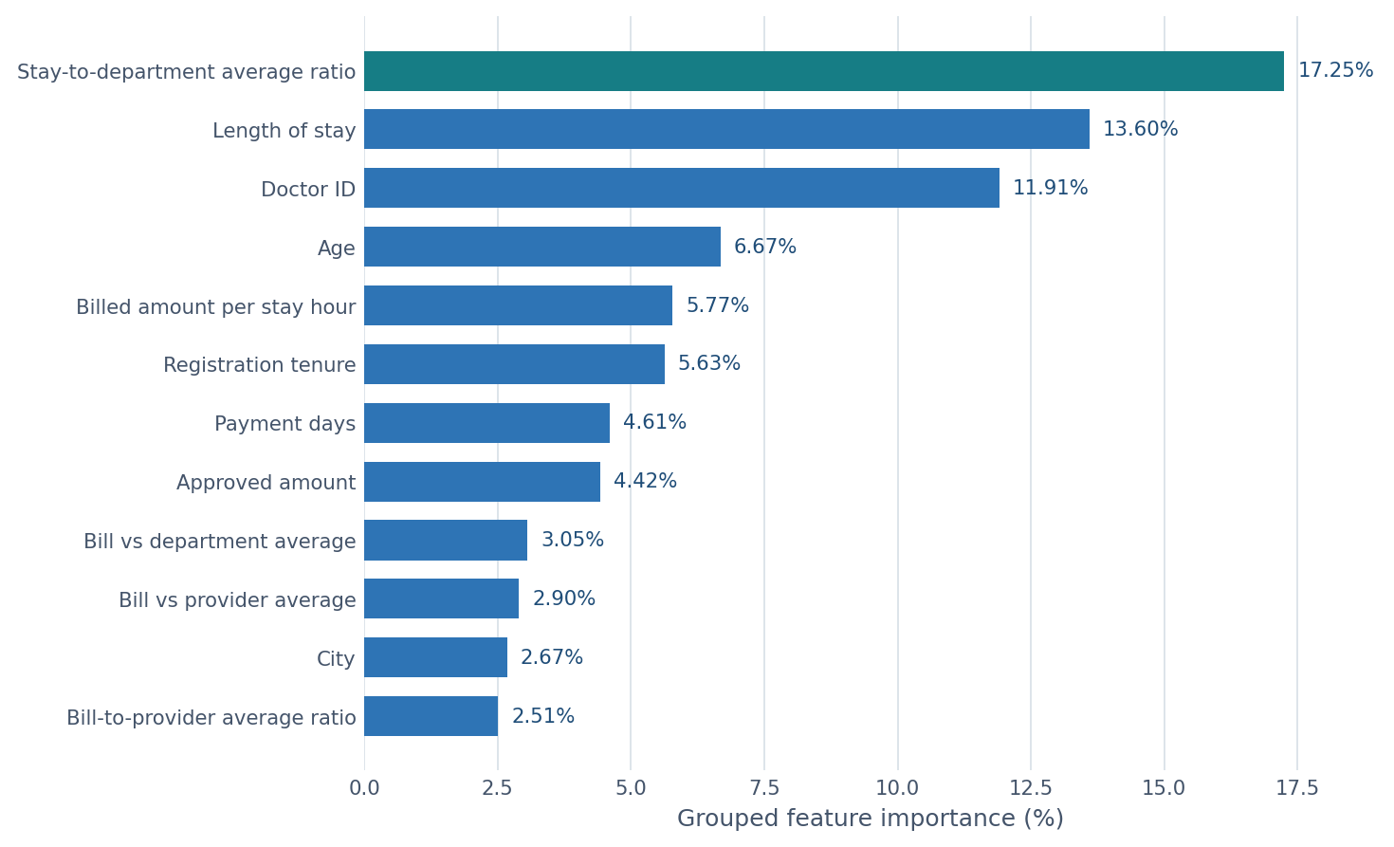
Figure 1. Top 12 grouped V5 feature importances

Interpretation of Leading Drivers
Driver | Importance | Interpretation
Stay-to-department ratio | 17.25% | Measures whether a visit is unusually long or short relative to its department. It is the strongest global splitter.
Length of stay | 13.60% | Captures absolute utilization intensity. Combined with the relative-stay ratio, stay-related variables contribute 30.85%.
Doctor ID | 11.91% | Represents provider-associated patterns. Treat cautiously because high-cardinality categorical fields can receive inflated impurity importance.
Age | 6.67% | Provides stable patient-level differentiation, but importance does not reveal whether higher age raises or lowers High-risk probability.
Billed amount per stay hour | 5.77% | Captures financial intensity adjusted for visit duration and links resource use with the engineered interaction layer.

Feature-Family Contributions
Feature family | Contribution | Included signals
Engineered interactions | 37.39% | Department/provider billing comparisons, stay ratios, and billed amount per stay hour.
Provider and operational categories | 16.48% | Doctor, department, insurance provider, and visit type.
Patient demographics and tenure | 15.92% | Age, chronic flag, registration tenure, gender, and city.
Core visit utilization | 13.60% | Raw length of stay.
Direct financial and claims | 12.28% | Billed amount, approved amount, payment days, and claim status.
Calendar timing | 4.34% | Month, quarter, day of week, weekend flag, and year.
Rounded family contributions sum to approximately 100%. Families are analytical groupings for interpretation, not separate model components.

Performance-Linked Explanation
Why V5 improves High-risk recall. V4 and V5 use the same raw and interaction features and nearly identical importance rankings. Random undersampling reduces the dominance of Low and Medium observations during fitting, allowing the same feature structure to create more High-risk predictions. This raises High-risk recall from 8.01% in V4 to 14.75% in V5.
Why accuracy declines. The model makes more minority-class predictions, increasing false positives and reducing overall accuracy from 42.22% in V4 to 41.50% in V5. The 0.72-point accuracy cost produces a 6.74-point High-risk recall gain and a 1.01-point Macro F1 gain.
Why interactions require caution. Interaction features receive 37.39% of total importance, but V4 showed that adding them did not improve holdout performance over V3. High importance means the forest uses a feature frequently; it does not prove incremental value, stability, or causality.
DEPLOYMENT WARNING Billing, approved amount, payment days, and claim status may not exist at admission time. If predictions are required before billing completion, the current V5 feature set may contain unavailable or post-visit information and should be replaced with a V2-style pre-visit feature contract.

Explainability Boundaries
Boundary | Implication
No direction | Importance does not show whether larger values increase or decrease High-risk probability.
Not class-specific | The values summarize all tree splits across High, Low, and Medium predictions.
Not causal | A prominent feature may be correlated with risk without causing it.
Cardinality bias | Doctor ID can appear overly important because it contains many category levels.
Correlated predictors | Raw billing fields and derived ratios can divide or duplicate importance credit.
No local explanation | Global importance cannot explain why an individual visit received a specific prediction.

Recommended Explainability Work
Step | Action
1 | Calculate holdout permutation importance using both Macro F1 and High-risk recall scorers.
2 | Generate class-specific TreeSHAP summaries for High, Low, and Medium predictions.
3 | Review SHAP explanations for true positives, false negatives, and false positives in the High-risk class.
4 | Test feature-importance stability across temporal folds and future monitoring periods.
5 | Audit Doctor ID and provider effects for overfitting, proxy behavior, and operational fairness.
6 | Retrain an undersampled model using only features available at the intended prediction time.

Governance Conclusion
CONCLUSION V5 is the preferred experimental model because Random undersampling improves balanced performance and High-risk recall. Its dominant signals are stay duration, department-relative stay behavior, provider identity, age, and financial intensity. The model still requires class-specific explanations, feature-timing validation, and substantial recall improvement before production use.

Appendix: Complete Grouped Importance Ranking
Rank | Feature | Importance | Rank | Feature | Importance
1 | Stay-to-department average ratio | 17.25% | 15 | Visit month | 1.95%
2 | Length of stay | 13.60% | 16 | Department | 1.81%
3 | Doctor ID | 11.91% | 17 | Visit day of week | 1.73%
4 | Age | 6.67% | 18 | Department average billed amount | 1.44%
5 | Billed amount per stay hour | 5.77% | 19 | Insurance provider | 1.39%
6 | Registration tenure | 5.63% | 20 | Visit type | 1.37%
7 | Payment days | 4.61% | 21 | Department average length of stay | 1.30%
8 | Approved amount | 4.42% | 22 | Provider average billed amount | 0.99%
9 | Bill vs department average | 3.05% | 23 | Claim status | 0.91%
10 | Bill vs provider average | 2.90% | 24 | Gender | 0.61%
11 | City | 2.67% | 25 | Visit quarter | 0.44%
12 | Bill-to-provider average ratio | 2.51% | 26 | Chronic flag | 0.34%
13 | Billed amount | 2.35% | 27 | Weekend visit | 0.22%
14 | Bill-to-department average ratio | 2.17% | 28 | Visit year | 0.00%
Source: fitted artifact models/risk/risk_random_forest_smote_undersampling_v5.pkl. Grouped importances sum to 100% before rounding.

