MODEL REVIEW
Claim Classification Model Comparison Report
03_claim_model_v1.ipynb through 03_claim_model_SMOTE_undersampling_v5.ipynb
Attribute | Value
Objective | Predict Paid, Pending, or Rejected before claim submission
Target | claim_status
Data | Cleaned Oracle PATIENTS, VISITS, and BILLING tables
Versions | V1 Random Forest, V2 XGBoost, V3 Tuned RF, V4 Interaction RF, V5 Resampled RF
Prepared | 1 July 2026
Decision summary. V2 XGBoost has the highest Macro F1, V3 Hypertuned Random Forest has the highest balanced accuracy and Rejected recall, and V5 has the highest raw accuracy but the weakest balanced result. V3 is preferred when Rejected-claim detection is the business priority; V2 remains the best balanced-model benchmark.

1. Executive Summary
This report compares five executed claim-outcome model versions. The sequence tests a regular Random Forest, XGBoost with additional patient-history features, temporal Random Forest tuning, leakage-safe interaction engineering, and aggressive SMOTE/undersampling.
- V5 Hybrid Resampling Random Forest achieves the highest accuracy: 46.92%.
- V2 XGBoost achieves the highest Macro F1: 36.99%.
- V3 Hypertuned Random Forest achieves the highest balanced accuracy: 42.28%, and Rejected recall: 61.07%.
- V4 interactions and V5 resampling do not improve the selected V3 business metrics.
Recommendation: Use V3 as the preferred Rejected-claim screening Random Forest, retain V2 XGBoost as the Macro-F1 benchmark, and do not select V5 solely for its higher accuracy.

2. Problem Statement
The objective is to classify each insurance claim as Paid, Pending, or Rejected using information intended to be available before adjudication. The operational value is prioritization: identify claims likely to require intervention while avoiding excessive false rejection alerts. No model should automatically submit, deny, or alter a claim at the current performance levels.

3. Dataset and Leakage Controls
Attribute | Value | Control
Records | 25,000 claims | All versions
Train / test | 20,000 / 5,000 | Chronological 80/20 split by billing_date
Target classes | Paid, Pending, Rejected | Paid is the majority class
Core sources | PATIENTS, VISITS, BILLING | Cleaned Oracle tables
Leakage exclusions | approved_amount, payment_days | Produced after adjudication
Holdout policy | Latest 20% | Never used for V3 tuning or V5 strategy selection
Comparison caveat: The notebooks sort by billing_date without bill_id as a secondary key. V2's tied-date ordering produces a slightly different class composition, so its holdout is not perfectly row-identical to V1/V3-V5.

4. Preprocessing and Feature Evolution
Version | Feature count | Feature contract | Change introduced
V1 | 21 | 14 numeric + 7 categorical | Calendar, registration tenure, billing delay
V2 | 24 | 17 numeric + 7 categorical | Adds billed amount per stay hour and prior-visit history
V3 | 21 | Same as V1 | No feature change; tunes Random Forest
V4 | 39 before one-hot | 21 raw + 18 interactions | Department/provider billing, stay, lag, and chronic interactions
V5 | 21 | Same as V3 | No feature change; resampling after preprocessing
All versions use median numeric imputation, most-frequent categorical imputation, one-hot encoding with unknown-category handling, and numeric scaling. V4 learns department/provider averages inside the saved pipeline on training rows only.

5. Models Compared
Version | Advanced model | Configuration | Experiment
V1 | Random Forest | 300 trees; depth 14; min leaf 3; balanced weights | Regular baseline
V2 | XGBoost | 350 trees; depth 6; learning rate .05; balanced sample weights | History/intensity features
V3 | Random Forest | 450 trees; depth 10; min split 12; min leaf 2; 75% features | Temporal hyperparameter tuning
V4 | Random Forest | V3 parameters | 18 leakage-safe interactions
V5 | Random Forest | V3 tree settings; no class weights | Hybrid SMOTE + undersampling

6. Evaluation Methodology
- Accuracy measures total correctness but is sensitive to the Paid majority class.
- Balanced accuracy averages Paid, Pending, and Rejected recall.
- Macro F1 gives each class equal weight and is the primary balanced-model indicator.
- Rejected recall measures the proportion of actual Rejected claims detected.
- V3 uses four-fold TimeSeriesSplit for hyperparameter search; V5 uses four-fold TimeSeriesSplit for resampling selection.
- Validation and holdout observations are never resampled.

7. Five-Model Performance
Model | Accuracy | Balanced accuracy | Macro F1 | Paid recall | Pending recall | Rejected recall
V1 Random Forest | 44.86% | 40.73% | 36.02% | 55.92% | 12.17% | 54.09%
V2 XGBoost | 42.72% | 40.84% | 36.99% | 49.17% | 21.19% | 52.15%
V3 Hypertuned RF | 42.96% | 42.28% | 36.70% | 49.31% | 16.46% | 61.07%
V4 Interaction RF | 42.48% | 41.09% | 35.69% | 49.87% | 14.36% | 59.06%
V5 Hybrid Resampling RF | 46.92% | 39.77% | 34.93% | 62.44% | 7.22% | 49.66%
Best values: V5 accuracy; V2 Macro F1; V3 balanced accuracy and Rejected recall. Highlighting marks V3 as the preferred rejection-screening model.

8. Experiment Outcomes
Experiment | Accuracy | Macro F1 | Rejected recall | Finding
V1 to V3: tuning | -1.90 pp | +0.68 pp | +6.98 pp | Improves balance and Rejected detection at an accuracy cost
V3 to V4: interactions | -0.48 pp | -1.01 pp | -2.01 pp | Added interactions do not generalize better
V3 to V5: resampling | +3.96 pp | -1.77 pp | -11.41 pp | Raises majority-driven accuracy but weakens business metrics

9. Visual Comparisons
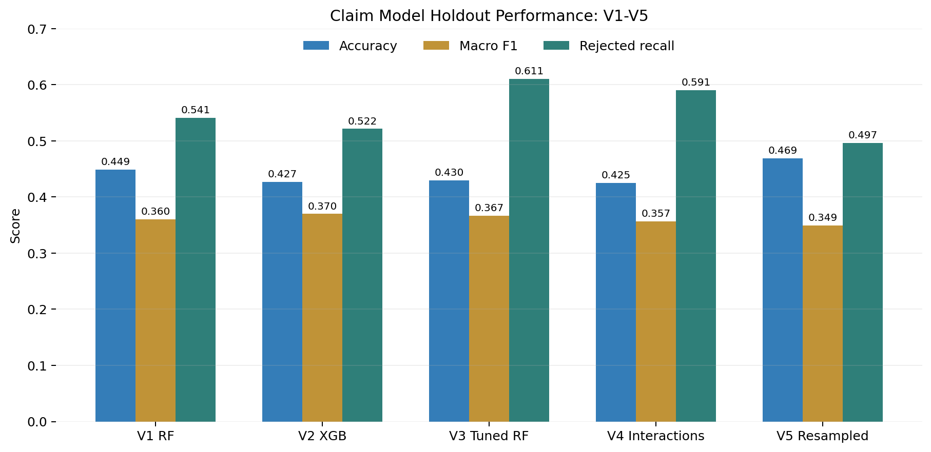
Figure 1. Accuracy, Macro F1, and Rejected recall across V1-V5.
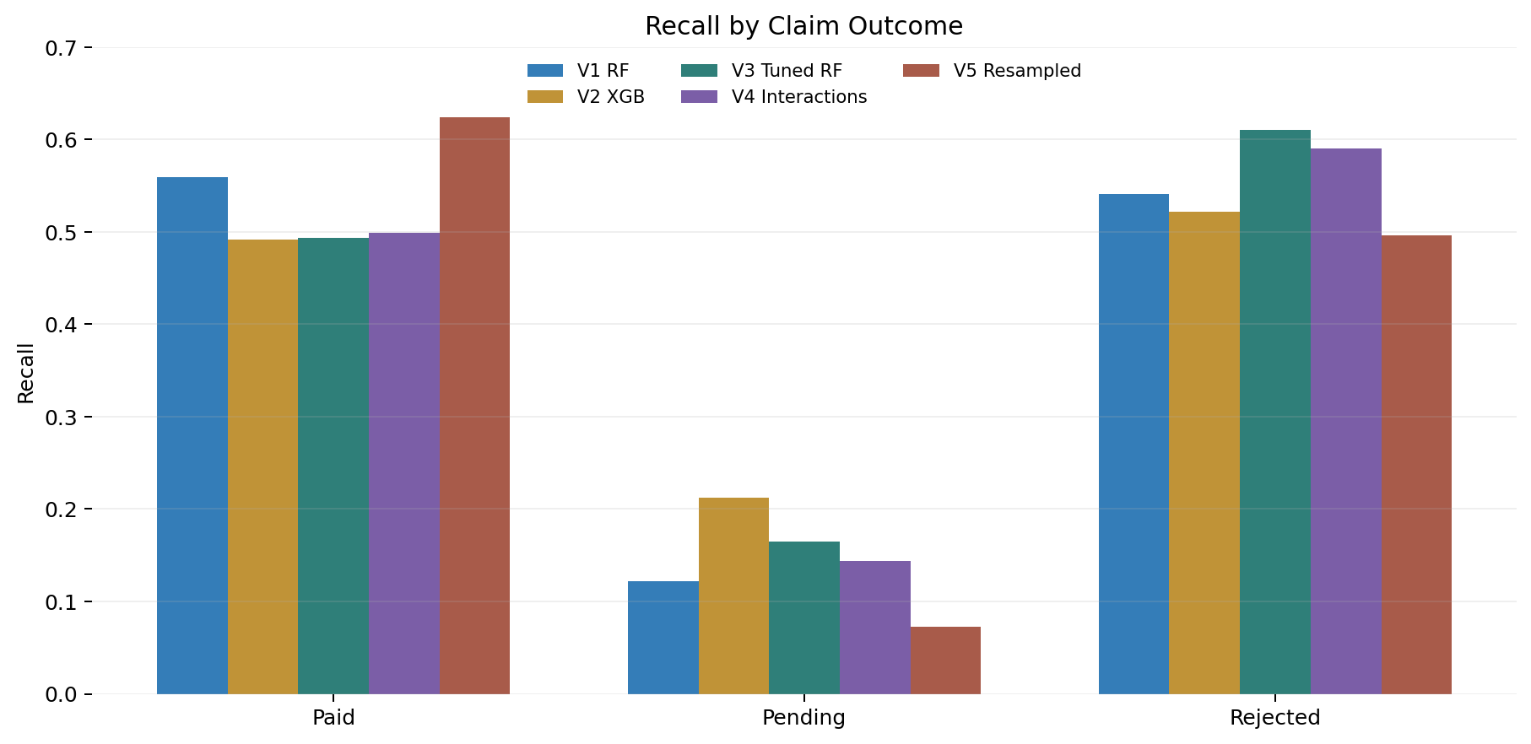
Figure 2. Recall by claim outcome across V1-V5.

10. Confusion Matrices and Error Analysis
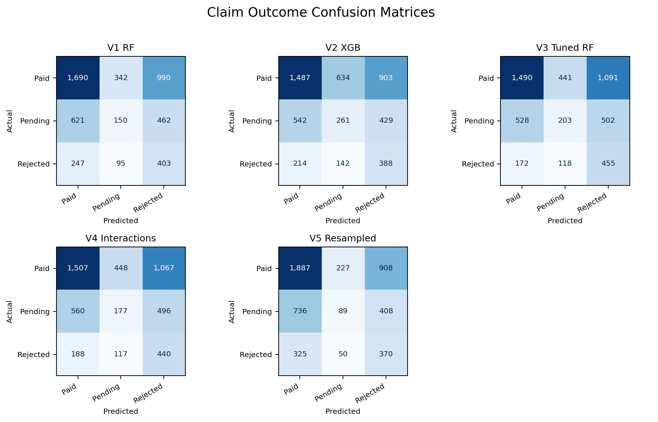
Figure 3. Holdout confusion matrices for the five advanced models.
Model | Paid correct | Pending correct | Rejected correct | Total correct | Paid predicted Pending
V1 RF | 1,690 | 150 | 403 | 2,243 | 342
V2 XGB | 1,487 | 261 | 388 | 2,136 | 634
V3 Tuned RF | 1,490 | 203 | 455 | 2,148 | 441
V4 Interactions | 1,507 | 177 | 440 | 2,124 | 448
V5 Resampled | 1,887 | 89 | 370 | 2,346 | 227
Pending remains the hardest outcome. V2 detects the most Pending claims (261), while V3 detects the most Rejected claims (455). V5's accuracy gain comes mainly from 1,887 correct Paid predictions and is accompanied by the lowest Pending recall and lowest Rejected recall among the Random Forest variants.

11. Resampling Strategy Evidence
Strategy | CV accuracy | CV Macro F1 | CV balanced accuracy | CV Rejected recall
Hybrid SMOTE + undersampling | 48.87% | 36.62% | 40.77% | 46.76%
Random undersampling | 37.29% | 35.20% | 42.55% | 65.89%
SMOTE | 53.31% | 34.43% | 39.21% | 35.67%
Hybrid balancing was selected by validation Macro F1. Random undersampling produced the strongest validation Rejected recall but substantially lower validation accuracy and Macro F1. The alternative strategies were not evaluated repeatedly on the holdout, preserving test-set integrity.

12. Interpretability and Deployment Complexity
Version | Explanation path | Artifact size | Deployment note
V1 | RF impurity/permutation importance | ~20 MB | Familiar sklearn baseline
V2 | XGBoost gain or SHAP | ~3.3 MB | Strong SHAP ecosystem; saved label encoder
V3 | RF importance or SHAP | ~18 MB | Tuned but same feature contract as V1
V4 | RF importance with 18 interactions | ~21 MB | More complex; aggregate mappings embedded
V5 | RF importance after resampling | ~25 MB | Sampler embedded; no resampling during predict

13. Strengths and Weaknesses
Version | Strength | Weakness
V1 | Highest pre-V5 accuracy; simple benchmark | Weak Pending recall; no tuning
V2 | Best Macro F1 and Pending recall | Lower accuracy; different feature/split composition
V3 | Best balanced accuracy and Rejected recall | Lower accuracy than V1/V5
V4 | Leakage-safe feature engineering | Interactions reduce all three selection metrics versus V3
V5 | Highest accuracy | Lowest Macro F1; weaker Pending and Rejected recall

14. Business Impact
On the 5,000-claim holdout, V5 makes the most correct predictions overall (2,346) because it recognizes Paid claims well. V3 identifies the most Rejected claims (455), detecting 52 more than V1, 67 more than V2, 15 more than V4, and 85 more than V5. V2 identifies the most Pending claims (261).
Model choice therefore depends on intervention cost. Accuracy favors throughput and Paid recognition; Macro F1 favors cross-class balance; Rejected recall favors denial-risk screening. At current precision levels, predictions should route claims for review rather than trigger automated adjudication.

15. Recommendation
Primary recommendation: Use V3 Hypertuned Random Forest when detecting likely Rejected claims is the main operational objective. It has the highest Rejected recall (61.07%) and balanced accuracy (42.28%).
Balanced benchmark: Retain V2 XGBoost as the Macro-F1 benchmark (36.99%) and preferred option when Pending detection and compact deployment are more important.
- Do not select V5 solely for 46.92% accuracy; its Macro F1 and minority-class recalls are weaker.
- Do not advance V4 without new evidence; the interaction features did not improve holdout performance.
- Define a minimum acceptable Rejected recall and false-alert workload before pilot approval.
- Calibrate probabilities and tune class-specific review thresholds using business costs.
- Use model output as a review-priority score, not a final claim decision.

16. Future Work
- Make the split deterministic with billing_date plus bill_id and reuse identical claim IDs across every model version.
- Tune thresholds against explicit costs for missed Rejections, false rejection alerts, and delayed Pending claims.
- Add one-vs-rest precision-recall curves, calibration, Brier scores, and bootstrap confidence intervals.
- Monitor class prevalence, Rejected recall, Pending recall, calibration, and feature drift after deployment.

17. Sources
Artifact | Project-relative path
V1 notebook | notebooks/03_claim_model_v1.ipynb
V2 notebook | notebooks/03_claim_model_v2.ipynb
V3 notebook | notebooks/03_claim_model_hypertuned_v3.ipynb
V4 notebook | notebooks/03_claim_model_interaction_features_v4.ipynb
V5 notebook | notebooks/03_claim_model_SMOTE_undersampling_v5.ipynb
V5 strategy results | metrics/claim/claim_resampling_comparison_v5.csv
All reported metrics are from executed notebook outputs and persisted JSON/CSV artifacts generated on 1 July 2026.

