MODEL EXPLAINABILITY REPORT
V3 Claim Model
Feature Importance and Explainability Summary
MODEL CONTEXT Selected Hypertuned Random Forest. Holdout accuracy 42.96%, Macro F1 36.70%, balanced accuracy 42.28%, and Rejected recall 61.07%.
Prepared from the fitted V3 artifact and refreshed 1 July 2026 evaluation

Executive Explainability Summary
The V3 model relies most heavily on billed amount, treating doctor identifier, and length of stay. These three grouped fields account for 61.33% of total Random Forest impurity importance. Billed amount alone contributes 43.61%, making financial intensity the dominant global splitter.
The top five fields contribute 73.52% of total importance and the top ten contribute 88.08%. Financial and billing-timing signals contribute 52.14%, while provider, patient, clinical, and visit-context signals share the remaining 47.86%.
KEY FINDING V3's grouped feature ranking is highly consistent with V1's (Spearman rank correlation 0.966), and both retain the same top-five order. The improvement in Rejected recall is therefore linked primarily to temporal hyperparameter tuning and tree regularization, not to a new feature set.

Model and Performance Context
Item | V3 result
Selection strategy | Four-fold TimeSeriesSplit randomized search using Macro F1.
Estimator | Random Forest: 450 trees, depth 10, minimum split 12, minimum leaf 2, 75% feature sampling.
Accuracy | 42.96%
Macro F1 | 36.70%
Balanced accuracy | 42.28%
Rejected precision | 22.22%
Rejected recall | 61.07% (455 of 745 Rejected claims detected)
Rejected F1 | 32.58%
The holdout set was not used for hyperparameter selection. Reported performance reflects the natural test-period class distribution.

Global Feature Importance
The chart reports grouped mean decrease in impurity from the fitted 450-tree forest. One-hot encoded category levels are summed back to their source field so Doctor ID, department, city, payer, and other categorical variables can be interpreted at field level.
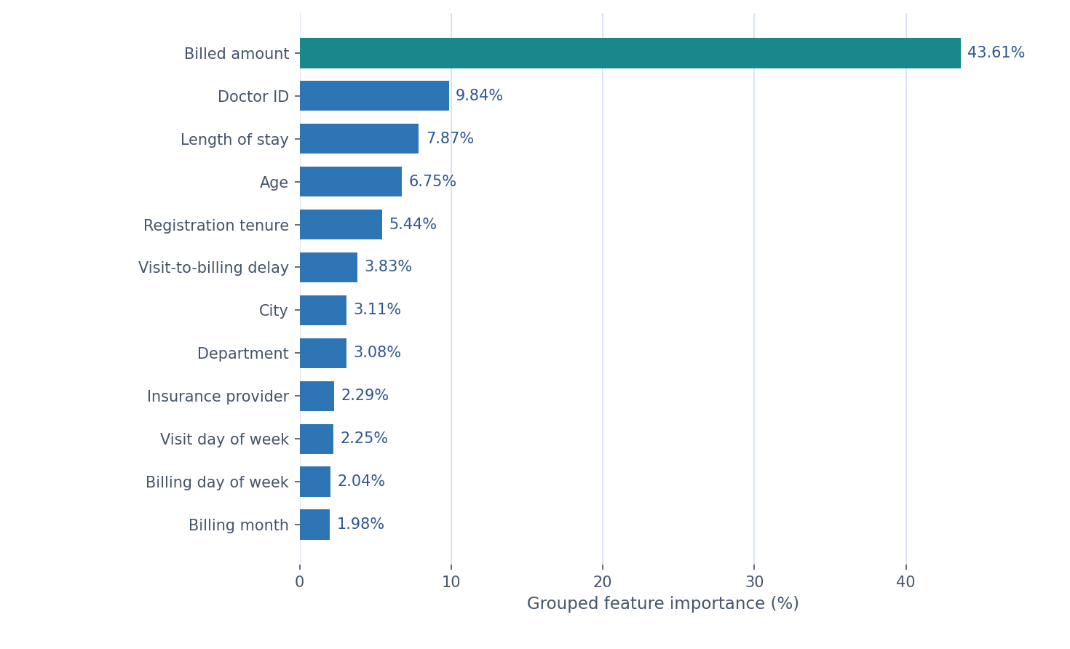
Figure 1. Top 12 grouped V3 feature importances

Interpretation of Leading Drivers
Driver | Importance | Interpretation
Billed amount | 43.61% | Captures claim-value intensity and is the dominant global splitter. Validate timing, drift, and continuous-variable bias.
Doctor ID | 9.84% | Represents provider-associated patterns. Treat cautiously because high-cardinality identifiers can receive inflated impurity importance.
Length of stay | 7.87% | Captures utilization intensity and may correlate with claim complexity and billed amount.
Age | 6.75% | Provides patient-level differentiation, but global importance does not show direction and requires fairness review.
Registration tenure | 5.44% | Measures how long the patient had been registered at the visit; direction and stability require class-specific validation.

Feature-Family Contributions
Feature family | Contribution | Included signals
Direct financial signal | 43.61% | Billed amount.
Provider and operational categories | 16.92% | Doctor, department, insurance provider, and visit type.
Patient demographics and tenure | 16.05% | Age, gender, city, and registration tenure.
Core visit utilization and clinical | 10.10% | Length of stay, visit risk score, and chronic flag.
Billing timing | 8.52% | Visit-to-billing delay and billing calendar fields.
Visit calendar timing | 4.79% | Visit month, quarter, day of week, and weekend flag.
Rounded family contributions sum to approximately 100%. Families are analytical groupings for interpretation, not separate model components.

Performance-Linked Explanation
Why V3 improves Rejected recall. V1 and V3 use the same 21 source fields and retain a highly similar importance hierarchy. V3's shallower, more regularized forest raises Rejected recall from 54.09% to 61.07% and balanced accuracy from 40.73% to 42.28%.
Why accuracy declines. V3 reduces Paid recall from 55.92% to 49.31% while raising Pending recall from 12.17% to 16.46% and Rejected recall by 6.98 points. The broader minority-class coverage reduces overall accuracy by 1.90 points relative to V1.
Why billed amount requires caution. Billed amount receives 43.61% of impurity importance, up from 25.00% in V1. This indicates frequent use in tree splits, but it may also reflect continuous-variable bias, correlation with utilization, or sensitivity to claim-value distribution shifts.

Explainability Boundaries
Boundary | Implication
No direction | Importance does not show whether larger values increase or decrease Rejected probability.
Not class-specific | The values summarize all tree splits across Paid, Pending, and Rejected predictions.
Not causal | A prominent field may be correlated with claim outcome without causing it.
Impurity bias | Continuous billed amount and high-cardinality Doctor ID can appear overly important.
Correlated predictors | Financial, stay, and calendar variables can divide or duplicate importance credit.
Exact holdout not packaged | Permutation importance and SHAP require the original Oracle holdout rows, not a non-matching local reconstruction.

Recommended Explainability Work
Step | Action
1 | Persist the exact chronological holdout claim IDs and feature snapshot used by V3.
2 | Calculate holdout permutation importance using Macro F1 and Rejected recall scorers.
3 | Review local explanations for Rejected true positives, false negatives, and false positives.
4 | Test feature-importance stability across temporal folds and future monitoring periods.
5 | Audit billed amount timing plus Doctor ID, city, department, payer, and risk-score proxy effects.

Governance Conclusion
CONCLUSION V3 is the preferred rejection-screening model because temporal tuning improves balanced accuracy and Rejected recall. Its dominant global signals are billed amount, provider identity, stay duration, age, and registration tenure. Production use still requires class-specific explanations, exact-holdout permutation validation, feature-timing checks, and human review controls.

Appendix: Complete Grouped Importance Ranking
Rank | Feature | Importance | Rank | Feature | Importance
1 | Billed amount | 43.61% | 12 | Billing month | 1.98%
2 | Doctor ID | 9.84% | 13 | Visit month | 1.94%
3 | Length of stay | 7.87% | 14 | Visit type | 1.70%
4 | Age | 6.75% | 15 | Visit risk score | 1.50%
5 | Registration tenure | 5.44% | 16 | Gender | 0.75%
6 | Visit-to-billing delay | 3.83% | 17 | Chronic flag | 0.73%
7 | City | 3.11% | 18 | Billing quarter | 0.43%
8 | Department | 3.08% | 19 | Visit quarter | 0.36%
9 | Insurance provider | 2.29% | 20 | Weekend visit | 0.25%
10 | Visit day of week | 2.25% | 21 | Weekend billing | 0.24%
11 | Billing day of week | 2.04%

