Article
The Geo-interventions Modelling Framework
Richard Wen and Songnian Li *
Citation: To be added by editorial staff during production.
Academic Editor: Firstname Lastname
Received: date
Revised: date
Accepted: date
Published: date

Copyright: © 2024 by the authors. Submitted for possible open access publication under the terms and conditions of the Creative Commons Attribution (CC BY) license (https://creativecommons.org/licenses/by/4.0/).
Department of Civil Engineering, Toronto Metropolitan University, Toronto, ON, M5B 2K3, Canada
* Correspondence: snli@torontomu.ca
Abstract: A single paragraph of about 200 words maximum. For research articles, abstracts should give a pertinent overview of the work. We strongly encourage authors to use the following style of structured abstracts, but without headings: (1) Background: Place the question addressed in a broad context and highlight the purpose of the study; (2) Methods: briefly describe the main methods or treatments applied; (3) Results: summarize the article’s main findings; (4) Conclusions: indicate the main conclusions or interpretations. The abstract should be an objective representation of the article and it must not contain results that are not presented and substantiated in the main text and should not exaggerate the main conclusions.
Keywords: machine learning, spatial, GIS, framework, intervention, model, optimization, generative

1. Introduction
Over a million deaths occur every year from preventable causes, such as traffic collisions [1] and homicide [2]. Interventions implemented in geographic space, such as hotspot policing [3] and traffic camera monitoring [4], have had success in greatly reducing the number of preventable deaths. These interventions are referred to as geospatial interventions (geo-interventions), which are actions applied to geographic spaces that are intended to alter target outcomes [5]. Geo-interventions result in benefits not only for the vulnerable, but also for people living in the surrounding area. A few examples include: reducing the patient load on hospitals [6], improving traffic flow [7], and increasing access to education [8] in relation to reducing traffic and crime related deaths. Geo-interventions are often designed within the constraints of available resources, such as expertise, data, and budget, which are difficult to optimally balance and are heavily reliant on domain expertise [9–11]. With high performance computing hardware and the abundance of geospatial data today, analyzing thousands of geo-intervention scenarios within practical periods of time for decision making has become possible [12]. Decision makers are then able to simulate the effects of potential interventions and evaluate outcomes before heavy investments in testing or implementing interventions are spent. This also helps discover more evidence-informed interventions with the available data. Currently, many studies in geo-interventions only consider a small range of alternative intervention scenarios, constraints, and models predetermined by experts based on experience, research, and experimentation [10,13–16]. The reliance on experts create difficulty in comparing results and approaches in a standardized manner – leading to issues in optimizing interventions, while leveraging all available data and models.
This paper aims to provide a generalized modeling framework for generating geo-interventions using geospatial data for a target outcome. Specifically, the following research questions are answered: (Q1) How do we use predictive models to generate geo-interventions that influence a target outcome? (Q2) How do we optimize geo-interventions for a target outcome? and (Q3) How do we apply the geo-intervention generation framework using available models and data? These research questions are answered with the following research contributions respectively: (C1) A framework component for using predictive models to generate geo-interventions for a target outcome, (C2) A framework component for optimizing geo-interventions based on a target outcome, and (C3) A case study of generating geo-interventions to reduce traffic collision deaths and serious injuries in Toronto, Ontario, Canada.

2. Materials and Methods
To answer research questions (Q1) to (Q3), a three-step approach was taken involving: (1) problem statement, (2) framework specification, and (3) case study. The first step, problem statement, defined concepts and relationships of actions, locations, and outcomes as they relate to geo-interventions. Research questions (Q1) and (Q2) were structured into quantifiable optimization problems based on spatial data containing actions and locations. The second step, framework specification, created conceptual components and sub-components based on the definitions of actions, locations, outcomes, and geo-interventions in the problem statement. The definitions of actions and locations were captured as a spatial data component, while the definitions of outcomes and geo-interventions were captured in the outcome modelling and geo-intervention generation components respectively. These three components formed the geo-interventions modelling framework, which structured the conceptual process of research question (Q3). In the third step, a case study in Toronto, Ontario, Canada was designed to answer research question (Q3), where geo-interventions were generated as locatable infrastructure changes to reduce the number of Killed or Seriously Injured (KSI) individuals using the geo-interventions modelling framework. A figure of the three-step approach is seen in Figure 1.
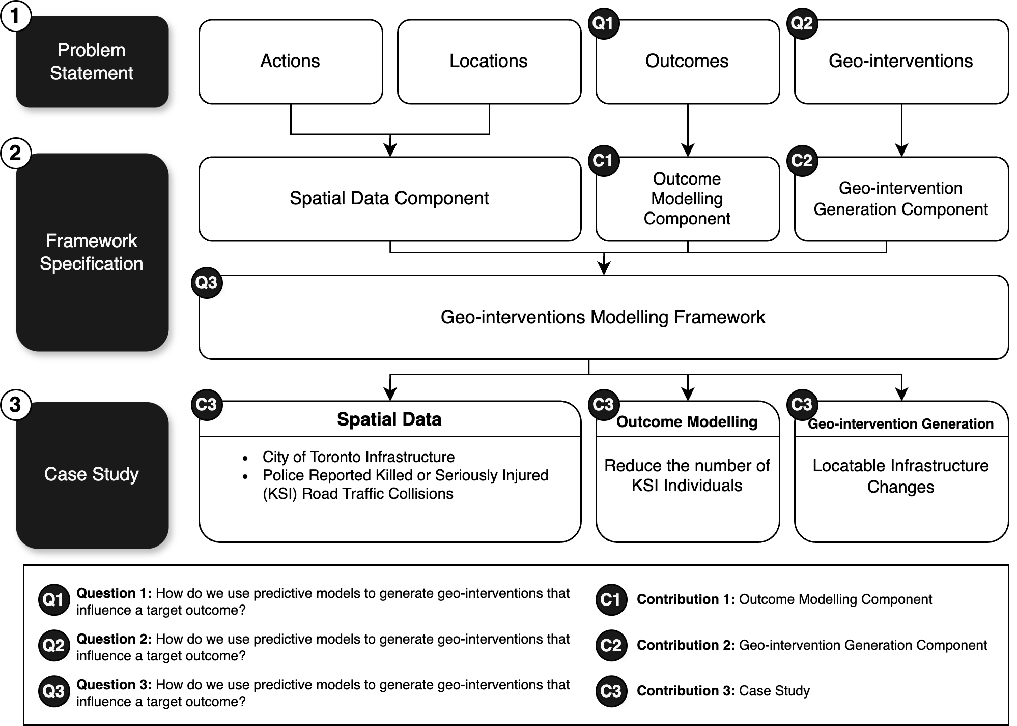
Figure 1. Three step approach to answering research questions.

2.1. Problem Formulation
This section defines the concept of geo-interventions based on the sub-concepts of actions, locations, and outcomes, while further structuring these defined concepts into quantifiable optimization problems. Geo-interventions are actions that change particular locations or areas in an attempt to produce desirable outcomes in the context of specific decision-making problems [17]. They consist of three interacting components seen in Figure 2:
- Actions: the actions that change entities or phenomena at certain locations or in certain areas (e.g., addition of traffic lights and reduction in road widths)
- Locations: the target locations or areas that the actions in 1. are applied to for producing a desirable outcome in the context of decision-making (e.g., neighborhoods with high traffic collisions and streets with high-speed limits)
- Outcomes: the outcomes from applying the actions in 1. to change the locations or areas in 2. (e.g., reduced traffic collisions and improved traffic flow)

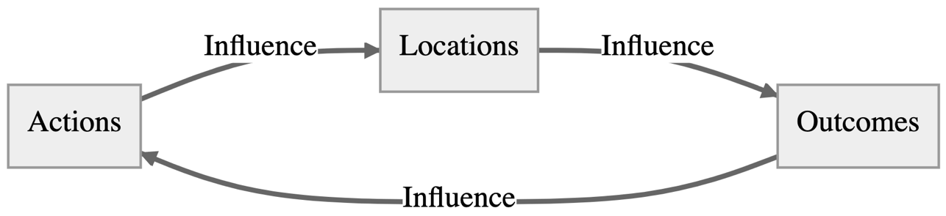
Figure 2. Geo-intervention component interactions.
The problem of generating geo-interventions becomes searching for actions at target locations that influence outcomes in a desired manner. For example, reducing road widths (the action) on streets with high traffic collision rates (the locations) to reduce road traffic injuries (the desired outcome). Sections 2.1.1 to 2.1.4 formulate the problem of generating geo-interventions by quantifying the three components (actions, locations, and outcomes), and their interactions into optimization functions representing desired outcomes.

2.1.1. Actions
x.

2.1.2. Locations
x.

2.1.3. Outcomes
x.

2.1.4. Geo-interventions
x.

2.2. Framework Specification
Based on the problem formulation in Section 2.1, the geo-interventions modelling framework answered research questions (Q1) how do we use predictive models to generate geo-interventions that influence a target outcome? and (Q2) how do we optimize geo-interventions for a target outcome? For (Q1), we produce research contribution (C1), by modelling outcomes based on existing actions and locations using spatial data.

2.2.1. Spatial Data Sub-components
The spatial data sub-components were specified using Geographic Information Systems (GIS) vector data as the major inputs for outcome modelling. Vector data was used as the main source of data as it enabled more flexibility and level of detail in geometric shapes (point, line, and polygon) than raster data, which required consistent square or rectangular pixels with level of detail dependent on the image resolution [19,20]. However, we incorporate raster data with the consideration of converting raster to vector data with various GIS techniques (e.g., polygon grids [20], edge-tracing [21], object detection [22]). As described in Section 2.1.1 and 2.1.2, each action is tied to a location represented by either a point, line, or polygon. This requires vector data to be standardized to geometric shapes (the locations) that fit the decision-making problem before modelling outcomes (e.g., census/neighborhood boundaries for public health interventions [23], or regularized grids for simulating land use change [24]). For the spatial data component, the modelling framework was required to include vector data (point, line, and polygon), raster data, and data standardization sub-components that were used as inputs for outcome modelling.

2.2.2. Outcome Modelling Sub-components
x.

2.2.3. Spatial Information Sub-components
x.

2.3. Case Study
x.

3. Results
This section may be divided by subheadings. It should provide a concise and precise description of the experimental results, their interpretation, as well as the experimental conclusions that can be drawn.

3.1. Subsection

3.1.1. Subsubsection
Bulleted lists look like this:
- First bullet;
- Second bullet;
- Third bullet.
Numbered lists can be added as follows:
- First item;
- Second item;
- Third item.
The text continues here.

3.2. Figures, Tables and Schemes
All figures and tables should be cited in the main text as Figure 1, Table 1, etc.

Figure 1. This is a figure. Schemes follow the same formatting.
Table 1. This is a table. Tables should be placed in the main text near to the first time they are cited.
Title 1 | Title 2 | Title 3
entry 1 | data | data
entry 2 | data | data ¹
¹ Tables may have a footer.
The text continues here (Figure 2 and Table 2).
 | 
(a) | (b)
Figure 2. This is a figure. Schemes follow another format. If there are multiple panels, they should be listed as: (a) Description of what is contained in the first panel; (b) Description of what is contained in the second panel. Figures should be placed in the main text near to the first time they are cited.
Table 2. This is a table. Tables should be placed in the main text near to the first time they are cited.
Title 1 | Title 2 | Title 3 | Title 4
entry 1 * | data | data | data
 | data | data | data
 | data | data | data
entry 2 | data | data | data
 | data | data | data
entry 3 | data | data | data
 | data | data | data
 | data | data | data
 | data | data | data
entry 4 | data | data | data
 | data | data | data
* Tables may have a footer.

3.3. Formatting of Mathematical Components
This is example 1 of an equation:
a = 1, | (1)
the text following an equation need not be a new paragraph. Please punctuate equations as regular text.
This is example 2 of an equation:
a = b + c + d + e + f + g + h + i + j + k + l + m + n + o + p + q + r + s + t + u + v + w + x + y + z | (2)
the text following an equation need not be a new paragraph. Please punctuate equations as regular text.
Theorem-type environments (including propositions, lemmas, corollaries etc.) can be formatted as follows:
Theorem 1. Example text of a theorem. Theorems, propositions, lemmas, etc. should be numbered sequentially (i.e., Proposition 2 follows Theorem 1). Examples or Remarks use the same formatting, but should be numbered separately, so a document may contain Theorem 1, Remark 1 and Example 1.
The text continues here. Proofs must be formatted as follows:
Proof of Theorem 1. Text of the proof. Note that the phrase “of Theorem 1” is optional if it is clear which theorem is being referred to. Always finish a proof with the following symbol. □
The text continues here.

4. Discussion
Authors should discuss the results and how they can be interpreted from the perspective of previous studies and of the working hypotheses. The findings and their implications should be discussed in the broadest context possible. Future research directions may also be highlighted.

5. Conclusions
This section is not mandatory but can be added to the manuscript if the discussion is unusually long or complex.
Supplementary Materials: The following supporting information can be downloaded at: www.mdpi.com/xxx/s1, Figure S1: title; Table S1: title; Video S1: title.
Author Contributions: Conceptualization, Richard Wen; methodology, Richard Wen, Songnian Li; Investigation, data curation, software, writing—original draft preparation, Richard Wen; supervision, funding acquisition, resources, project administration, Songnian Li; writing—review and editing, Richard Wen, Songnian Li. All authors have read and agreed to the published version of the manuscript.
Funding: This work was funded by the Natural Sciences and Engineering Research Council of Canada, grant number RGPIN-2017-05950.
Data Availability Statement: We encourage all authors of articles published in MDPI journals to share their research data. In this section, please provide details regarding where data supporting reported results can be found, including links to publicly archived datasets analyzed or generated during the study. Where no new data were created, or where data is unavailable due to privacy or ethical restrictions, a statement is still required. Suggested Data Availability Statements are available in section “MDPI Research Data Policies” at https://www.mdpi.com/ethics.
Conflicts of Interest: The authors declare no conflicts of interest.
Appendix A
The appendix is an optional section that can contain details and data supplemental to the main text—for example, explanations of experimental details that would disrupt the flow of the main text but nonetheless remain crucial to understanding and reproducing the research shown; figures of replicates for experiments of which representative data is shown in the main text can be added here if brief, or as Supplementary data. Mathematical proofs of results not central to the paper can be added as an appendix.
Appendix B
All appendix sections must be cited in the main text. In the appendices, Figures, Tables, etc. should be labeled starting with “A”—e.g., Figure A1, Figure A2, etc.

References
1. World Health Organization Global Status Report on Road Safety; Geneva, 2018;
2. United Nations Office on Drugs and Crime Global Study on Homicide; Vienna, 2019;
3. Braga, A.A.; Schnell, C. Evaluating Place-Based Policing Strategies: Lessons Learned from the Smart Policing Initiative in Boston. Police quarterly 2013, 16, 339–357.
4. Yang, B.-M.; Kim, J. Road Traffic Accidents and Policy Interventions in Korea. Injury Control and Safety Promotion 2003, 10, 89–94, doi:10.1076/icsp.10.1.89.14120.
5. Richard Wen Generative Design of Geospatial Interventions With Automated Machine Learning and Bayesian Optimization, Toronto Metropolitan University: Toronto, 2023.
6. Bonnet, E.; Lechat, L.; Ridde, V. What Interventions Are Required to Reduce Road Traffic Injuries in Africa? A Scoping Review of the Literature. PLOS ONE 2018, 13, e0208195, doi:10.1371/journal.pone.0208195.
7. Bunn, F.; Collier, T.; Frost, C.; Ker, K.; Roberts, I.; Wentz, R. Traffic Calming for the Prevention of Road Traffic Injuries: Systematic Review and Meta-Analysis. Injury Prevention 2003, 9, 200–204, doi:10.1136/ip.9.3.200.
8. Yang, B. GIS Crime Mapping to Support Evidence-Based Solutions Provided by Community-Based Organizations. Sustainability 2019, 11, 4889, doi:10.3390/su11184889.
9. Boulos, M.N.K. Towards Evidence-Based, GIS-Driven National Spatial Health Information Infrastructure and Surveillance Services in the United Kingdom. Int J Health Geogr 2004, 3, 1, doi:10.1186/1476-072X-3-1.
10. Nykiforuk, C.I.J.; Flaman, L.M. Geographic Information Systems (GIS) for Health Promotion and Public Health: A Review. Health Promotion Practice 2011, 12, 63–73, doi:10.1177/1524839909334624.
11. Wang, R.; Murayama, Y.; Morimoto, T. Scenario Simulation Studies of Urban Development Using Remote Sensing and GIS: Review. Remote Sensing Applications: Society and Environment 2021, 22, 100474, doi:10.1016/j.rsase.2021.100474.
12. Elsahlamy, E.; Eshra, A.; Eshra, N.; El-Fishawy, N. Empowering GIS with Big Data: A Review of Recent Advances. In Proceedings of the 2021 International Conference on Electronic Engineering (ICEEM); July 2021; pp. 1–7.
13. Bailey, P.E.; Keyes, E.B.; Parker, C.; Abdullah, M.; Kebede, H.; Freedman, L. Using a GIS to Model Interventions to Strengthen the Emergency Referral System for Maternal and Newborn Health in Ethiopia. International Journal of Gynecology & Obstetrics 2011, 115, 300–309, doi:10.1016/j.ijgo.2011.09.004.
14. Franch-Pardo, I.; Napoletano, B.M.; Rosete-Verges, F.; Billa, L. Spatial Analysis and GIS in the Study of COVID-19. A Review. Science of The Total Environment 2020, 739, 140033, doi:10.1016/j.scitotenv.2020.140033.
15. Ištoka Otković, I.; Karleuša, B.; Deluka-Tibljaš, A.; Šurdonja, S.; Marušić, M. Combining Traffic Microsimulation Modeling and Multi-Criteria Analysis for Sustainable Spatial-Traffic Planning. Land 2021, 10, 666, doi:10.3390/land10070666.
16. Piza, E.L.; Kennedy, L.W.; Caplan, J.M. Facilitators and Impediments to Designing, Implementing, and Evaluating Risk-Based Policing Strategies Using Risk Terrain Modeling: Insights from a Multi-City Evaluation in the United States. Eur J Crim Policy Res 2018, 24, 489–513, doi:10.1007/s10610-017-9367-9.
17. Wen, R.; Li, S. Generative Design for Precision Geo-Interventions. In Proceedings of the ISPRS Annals of the Photogrammetry, Remote Sensing and Spatial Information Sciences; Copernicus GmbH, October 27 2022; Vol. X-3-W2-2022, pp. 37–42.
18. Wen, R.; Li, S. Spatial Decision Support Systems with Automated Machine Learning: A Review. ISPRS International Journal of Geo-Information 2023, 12, 12, doi:10.3390/ijgi12010012.
19. Maffini, G. Raster versus Vector Data Encoding and Handling: A Commentary. Photogrammetric Engineering and Remote Sensing 1987, 53, 1397–1398.
20. Congalton, R.G. Exploring and Evaluating the Consequences of Vector-to-Raster and Raster-to-Vector Conversion. Photogrammetric Engineering and Remote Sensing 1997, 63, 425–434.
21. Teng, J.; Wang, F.; Liu, Y. An Efficient Algorithm for Raster-to-Vector Data Conversion. Annals of GIS 2008, 14, 54–62, doi:10.1080/10824000809480639.
22. Adegun, A.A.; Fonou Dombeu, J.V.; Viriri, S.; Odindi, J. State-of-the-Art Deep Learning Methods for Objects Detection in Remote Sensing Satellite Images. Sensors 2023, 23, 5849, doi:10.3390/s23135849.
23. MacQuillan, E.L.; Curtis, A.B.; Baker, K.M.; Paul, R.; Back, Y.O. Using GIS Mapping to Target Public Health Interventions: Examining Birth Outcomes Across GIS Techniques. J Community Health 2017, 42, 633–638, doi:10.1007/s10900-016-0298-z.
24. Almeida, C.M.D.; Monteiro, A.M.V.; Câmara, G.; Soares‐Filho, B.S.; Cerqueira, G.C.; Pennachin, C.L.; Batty, M. GIS and Remote Sensing as Tools for the Simulation of Urban Land‐use Change. International Journal of Remote Sensing 2005, 26, 759–774, doi:10.1080/01431160512331316865.

Disclaimer/Publisher’s Note: The statements, opinions and data contained in all publications are solely those of the individual author(s) and contributor(s) and not of MDPI and/or the editor(s). MDPI and/or the editor(s) disclaim responsibility for any injury to people or property resulting from any ideas, methods, instructions or products referred to in the content.

