**CS5560 KDM - LAB1**

**Rajesh Kannan Rajendran**

**16164021**

**ER – Diagram:**

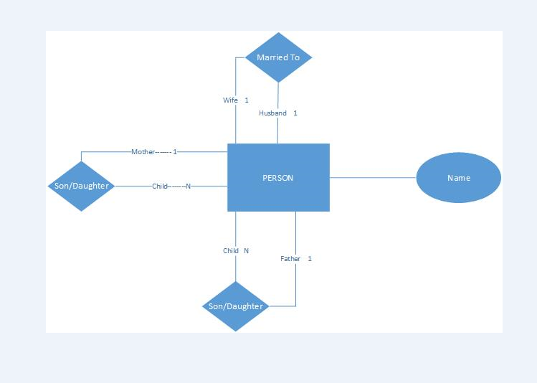

**Class – Diagram:**

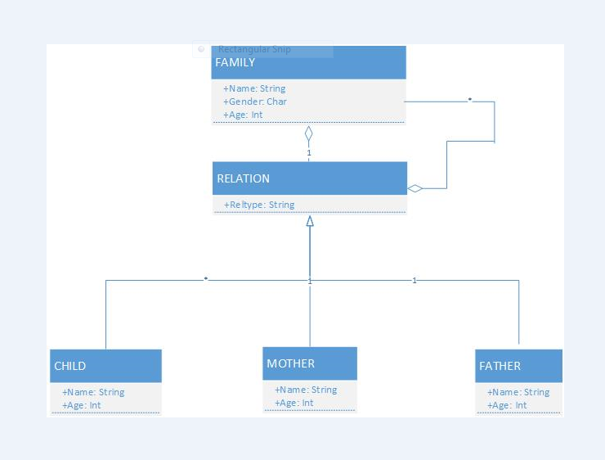

**GITHUB Account:**

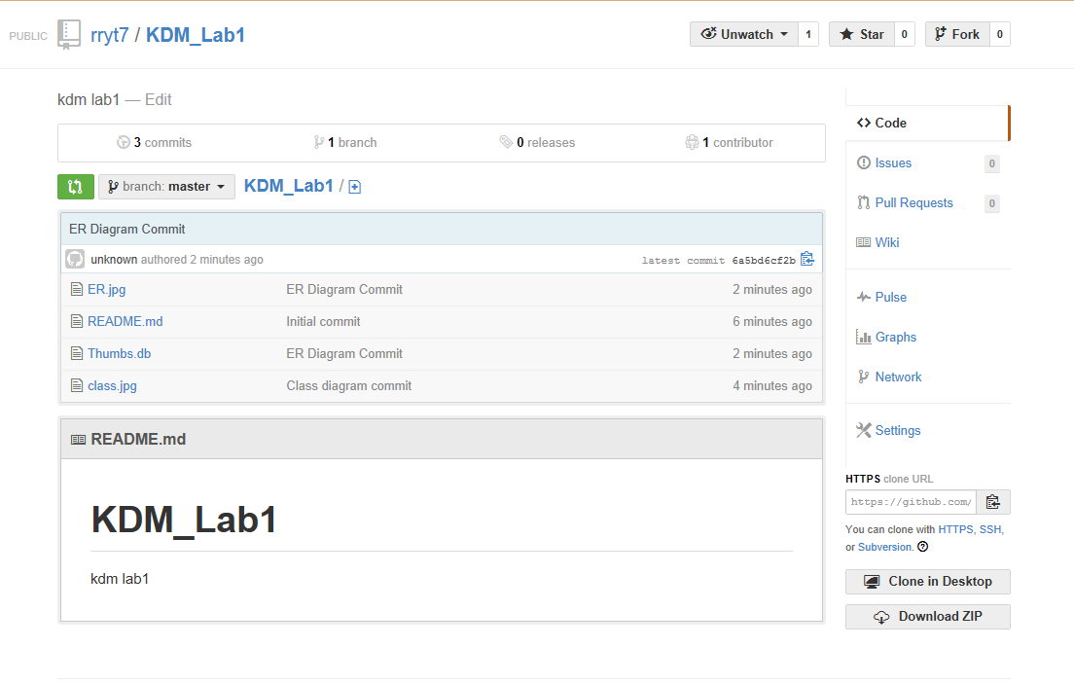

**ScrumDo Account:**

