**CS5560 Lab Assignment – 2 Report**

As a part of Lab2 Assignment, I created an application for UMKC mobile app. In this application I created four tabs like Departments, Library, Weather report at UMKC and Locations.

I have used Google Maps web services and Yahoo weather web services for this application. I have created the application by making use of HTML, CSS, Javascript and JQuery Mobile.

Also, I took the screenshot of my application and it was shown below:

**Jsfiddle.net Link:** http://jsfiddle.net/rryt7/J77Lp/8/

**Screenshots from Jsfiddle.net:**

1. The user is at the Home page by default and he can come back at any point of time to this page by clicking the “Home” button at the top left of every page.

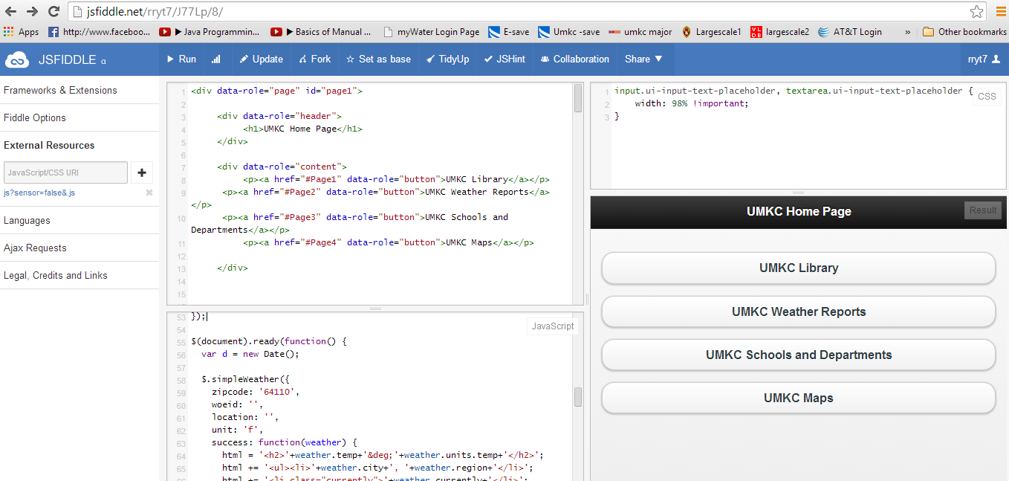

1. The user has the option to click for Directions on the “UMKC Library”, “UMKC Weather Reports”, “UMKC Schools and Departments” and “UMKC Maps”.



1. UMKC Library:

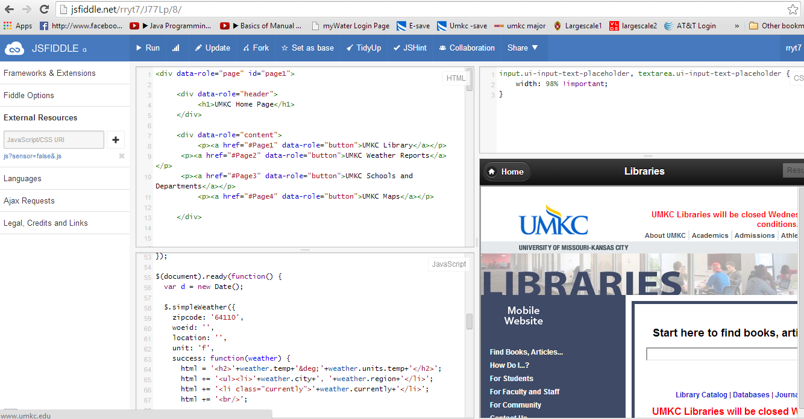

1. UMKC Weather Reports:

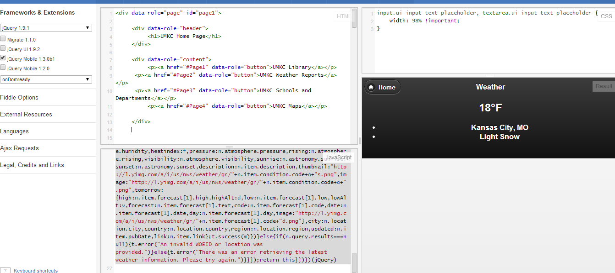

1. UMKC Schools and Departments

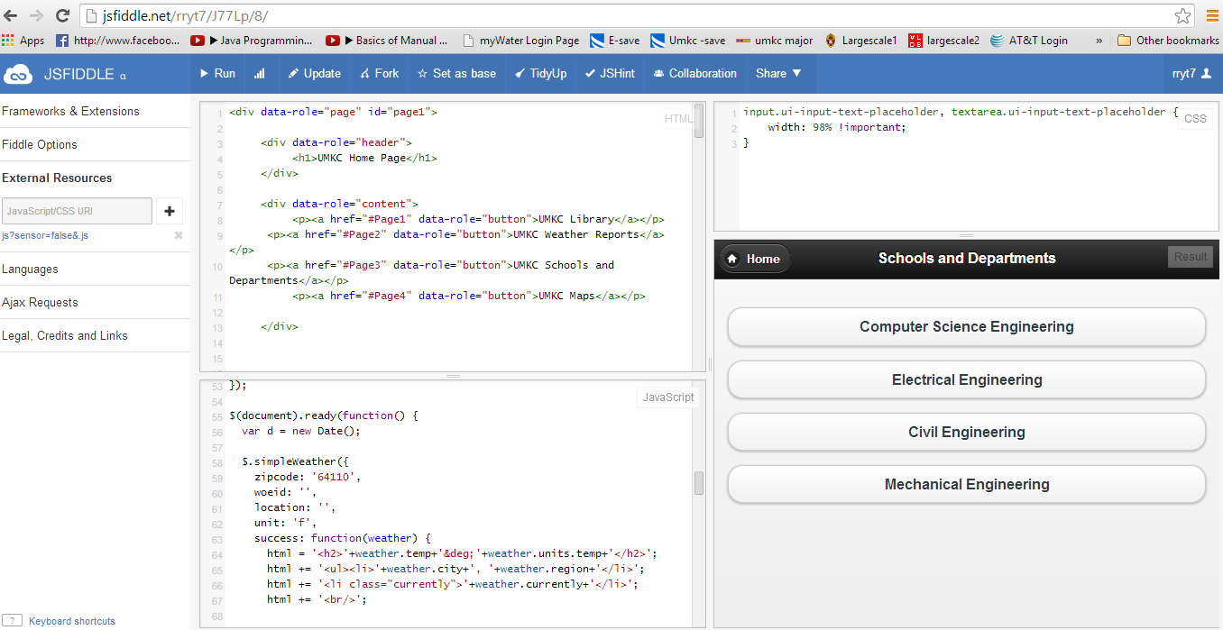

CSE,EE,CIVIL and MECH:

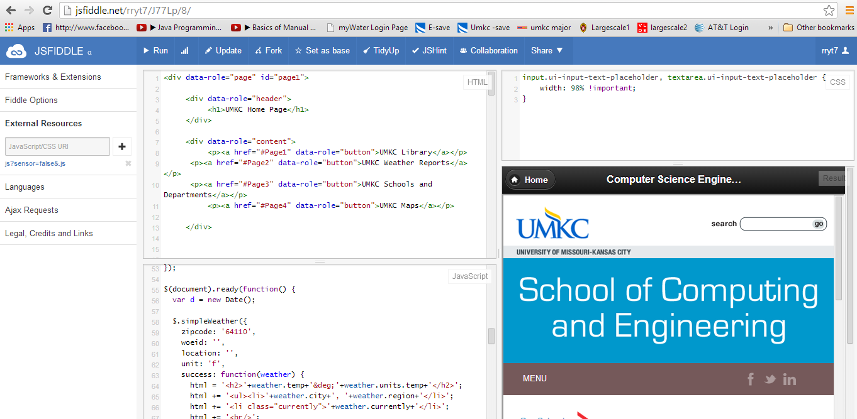

1. UMKC Maps

