CS5560 Lab Assignment – 3 Report

As a part of Lab3 Assignment, I created mash up application for finding all the gas stations that are available for the given address. In this application I have created three edit text for getting street address, city and state. Two buttons, one button on click will show zip code for that corresponding address in a text view and the second button on click will take the zip code from the text view as the input and display all the gas stations nearer to the zip code in a listview. I can also display address, price details of the gas also in the app.

I have used Google location services and Gas station for the zip code API for this application. I have created the application by making use of eclipse in ADT bundle.

Also, I took the screenshot of my application and it was shown below:

**Screenshots from Emulator:**

1. Once opened, the application will ask the user to enter street address, city and state as shown below:

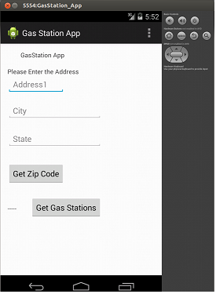

1. For example, I am giving address as 5311 Harrison st, Kansas city, MO.

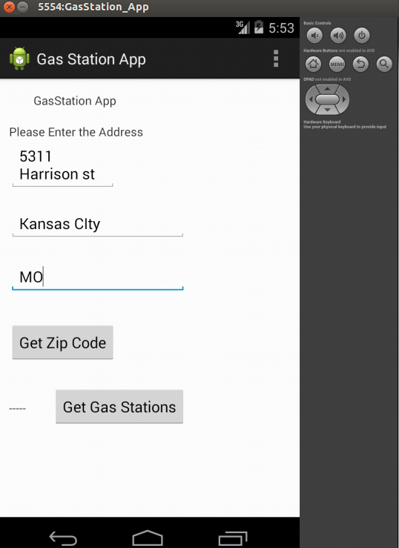

1. Now clicking Get Zip Code button will get the zip code for that address. I used API to get that address.

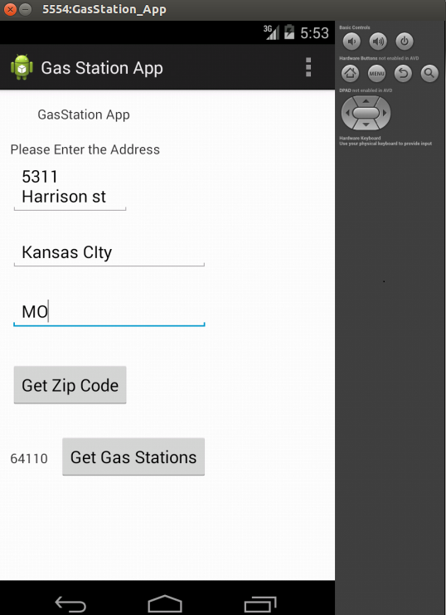

1. Getting this zip code and find all the nearest gas stations. As shown below:

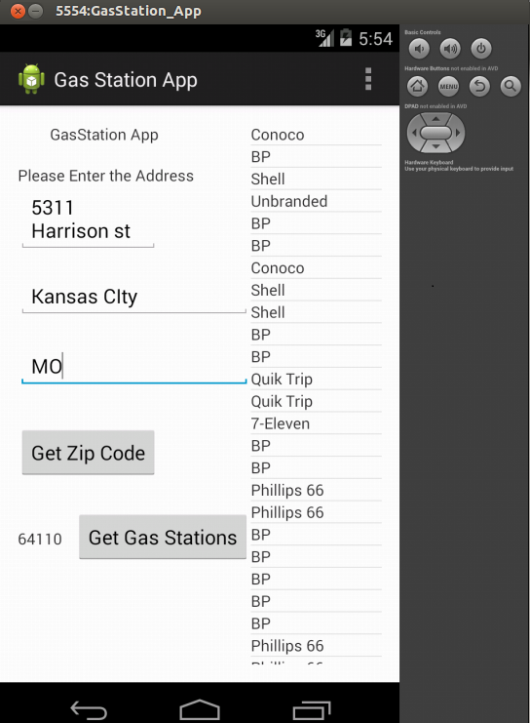

1. For example2, I am giving address as 4912 Grand Ave, Kansas city, MO.

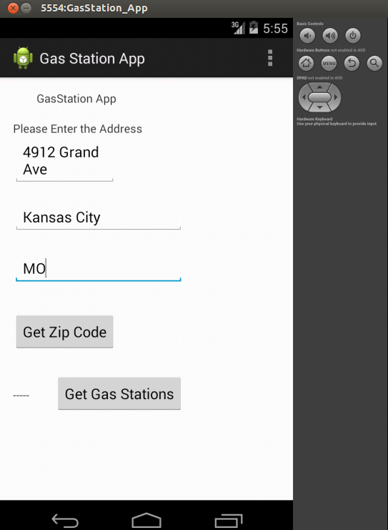

1. Now clicking Get Zip Code button will get the zip code for that address. I used API to get that address.

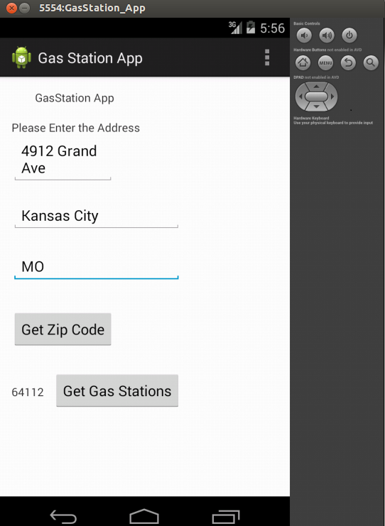

1. Getting this zip code and find all the nearest gas stations. As shown below:

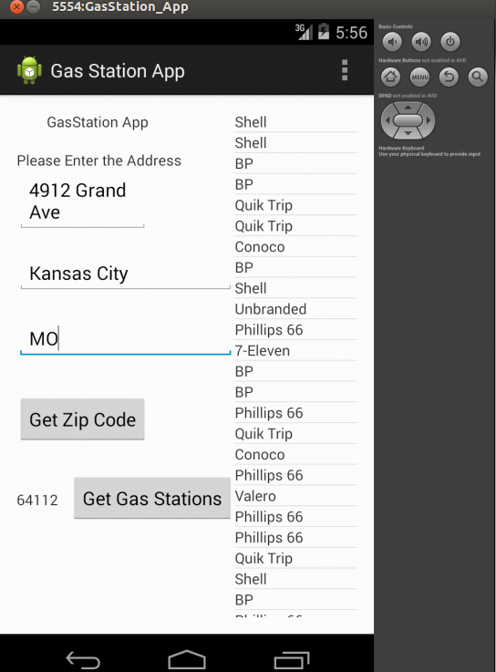

**Cloudera Screen shots:**

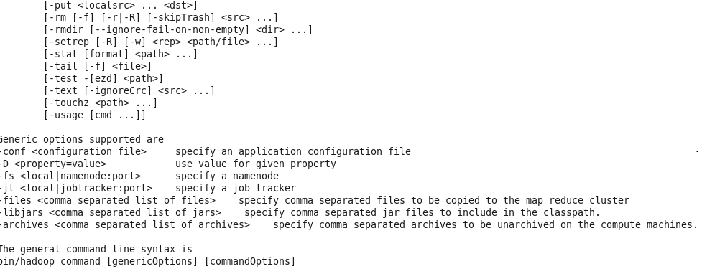

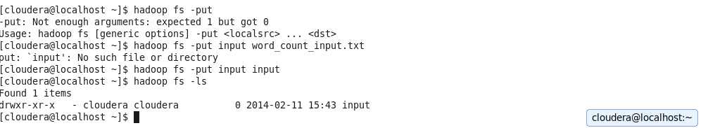

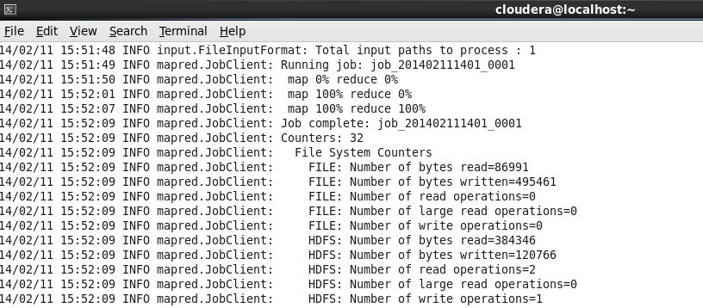

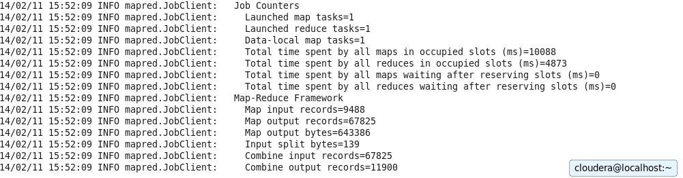

**Mahout Screen shots:**

