CS5560 Lab Assignment – 4 Report

As a part of Lab4 Assignment, I implemented mahout application for recommendation systems. Recommendation system is created for tourists who are visiting different places in the world. This application will recommend tourists who are all visited the places they went and who else visited this place and other places also, it will recommend to the user. It suggests them they can go to this place. I reused the recommendation algorithms provided in the tutorial.

Most of the things I followed from tutorial-8 provided in the blackboard.

**Screenshots:**

1. Implemented Recommender Algorithm for tourists to suggest the places that they can visit:

Id’s and Places:

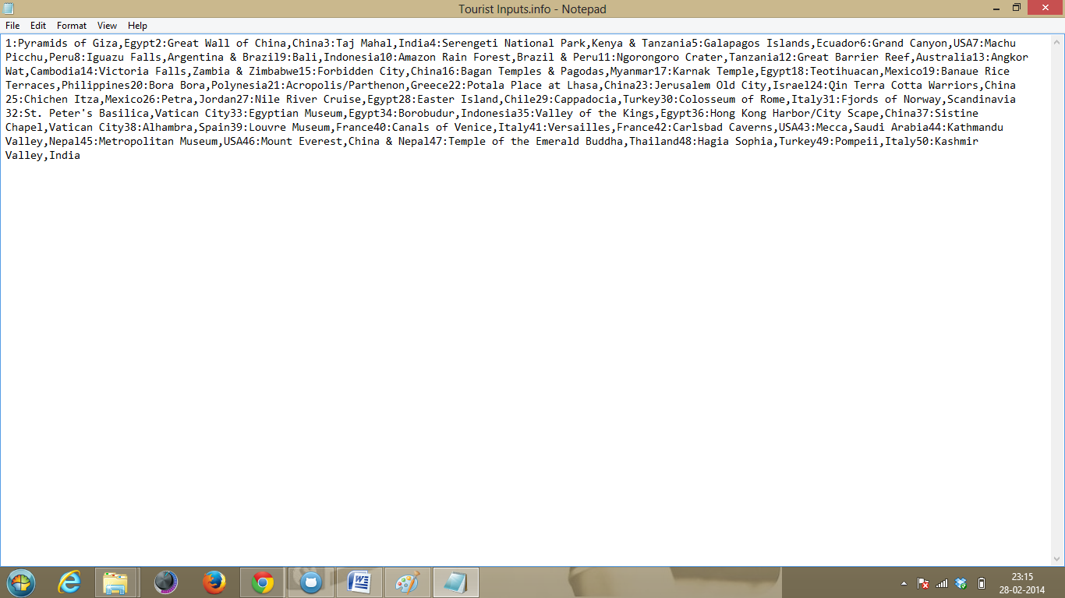

1. Places suggested for each Id’s

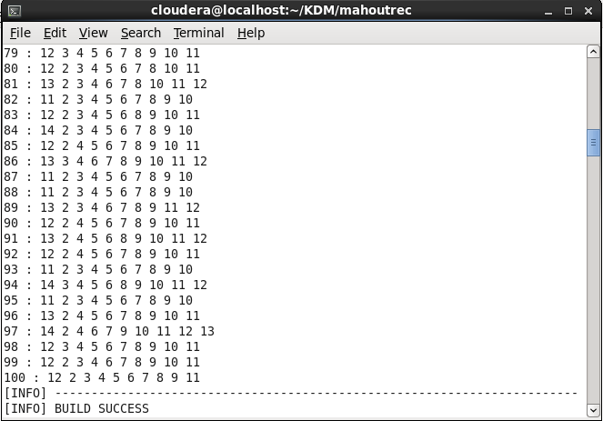

1. Output also saved in txt file pushed to the github.
2. This was used by mobile application. As shown below:

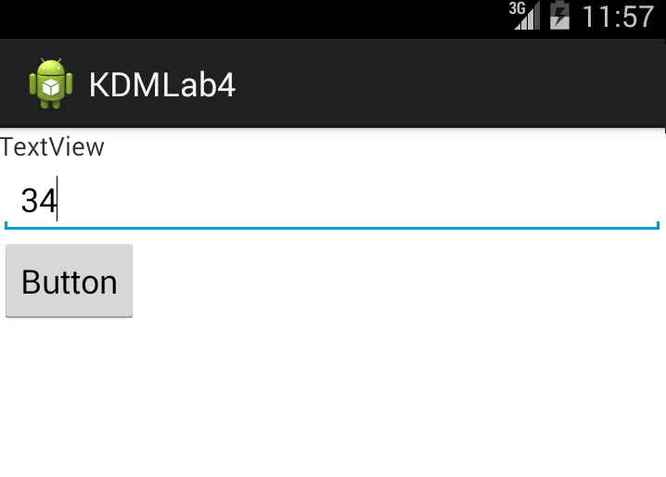

1. Final output for the suggested id:

