CS5560 Hackathon – Report

Music Recommendation Mobile App

**Design and Model:**

As a part of kdm midterm, I created a application using two datasets from <http://labrosa.ee.columbia.edu/millionsong/pages/getting-dataset>. One dataset is for artist containing artist id, artist. The other dataset is for songs containing song id, title, artist id, user id and rating. So, I integrated these two datasets with artist id.

These two data sets are merged by common attribute artist id using hadoop map reduce algorithm. This merged dataset was given as the input to the mahout application. Mahout recommendation will suggest what are the songs he loves to listen based on the rating he given to other songs. This will be displayed on the screen on the android mobile app.

Whenever user require for a recommendation, all his previous rating from the dataset will be taken into consideration and mahout recommendation program will suggest the songs based on this.

**Implementation:**

I have created the application by making use of eclipse in ADT bundle. And I used my own emulator for android.

Also, I took the screenshot of some of my application and it was shown below:

**Recommendation Ref:** <http://www.javacodegeeks.com/2013/10/creating-an-on-line-recommender-system-with-apache-mahout.html>

1. **Screenshots from Mahout:** For example user 102 and 103 recommends for the music that he can like based on the rating he given for the songs he listen previously as shown below:

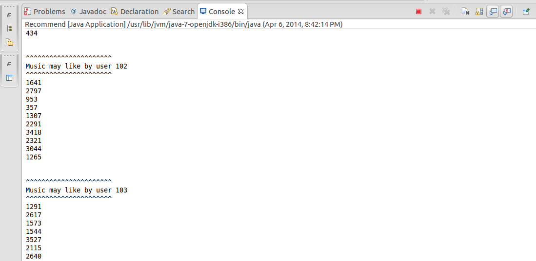

1. Ran for user 108 and 109 recommends for the music that he can like based on the rating he given for the songs he listen previously as shown below:

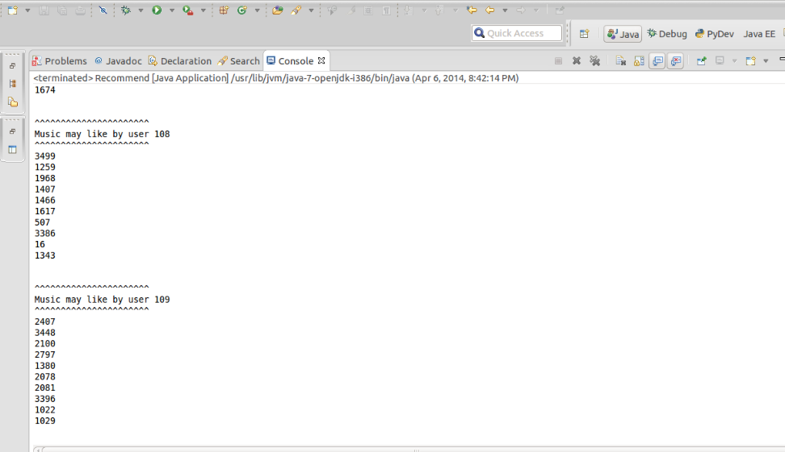

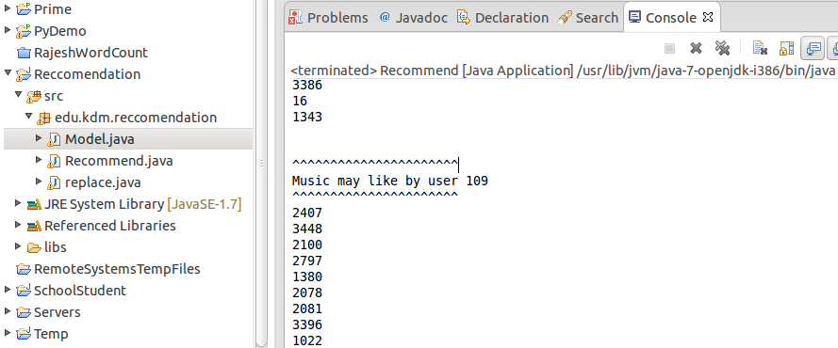

**Output:**

**Screenshots from Emulator:**

1. Home screen – User has some of the the musics that he likes to select as shown in the screen below:

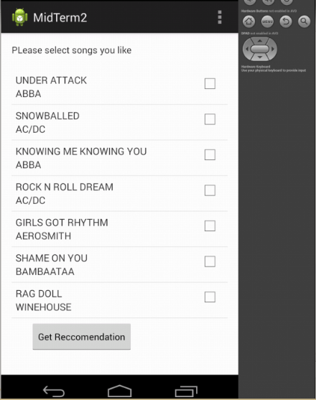

1. User has the option to select the songs and as shown below for example the user selected the following musics he liked.

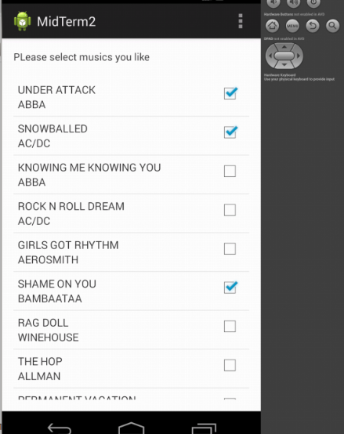

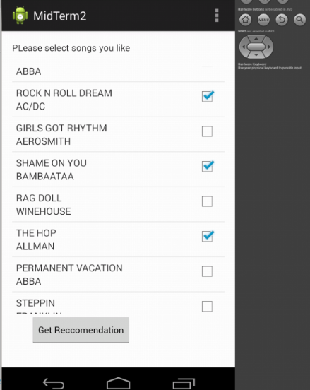

1. On clicking the get recommendation system, the following musics will be suggested for the user. As shown below:

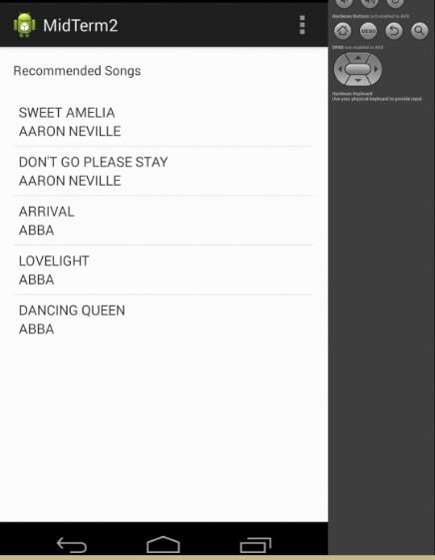

**GIT HUB Link:**

[**https://github.com/rryt7/Midterm**](https://github.com/rryt7/Midterm)

**URL’s used and referred:**

<http://www.javacodegeeks.com/2013/10/creating-an-on-line-recommender-system-with-apache-mahout.html>

<http://labrosa.ee.columbia.edu/millionsong/pages/getting-dataset>

<http://134.193.136.127:8983/solr/collection1_shard1_replica1/select?q=id>

134.193.136.127:8080/SolrWS/jaxrs/generic/uploadJson2Solr//home/cloudera/Desktop/test6.json