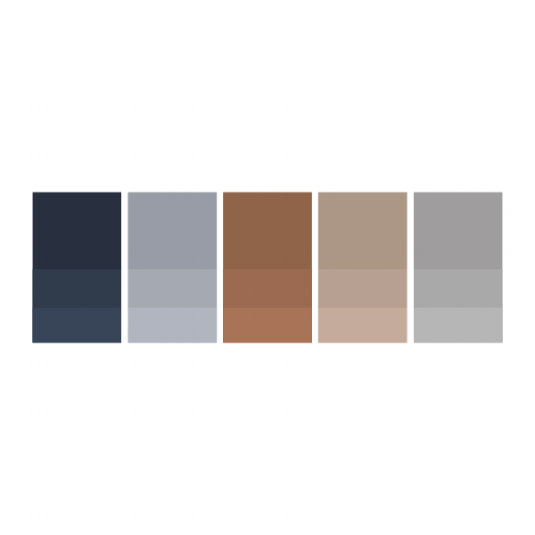

Storm: #222c3c | Moon: #989da6 | Leather: #93634a | Nude: # | Cloud: #a19e9f

