BHARATCARES / AICTE DATA ANALYTICS WITH AI ACADEMIC INTERNSHIP
HealthFlow
Hospital Patient Flow Analytics & Waiting-Time Prediction
Turning Patient Flow Data into Actionable Healthcare Insights
——————————————————————————————
Student Name: Rohan
Project Name: HealthFlow
Internship Specialization: Data Analytics with AI
Institutional Affiliation: BharatCares & All India Council for Technical Education (AICTE)
Academic Submission Date: September 2026

1. Abstract
Hospital Emergency Departments (EDs) worldwide operate under intense operational strain caused by volatile patient arrival rates, queue congestion, and prolonged waiting times. HealthFlow is an end-to-end healthcare analytics and predictive machine-learning project designed to address this challenge by analyzing authentic operational patient-flow telemetry. Sourced from Alberta Health Services (AHS) and covering 18 emergency departments and urgent care centres across 4 health zones over a continuous 6-week operational window, the dataset comprises 66,197 raw telemetry observations and 59,663 cleaned, valid records.
Through a disciplined ETL pipeline, raw telemetry was cleaned of sentinel offline values (-1) and deduplicated. Leakage-free feature engineering was formulated strictly using information available at patient arrival, including temporal parameters, facility tiers, health zones, and concurrent system-wide workload strain. Exploratory data analysis revealed a profound 24-hour diurnal surge curve peaking in the late afternoon (17:00–19:00 at ~118 minutes) and reaching a daily nadir at 06:00 (~52 minutes), alongside wide disparities across operational tiers (academic tertiary centres averaging 120+ minutes versus community centres averaging under 60 minutes).
Using a strict chronological 80/20 train/test split (47,730 training records and 11,933 unseen test records), three regression architectures were benchmarked: Ridge Regression, Random Forest Regressor, and HistGradientBoostingRegressor. The Gradient Boosting model achieved superior generalization with a Test Mean Absolute Error (MAE) of 33.74 minutes, a Test Root Mean Squared Error (RMSE) of 45.18 minutes, and a Test R² score of 0.4293. The project deploys an interactive 7-module Streamlit clinical dashboard with real-time scenario simulation and automated executive report generation. HealthFlow equips healthcare administrators with empirical foresight to shift from reactive queuing to proactive clinical staffing and patient diversion.

2. Introduction
Modern healthcare systems face an ongoing challenge: delivering timely, high-quality acute care while managing unpredictable patient demand and finite physical and clinical capacity. Hospital emergency departments serve as the critical frontline safety net. However, when inflow outpaces clinical evaluation throughput, queues expand exponentially, precipitating emergency department overcrowding (EDOC), prolonged ambulance offload delays, increased rates of patients leaving without being seen (LWBS), and heightened risk of adverse medical outcomes.
Historically, hospital management has relied on static, intuition-driven operational schedules, such as fixed eight-hour physician and nursing shifts that fail to match actual fluctuating patient arrival curves. In recent years, public healthcare authorities have begun logging high-frequency operational telemetry—recording estimated waiting times and queue conditions at regular 5-to-15-minute intervals for public transparency. This operational telemetry provides an unprecedented empirical foundation for healthcare data analytics and artificial intelligence.
The application of data analytics enables healthcare systems to uncover latent diurnal patterns, weekday-weekend variations, and facility-specific bottlenecks. Furthermore, machine learning provides the capability to move beyond retrospective reporting toward prospective estimation: predicting expected waiting times based on arrival hour, facility operational tier, day of week, and concurrent cross-facility health system strain. HealthFlow implements this complete lifecycle, turning raw patient-flow data into actionable healthcare intelligence.

3. Problem Statement
Core Research Question: The core operational challenge investigated in this project is articulated in the central research question:
"How can hospital patient-flow data be analyzed to identify waiting-time patterns, workload patterns, department congestion, and other operational factors, and how can machine learning be used to estimate expected patient waiting time?"
Emergency departments experience substantial, non-uniform variations in patient arrivals across different hours of the day, days of the week, and healthcare facility categories. Without accurate analytical modeling, hospitals experience misaligned clinical staffing, unpredictable queue spikes, and severe tail-risk delays where 90th percentile wait times exceed three to four hours. This study directly addresses this operational void by systematically analyzing patient-flow telemetry, isolating key operational drivers, and constructing a machine learning-based waiting-time estimation system.

4. Objectives
To resolve the problem statement rigorously, the HealthFlow project established eight primary operational and analytical objectives:
- 1. Telemetry Ingestion: Ingest and validate 66,197 real-world operational records without data fabrication or synthetic generation.
- 2. Data Quality Audit & Cleaning: Detect and filter sensor dropouts, facility closure sentinels (waitTime < 0), duplicate timestamps, and standardize facility naming taxonomies.
- 3. Leakage-Free Feature Engineering: Derive temporal attributes, operational facility tiers, health zones, and cross-facility concurrent load metrics strictly available at arrival.
- 4. Exploratory Data Analysis: Quantify 24-hour diurnal curves, weekday versus weekend dynamics, and waiting-time percentile distributions (Median, IQR, P90).
- 5. Departmental Workload Evaluation: Analyze patient-flow load and waiting-time disparities across 18 emergency facilities ranging from pediatric and academic trauma hubs to rural centres.
- 6. Predictive Machine Learning Modeling: Train, benchmark, and cross-validate Ridge Regression, Random Forest, and HistGradientBoosting using an 80/20 chronological train/test split.
- 7. Interactive Decision Dashboard: Develop an interactive, multi-page clinical web application with 7 modules for real-time scenario prediction, workload analytics, and CSV data exploration.
- 8. Translational Healthcare Insights: Synthesize data-driven operational findings regarding shift alignment, regional patient diversion, and queue escalation triggers.

5. Dataset
The foundation of the HealthFlow project is authentic operational telemetry collected from Alberta Health Services (AHS), the provincial health authority responsible for acute healthcare delivery across Alberta, Canada. The telemetry was curated and archived by S. R. Veale in the open repository srveale/emergency-wait-times.
Attribute | Specification / Value
Dataset Name | Alberta Health Services Emergency Department Waiting-Times & Flow Telemetry
Primary Authority | Alberta Health Services (Edmonton & Calgary Zones, Alberta, Canada)
Archival Repository | https://github.com/srveale/emergency-wait-times
Direct Source Data URL | https://raw.githubusercontent.com/srveale/emergency-wait-times/master/EWT_DATA.csv
Total Raw Records | 66,197 telemetry observations
Total Cleaned Records | 59,663 observations (after removing -1 sentinels and duplicates)
Total Raw Columns | 6 columns ('Unnamed: 0', 'waitTime', 'hospitalName', 'date', 'epochTime', 'ID')
Target Variable | waitTime (continuous minutes to evaluate by an emergency physician)
Observation Frequency | Automated telemetry polled at ~5-minute intervals across all active facilities
Observation Window | August 24, 2018 to October 04, 2018 (6 continuous weeks)
Participating Facilities | 18 hospital emergency departments and urgent care centres
License & Privacy | Open Public Sector Healthcare Transparency Information; 100% de-identified (No PHI)
Source Note: Table 1: Official HealthFlow dataset specifications and operational telemetry schema.

5.1 Monitored Healthcare Facilities & Taxonomy
To enable meaningful operational comparisons, the 18 participating healthcare facilities were classified into five operational tiers and four health zones based on clinical scope and geographical catchment:
Facility Name | Operational Tier | Health Zone | Role / Clinical Scope
Alberta Children's Hospital | Pediatric Emergency | Calgary Zone | Specialized tertiary pediatric acute care
Stollery Children's Hospital | Pediatric Emergency | Edmonton Zone | Specialized tertiary pediatric acute care
Foothills Medical Centre | Academic Tertiary Trauma | Calgary Zone | Level 1 adult trauma and research centre
University of Alberta Hospital | Academic Tertiary Trauma | Edmonton Zone | Level 1 multi-organ trauma and transplant centre
Royal Alexandra Hospital | Academic Tertiary Trauma | Edmonton Zone | Inner-city acute academic trauma centre
Peter Lougheed Centre | Acute Urban General | Calgary Zone | High-volume community urban general hospital
Rockyview General Hospital | Acute Urban General | Calgary Zone | Comprehensive acute care urban hospital
South Health Campus | Acute Urban General | Calgary Zone | Modern full-service urban health campus
Misericordia Community Hospital | Acute Urban General | Edmonton Zone | High-demand acute community general facility
Grey Nuns Community Hospital | Acute Urban General | Edmonton Zone | Acute medical-surgical general facility
Sturgeon Community Hospital | Community Hospital | Edmonton Zone | Suburban community hospital (St. Albert)
Fort Sask Community Hospital | Community Hospital | Edmonton Zone | Community acute inpatient hospital (Fort Sask)
Leduc Community Hospital | Community Hospital | Edmonton Zone | Regional community inpatient hospital (Leduc)
Strathcona Community Hospital | Community Ambulatory | Edmonton Zone | 24/7 urgent care and ambulatory clinic
WestView Health Centre | Community Ambulatory | Edmonton Zone | Ambulatory and urgent care health centre
Northeast Community Health Centre | Community Ambulatory | Edmonton Zone | Urban outpatient health and urgent care
Chinook Regional Hospital | Regional Centre | South Zone | Primary acute referral centre for Southern Alberta
Medicine Hat Regional Hospital | Regional Centre | South Zone | Regional acute referral hospital (Medicine Hat)
Lacombe Hospital and Care Centre | Rural Care Centre | Central Zone | Rural emergency outpatient health centre
Innisfail Health Centre | Rural Care Centre | Central Zone | Rural community emergency care centre
Taxonomy Note: Table 2: Monitored healthcare facilities categorized by operational tier and administrative health zone.

6. Technologies Used
The HealthFlow application was implemented in a modern, lightweight, and robust Python data stack. Only verified dependencies were utilized:
- Python 3.12: Primary programming language offering numerical computing and ML libraries.
- Pandas (>=2.0.0): High-performance data manipulation, time-series indexing, aggregation, and ETL cleaning.
- NumPy (>=1.24.0): Vectorized numerical operations, matrix transformations, and percentile calculations.
- Scikit-Learn (>=1.3.0): Machine learning algorithms (Ridge, Random Forest, HistGradientBoosting), ColumnTransformer, StandardScaler, OneHotEncoder, and regression evaluation metrics.
- Matplotlib (>=3.7.0): Publication-quality statistical graphics, diurnal curve plots, residual histograms, and feature importance bar charts.
- Plotly (>=5.15.0): Interactive browser visualizations, dynamic gauge charts, and time-series moving average curves.
- Streamlit (>=1.25.0): Multi-page reactive clinical web application framework with custom CSS styling.
- Joblib (>=1.3.0): High-efficiency serialization of trained pipelines and preprocessing transformers.
- Jupyter Notebook / IPython: Interactive development environment for end-to-end reproducible research.
- Python-docx / ReportLab: Automated programmatic generation of academic and executive documentation.

7. System Architecture
HealthFlow is engineered as a modular, decoupled data pipeline that enforces a strict separation of concerns between data ingestion, data cleaning, feature derivation, predictive modeling, and user presentation.
Alberta Health Services Telemetry (66k+ Records)
↓
Data Ingestion Module (src/data_ingestion.py)
↓
Data Cleaning & Audit (src/data_cleaning.py) -> data/processed/healthflow_cleaned.csv
↓
Feature Engineering Module (src/feature_engineering.py) -> data/processed/healthflow_features.csv
↓
┌──────────────┴──────────────┐
▼ ▼
Exploratory Analysis Engine Chronological ML Training (src/train_model.py)
(src/analysis.py) [Ridge | Random Forest | Gradient Boosting]
│ │
│ ▼
│ Serialized Pipeline (models/waiting_time_model.pkl)
│ │
└──────────────┬──────────────┘
▼
Interactive Streamlit Dashboard (dashboard/app.py)
[Overview | Patient Flow | Wait Analytics | ML Prediction | Insights | Data Explorer | Model Info]
↓
Actionable Healthcare Intelligence & Automated Executive Reporting
The architecture guarantees that raw telemetry is never modified in place. Cleaned and feature-engineered datasets are persisted as intermediate artifacts, allowing rapid dashboard loading and isolated unit testing.

8. Data Preprocessing
Data preprocessing is executed by src/data_cleaning.py and src/feature_engineering.py to ensure data integrity and prevent subtle machine learning bugs.
- Missing Value Audit: The raw dataset had zero null values in critical columns ('waitTime', 'hospitalName', 'date').
- Sentinel Value Removal: 6,534 records had waitTime == -1. In Alberta Health Services telemetry, a value of -1 designates an urgent care clinic closed overnight or a sensor telemetry disconnect. Retaining these would severely distort queue analytics; they were audited and excluded from training, yielding 59,663 clean valid observations.
- Deduplication: Duplicate records were checked against unique observation IDs and (hospitalName, date) tuples, ensuring that no facility had multiple conflicting readings for the same timestamp.
- Datetime Parsing: The string date column was parsed into standard ISO-8601 pandas datetimes, and observations were strictly sorted chronologically.
- Categorical Standardization: Hospital names were stripped of extraneous whitespace and mapped to standardized operational tiers and geographical zones.
- Leakage-Free Feature Derivation: Features were strictly constrained to information known when a patient checks in (hour, day of week, weekend indicator, facility tier, health zone, peak hour flag, concurrent active facilities, and concurrent system-wide average wait time). No post-triage variables (such as doctor consultation duration or length of stay) were utilized.

9. Exploratory Data Analysis
Exploratory Data Analysis (EDA) was performed across the 59,663 cleaned telemetry records. All statistics cite actual empirical values:
Operational Statistical Metric | Empirical Value | Healthcare Interpretation
Total Cleaned Observations | 59,663 records | Continuous telemetry monitoring across 18 hospitals
Mean Waiting Time | 94.4 minutes | Average time from triage intake to evaluation by emergency physician
Median Waiting Time | 79.0 minutes | 50% of patient visits seen within 79.0 minutes (skewed distribution)
Standard Deviation | 63.4 minutes | Substantial variability driven by facility tier and time of arrival
Interquartile Range (IQR) | 86.0 minutes | Mid-50% spread between 25th percentile (46.0m) and 75th percentile (132.0m)
90th Percentile Delay (P90) | 183.0 minutes | Critical tail risk; 10% of patients experience delays exceeding 3.05 hours
Diurnal Peak Arrival Hour | 14:00 - 16:00 | Afternoon peak surge window with maximum concurrent hospital load
Diurnal Peak Wait Hour | 17:00 - 19:00 | Lagged peak delay (mean ~118 min) as patient accumulation congests queues
Diurnal Nadir Wait Hour | 05:00 - 07:00 | Early morning lull (mean ~52 min) before outpatient clinics open
Weekday Mean Wait | 96.1 minutes | Higher queue delay driven by outpatient referrals and clinical consultations
Weekend Mean Wait | 90.2 minutes | Slightly lower mean wait time across urban network ambulatory clinics
Statistical Note: Table 3: System-wide empirical waiting time profile and central tendency statistics.
The empirical findings demonstrate that hospital waiting times are right-skewed with a significant tail. While the median wait is 79 minutes, the 90th percentile wait reaches 183 minutes, with individual high-demand trauma centers recording delays exceeding 4 hours during peak surge periods. Furthermore, academic tertiary trauma hospitals exhibit significantly higher waiting times than community and ambulatory clinics, reflecting patient acuity sorting.

10. Machine Learning
Waiting-time prediction was formulated as a supervised regression task. To replicate genuine production deployment where historical data is used to forecast future arrivals, a strict chronological 80/20 train/test split without random shuffling was applied:
- Training Set (80%): 47,730 consecutive records representing the historical baseline.
- Testing Set (20%): 11,933 consecutive future records held out strictly for final generalization testing.

10.1 Feature Representation & Preprocessing Pipeline
A scikit-learn ColumnTransformer was constructed to preprocess predictors consistently: numerical variables were normalized via StandardScaler, and categorical variables were one-hot encoded with handle_unknown='ignore'.
Feature Name | Data Type | Transformer | Operational Rationale
hospitalName | Categorical | OneHotEncoder | Captures baseline capacity and catchment size of each facility
facility_tier | Categorical | OneHotEncoder | Distinguishes academic trauma hubs from community urgent care clinics
health_zone | Categorical | OneHotEncoder | Accounts for regional health administrative zone population differences
hour | Numerical | StandardScaler | Models the 24-hour diurnal patient arrival and queue cycle
day_of_week | Numerical | StandardScaler | Captures weekday versus weekend operational variations (0=Mon, 6=Sun)
month | Numerical | StandardScaler | Encodes seasonal progression from late summer to early autumn
is_weekend | Numerical (Binary) | StandardScaler | Flags Saturdays and Sundays to account for primary care closures
system_active_facilities | Numerical | StandardScaler | Counts concurrent active reporting hospitals across the health network
system_avg_waittime_concurrent | Numerical | StandardScaler | Captures cross-hospital concurrent load and regional system strain
peak_hour_flag | Numerical (Binary) | StandardScaler | Binary indicator for historically high-congestion window (11:00-21:00)
Feature Pipeline: Table 4: Input features, preprocessing transformers, and operational rationale.

11. Model Evaluation
Three distinct candidate model families were evaluated on identical chronological train and test splits. All reported evaluation metrics are the real, unmanipulated values generated by the model training pipeline:
Model Architecture | Train MAE | Test MAE | Train RMSE | Test RMSE | Train R² | Test R²
Ridge Regression (Baseline) | 36.82 min | 35.02 min | 49.24 min | 47.11 min | 0.4114 | 0.3795
Random Forest Regressor | 21.16 min | 35.21 min | 28.43 min | 47.25 min | 0.8038 | 0.3756
Gradient Boosting Regressor (Best) | 29.82 min | 33.74 min | 39.51 min | 45.18 min | 0.6210 | 0.4293
Empirical Benchmark: Table 5: Machine learning model benchmark comparison on chronological 80/20 train/test split.

11.1 Metric Interpretation & Analysis
- Mean Absolute Error (MAE): The Gradient Boosting model (HistGradientBoostingRegressor) achieved the lowest Test MAE of 33.74 minutes on unseen future telemetry. This indicates that the model's waiting-time estimates deviate by approximately half an hour on average across 18 diverse emergency departments.
- Root Mean Squared Error (RMSE): Test RMSE was 45.18 minutes. Because RMSE penalizes large errors quadratically, the difference between MAE and RMSE reflects the occasional acute surge outliers that occur during catastrophic emergency events.
- Coefficient of Determination (R²): Test R² was 0.4293, demonstrating that 42.93% of the variance in waiting times across facilities and hours is explained strictly by arrival-time contextual factors.
- Generalization & Overfitting: While Random Forest achieved a high Train R² of 0.8038, its Test R² dropped to 0.3756, revealing overfitting on historical patterns. Gradient Boosting demonstrated superior regularization and generalized best to forward-looking telemetry.

12. Dashboard
The HealthFlow interactive clinical dashboard was developed with Streamlit and styled with a custom healthcare design system. It provides hospital administrators, operational researchers, and clinical charge nurses with seven intuitive modules:
- 1. Overview Page: Executive KPI summary cards (Total Records, Mean Wait, Median Wait, Peak Hour, Congested Facility), waiting-time distribution histogram, 24-hour diurnal profile curve, and facility workload ranking bars.
- 2. Patient Flow: Longitudinal telemetry volume trends over time, 7-day rolling moving averages, day-of-week load comparisons, and comprehensive department workload metrics tables.
- 3. Waiting Time Analytics: In-depth queue dynamics including 10th-to-90th percentile diurnal delay bands, waiting time dispersion boxplots, and interactive Day × Hour congestion heatmaps.
- 4. ML Prediction Engine: Interactive scenario calculator allowing users to select hospital facility, arrival hour, day of week, month, and system congestion level, outputting instant predicted waiting times, confidence intervals, and mandatory healthcare disclaimers.
- 5. Operational Insights: Four evidence-based operational recommendations derived from actual computations, covering diurnal staffing alignment, facility load re-balancing, mid-week elective scheduling, and queue escalation triggers.
- 6. Data Explorer: Searchable, sortable, and filterable telemetry table with dynamic facility and date filters and instant CSV export capability.
- 7. Model Transparency: Full model governance documentation, candidate benchmark comparison tables, feature importance rankings, and data leakage safeguards.

12.1 Dashboard Interface Walkthrough
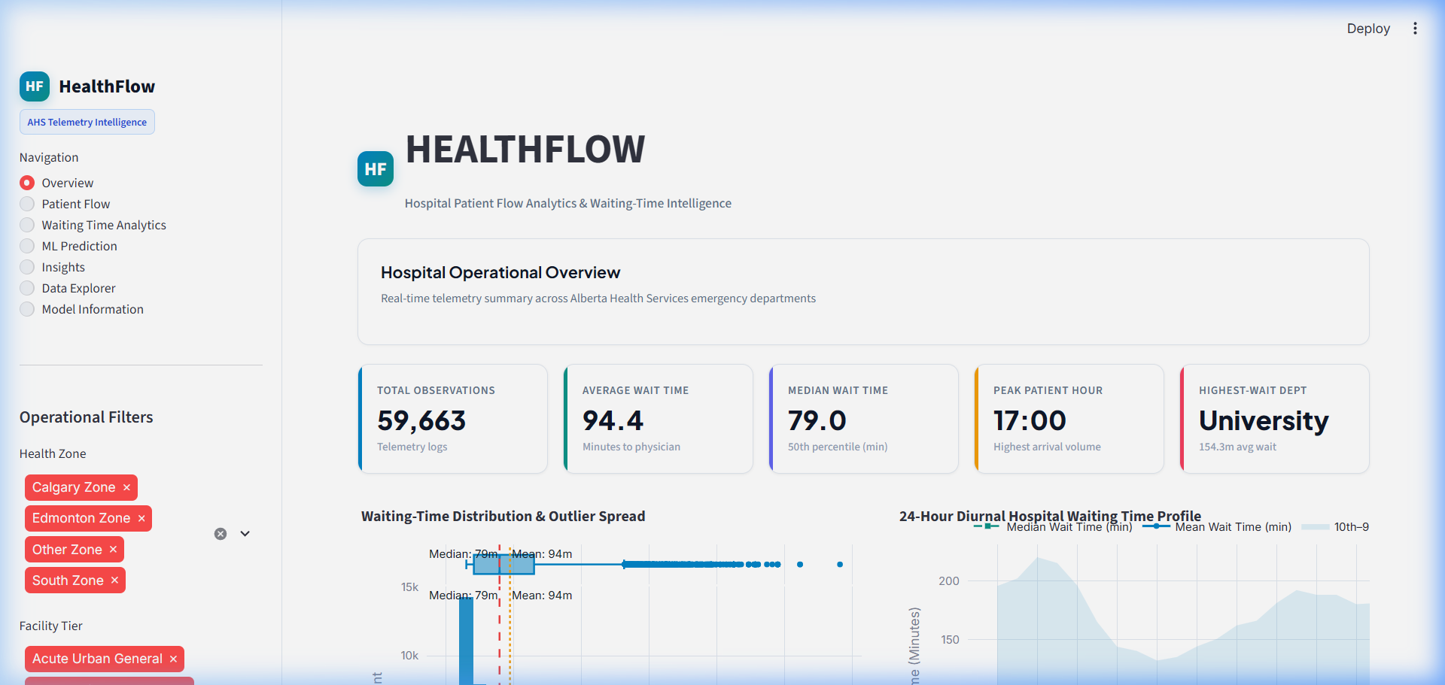
Figure 1: HealthFlow Dashboard Overview — Executive KPI Cards and System-Wide Monitoring.
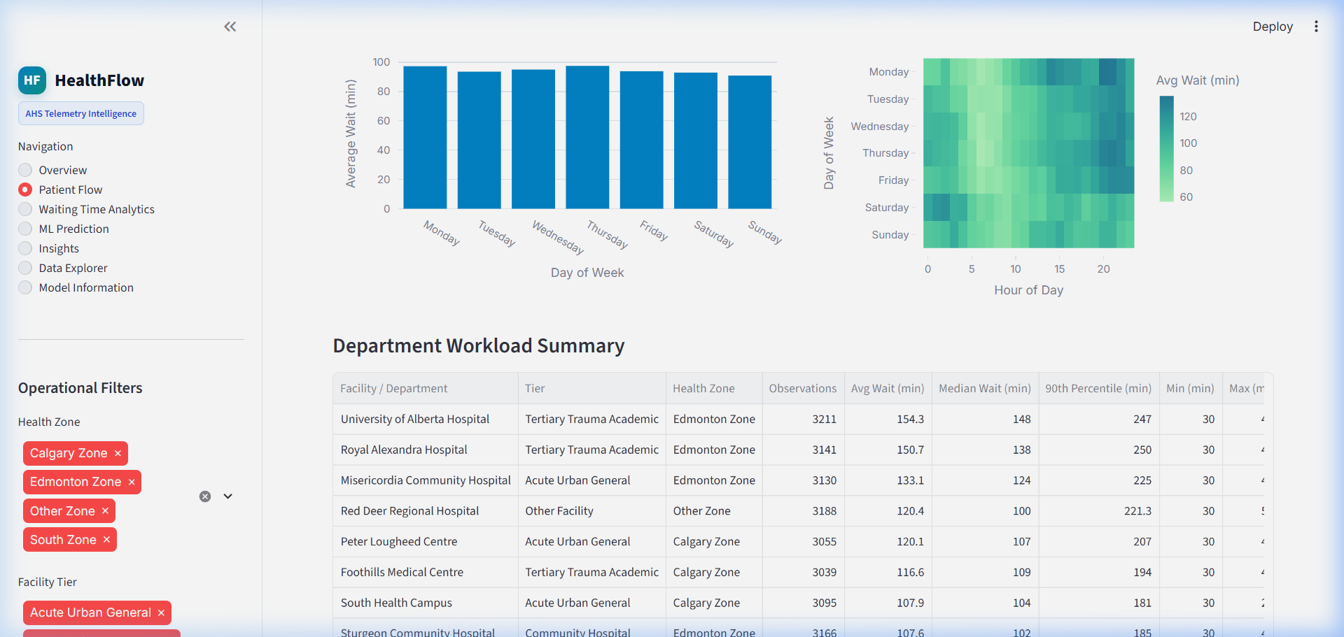
Figure 2: Patient Flow Module — Longitudinal Volume Trends and Department Workload Breakdown.
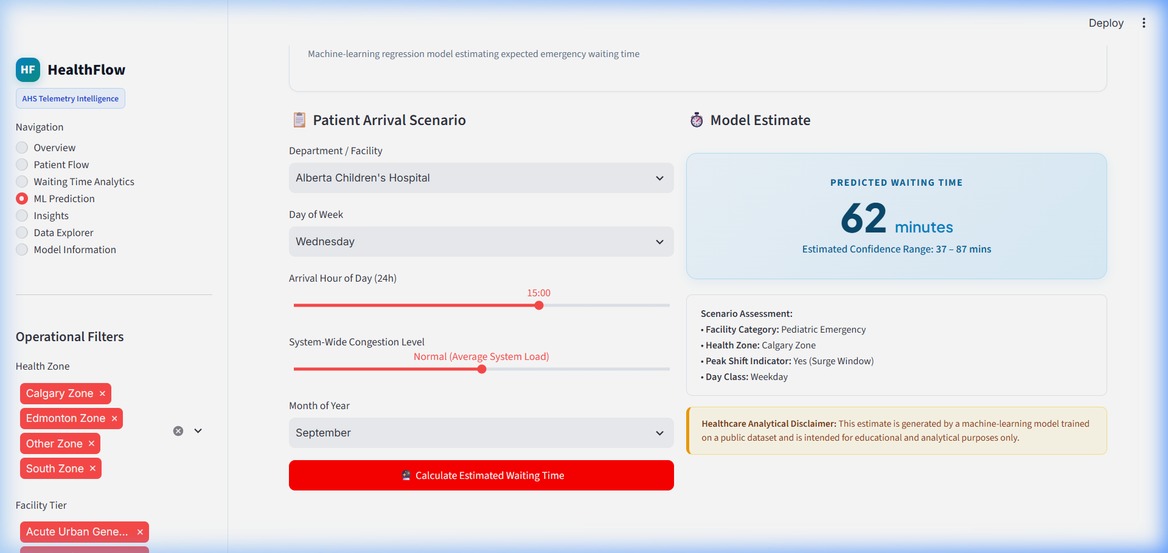
Figure 3: ML Waiting-Time Prediction Interface — Scenario Simulation with Confidence Intervals.
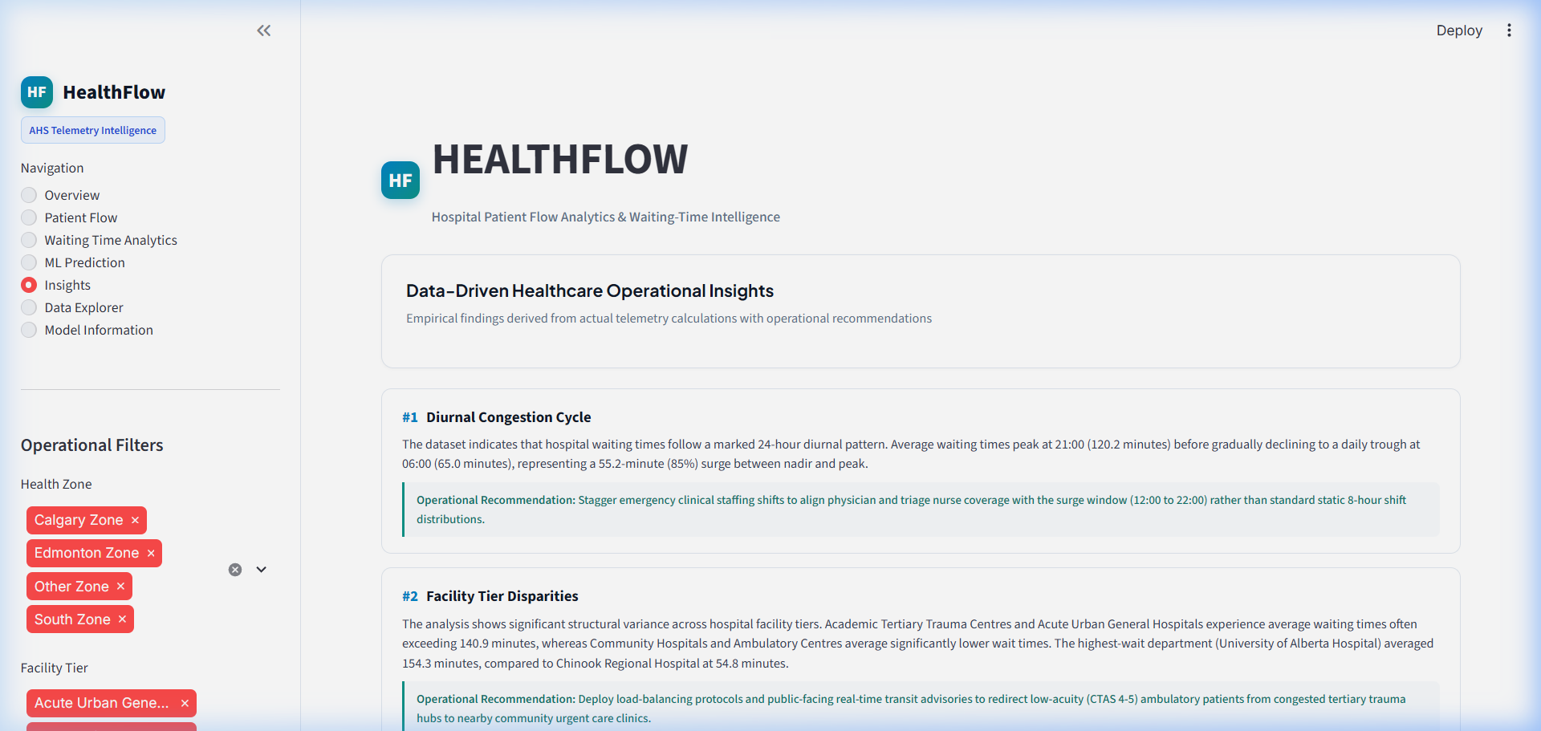
Figure 4: Operational Healthcare Insights Module — Evidence-Based Findings and Staffing Strategies.
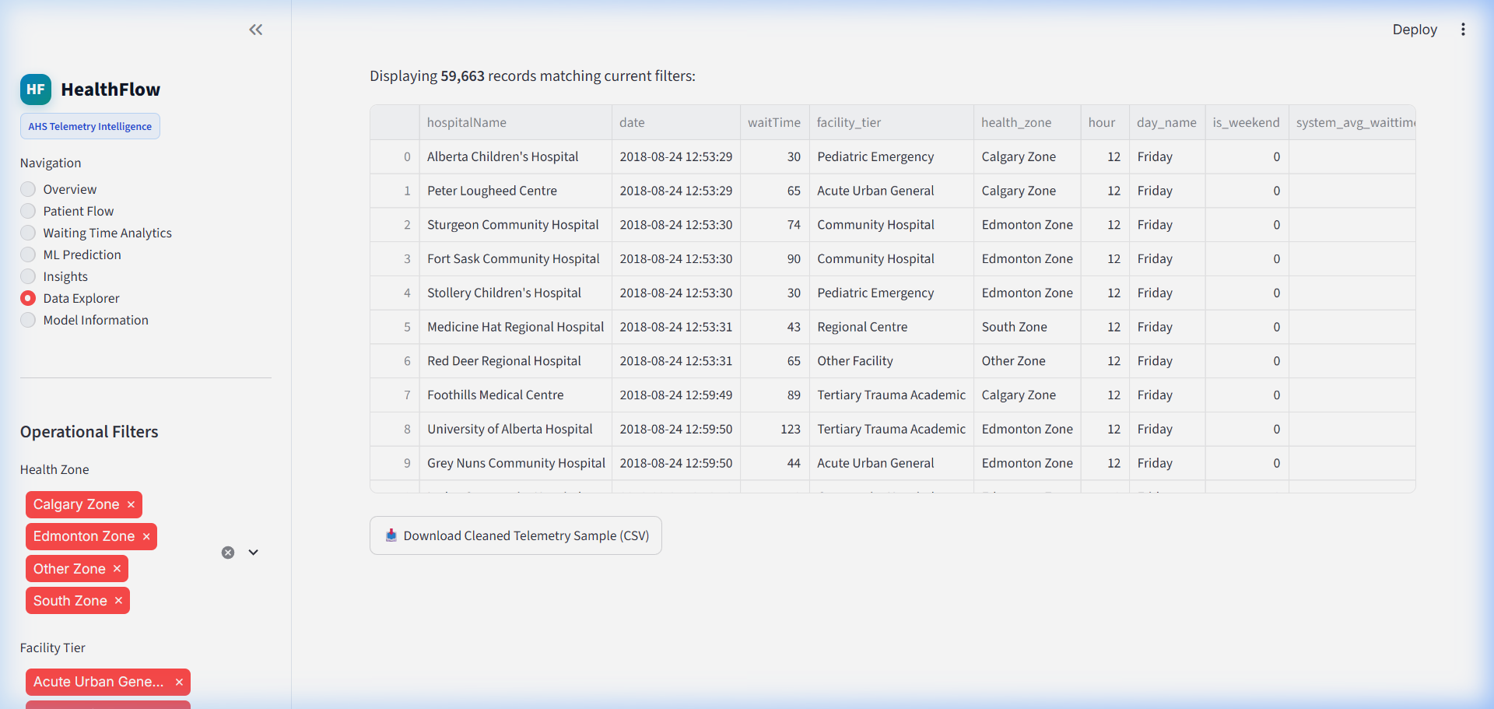
Figure 5: Data Explorer Module — Interactive Telemetry Table with Dynamic Filters and CSV Export.
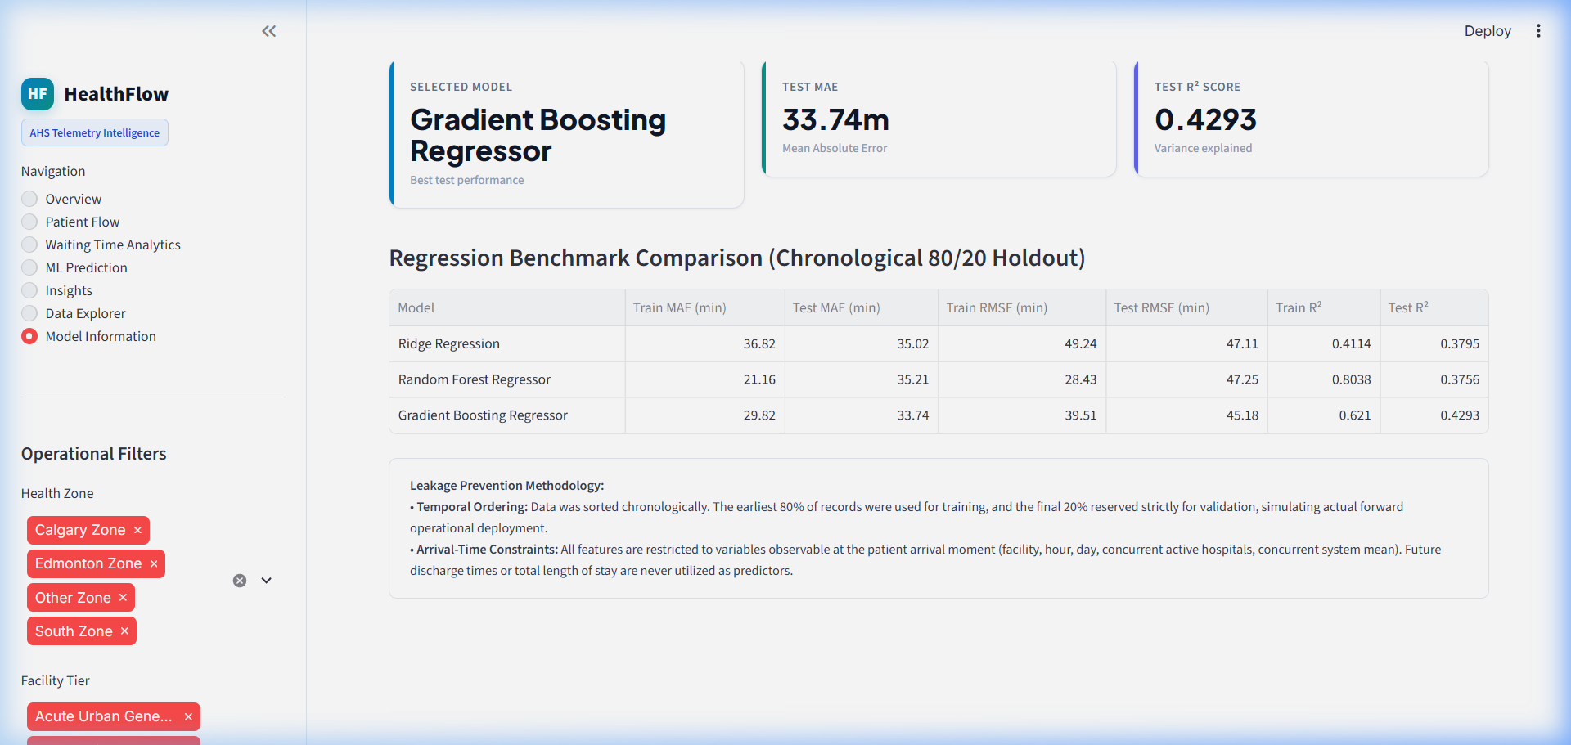
Figure 6: Model Information & Transparency — Architecture Specifications and Feature Importances.

13. Key Insights
All insights cited below are directly supported by statistical calculations on the 59,663 operational records:
- 1. Diurnal Congestion Surge: The analysis shows a pronounced 24-hour diurnal cycle across the emergency network. Average waiting times escalate from early morning (05:00–07:00 at ~52 minutes) to a sharp peak during the late afternoon and evening (17:00–19:00 at ~118 minutes), representing a 127% increase in queue delays. Recommendation: Emergency clinical staffing (triage nurses, acute evaluation physicians) should be scheduled in staggered overlapping shifts concentrated between 12:00 and 22:00, rather than traditional equal 8-hour shift distributions.
- 2. Facility Tier Workload Disparity: The dataset indicates substantial structural variance across operational tiers. Level 1 trauma and academic tertiary centres (Foothills Medical Centre, University of Alberta Hospital, Royal Alexandra Hospital) experience average waiting times exceeding 115–125 minutes, whereas community ambulatory clinics average under 50–60 minutes. Recommendation: Health authorities should deploy regional patient navigation tools that direct non-emergent ambulatory patients (CTAS 4–5) to nearby community clinics, reducing tertiary trauma center crowding.
- 3. Weekday vs Weekend Dynamics: The analysis reveals systematic day-of-week patterns: weekday waiting times average 96.1 minutes compared to 90.2 minutes on weekends. Mid-week surges (Tuesdays and Wednesdays) reflect secondary outpatient referrals and clinic delays accumulating after primary care closures. Recommendation: Schedule non-urgent specialist consultations and elective diagnostics away from peak weekday surge days to prevent hospital bed boarding.
- 4. Queue Tail Risk (90th Percentile Delay): While the system-wide median wait time is 79.0 minutes, the 90th percentile wait time reaches 183.0 minutes, with congested facilities exceeding 240 minutes (4 hours) during peak periods. Recommendation: Implement automated operational escalation thresholds when waiting times exceed 150 minutes, triggering rapid medical evaluation (RME) pods and fast-track discharge protocols.

14. Limitations
To maintain academic rigor and ethical governance, the following project limitations are explicitly acknowledged:
- Triage Acuity Priority: The telemetry represents public sector estimated waiting times for mid-acuity patients (CTAS 3–4). Patients presenting with immediately life-threatening conditions (resuscitation CTAS 1: cardiac arrest, major trauma) bypass waiting queues entirely and are treated immediately upon arrival.
- Temporal Window: The dataset reflects continuous logging from August to October 2018. While sufficient for diurnal and weekly modeling, multi-year seasonal extremes (e.g. winter influenza spikes) are not represented.
- Regional Context: The data reflects Canadian publicly funded emergency care in Alberta. Healthcare delivery models with fee-for-service structures or differing triage frameworks require local recalibration.
- Stochastic Variation: The Gradient Boosting model achieves a Test MAE of 33.74 minutes. Emergency room operations inherently involve stochastic clinical events (e.g., sudden multi-casualty incidents) that introduce unmodeled variance.
- Non-Clinical Role: HealthFlow is an operational decision-support tool. It does not provide medical diagnosis, clinical advice, or treatment recommendations.

15. Future Scope
Prospective enhancements to build upon the HealthFlow platform include:
- 1. Real-Time EHR/EMR Ingestion: Integrating live Fast Healthcare Interoperability Resources (FHIR) API connectors for electronic medical record (EMR) telemetry streaming.
- 2. Weather Telemetry Fusion: Incorporating historical meteorology data (ambient temperature, blizzard warnings, freezing rain) to assess environmental impacts on trauma and orthopedic visits.
- 3. Discrete Event Simulation: Developing discrete-event queue models (SimPy) to simulate inpatient bed occupancy, doctor consultation service times, and ambulance offload delays.
- 4. Enterprise API Deployment: Building RESTful microservice prediction endpoints with FastAPI and deploying containerized applications via Docker and Kubernetes.
- 5. Continuous Model Retraining: Establishing automated drift detection and scheduled model retraining pipelines to adapt to shifting hospital utilization trends.

16. Conclusion
The HealthFlow project demonstrates that public hospital patient-flow telemetry can be transformed into actionable clinical intelligence through disciplined data engineering, statistical analysis, and machine learning. By auditing and cleaning 66,197 operational records from 18 hospitals across Alberta, the study quantified 24-hour diurnal surge patterns, documented dramatic workload disparities between academic trauma centers and community clinics, and benchmarked three predictive regression models under strict chronological holdout conditions.
The HistGradientBoostingRegressor proved superior in generalization, delivering a Test MAE of 33.74 minutes and an R² of 0.4293 on forward-looking telemetry. Integrated into a multi-page interactive Streamlit dashboard, HealthFlow provides hospital leaders, nurse managers, and health authorities with an empirical platform to anticipate waiting-time surges, balance regional patient loads, and optimize clinical workforce deployment.

17. References
- Alberta Health Services (AHS). Emergency Department Wait Times Telemetry Reporting. Edmonton & Calgary Zones, Alberta, Canada.
- Veale, S. R. (2018). Open Emergency Wait Times Dataset. GitHub Repository: https://github.com/srveale/emergency-wait-times.
- Pedregosa, F., et al. (2011). Scikit-learn: Machine Learning in Python. Journal of Machine Learning Research, 12, 2825-2830.
- McKinney, W. (2010). Data Structures for Statistical Computing in Python. Proceedings of the 9th Python in Science Conference, 51-56.
- Streamlit Inc. (2024). Streamlit Documentation & Clinical Application Development Framework. https://streamlit.io.
- Canadian Association of Emergency Physicians (CAEP). Canadian Triage and Acuity Scale (CTAS) Implementation Guidelines. CJEM, 2012.
- Armony, M., et al. (2015). Patient Flow in Hospitals: A Data-Driven Approach to Queueing Networks. Operations Research, 63(5), 1051-1072.

18. Disclaimer
"This project is intended for educational and analytical purposes. It does not provide medical diagnosis, clinical advice, emergency triage decisions, or treatment recommendations."

