Probability and Statistics

Lab DA-3

23BCI0008
  - Raghav Sharma

1. It is known that probability of an item produced by a
certain machine will be defective is 0.05. If the
produced items are sent to the market in packets of
20, then write down the R code to find the number of
packets containing at least, exactly and at most 2
defectives Items in a consignment of 1000 packets.
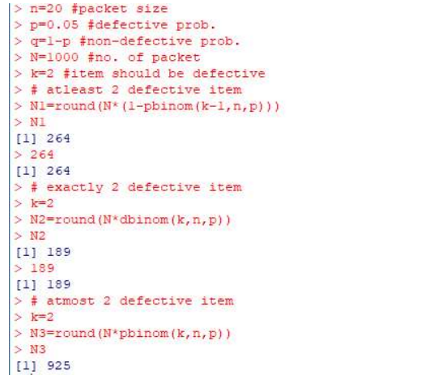
2. A car hire firm has 2 cars which it hires out day by day.
The number of demands for a car on each day follows a
Poisson distribution with mean 1.5. Write down the R code
to compute the proportion of days on which (i). neither car
is used, (ii). at most one car is used and (iii). some
demand of car is not fulfilled.
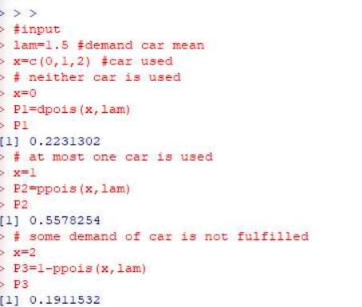

3. The local corporation authorities in a certain city install
10,000 electric lamps in the streets of the city with the
assumption that the life of lamps is normally distributed. If these
lamps have an average life of 1,000 burning hours with a
standard deviation of 200 hours, then write down the R code to
calculate the number of lamps might be expected to fail in the
first 800 burning hours and also the number of lamps might be
expected to fail between 800 and 1,200 burning hours.
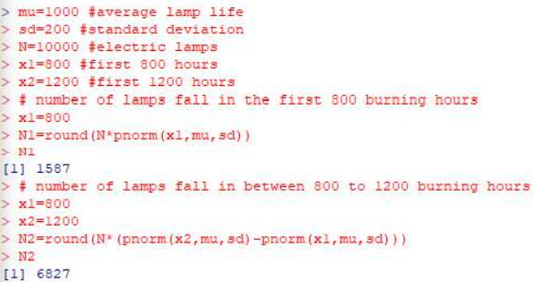

4. A factory produces items, and the probability of any item being defective is 0.02. If these items are packed in boxes of 30, determine how many boxes in a consignment of 500 boxes will have:
At least 3 defective items
Exactly 3 defective items
At most 3 defective items

Code:

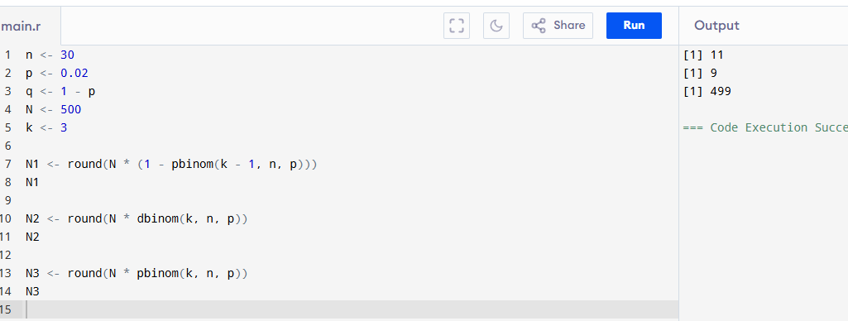

5. A machine produces electronic chips, and 1% of them are defective. The chips are packed in boxes of 50. Find the number of boxes (out of 800) that contain:

At least 1 defective chip
Exactly 2 defective chips
At most 2 defective chips

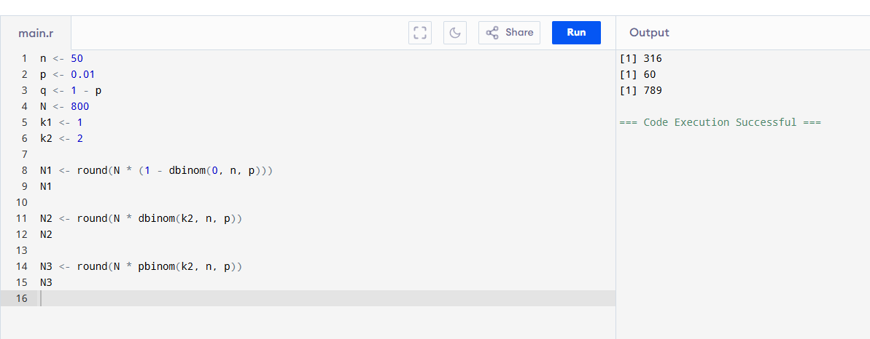

6. A printing press has a defect rate of 3% per page. A customer receives booklets of 40 pages each. In a batch of 1200 booklets, determine how many booklets have:

At least 4 defective pages
Exactly 4 defective pages
At most 4 defective pages
