Timers

Pre-information for the readers that this article will be long as I intend it to be. This article could be made short as well but it will lead you directly into topic without clarification and real life examples. Earlier on I used to prefer books and articles with less volume. I found their contents to be memorized and some of them don’t go through my head due to which I stopped reading for several hours and spent those hours just feeling the pain of my head. If those books and articles were presented with examples and clear idea of the topics being discussed despite it takes several texts or pages, those hours of pain would be spent learning in delightful manner. This refrain me being limited to less volume resources and attract towards dense resources as well. As a consequence of this, I attempt to present the contents of my article including examples and somehow long explanation although it results to long article which readers find less attracted too. What I believe through this article is reader spends more time reading and learning than avoiding after few lines but I could be wrong as well and if it is I pre-apologize for that.

Pre-Introduction
Since the development of human civilization time has been a matter of concern. In the days when the present days clocks were not invented, human still are aware of time with the help of the Sun, the Moon. The shape of shadow during day time helps to keep track to hours. People would wait for a big full moon to travel out at night. These methods does not provide exact time and are not applicable when the sky is not clear. Considering this lacking many advancement had taken place and now we have come to the phase that we can track even micro or nanoseconds. Remember that we are still in the path of advancement.
Suppose you wake up 6 AM in the morning, study 2 hours, be at school for 6 hours, watch movie of 2 hours and 11 minutes, sleeps for 8 hours. If you are late to something like waking up then you say I wake up 45 minutes late today. You tell that seeing the clock. Your body has inbuilt clock due to which you feel sleepy after 10 pm if you have sleeping habit at 10 pm. Your day to day activity is synchronized with time.
Don’t think only of human, electronics components work on time basis too. You may have used the terms like my computer or mobile is slow or faster in comparison to others. To open a image or display what you typed on your screen, it takes no time but takes a bit of time to turn off or on your computer. So these are all related with time.
Due to the huge importance for time to human world, AVR manufactures have included inbuilt hardware for timer so that external hardware is not needed for this.
Like enabling internal pull-up resistor from software, we can use timer with some few lines of code. This contributes much to make embedded systems like washing machine, AC, etc that operate with time.
The AVR timer can handle a few microseconds(like the ticks of a processor) to many hours (like child playing time), accurately to the resolution of microseconds.
Slowly lets enter into the topic. You must have heard of processor speed. If not then atleast while buying mobile or computer you see processor specification like 2.4GHz. Go to the internet and find the processor speed of your phone and computer. My laptop has speed of 4 GHz(Giga Hertz).
If I ask you about frequency then you can atleast tell something or write an essay about it. Simply it is the number of times an event occurs per unit of time. Suppose I want to check how much words can I type per minute and after checking I found that I can type only 35 words per minute, so I need to improve my typing skill. You can check yours and can improve by practicing. But for now, see what I am considering in this case as event. Its “typing words” and “minute” as unit time. So my frequency of typing words is 35 words per min. In case of computer, we consider instructions that we provide to computer like clicking mouse, keyboard press, run movie or like that as event. Second is standard unit time as given by the International System of Units(SI). We used words(event) per minute as unit of frequency. But Hertz(Hz) is the SI unit, which tells no of times an event occurs per second.
Again to be familiar with GHz term I want to remind you of GB. You tell I’ve 500 GB(Giga Byte) of hard disk. Here Giga refers to (1 or sth)*10⁹. 1 GB = 1 billion bytes. Like that 1GHz = 1 billion Hertz. Finally you should be ready to tell that your mobile processor has specification of 2.4GHz means your mobile can run 2.4 billions instructions per second. Now you may believe your mobile can detect 2.4 billions pressed at a time, but its not. For each key pressed your mobile processor has to do some tasks like stop other recent operations, focus on key press, detect which key and much more such that it can understand what instruction you are giving to your mobile. Its takes 100s of instruction to display in the screen what you press. So better to tell 2.4 billion machine lBe careful with the case of the letters, before underscore is the name of the peripheral or interrupt source all in capital letters. If the source has more than one sub source like timer can produce interrupt for overflow and compare match then the name of sub source should be include after underscore in capital letters. Finally ‘_vect’ which is in small letters is added at the end which is short form of vector. Simply understand that vector is added in the parameter name as it gives direction to AVR to perform task whenever interrupt takes place. For more information see “AVR’s interrupt tutorial ” online.

evel instructions per second. Its fine if you don’t understand, just feel cool up to where you have learned.
AVR has frequency in the range of MHz(Mega Hertz) which is 1000 times smaller than GHz. It is because computer and mobile are for multitasking i.e. you need to watch movie, do calculation, use internet, and many more with the same device. But AVR is mostly used for specific purpose like only printing in case of printer or control temperature in case of AC.

In your earlier steps of learning AVR, you may have blink LED at an interval of 1 second or like that. The example code for it is:

#define F_CPU 1000000UL
#include <avr/io.h>
#include <util/delay.h>

#define LED_PORT PORTB
#define LED_DDR DDRB
#define LED1 PB2
#define DELAY_TIME 1000 // 1s = 1000 ms

int main(void) {
LED_DDR = (1 << LED1);
while(1) {
LED_PORT ^= (1 << LED1); // Toggle LED after each second
// to make it appear blink
_delay_ms(DELAY_TIME);
}
return 0;
}

If the code is clear to you then its fine continue reading. Otherwise see my bit twiddling article to understand “^”, “|”, “<<” operators and the whole code.

This is an example of time based project. The above code works fine if your task is to only blink a LED using AVR. But what if I want to blink another LED at an interval of 2 sec.

From above code, “util/delay.h” header file is included and F_CPU is defined to 1MHz before including the header file. Note that F_CPU should be defined before including the “util/delay.h” header as the code inside the header file search for the definition of F_CPU in the lines preceding its inclusion, if defined below shows warning message and considered default value define inside the code which is normally 1MHz. With this definition we are telling that frequency of CPU or AVR is 1MHz, 1*10⁶ machine cycle instructions per second. UL at the end denotes the value is of unsigned long type to the compiler as the value is greater than the range the integer data type can handle.
In ATmega32 we can select the operating frequency of 1, 2, 4 or 8MHz by changing some fuse bit(just extra information, I won’t teach you how to do that here as it doesn’t come under this topic). Or if you want other frequencies than that, you can use external crystal or resonator.
You have to provide the exact frequency of your AVR in the F_CPU definition. Initially the ATmega32A chip comes with the setting of 1MHz frequency. If your AVR is set to work at 1MHz frequency and you defined it as 2MHz, then the delay function will produce delay of 2 sec although you write code for 1 sec delay.
I recommend you to change the F_CPU definition to 8000000UL and run the code in your AVR. If your LED was toggling every 1 sec when written 1MHz frequency, now you must observe your LED being toggled every 8 seconds. That is why you should provide the exact frequency to F_CPU definition.

#define F_CPU 1000000UL
#include <avr/io.h>
#include <util/delay.h>

#define LED_PORT PORTB
#define LED_DDR DDRB
#define LED1 PB2
#define LED2 PB4
#define DELAY_TIME1 1000 // 1s = 1000 ms
#define DELAY_TIME2 2000 // 2s = 2000 ms

int main(void) {
LED_DDR = (1 << LED1) | (1 << LED2);
while(1) {
LED_PORT ^= (1 << LED1);
_delay_ms(DELAY_TIME1);
LED_PORT ^= (1 << LED2);
_delay_ms(DELAY_TIME2);
}
return 0;
}

Does this work? I believe not. When we enter into the while loop the first LED remains ON for 1 sec because of the delay function. After that next instruction is executed which makes second LED ON for 2 sec. At this time both LEDs remain ON. After 3 sec only the first LED turns OFF which does not match our requirement.
Some of you may think of replacing the while part with the below statements:
LED_PORT ^= (1 << LED1);
_delay_ms(DELAY_TIME1);
while(1) {
LED_PORT ^= (1 << LED1);
_delay_ms(DELAY_TIME1);
LED_PORT ^= ((1 << LED1) | (1 << LED2));
_delay_ms(DELAY_TIME1);
}

Okay that does work. I still have a but for you. AVR is not just for LED blinking. If I add codes to use character LCD display or keypad or like that then I am sure you can’t obtain the required result at least not accurately. I have an example for you of our real world. Teacher is teaching us in the classroom. If the teacher herself has to check whether her period time is up or not, then she can’t leave the class at exact time. There is always change of 5 10 minutes delay. But if there is a timekeeper in your school to ring bell after completion of period then the burden of teacher is also minimized and she can leave the class on time. Like we have a timekeeper if we have some hardware part in AVR then we can blink LEDs and operate character LCD or like that. We have Timer as timekeeper in our AVR whose job is to inform us about time.

Introduction
Basically, a timer is a register like PORTx, DDRx, etc. But has special features than other registers. The value of this register increases/decreases automatically independent of AVR CPU(main processor of AVR that executes the instruction provided by us) i.e. the increment/decrement in the value of that register takes place even if the AVR is performing some other task. like timekeeper observing time while teacher is teaching. For this reason timer gives us accurate result. In AVR, timers are of two types: 8-bit and 16-bit timers. In an 8-bit timer, the register used is of 8-bit whereas of 16-bit in case of 16-bit timer. So, the 8-bit timer can count up to 2^8=256 steps from 0 to 255 and 16-bit timer up to 2^16=65536 steps. Due to this it is considered as counter and you will see timer/counter as it can be used to know time as well as count events like no of men entering a room, no of vehicles over speeding, no of peas coming out of machine... Suppose it is in auto increment mode. After some time, the register stores its maximum value. What happens after that? Does the timer stops working from now on or AVR also stops its operation? Well, no such things take place. It returns to its initial value i.e. zero. We say that the timer overflows.

Timer Concepts
The timer register store the numbers but we need time like 10 ms(mili seconds) or 5 sec as our tasks will be like blink LED every 1sec or take data from sensor every 10ms. So how to convert the number in the register into time?
AVR has a clock inside it which generates clock signal, a signal that oscillates between a high and a low state.
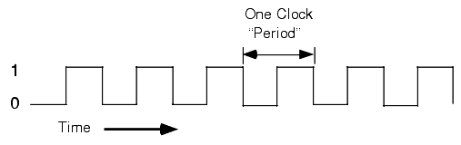
In the figure there are 6 clock signals. If the AVR frequency is set to 1MHz then 1 million such clock signals are produced in 1 sec. If so, how much time does it take to produce one clock signal? Using unitary method you can get it.

For 1 million i.e. 1*10^6 clock signals, time req. = 1 sec
For 1 clock signal, time req. = 1/(1000000)sec
= 10^(-6) sec or 1 microsecond

Or the know relation between time and frequency,
Time Period = 1
Frequency

This also gives the same result.
If you have idea of the up counter register, you are well aware of the information that the register gets incremented at each clock pulse. Else you take a tour of “register” or just keep that in mind that it takes one clock pulse to go from 0 to 1, another clock pulse to go from 1 to 2 and so on. In terms of time, the timer register changes from 0 to 1 after one microsecond, 1 to 2 after another microsecond and so on(consider 1MHz frequency). With this you can convert the register value into equivalent time. Doesn’t it fell like opposite to you. We know how much delay we want but not the value of the register. If so how to know the register value according to required delay?
Its lower level mathematics time.

For 1sec delay, frequency no of counts required.
(For e.g. if frequency = 1 MHz then, 1 million clock signals are produced in 1 sec and at each clock signal, the count is increased by 1.)
To see the above bold texts as in formula,
For 1 sec delay, count = frequency
For x sec delay, count = x(required delay time in sec)*frequency, required formula.
E.g. for 10ms delay having frequency 2MHz,
Count = 10*10^(-3)*2*10^(6) = 2000
i.e. 2000 counts are required to produce delay of 10 ms if frequency of 2MHz is used.
Note if you want to use time period instead of frequency then,
Count = x(required delay time in sec)*1/(time period)
If you have seen other articles you may have seen -1 at the end. For now don’t consider -1. When time comes I’ll explain why -1 also included in other articles.

Note
Time period of a clock signal = HIGH time + LOW TIME.
If considered only HIGH time, it is called clock pulse.
The digital circuits like ICs, flip-flops get synchronized with clock pulse. To understand this statement lets consider a up-counter register. The register value increases with the clock signal provided to it. So here, clock signal and the register are operating simultaneously.
The clock signal is of certain time period. During this time period of clock signal, at what time the up-counter gets incremented? The answer is either at the rising(leading) edge, falling(trailing) edge or during the pulse width(edge triggered or level triggered if you have heard of). Among this options only one is used and it may be already defined or the programmer gets to choose. You will get to choose either rising edge or falling edge in the timer of AVR later on.
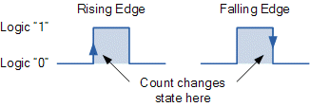

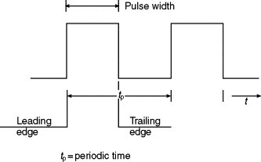

How many counts are possible between 0 and 255? First count when the register changes its value from 0 to 1, second from 1 to and like that we get 255 counts. In case of 8-bit timer as I mentioned earlier, when it reaches 255 it again gets back to 0. To change the register value from 255 to 0 it takes one clock cycle. During this one clock cycle another change also takes place within AVR to indicate the timer count has reached its maximum value. Its in overflow flag which is one of the bit of a register of AVR. If you are keen to football then referee raises the flag to indicate foul or offside. You can consider this overflow flag similar to that. If this bit is 1, the overflow flag is raised to indicate the maximum reach of timer and if 0, no overflow. Will you be confused if I say the 8-bit counter can count up to 256? Up to 255 you are sure but 1 extra how? Previously included, one extra clock pulse is required to indicate the AVR, overflow takes place. So 255 counts and this extra clock pulse makes count of 256. For simplicity, consider 0 as extra count as one extra clock pulse is required to become value 0 from 255. Similar in the case of 16 bit register considering 2^16(65536) instead of 2^8(256)..
Back to the count and timer relation. 1 count is equal to 1 clock signal which is equal to reciprocal of frequency(1s for 1MHz frequency). 8-bit counter can count maximum of 256 which means we can have maximum delay up to 256s. This delay is huge for AV although negligible to human persistence. Don’t waste you time imagining of having delay more than this. By the end of this article you will have knowledge more than you are imagining now.
Let me introduce the registers. Focusing ATmega32A it has 3 timers:
Timer0 - 8-bit timer
Timer1 - 16-bit timer
Timer2 - 8-bit timer
To get to know 8-bit timer, I will consider Timer0. Formerly talked register which stores count from 0 to 255 for Timer0 is TCNT0(Timer/Counter0).

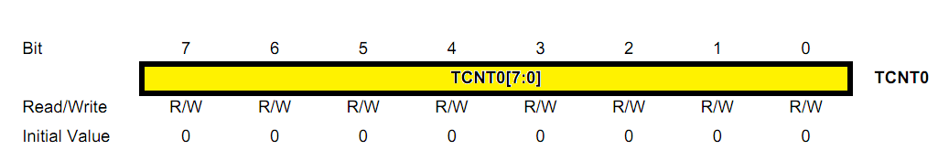

It is a read/write register i.e. value can be written to it as well as its value can be read as shown below.
TCNT0 = 35; // Write to the register.
Unsigned char count_value = TCNT0; // Read the // value of the register and store in the variable.

Observe that I’ve used “unsigned char” instead of int. It’s because our requirement is to store the TCNT0 value which is of 8 bits or 1 byte. Int occupies 2 bytes memory while unsigned char occupies 1 byte memory. As AVR has very less memory, programmers should be concerned of minimizing as much memory use as possible. But for 16-bit timer unsigned int type variable is required.
In AVR there is a register, TIFR(TImer/Counter Interrupt Flag Register) and it has a bit named TOV0 which is generally 0 but becomes 1 when overflow takes place in Timer0. Through this bit, AVR gets to know whether overflow occured or not.
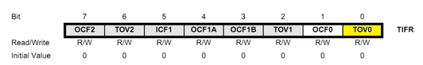
Always consider the point that whenever overflow takes place we have to do something like blinking led or increment a variable to count some event or like that. Following the above conditions, I mean to say 1 MHz frequency, if we need to have 256 s then we set TCNT0 to 0 although it is initially 0 just for our confirmation or as an example that we can provide any initial value to TCNT0 register. The register then starts to increment from that initial values every clock pulse. To have delay of 256 s we need 256 time count or clock pulse and this much time count is obtained when the register value increments from 0 and overflows or changes from 255 to 0. So we need to check the TOV0 flag to know this and this is done through the code shown below:
if (TIFR & (1 << TOV0)) {
LED_PORT ^= (1 << LED_PIN); // LED_PORT and LED_PIN are macros // whose value can be chosen by yourself like PORTA and PA0 // respectively.
TCNT0 = 0;
TIFR |= (1 << T0V0); // Clear TOV0 bit
}

You surely will understand the condition for if statement if you are familiar to bit twiddling/manipulation otherwise learn it first from here. The statement below if, “LED_PORT... “ is also clear to you which toggles the LED state each time overflow tales place. But why the statements below them are necessary? “TCNT0 = 0;” is not necessary in this case but still I’ve included it. The reason for this will be cleared to you in the next example. Remember that “TIFR |= ...” statement is necessary.
Whenever overflow takes place in Timer0, TOV0 bit becomes 1, TCNT0 becomes 0 and then 1, 2, 3, ......, 255 after each clock pulse. After 255, overflow takes place and sets TOV0 flag but TOV0 flag is already set. To know whether the overflow has occurred for second time or not, we have to clear the TOV0 bit after performing the required task which in this case is to blink LED. Actually clearing the overflow flag is one of the task to be done whenever overflow took place. To clear the bit we have to set that bit, which is guided by the data sheet. This seem confusing to you and may even think this one as mistake and should be “TIFR &= ~(1 << TOV0); but the previous one is 100% correct. From now on, be sure that when I say to clear any flag bit, you should write the code to set that bit manually which results 0 to that bit. If this bit was not cleared, the condition for if will be true forever after the first overflow. So LED toggles at around 2 s delay.(To check how much delay has been provided, you need oscilloscope or you can check virtually using simulation software like proteus.)
Try to write the code for 50 s delay.

From formula, time count = frequency* required delay
= 1*10^6*50*10^(-6)
= 50
If we set TCNT0 = 0 then when TCNT0 = 50 we need to toggle the LED. But the AVR overflow flag is not set at this case. To set the overflow flag for 50 s delay also we should set initial value of TCNT0 such that at count 50 from that overflowed takes place. To find the initial value of TCNT0 such that at count 50 from that, overflow takes place. For this we subtract the time count value from 256.
So the formula for TCNTx value is
TCNTx = 256 - (frequency* required delay)

Using this formula we obtain TCNT0 initial value as 206 and the code is;

TCNT0 = 206;
if (TIFR & (1 << TOV0)) {
LED_PORT ^= (1 << LED_PIN); .
TCNT0 = 206;
TIFR |= (1 << T0V0); // Clear TOV0 bit
}

Here if TCNT0 is not set to 206 then the count starts from 0 which is not what we required.
As you see, in this method we are checking manually whether overflow occurred or not. It’s kike you have kept your mobile phone in silent mode and you are manually checking time to time whether someone has called you or not. Maximum time you see no call, if you see call also it may be missed and there is rare chance that you attain the call. You are wasting your valuable time for checking your phone and you must not like it. This method is called polling and is not effective. You know why from the phone example. Like this if you observe the delay time using oscilloscope or simulation software in the AVR, you will get somehow more delay than required. As a solution to phone checking problem, must of keep our phone in ringing or atleast in vibration mode due to which phone itself notify us whether or not someone is calling us and there is less chance of missing call. If your are playing game in your phone and someone calls you, the phone will interrupt your game and notify you about the phone call. You can use any function of your phone but your operation is interrupted whenever you have a phone call. So such method is called interrupt and is available in AVR too.
To keep your phone in ringing mode you have to do some task to enable interrupt method. Likewise there is some job for you to be done to enable interrupt in AVR. After that you have to group the tasks your would like AVR to do whenever overflow takes place inside a special function called Interrupt Service Routine(ISR) as the AVR looks inside thid function to know what to do whenever overflow takes place.
To know how to enable interrupt we need to know about another register called TIMSK(Timer/Counter Interrupt Mask Register).
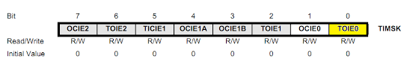

In the above register you will find TOIE0(Timer/Counter Overflow Interrupt Enable 0) bit and you need to set this bit . Just don’t care if you don’t understand other bits but you can see and guess what other bits does.
The function which is executed whenever interrupt takes place look like this:
ISR(TIMER0_OVF_vect) {
LED_PORT ^= (1 << LED_PIN);
TCNT0 = 206;
}

Like DDRx, PORTx etc being defined under <avr/io.h> file, ISR, TIMER0_OVF_vect are defined under <avr/interrupt.h> file, so need to be included for using it in program.
Just like your phone interrupt you by notifying you for call, message, facebook notification etc, AVR also has to handle different types of interrupt sources, ATmega32 has 3 timer and each timer has two interrupt sources: one is overflow and another compare match. Other peripherals present inside AVR like UART, EEPROM, ADC etc also have interrupt sources. You have to perform one task whenever timer0 overflows and another task whenever timer2 overflows. How do you provide the separate task? ISR() takes an parameter, like TIMER0_OVF_vect in above code which specifies what task to perform for what interrupt source. The above code does not run whenever timer2 overflows as it is specified for timer0. To perform the same task for timer2 as well we have to write another ISR() function with TIMER2_OVF_vect as an parameter.

Be careful with the case of the letters, before underscore is the name of the peripheral or interrupt source all in capital letters. If the source has more than one sub source like timer can produce interrupt for overflow and compare match then the name of sub source should be include after underscore in capital letters. Finally ‘_vect’ which is in small letters is added at the end which is short form of vector. Simply understand that vector is added in the parameter name as it gives direction to AVR to perform task whenever interrupt takes place. For more information see “AVR’s interrupt tutorial ” online.

In the code you must have noted that I have not clear the overflow flag manually as it is done by the ISR() function implicitly.
There is one more thing I need to tell you in the interrupt. Like our house’s electrical wiring system contains a main switch which can turn off all the lights in our house despite the switch to control that light is on, AVR also has a main switch which should be enabled before using interrupt otherwise just enabling the individual interrupt enable(e.g. TOIE0 bit for timer0 overflow) bit won’t work. To enable the AVR’s interrupt main switch we need to write sei() in our code and to disable it, cei().
You have shown patience till now, there is one more topic to introduce you and then you are capable to some fun thing with timer of AVR.

The Prescaler
I’ve made you capable of introducing delay up to 256us, not more than that. The formula for maximum delay we can have using 8-bit timer is:

Max delay = 256*1/Frequency

This is not new formula. If you replace count with 256, required delay with max delay and rearrange the formula, we obtain this formula. This formula shows the inverse relation of max delay with frequency. If we are able to reduce the frequency we can increase the delay time. Instead of 1MHz if we use 0.5MHZ , the maximum delay time increases to 512us. There is a range of frequency in which AVR can operate on. Moreover if we decrease the AVR frequency the AVR becomes less responsive and takes longer time to execute instructions which we don’t want.
AVR provides a feature to decrease the frequency of clock provided to timer keeping the operating frequency of AVR or actual F_CPU as it is. This technique of frequency division is called prescaling. We can do this by setting some bits of TCCR0(Timer/Counter Control Register).
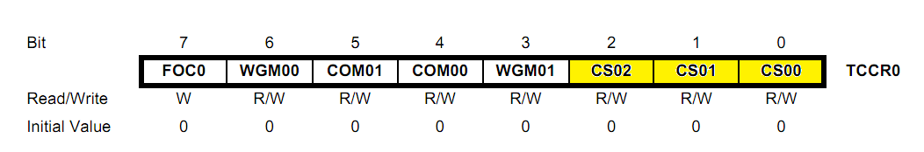
The bits highlighted by yellow color, CS00(Clock Select 00), CS01 and CS02 are used to set clock frequency for timer0.
Leave last two options foe now in the table below.

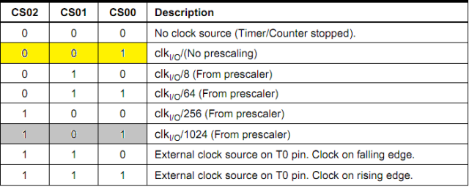

Doing nothing with this register bits means we are providing 0 to CS00, CS01 and CS02 by default. This will disable the timer0 as shown by the above table. To enable the timer and providing it with frequency equal to F_CPU/ clk_{I/o} we have to set CS00 bit and clear other two bits. Similarly 1 to all 3 bits will enable timer 0 with frequency equal to F_CPU/1024(if F_CPU = 1MHz, timer frequency = 976.5625Hz and max delay = 262ms ). You may be clear from the table that you cannot divide F_CPU value by any random numbers. You should choose one of the prescale from the available one and no more than that.
You see the advantage of prescaling. You should be aware that prescaling decreases resolution. Here resolution is the minimum time that can be measured. Using 1MHz frequency you can have minimum delay of 1us but with prescale of 1024 reduces 1MHz frequency to around 977Hz and minimum delay possible is around 1 ms which is its resolution. If you wish to have delay of 3us, it is not possible using 1024 prescale.

Start of Practical Implementation of Timer
1.Poling method(184ms delay)
/*-- Description : Toggle LED at 184ms delay using timer0 with prescale 1024.
* F_CPU frequency is 1MHz which makes timer frequency equals 976.5625
* For the delay of 184ms timer count equals req delay*time period
* i.e. .184*976.5625 = 179.69 ~ 180 counts
* After 180 counts the timer should overflow for which TCNT0 value should be
* equal to 256 - 180 = 76
* WITHOUT INTERRUPT
* Date : 29th May 2020
*--*/

#define F_CPU 1000000UL
#include <avr/io.h>
#include <util/delay.h>

void timer0_int() {
TCCR0 = (1 << CS02) | (1 << CS00); // Prescale of 1024
TCNT0 = 76; // As calculated in Descrition
}

int main(void) {
DDRB = (1 << PB0); // Set PBO to OUTPUT
timer0_int();
PORTB |= (1 << PB0);

while(1){

if (TIFR & (1 << TOV0)) {
PORTB ^= (1 << PB0); // Toggle PB0
TCNT0 = 76;
// Again start the connt from 76 rather than 0
TIFR |= (1 << TOV0); // Clear the overflow flag
}

}

return 0;
}

For output see the video shown in the link

The output is shown using Proteus simulation software. In actual the output may not be as accurate as shown here. To get the accurate result you should use external crystals or resonators. Later I will show how to use it but for now continue using internal RC oscillator or take help of internet.

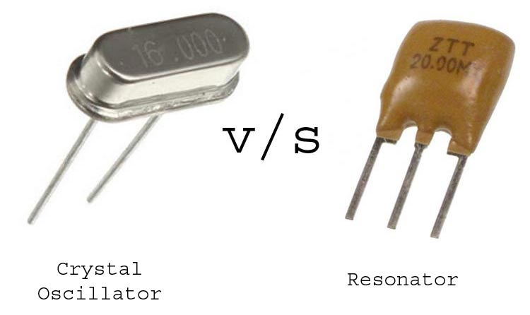

2. Interrupt method(184ms delay)
/*-- Description : Toggle LED at 184ms delay using timer0 with prescale 1024.
* F_CPU frequency is 1MHz which makes timer frequency equals 976.5625
* For the delay of 184ms timer count equals req delay*time period
* i.e. .184*976.5625 = 179.69 ~ 180 counts
* After 180 counts the timer should overflow for which TCNT0 value should be
* equal to 256 - 180 = 76
* USE OF INTERRUPT
* Date : 30th May 2020
*--*/

#define F_CPU 1000000UL
#include <avr/io.h>
#include <avr/interrupt.h>

void timer0_init_with_interrupt() {
TCCR0 = (1 << CS02) | (1 << CS00); // Prescale of 1024
TCNT0 = 76; // As calculated in Descrition
TIMSK |= (1 << TOIE0); // Enable the interrupt for timer0 overflow
}

ISR(TIMER0_OVF_vect) {
PORTB ^= (1 << PB0); // Toggle PB0
TCNT0 = 76; // Again start the connt from 76 rather than 0
// TIFR |= (1 << TOV0); Clear the overflow flag statement is commented as
// this is done automatically by ISR function
}

int main(void) {
DDRB = (1 << PB0); // Set PBO to OUTPUT
timer0_init_with_interrupt();
PORTB |= (1 << PB0);
sei(); // Enable global interrupt. This is like turning ON the
// meter box of our home electricity system. Not including this
// function is similar to keeping meter box off and we cannot turn
// on the light with individual switch.

while(1); // We have to do nothing as AVR itself detect the overflow
// and run the ISR written by us. So while loop is empty or we can
// perform other tasks inside this loop like using character LCD...

return 0;
}

For output see the video shown in the link
In the oscilloscope you can see square wave as we are toggling the output state of PB0 pin at an interval of 184ms. Can you tell me the frequency of square wave being generated? I will help you if you can’t or it will be revision for you if you can. The time period of the square wave equals 184 + 184 = 368ms as it is the sum of high and low time. Frequency being inverse of time period give the frequency of the square wave equals 1/(368*10^(-3)) = 2.72Hz.

1 second delay or more using 8-bit timer
Even the maximum prescale which is 1024 can give us some mili seconds of delay. What to do if 1 second delay is require? Lets slowly step forward.
Consider I am using AVR in 1MHz frequency. In case of timer0 I am using this frequency with prescale of 64 which means timer0 operating frequency is 1000000/64 = 15.635KHz i.e. in 1S 15635 clock pulse are generated and as 1 clock pulse equals 1 count, 15635 counts are required. But maximum of 256 count is possible in 8-bit timer. After that overflow occurs and starts to count from 0 again to overflow. This process continues as long as the AVR is on if our program does not contain code to stop it. For the second overflow to take place 512 clock pulses or counts are required considering from the beginning. Likewise additional 256 clock pulse are required for the third overflow which makes total of 768 counts. This gives us idea that the overflow count helps to acquire longer delays.
How may overflows are needed for our required delay is to be calculated and it is possible by dividing the required count by 256, considering only the integer part and neglecting the decimal part.
15635/256 = 61.07421875, considering only integer part give us 61 overflows are required for 1 sec delay.
The time delay for 61 overflows equals to 61*256*1/15635(61*256 is the count no and 1/15635 is the time period) = 0.998784778 seconds delay. This is not equal to 1 sec delay because in 61 overflows we are counting only 61*256 = 15616 counts which is (15635 - 15616) = 19 count less. To include this 19 count also we require TCNT0 register value equal to 19 after 61 overflows. This will be clear in the programming section.
To keep record of the number of overflows we require a variable. The variable should of global type as this variable is to be used inside ISR() function and may be inside while loop as well. This is not enough. The variable should be of volatile type. volatile keyword prevents compiler for modifying or simply don’t allow to be smart. As this variable is controlled by ISR() function, the compiler believes the modification is mistakenly done and don’t allow the modification without this keyword which will be undesired result in our case. volatile keyword is especially used in embedded C. You make internet your friend for more information.

/*-- Description : Toggle LED at 1s delay using timer0 with prescale 1024.
* F_CPU frequency is 1MHz which makes timer frequency equals 15625
* For the delay of 1s timer count equals req delay*time period
* i.e. 1*15625 = 15625 counts
* After 256 counts the timer overflows for the first time and second
* overflow takes place at (256 + 256) 512 counts. Counting the no of
* overflows we can have greater delays.
* No of overflows required = 15625/256 = 61.07421875.
* But no of overflows can be interger value only so 61 is the required
* no of overflows.
* After 61 overflows time count = 256* 61 = 15616.
* Remaining counts = 15625 - 15616 = 19
* Date : 31th May 2020
*--*/
#include <avr/io.h>
#include <avr/interrupt.h>

#define LED_DDR DDRB
#define LED_PORT PORTB
#define LED_PIN PB0

volatile unsigned char overflows_count = 0;
/* 'volatile' keyword is used to prevent the compiler from applying any
* optimizations on objects that can change in ways that cannot be
* determined by the compiler.
* We change the value of this variable inside ISR() function which
* compiler cannot detetect and resist to change its value. And we
* want to prevent compiler for doing this due to which 'volatile'
* keyword in compulsary.
*/

ISR(TIMER0_OVF_vect) {
overflows_count ++;

if(overflows_count == 61) {

while(TCNT0 < 19); // Wait until count reaches 19.

LED_PORT ^= (1 << LED_PIN);
TCNT0 = 0;
/*-- Description : Toggle LED at 1s delay using timer0 with prescale 1024.
* F_CPU frequency is 1MHz which makes timer frequency equals 15625
* For the delay of 1s timer count equals req delay*time period
* i.e. 1*15625 = 15625 counts
* After 256 counts the timer overflows for the first time and second
* overflow takes place at (256 + 256) 512 counts. Counting the no of
* overflows we can have greater delays.
* No of overflows required = 15625/256 = 61.07421875.
* But no of overflows can be interger value only so 61 is the required
* no of overflows.
* After 61 overflows time count = 256* 61 = 15616.
* Remaining counts = 15625 - 15616 = 19
* Date : 31th May 2020
*--*/
#include <avr/io.h>
#include <avr/interrupt.h>

#define LED_DDR DDRB
#define LED_PORT PORTB
#define LED_PIN PB0

volatile unsigned char overflows_count = 0;
/* 'volatile' keyword is used to prevent the compiler from applying any
* optimizations on objects that can change in ways that cannot be
* determined by the compiler.
* We change the value of this variable inside ISR() function which
* compiler cannot detetect and resist to change its value. And we
* want to prevent compiler for doing this due to which 'volatile'
* keyword in compulsary.
*/

ISR(TIMER0_OVF_vect) {
overflows_count ++;

if(overflows_count == 61) {

while(TCNT0 < 19); // Wait until count reaches 19.

LED_PORT ^= (1 << LED_PIN);
TCNT0 = 0;
overflows_count = 0;
}

}

void timer0_init_with_interrupt() {
TCCR0 = ((1 << CS01) | (1 << CS00)); // Start timer0 with prescale if 64
TCNT0 = 0;
TIMSK = (1 << TOIE0); // Enable timer0 overflow interrupt bit
}
overflows_count = 0;
}

}

void timer0_init_with_interrupt() {
TCCR0 = ((1 << CS01) | (1 << CS00)); // Start timer0 with prescale if 64
TCNT0 = 0;
TIMSK = (1 << TOIE0); // Enable timer0 overflow interrupt bit
}

int main()
{
DDRB = (1 << PB0);
timer0_init_with_interrupt();
sei(); // Enable global interrupt.

while (1)
;
return 0;
}

You can use the statement to increment the overflow_count variable inside the ISR() function and the remaining polling part inside the while loop. Inside while loop you don’t need to wait until TCNT0 becomes 19. You can replace the while loop with the if. But to do this the condition should be like if(TCNT0 >= 19). Although we require exactly the count of 19 but we need to use “greater than or equal” symbol. This is because the timer and the code execution are run independently. When the timer counts 19 the execution of code may be at somewhere other than this if statement. When the code execution reaches the if statement the timer count value will be other than 19 which makes if statement false and brings error. This brings some inaccuracy in delay which we should consider.
If have seen other tutorials you may find the code at the beginning of timer like

while (1) {
if(TCNT0 >= 180) {
PORTB ^= (1 << PB0);
TCNT0 = 0;
}

TCNT0 value always starts with 0 and the required count is kept inside the if statement to compare with the current TCNT0 value. This brings inaccuracy for small delays like in micro or miliseconds which avoids me to teach you this method at the beginning and use the overflow concept by changing TCNT0 value rather than starting it with 0.
See we have used both polling and interrupt method. Polling method is less accurate than interrupt by some microseconds but for greater delays microseconds inaccuracy does not affect much.

CTC mode
So far we were talking about normal mode. Its time to move another step forward in timer by knowing about CTC mode.
The AVR hardware knows when the timer count value overflows or reaches its maximum value (255 in case of 8-bit and 65535 in case of 16-bit). But for some middle value like 180, we were checking manually i.e. using software which is not so accurate. To increase accuracy, AVR timer provides a way by which the AVR hardware knows by itself when the timer count value reaches 180 or any other possible values the timer can count. The CTC(Clear Timer on Compare) mode is for this. With this, we no longer have to worry about comparing the timer count value we required. We are given a register OCR0 (for timer0) where we can provide the required time count value like 180. When the TCNT0(in case of timer0) value reaches the required time count value, the TCNT0 value clears to 0 in the next clock pulse, the flag OCF0 in the register TIFR is set as in case of overflow condition. The name CTC for this mode is because of the reason, the hardware itself compares the value

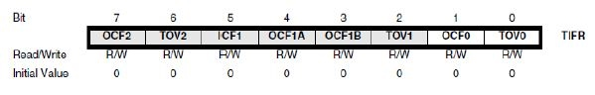
What happen is known but how to make it happen or how to use timer in CTC mode? This will be the topic for further discussion.
You may have started worrying about the registers and its bits as the course increases. I will list all the registers used for timer0 so that you know how much registers are to be known and don’t need to fear of how many new registers to come:
1. TCNT0
2. OCR0
3. TIFR
4. TCCR0
5. TIMSK
The first two registers are for count purpose so its individual bits does not worry us. We are to be aware of individual bits of the remaining three register, each register is of 8 bits which make us to know about 24 bits. Also the registers whose name ends with ‘0’ are only for timer0 and the remaining registers are common to all the three timers available in ATmega32.
To enable CTC mode we have to deal with TCCR0 register as it is control register for timer0. We are familiar with three of its bits, clocks select bits and its time to know additional two bits WGM00 (Wave Generation Mode) and WGM01.
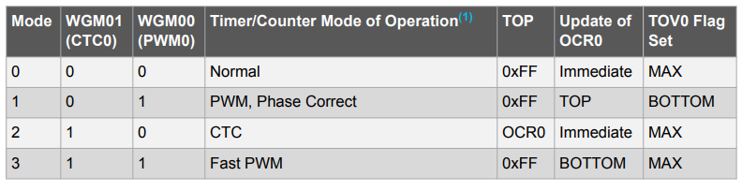

Don’t thing Mode as bit rather consider it as SN. I won’t make you clear about the last three columns for now. We are now focused to CTC mode only so setting the WGM01 bit fulfill our job. You may also be clear that doing nothing to these bits sets our timer in Normal mode.
For this also we need to calculate the required time count and the formula is similar but not same as above.
Required Delay
Time Count = ------------------------ - 1
Clock Time Period

Time Count = Required Delay*Frequency - 1
(Frequency is inverse of time period)

Reply to inclusion of “- 1” in formula of time count
Finally it is where I will explain why “- 1” is added in the formula. Suppose without considering “- 1”, we require time count of 180. If we set the OCR0 value to 180 then TCNT0 value reaches to 180, the hardware detects the match between TCNT0 value and OCR0 value. After the next clock pulse TCNT0 value is cleared to 0 and the OCF0 bit is set in the TIFR register. Although we require 180 clock pulse but 181 time count is consumed by hardware to detect the match. Simply understand that hardware takes one extra clock pulse to clear the TCNT0 value after match like in the case of overflow where it takes once extra clock pulse to become 0 from 255. To balance this extra clock pulse we decrement the time count value by one.
You may still be in confusion that why we don’t consider “- 1” in our previous formula. The reason is that 255 counts are possible for 8-bit timer but we have considered 256 counts possible. One extra count is for the TCNT0 value to become 0 from 255

Playing with hardware to test CTC mode
Blink LED at the delay of 20ms at 4MHz frequency
Before starting coding or connect hardware if you have, you first need to choose the prescale, calculate the required time count. Let’s do it first.
We are dealing with timer0 for now so no need to decide for which timer to use but there are situations when you need to decide which timer to use.
Prescale | Frequency(4MHz/Prescale) | Time Count (Required delay * Frequency -1)
8 | 500000 | 9999
64 | 62500 | 1250
256 | 15325 | 312.5
1024 | 3906.25 | 78.125

To have exact time delay you should choose prescale such that time count value is purely integer. . So we can either choose 8 or 64 as prescale but timer0 can’t count up to that value. This is the case where you required timer1 which can count up to 65535. Note that if time count is less than 256 then its best to use timer0 than timer1 as timer0 provides less load to the AVR since our AVR being 8-bit can process only 8-bit at a time. To process 16-bit data like timer1 count value the AVR splits it into two 8-bit value and process one by one. We are forced to choose prescale of 1024 despite of its inaccuracy as we are dealing with timer0. Time count in this case is 78, considering integer part only.
I’ve missed one thing to inform you i.e. like TOV0 flag in the TIFR register when set indicates overflow, OCF0(Output Compare Flag 0) in the same register when set indicates compare match took place. And the parameter to be passed inside the ISR() function for this case is “TIMER0_COMP_vect”. With this information you are ready to program yourself. You can either check the flag manually or use interrupt method. I will choose interrupt method to demonstrate you.

/*-- Description: Toggle the state of PB0 at each 20ms time using CTC
* mode of timer0
* Date: 3rd June 2020
* --*/

#include <avr/io.h>
#include <avr/interrupt.h>
#define F_CPU 4000000UL // If you can change the fuse bits set the
// AVR frequency to 4MHz otherwise do calculate for 1MHz and operate
// like this
#include <util/delay.h>

#define LED_PORT PORTB
#define LED_PIN PB0

ISR(TIMER0_COMP_vect) {
LED_PORT ^= (1 << LED_PIN);
}+

void timer0_setup() {
TCCR0 = ((1 << CS02) | (1 << CS00) | (1 << WGM01));
TCNT0 = 0;
OCR0 = 78;
TIMSK = (1 << OCIE0);
sei();
}

int main() {
LED_DDR = (1 << LED_PIN);
DDRB = (1 << PB1);
timer0_setup();

while(1) { // The code inside while loop is just to show that timer runs
// independent of AVR cpu and can perform any task as required
// while the timer is doing its job. For now I’m blinking LED at PB1.
PORTB ^= (1 << PB1);
_delay_ms(1000);
}

return 0;
}

If you see the video demo for this code then you must notice that LED remains off all the time. This is because of a mistake in the code. The mistake is at the second statement inside main. I should have writ “DDRB |= (1 << PB1). The missing of ‘|” has made everything wrong. This is related to bit twiddling. The missing of this “|” made PB0 or LED_PIN as input. It was done by me unknowingly which took me a lot of time to debug. Then instead of correcting it myself I believe it best to show you the incorrect result, tell its consequences and made you to correct yourself so that you don’t need to spend time in debugging such problem in future.

Get Rid of ISR routine as well
We are still not at that point where we could use the timer totally independent of AVR CPU. For example you are using your own mobile and your friend is using his’/her’s then you both can use mobile phone without disturbing each other once also. We want to make timer operation and AVR CPU relation like that, both can operate their task parallelly. ISR() function does not allow us that so we should get rid of this in order to do so and learn few more new things.
COM00 and COM01, have you seen it somewhere? Yeah but probably may not have noticed. They are one of the bits available in TCCR0 register, have a look.

These bits control the Output Compare pin(OC0) behaviour. OC0 pin, can you find this pin? If not you surely will find the PB3 pin in ATmega32, this is OC0 pin. This pin can perform multiple function. It can be used as PB3 or OC0 or even AIN0 but we won’t talk about this. Consider this like multimeter which can be used as voltmeter, ammeter, ohmmeter or more depending on its configuration done by us. How to choose between PB0 and OC0. COM00(Compare Match Output Mode) and COM01 bits play the role for it.

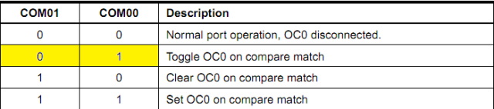

Initially these bits are 0 due to which this pin functions as PB0. Any changes to this bit will enable the pin as OC0.( Notice one thing that to use as OC0, you must set it to OUTPUT mode in DDRB register.) Here compare match indicates TCNT0 value equals to the value provided by us in OCR0 register. The above table is true for not only CTC mode but works for normal mode as well. But they have some differences which will be shown below.
The time vs TCNT0 graph for CTC mode is as shown below:
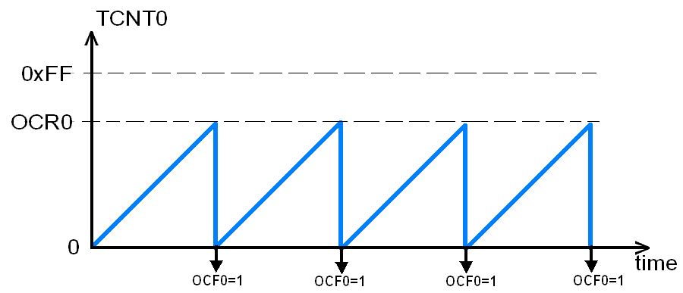
You can clearly see that TCNT0 value is cleared when reaches OCR0 value and can’t go above that despite the timer has capacity up to 255 count. So the top value, which is the value up to which TCNT0 can count in this case is equal to OCR0 where as maximum value of TCNT0 is 255. But in normal mode, top value equals the normal mode as timer continues to count up until it reaches the maximum value.
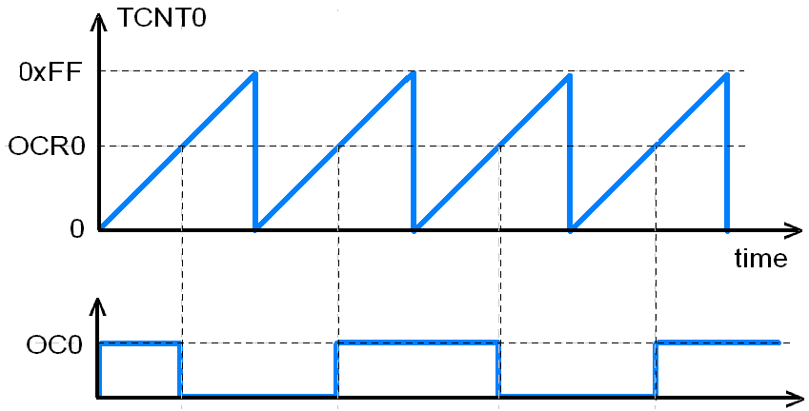
The difference between normal mode and CTC mode exits at the toggle OC0 case i.e. set COM00 bit. At each compare match the logic state (HIGH and LOW or 0 and 1 or 0V and 5V)of OC0 pin is changed. This generates square wave. Note AVR being digital, can generate square wave only. When we talk about wave it has certain frequency.
The TCNT0 value vs time graph and the equivalent square waveform generated for the two modes is observed like below.

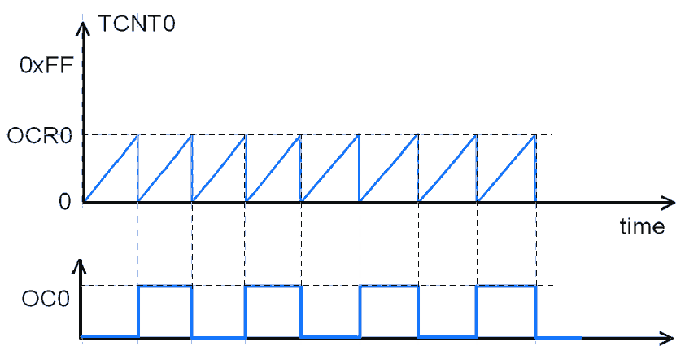
It should not be necessary to tell you which one is normal mode and CTC mode.
Can you calculate the frequency of the square wave in normal mode? You may can but first I’ve to provide some information about frequency of the timer which I considered to be 16MHz. This should be enough. Try on your own or follow me if you are confused.

Timer Frequency = 16MHz
Time period (for single time count) = 1/16*10^(6) = 0.0625us
Time period of the square wave = 2*256*0.0625us = 32us (as time period is the sum of ON as well as OFF time so we multiply by two)
Frequency of square wave = 1/32us = 31.25KHz

For CTC mode,
Time period of the square wave = 2*(OCR0+1)*0.0625us

The frequency of the wave generated by CTC mode can be controlled by changing the OCR0 value but the frequency remains same as long as the timer frequency is constant in case of normal mode.
`
Demonstration of square wave generation using CTC mode (Coding without ISR())

/*-- Description: Toggle the state of OC0 at each 20ms time using CTC
* mode of timer0 completely by hardware itself i.e. disabling the
* GPIO pin PB3 and enabling OC0 which is another functionality of that
* pin.
* The frequency of the square wave so generated is equal to 1/(20+20)
* = 25Hz
* Here no interrupt is necessary. The timer is performing its job and
* the AVR cpu other jobs independently or say parallelly.
* Date: 3rd June 2020
* --*/

#include <avr/io.h>
#include <avr/interrupt.h>
#define F_CPU 4000000UL
#include <util/delay.h>

#define LED_DDR DDRB
#define LED_PORT PORTB
#define LED_PIN PB3 // Actually we are using OC0

void timer0_setup() {
TCCR0 = ((1 << CS02) | (1 << CS00) | (1 << WGM01) | (1 << COM00));
// prescale of 1024, CTC mode and toggle OC0 on compare match
TCNT0 = 0;
OCR0 = 78; // For 20ms delay.
}

int main() {
LED_DDR =(1 << LED_PIN);
DDRB |= (1 << PB1);

timer0_setup();

while(1) { // The code inside while loop is just to show that timer runs
// independent of AVR cpu and can perform any task as required
// while the timer is doing its job. For now Im blinking LED at PB1.

PORTB ^= (1 << PB1);
_delay_ms(1000);
}

return 0;
}

The task for you is to do the same for normal mode by configuring the WGM00 and WGM01 to 0. This will change the frequency of square wave. Include the frequency of the wave so generated in the description.

Duty Cycle Control in AVR
Duty cycle is the ratio of time during which a clock signal is high to its total time period. It is generally expressed in terms of percentage.

ON time of clock signal
Duty cycle = ----------------------------------*100%
Time period of the clock

For the above case where OCO pin toggles after each 20ms, the duty cycle is (20ms/(20ms + 20ms))* 100% = 50%. Till now we have generated the square wave of 50% duty cycle. I will show you the program with duty cycle other than 50%. First see the waveform we will generate and then straight forward to program.

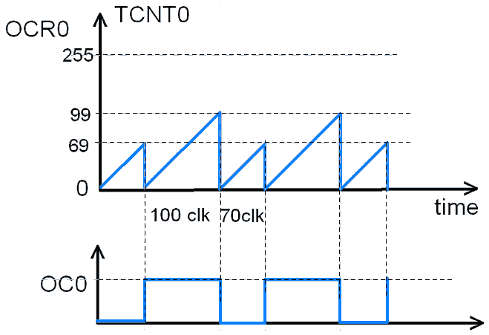

/*-- Description: Changing the duty cycle by changing the OCR0 value with in the
* program.
* F_CPU frequency = 1MHz = Timer frequency
* Time period of one count = 1us
* Time period of square wave = ON + OFF time = 70*1us + 100*1us = 170us
* This ON time (70us) is achieved by providing OCR0 value equal to 69 (70-1) and
* setting TCCR0 value such that it operates in CTC mode, set on compare match
* and no prescale.
* For OFF time OCR0 value equals 99, TCNT0 is configured in CTC mode, clear on
* compare match, no prescale.
* Frequency of square wave = 1/170us = 5.88KHz
* Duty cycle = (70/170)*100% = 41.18%
* Date: 5th June 2020
*--*/

#include <avr/io.h>
#define F_CPU 1000000UL

int main(void) {
DDRB = (1 << PB3); // Set PB3(OC0) as output

while(1) {
OCR0 = 69;
TCCR0 = (1 << CS00) | (1 << WGM01) | (1 << COM01) | (1 << COM00);
// No prescale, CTC mode, set on match
while (!(TIFR & (1 << OCF0))); // Wait until OCF0
// flag is set
TIFR = (1 << OCF0); // Clear OCF0 flag
OCR0 = 99;
TCCR0 = (1 << CS00) | (1 << WGM01) | (1 << COM01);
while (!(TIFR & (1 << OCF0))); // Wait until OCF0
// flag is set
TIFR = (1 << OCF0); // Clear OCF0 flag
}

return 0;
}

Do you have any confusion that using timer such way is fully independent of AVR CPU but we are controlling it through while loop? Its still true that the operation is independent of AVR CPU. The output of the OC0 pin is becoming HIGH and LOW but you can’t see any code like “PORTB = (1 << PB3);”, we are just configuring the hardware and remaining job is done by hardware itself. So understand like this, the timer setup can be changed any time from the program and the timer performs the task according to the setup itself without aid of CPU.

Motor Control/Digital Way of Sending Analog, PWM
Most of you want to learn AVR timer in order to control the motor speed in your project or control LED brightness. This is the portion you are actually interested in but you can’t dive directly here if you don’t have the knowledge provided in the above pages. If you are known to timer and you want revision for you motor control then jumping straight to this portion may work. The above discussed topics includes timer concepts, prescalers, interrupts, CTC mode etc.

