---------- ------------------------------------------------------------------------------------------------------------------------------- WEATHER APP

**INDEX**

**Chapter – 1**

**Introduction**

* 1. Purpose
  2. Scope
  3. Technologies to be used

**Chapter – 2**

**Overall Description**

2.1) Goal of Purposed System

2.2) Requirements of Project

**Chapter- 3**

**Feasibility Study**

3.1) Technical feasibility

3.2) Operational Feasibility

**Chapter – 4**

**Project Snapshots**

4.1) GUI Interface & Coding

1.**Introduction**

**1.1** ) Purpose

. The Software is used to provide weather information of any area in the world.

**1.2)** Scope

It can be used on any android mobile handset.

**1.3)** Technologies to be used

This Project will be a mobile application to be developed on xamarin packages using visual studio 2017,C# programming language.

Application is integrated with Openweathermap.org via API integration

**2.Overall Description**

**2.1) Goal of Purposed system**

**Accuracy :** The level of accuracy of information about weather is high.

**Easy to operate:** Application has smart GUI interface and it provide two options to get weather information, user can either enter a city name or pin code to retrieve the weather information.

**2.2) Project Requirements**

**System Specification:**

. I3 Processor

. 8GB RAM

**Operating System and Software:**

**.** Windows 10 64Bit

. Visual studio 2017

. Programming language C#

. xamarin package integrated with visual studio

**Third Party weather API:**

**.** Openweathermap.org/api

3.**Feasibility Study**

**3.1)** Technical feasibility

Application can be deployed and run on Android 5 & higher versions. Application integrated with third party openweathermap.org api and successfully parse json format data.

**3.2)** Operational feasibility

To use openweathermap.org API a API key is generated that’s freely available for development and testing purpose.

**4. Project Snapshots**

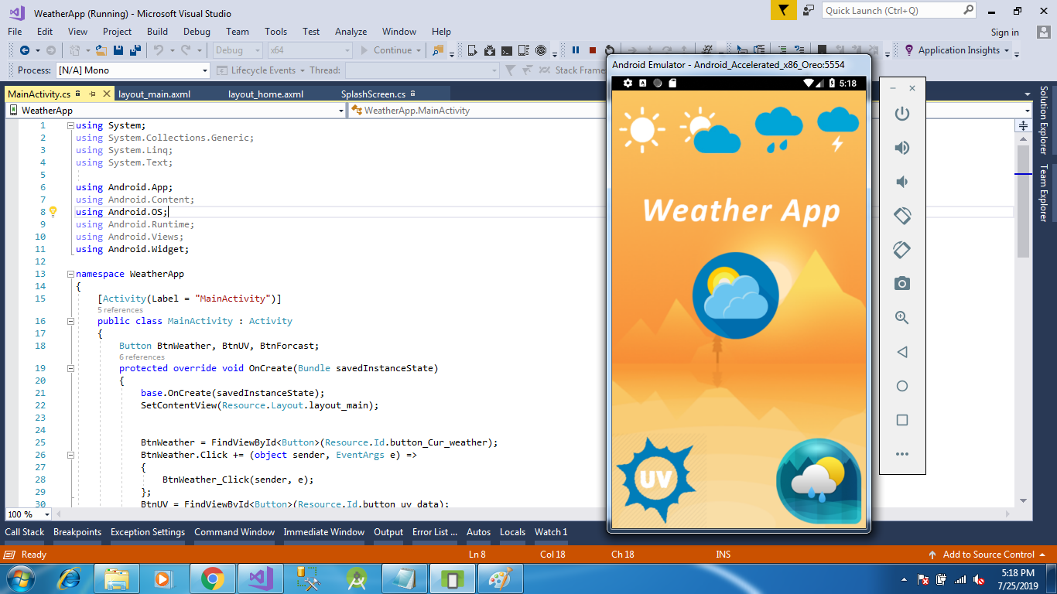

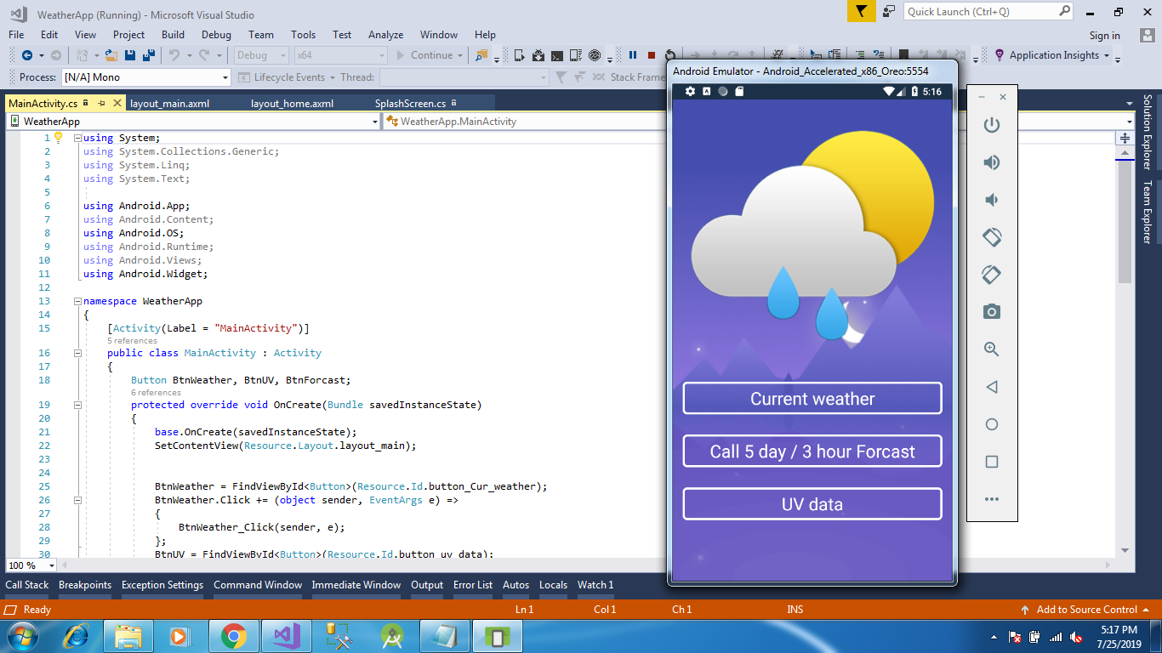

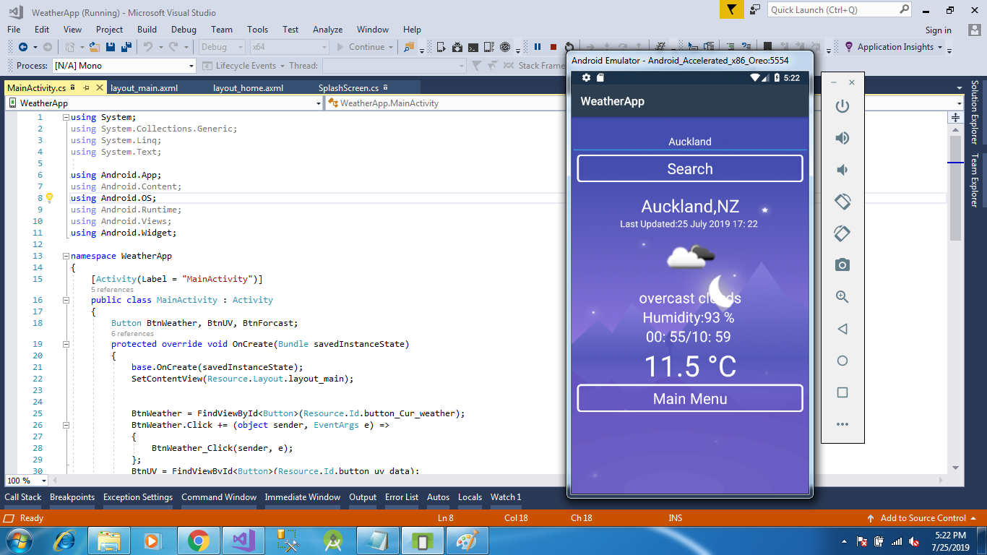

**Project Time Deviation (20 days)**

|  |  |
| --- | --- |
| From Date – To Date | Task |
|  | Feasibility Study |
|  | Requirement Gathering |
|  | Designing |
|  | Coding |
|  | Testing & Implementation |