Assignment-1
Ravi Shrimal
15110102

Introduction:
In this assignment we are performing PCA for dimensionality reduction on a data base.
Principal component analysis (PCA) is a statistical procedure that uses an orthogonal transformation to convert a set of observations of possibly correlated variables into a set of values of linearly uncorrelated variables called principal components (or sometimes, principal modes of variation).
Data Set:
The data set used is the Iris flower data set. It is a multivariate data set. The data set consists of 50 samples from each of three species of Iris (Iris setosa, Iris virginica and Iris versicolor). Four features were measured from each sample are:
- Sepal length
- Sepal width
- Petal length
- Petal width

Pseudo code:
- Load the data set using pandas (python library) .
- Compute the covariance matrix.
- Now perform an eigenvalue decomposition on the covariance matrix.
- Choose two eigenvectors with the highest eigenvalues.
- Compute the projection matrix which will be used to transform the Iris data onto the new feature subspace.
- Plot the projection matrix.

Result:
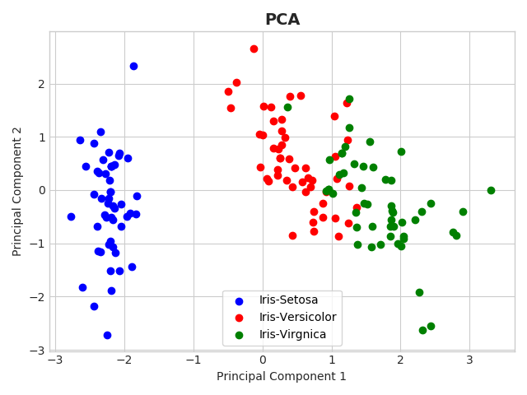

References:

- https://archive.ics.uci.edu/ml/datasets/iris
- https://en.wikipedia.org/wiki/Principal_component_analysis

