Assignment-2
Signal Detection
Ravi Shrimal
15110102

Introduction:
An important problem in sonar and radar is to be able to determine when an object, such as a submarine in sonar or an aircraft in radar, is present.A digital computer is used to sample the received waveform in time and store the samples in memory for further processing.If there is no reflection, this means nothing is present and received signals consist
Of noise only. However,if, there is a reflected pulse,the received samples will consist of a signal added to the noise.

Brief Derivation:

We denote the received samples as X₁, X₂,... , X_{N}.
For noise only, we assume:
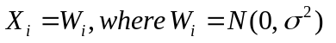
For signal plus noise:
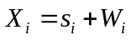
The noise samples W_{i} are assumed to be IID.

With this modeling we can formulate the signal detection problem as the problem of deciding between the following two hypotheses.

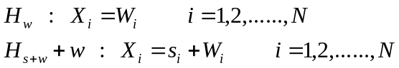
We decide a signal present if.
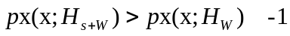
Assumption: As an example, assume that the signal is a "DC level" pulse or 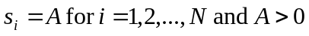
From 1 and this assumption we will get :
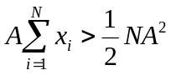
and since A > 0, we decide a signal is present if

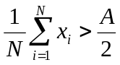
I have chosen 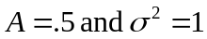.
Result:
By comparing the sample mean to the threshold of A/2 = 0.25 we should be able to decide if a signal is present or not most of the time.

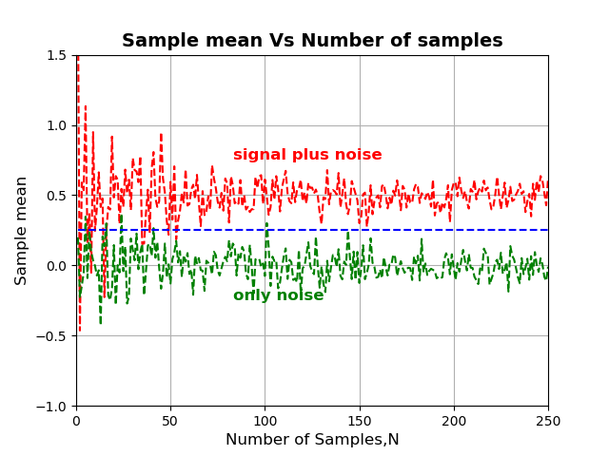

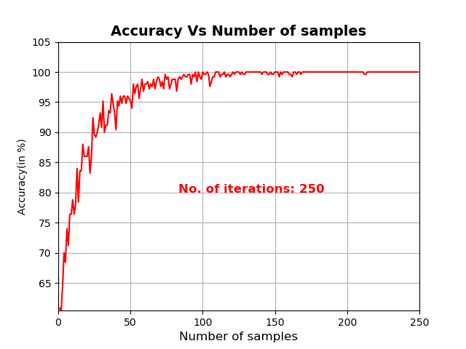
Reference:
- INTUITIVE PROBABILITY AND RANDOM PROCESSES by STEVEN M. KAY
- https://en.wikipedia.org/wiki/Detection_theory
- Class notes by Prof: Shanmuga R

