Assignment - 2
Implementation of Iterative Closest Point technique
Ravi Shrimal
15110102

Introduction:
Given two 3D point clouds (RGB-D), the task is to design a technique using Iterative Closest Point (ICP) to jointly estimate the point correspondences as well as the global rotation matrix and the translation vector. In the Iterative Closest Point or, in some sources, the Iterative Corresponding Point, one point cloud (vertex cloud), the reference, or target, is kept fixed, while the other one, the source, is transformed to best match the reference. The algorithm iteratively revises the transformation (combination of translation and rotation) needed to minimize an error metric, usually a distance from the source to the reference point cloud, such as the sum of squared differences between the coordinates of the matched pairs.

Dataset:
Dataset is provided by the course TA Mr. Gagan Kanojia.

Pseudo Code
- First read the two images and their depth map in matlab.
- Find the corners.
- Extract the neighborhood features.
- Match the features
- Retrieve the locations of the corresponding points for each image.
- Now we have two sets of data points. Lets call them p and q.
- Also compute the weight vector w
- Let p be the set which we have to transformed and q be the reference or target data set.
- Compute the weighted centroids of both the sets
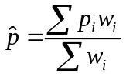
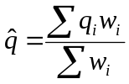
- Compute
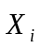 and 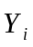
for i = 1,2....n,
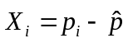
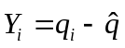
- Compute
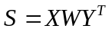

- Compute singular value decomposition of S
S = U∑V^{T}
- Compute optimal rotation matrix R*
- Compute optimal translation vector t*
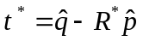
14) Compute
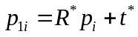
for i = 1,2....n.
- Now for every data point in this new set calculate the distance with each point in the q data set and the point in the q which has minimum will be the new matching point for that point.
- Again compute the weight vector and iterate couple of times(3 or 4) and return the optimal rotation matrix and optimal translation vector.
- At the end form the apply the rotation matrix and translation vector on the first image and its depth map and display the result.

Result:

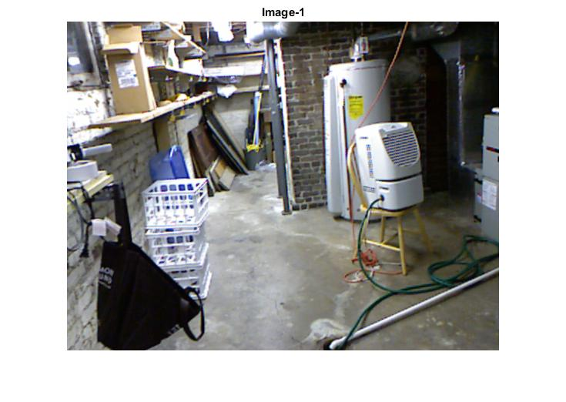
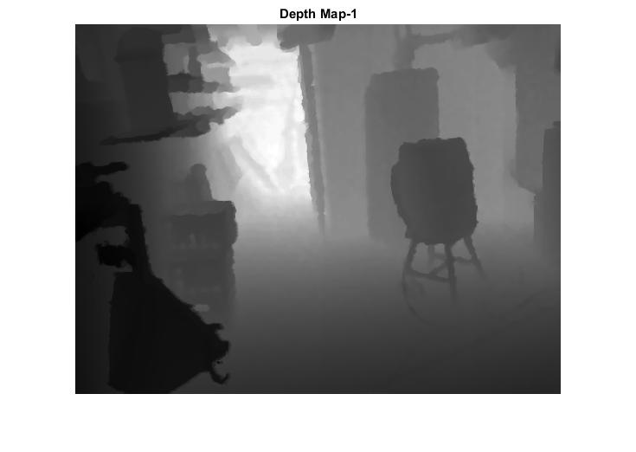
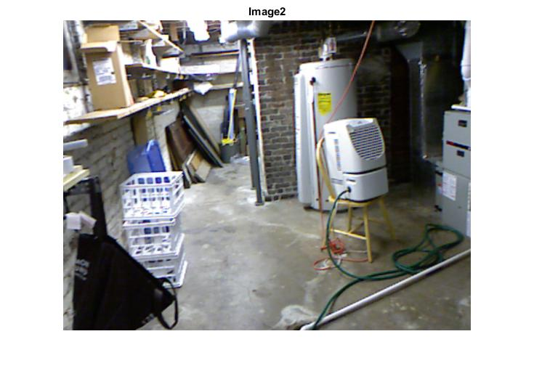
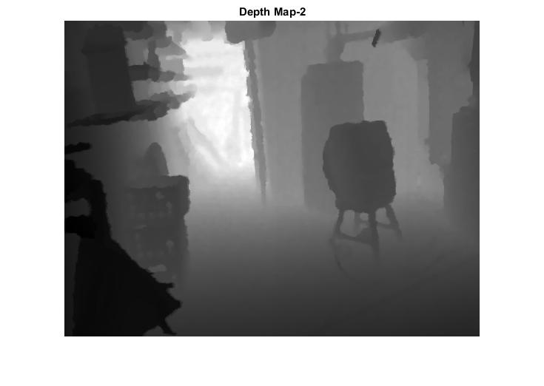
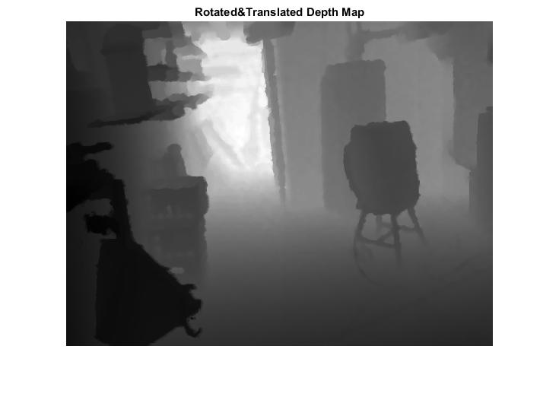
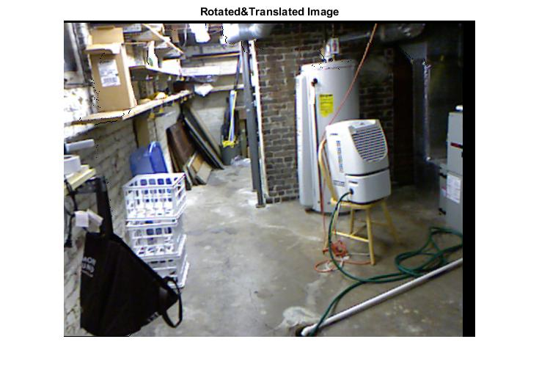
Reference:
- Prof Shanmuga R Notes (posted on google classroom).
- https://en.wikipedia.org/wiki/Iterative_closest_point
- https://in.mathworks.com/help/vision/ref/matchfeatures.html

