Assignment - 3
Optical Flow
Ravi Shrimal
15110102

Introduction:
Optical flow or optic flow is the pattern of apparent motion of objects, surfaces, and edges in a visual scene caused by the relative motion between an observer and a scene. The optical flow methods try to calculate the motion between two image frames which are taken at times t and 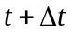 at every voxel position. These methods are called differential since they are based on local Taylor series approximations of the image signal; that is, they use partial derivatives with respect to the spatial and temporal coordinates.

For a 2D+t dimensional case (3D or n-D cases are similar) a voxel at location (x,y,t) with intensity I(x,y,t) will have moved by Δx ,Δy and Δt between the two image frames, and the following brightness constancy constraint can be given:
Using Taylor series :
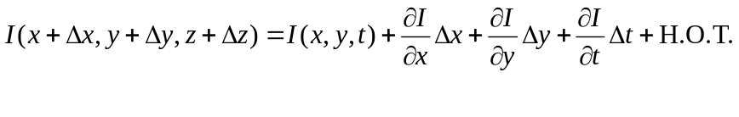
which results in :-
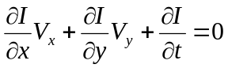
Where V_{x} ,V_{y} are the x and y components of the velocity or the optical flow of I(x,y,t).
Thus:
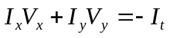
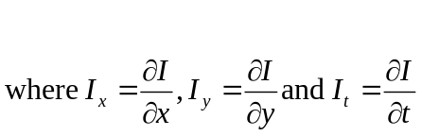
Methods for determination:
- Horn Schunck method:
The Horn-Schunck algorithm assumes smoothness in the flow over the whole image. Thus, it tries to minimize distortions in flow and prefers solutions which show more smoothness.
The flow is formulated as a global energy functional which is then sought to be minimized. This function is given for two-dimensional image streams as:
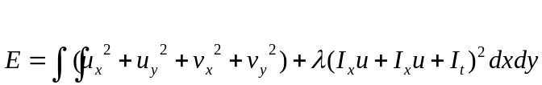
Where are the derivatives of the image intensity values along the x,y and time dimensions respectively.
The functional can be minimized by solving the associated multi-dimensional Euler-Lagrange equations. From which we will get:
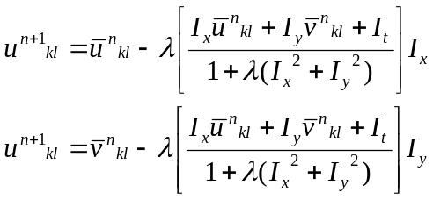
where the superscript k+1 denotes the next iteration, which is to be calculated and k is the last calculated result.
- Lucas-Kanade method
The Lucas–Kanade method assumes that the displacement of the image contents between two nearby instants (frames) is small and approximately constant within a neighborhood of the point p under consideration. Thus the optical flow equation can be assumed to hold for all pixels within a window centered at p. Namely, the local image flow (velocity) vector (V_{x},V_{y}) must satisfy:
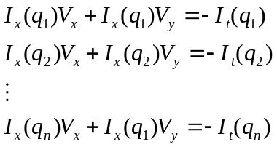
Where q₁,q_{2,.....,}q_{n} are the pixels inside the window, and I_{x}(q_{i})I_{y}(q_{i}),I_{x}(q_{i}) are the partial derivatives of the image I with respect to position x,y and time t,evaluated at the point q_{i} and at the current time.
Data Set:
Data set is taken from vision.middlebury.edu
Result:
1) Horn Schunck method:
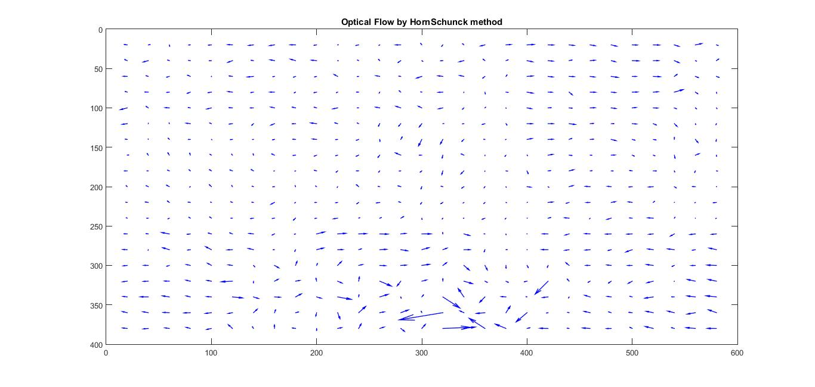
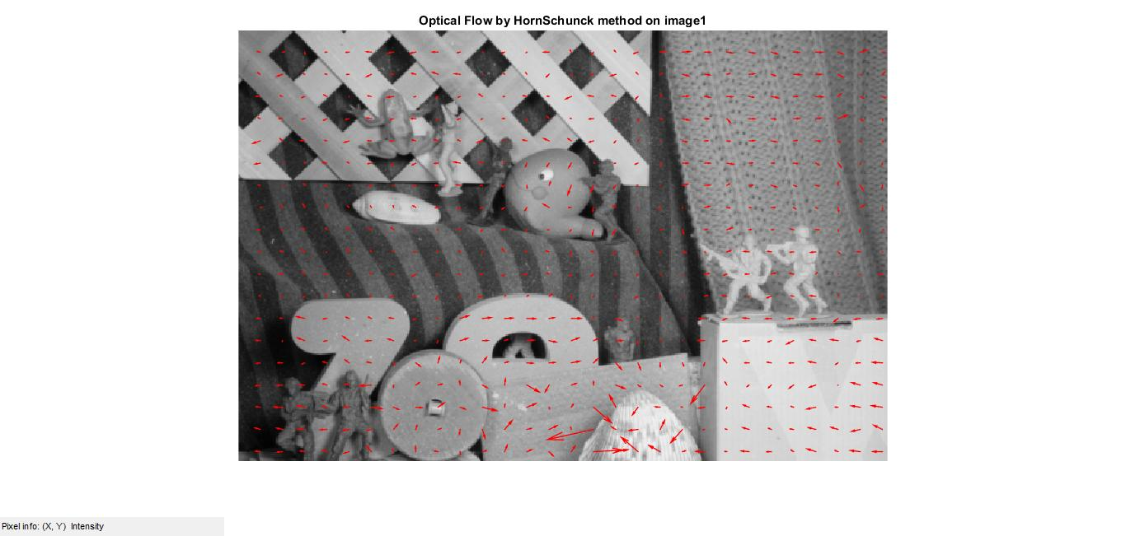
- Lucas Kanade method :
- 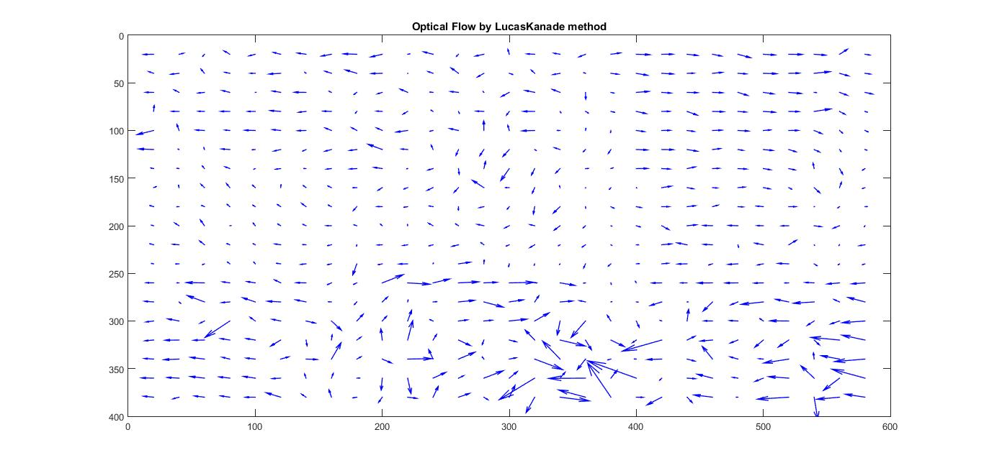
Reference:
- Class notes by Prof: Shanmuga R
- https://en.wikipedia.org/wiki/Lucas%E2%80%93Kanade_method
- https://en.wikipedia.org/wiki/Horn%E2%80%93Schunck_method
- https://en.wikipedia.org/wiki/Optical_flow
- http://vision.middlebury.edu/flow/data/

