Assignment-4
Over-segmentation using Normalized Cuts.
15110102
Ravi Shrimal

Introduction:
The image segmentation problem is concerned with partitioning an image into multiple regions according to some homogeneity criterion. The set of points in an arbitrary feature space can be represented as a weighted undirected complete graph G = (V, E), where the nodes of the graph are the points in the feature space. The weight w_{ij} of an edge (i,j) ϵ E is a function of the similarity between the nodes i and j. In this context, we can formulate the image segmentation problem as a graph partitioning problem that asks for a partition V₁,.....,V_{k} of the vertex set V, where, according to some measure, the vertices in any set V_{i} have high similarity, and the vertices in two different sets V_{i},V_{j} have low similarity.

Algorithm for normalized spectral clustering :
- Construct a similarity graph from the input image.
- Let W be its weighted adjacency matrix.
- Compute the unnormalized Laplacian L.
- Compute the first k generalized eigenvectors u₁,u_{2,}.......u_{k} of the generalized eigenproblem Lu = λDu.
- Let U ϵ R^{nxk} be the matrix containing the vectors u_{1,}. . . . .u_{k} as columns.
- For i = 1 to n, let y_{i} ϵ R^{k} be the vector corresponding to the i-th row of U.
- Cluster the points (y_{i})_{i = 1,.....,n} in R^{k} with the k-means algorithm into clusters C₁, . . . . . C_{k} .
Output: Clusters A₁, . . . . . .A_{k} with A_{i} = {j| y_{j} ϵ C_{i}}

Result:

Original Input Image
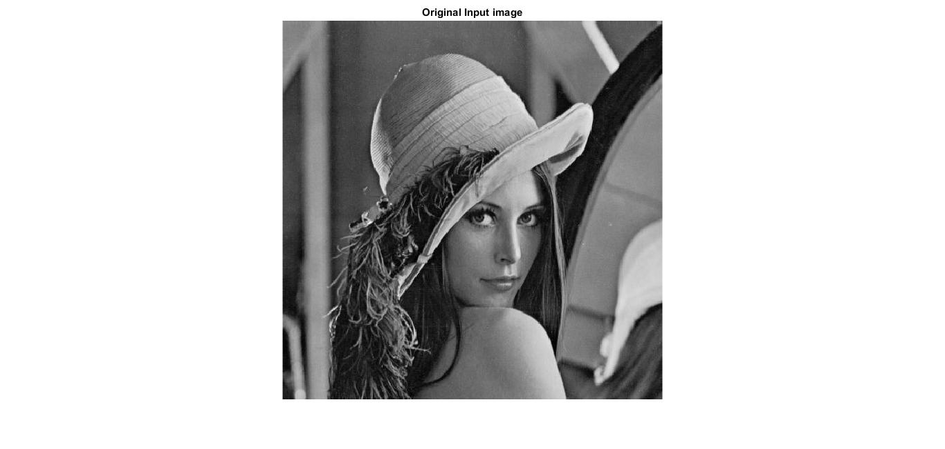

Input resized image
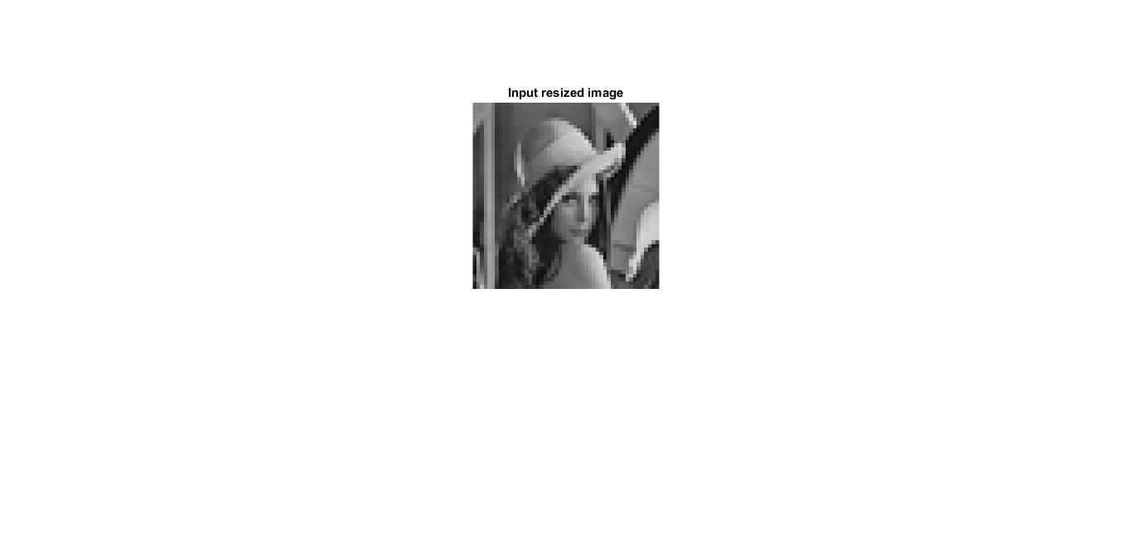

Clusters
No. Of clusters = 10

Reference:
- Classnotes by Prof: Shanmuga R
- https://people.eecs.berkeley.edu/~malik/papers/SM-ncut.pdf
- https://en.wikipedia.org/wiki/Segmentation-based_object_categorization

