AIML PROJECT

GROUP MEMBER:

Ashish Kr. Verma -- AP22110020005 Rudra Pratap Singh -- AP22110020045

# Project title:

Food Reorder Prediction: Analyzing Feedback

# Problem statement:

The objective of this project is to utilize the provided dataset features to predict whether a customer is likely to reorder food or not based on their feedback.





Features of dataset:

**the age of the customer marital status of the customer occupation of the customer**

**monthly income of the customer educational qualification of the customer family size of the customer**

**latitude and longitude of the location of the customer pin code of the residence of the customer**

**did the customer order again (Output)**

**Feedback of the last order (Positive or Negative)**







Analysis of the data set

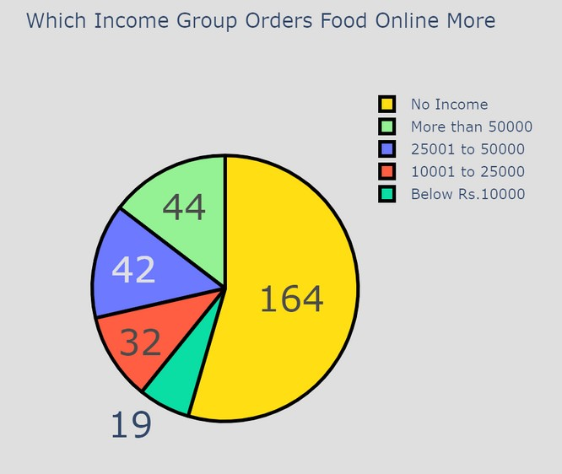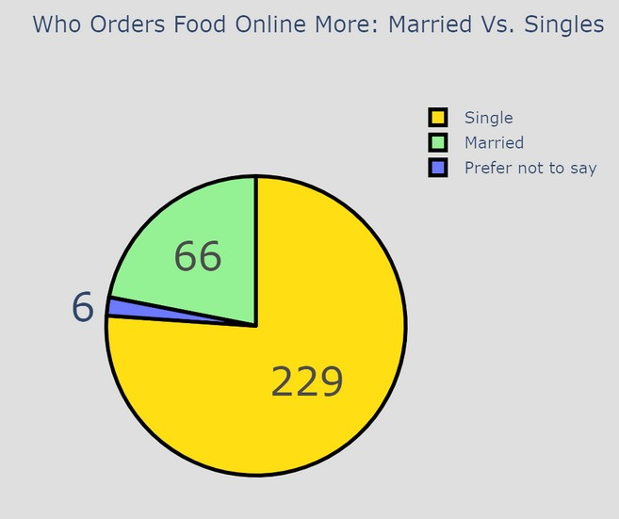

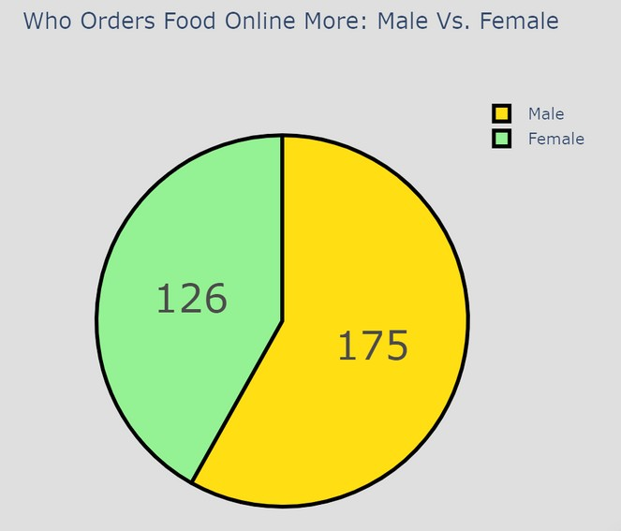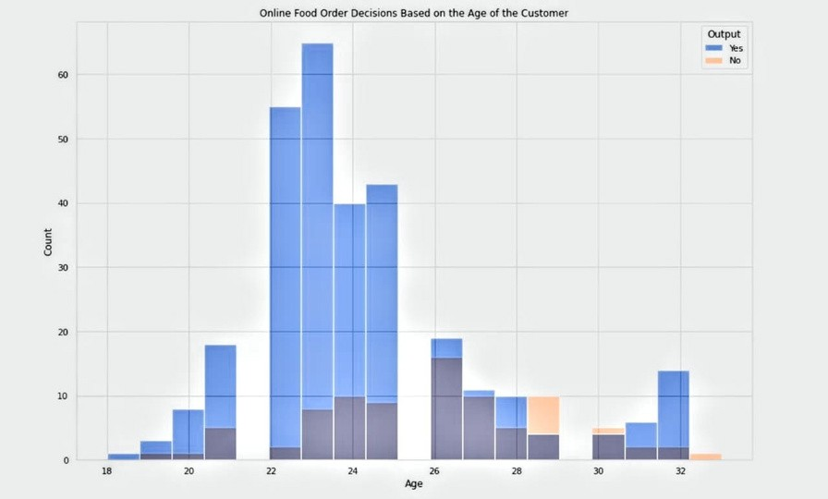

classification report: Class-wise Performance Metrics

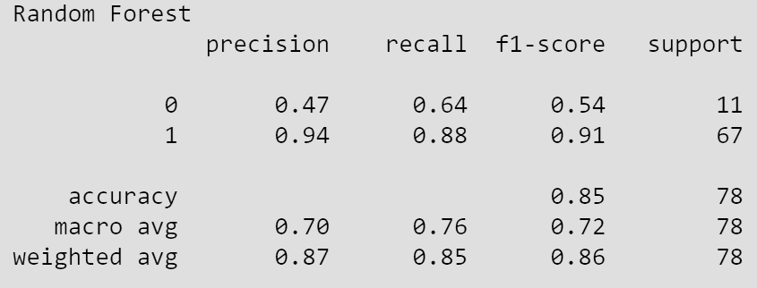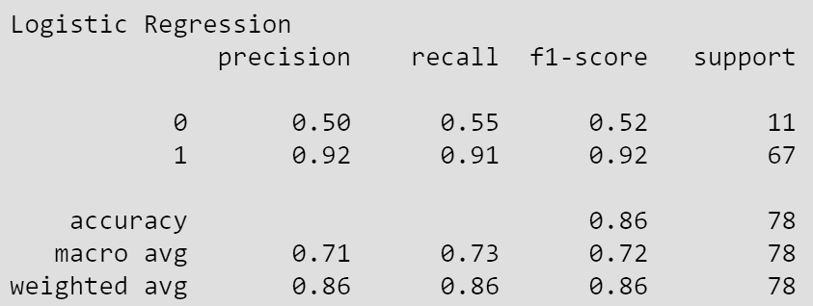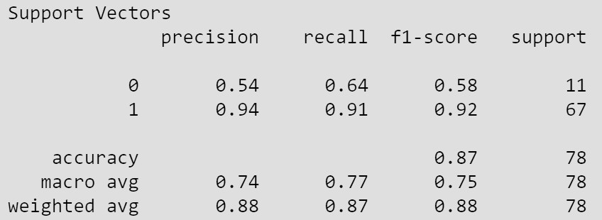

Accuracy percentage of the models :

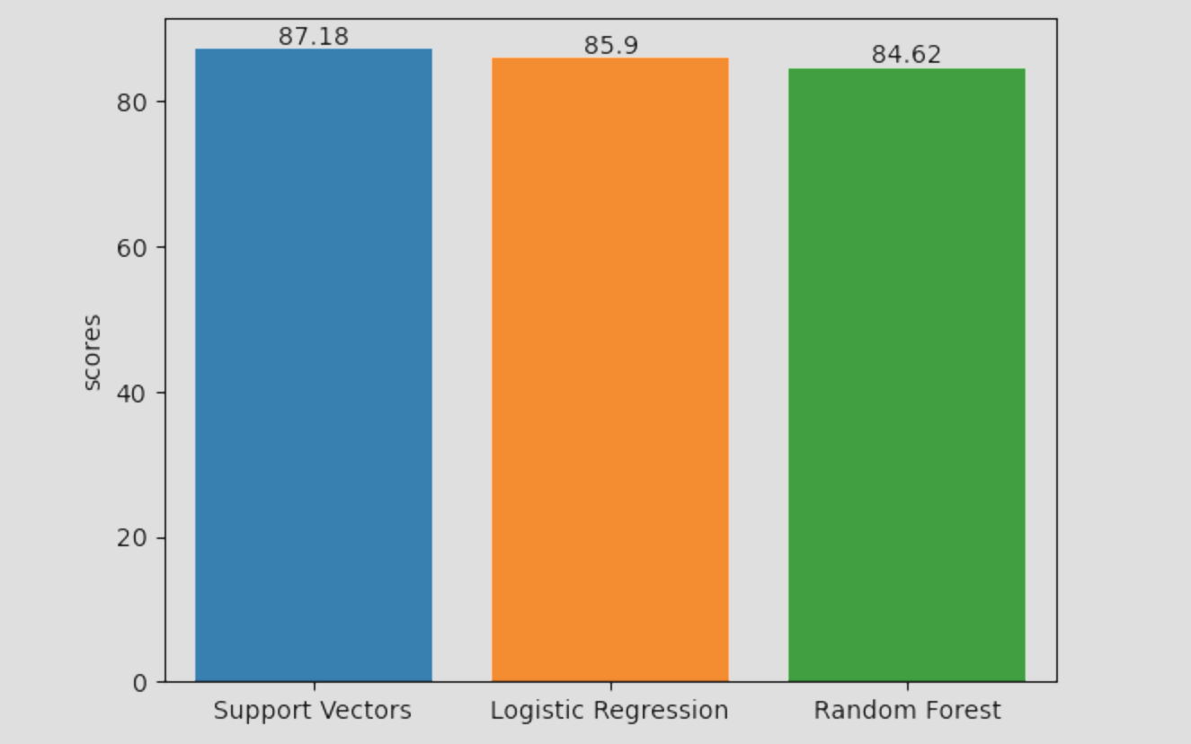

The user is required to respond to the following inquiries in order to obtain the prediction:

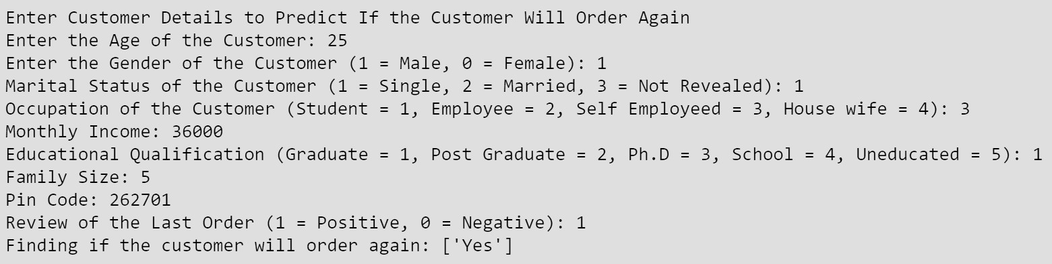

Nobility of our project:

accuracy of the available sources:

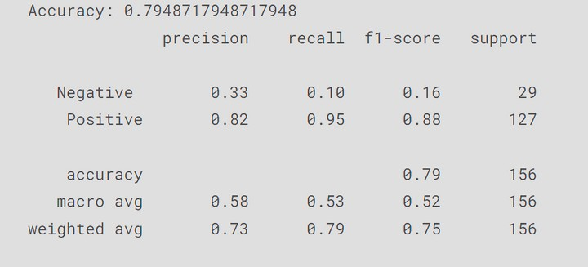LogisticRegression: 79%

SVM:84%

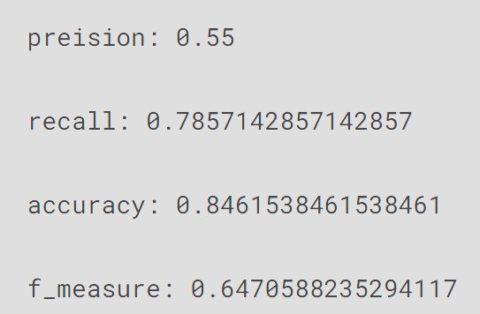

Random forest:85



WebPage

