Agenda:
1.Need of messaging systems
2. Apache Kafka Introduction
3. Kafka Terminology
4. Apache Kafka Use cases
5. Apache Kafka Installation
6. Kafka integration with Spring boot

With our daily actions data is generated. Kafka is used for data storage.
If already data base is there, then why Kafka used for data storage?
Data is generating continuously while chatting. That is called data stream.
Event streaming: Continuously real time data capturing from event source (WhatsApp, Facebook, database, mobile device, cloud service etc…) , storing and analysis for our business operations is called event streaming.
How whatever I have searched on flipkart is displaying in the facebook as a advatisment? That is called message que are used. Apached kafka is used between flipkart and facebook. Flipkart will give your data to apache kafka and apache kafka will your data to facebook.
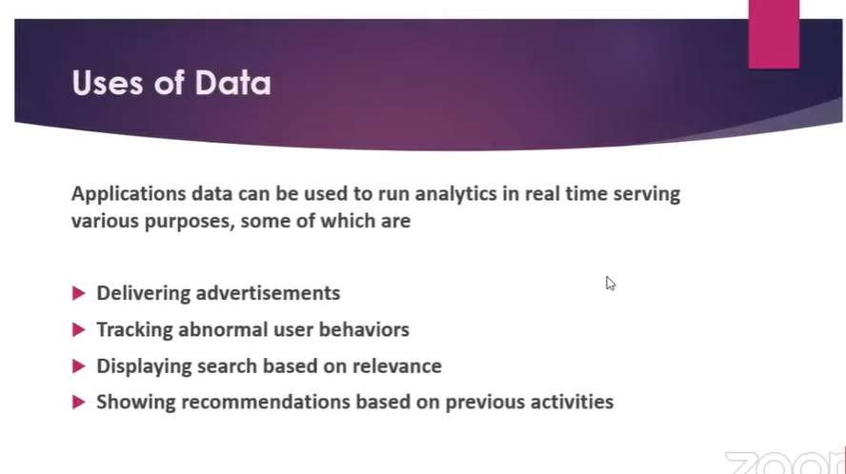
How to share data from one application to another application.
Establish a data pipeline between one to one or one to many apps. That will becomes very difficult.
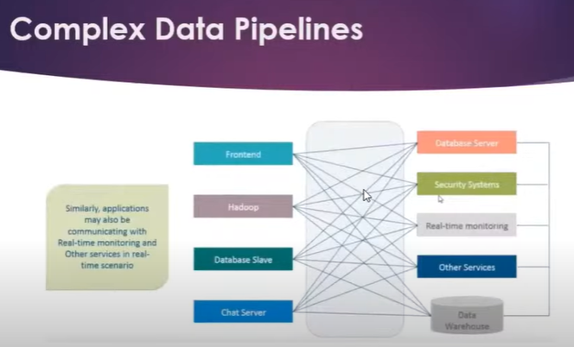
To overcome this problem messaging system came into picture in our apps.
Not possible to establish the connections between multiple apps like below—
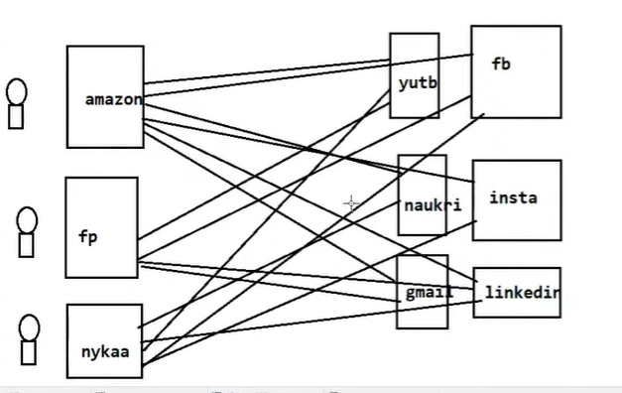
To overcome this problem use messaging que.
