**Robert Stewart**  **3/29/2024**

**Module 2.2**  **Visual Paradigm**

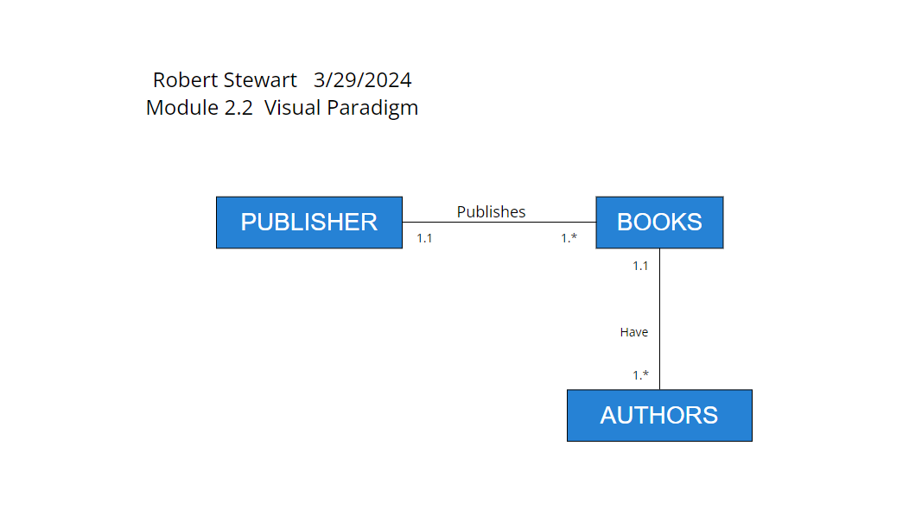

*Added - Done in Workbench

