# Robert Stewart 6/1/2024

# Module 1 Assignment 1.2

# GitHub Repository Setup

GitHub Repository Link:

<https://github.com/rs691/csd-340.git>

Screenshot of your local directory (properly formatted):

*\*Created module directories ahead of time*

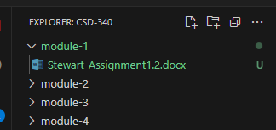

Screenshot of GitHub Repository:

