## Robert Stewart 6/1/2024

## Module 1.3 Assignment: Building a Web Page Exercise Part 1

***Initial Check Errors:***

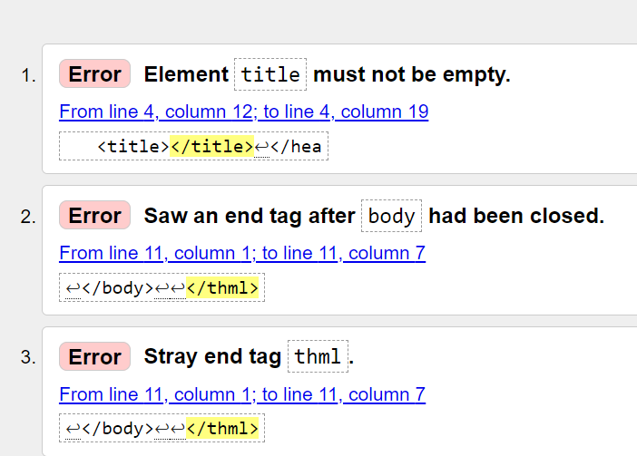

***Corrected No errors:***

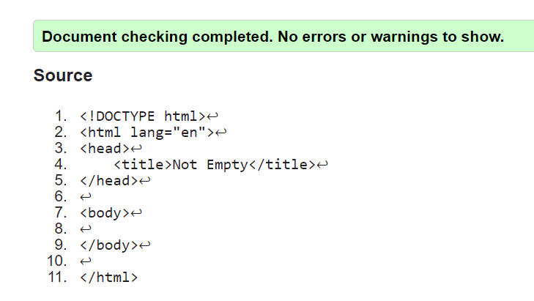

***Added elements to the page.***

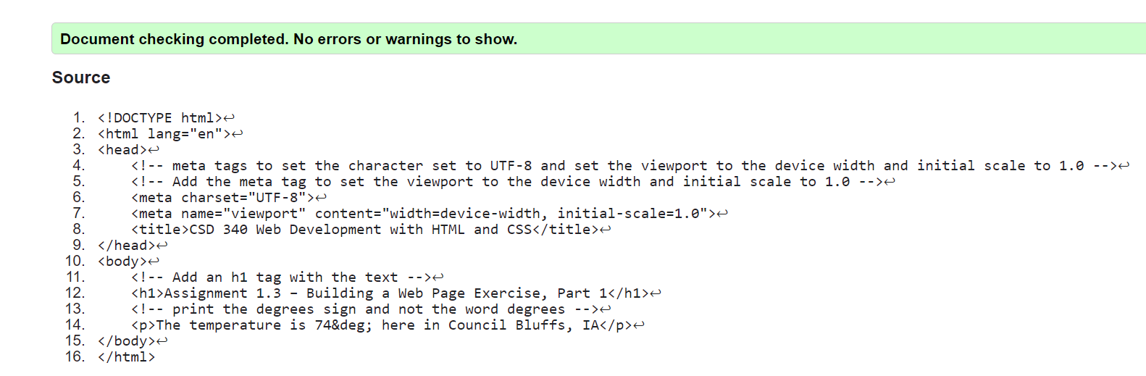

***Running locally in browser***

