|  |
| --- |
| **Specialization in NLP** |

** DEPARTMENT OF COMPUTER SCIENCE AND ENGINEERING**

**Approved by AICTE, New Delhi & Affiliated to JNTUH, Hyderabad**

**Accredited by NBA & NAAC, an ISO 9001:2015 Certified Institution**

**Shaikpet, Hyderabad-500104**

**G. Narayanamma Institute of Technology & Science (For Women) (Autonomous)**

**(Autonomous) (For Women)**

**<R-18> (2021 - 2022) III B.Tech II Sem Mini Project**

on “Stress Detection in women using Speech Analysis”

Under the guidance of

Mrs. R.. Mamatha ,Assistant professor

**H/W & S/W Requirements:**

**Software Requirements: Hardware Requirements:**

Platform - Windows 10 or Windows 7 Processor Name - Windows 10 intel® core™ i5

Development Environment -Jupyter Notebook Hard Disk Capacity - 1TB

Frontend - Machine learning algorithms RAM Capacity - 8GB

(Python)

**Abstract:**

Stress is one of the most common emotional states of humans. Stress can be positive and motivate women to achieve notable goals. But stress can also be negative and destructive, taking its toll in many life areas. When stress becomes chronic or excessive, it becomes harder to adapt and cope. Chronic stress builds up so that stress seems like a normal way of life for some women. Oftentimes women are so busy that they do not take time to slow down long enough to think about how stress negatively affecting them.

Now-a-days, smart watches can be used for monitoring heart rates, blood pressures and skin temperature – but for the most part, assessing stress-related biomarkers is still relatively invasive, requiring (for example) a blood or sample from the individual. Speech represent he mental aspects of individuals and is characterized by the different emotional cues and stress in voice. Voice Stress Analysis (VSA) is the study of analysing the mental states of women from their voice when they are under stress and how the brain functions with stressed states of human beings.

The above said limitations of physiological measurements make assessing stress using speech very attractive, especially given that doing so is now relatively inexpensive and non-intrusive. Steps in assessing stress using speech include, when an individual speaks in the presence of an actively recording smartphone or smart speaker, an audio signal is captured. Various features of the audio signal (e.g., pitch, jitter, energy, speaking rate, length, and number of pauses) are then extracted and used as inputs to a machine learning algorithm that yields a result. That depicts whether the woman is under stress or not. In this case our voice analyzer can help women by detecting their stress levels using their routine speech without any special intervention.

*Dept R&D: Yes / No (Yes) * If No __________________________________ (Company Name)

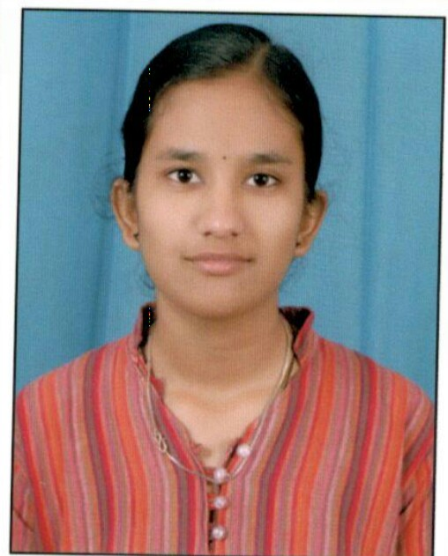

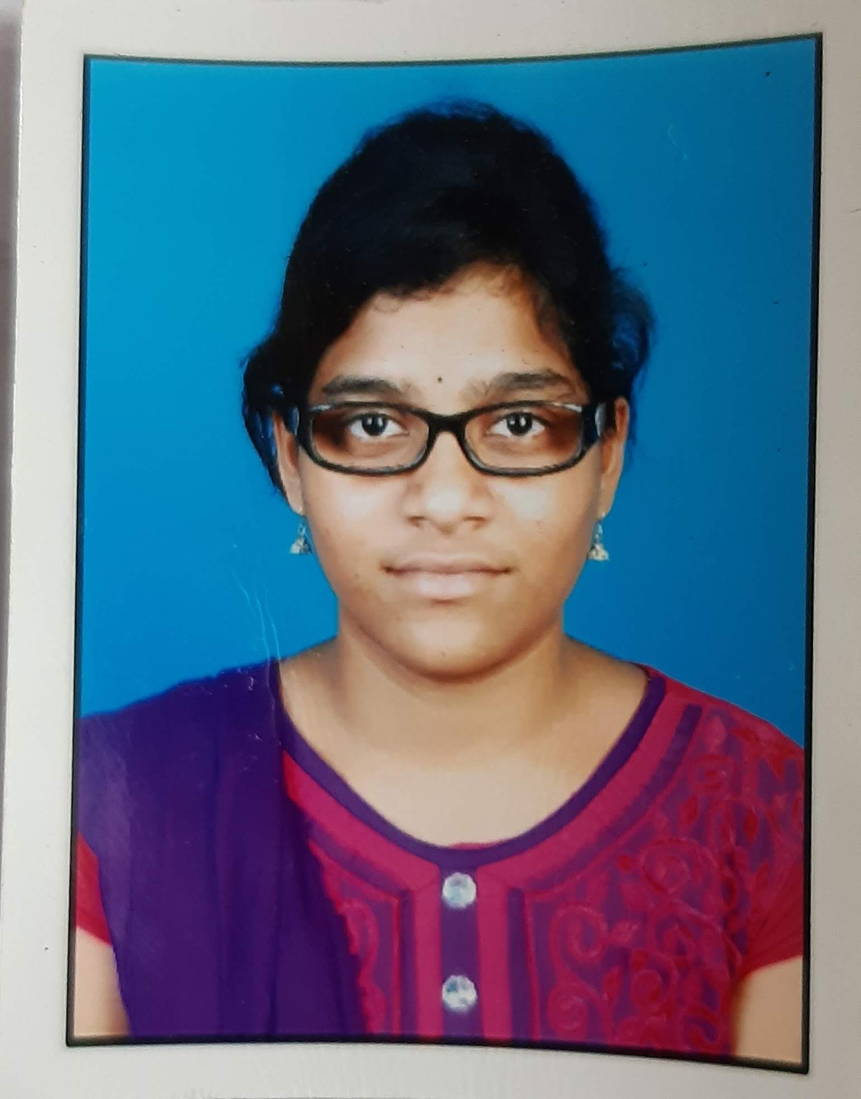



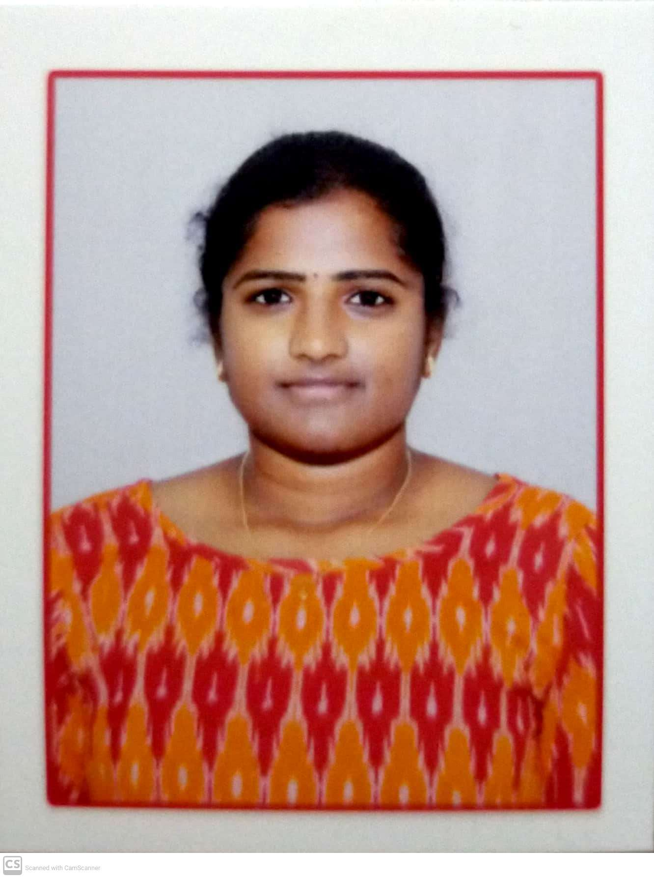

19251A05C3 19251A05E6 19251A05F1 19251A05F3

A.Monika G.Sarvagna K.Meghana Shirley Angelina allamonikajan03[@gmail.com](mailto:@gmail.com) sarvagnagudlavalleti[@gmail.com](mailto:@gmail.com) [kskmeghana1040@gmail.com](mailto:kskmeghana1040@gmail.com) [angelinasamuel@gmail.com](mailto:angelinasamuel@gmail.com)

**9182538870 9963474250 9390379467 8309260011**

**Internal Guide Class Coordinator Project Coordinator Head of the Department**