Name: Robert Smith
UCID: RS854
Email: rs854@njit.edu

CS 634 Midterm Project

Table of Contents

Overview 2
Algorithm Comparison 2
Screenshots 4
Source Code 13
.\Program.cs 13
.\items.txt 21
.\transactions\1.txt 22
.\transactions\2.txt 23
.\transactions\3.txt 24
.\transactions\4.txt 25
.\transactions\5.txt 26

Overview
The source code for this project was written in C# and run on a PC running Windows 10 operating system. The application code is contained in the file Program.cs, located in the root directory. An auxiliary file, items.txt, contains the list of 30 items available for purchase (this file is also located in the root directory). 5 files which contain the transactions are included in a folder named “transactions” which is located in the root directory. These 5 files are named 1.txt, 2.txt, 3.txt, 4.txt, and 5.txt.
This application can be compiled and executed using the .NET Core 3.1 SDK by running the following command from the root project directory: dotnet run
The application will prompt the user to enter the minimum support and confidence thresholds. These values should be entered as decimal values between 0 and 1. The program will also prompt the user to select the database file by typing in the associated number (1, 2, 3, 4, or 5) which correspond to the files in the “transactions” folder. Finally, the program will prompt the user to select the algorithm that the program will use. Typing “1” will select the Apriori algorithm and typing “2” will select the Brute Force algorithm.
Once all user input has been collected, the selected algorithm will be performed. The program will output tables of data displaying the frequent item groups (item groups who’s support exceeds the user specified minimum support). The program will also output tables will the discovered association rules that exceed the specified minimum support and confidence levels. Finally, the execution time is displayed in order to compare the performance of the Apriori algorithm and the Brute Force algorithm.

Algorithm Comparison
The performance of the Brute Force and Apriori algorithms were compared by running both algorithms on each of the database files with the same minimum support and minimum confidence values. As shown in the table and graph below, the Apriori algorithm performed much faster than the Brute Force algorithm on all five database files.
Database | Min Support | Min Confidence | Brute Force Execution Time | Apriori Execution Time
1 | 0.35 | 0.8 | 382 ms | 85 ms
2 | 0.4 | 0.8 | 1869 ms | 58 ms
3 | 0.3 | 0.7 | 365 ms | 67 ms
4 | 0.3 | 0.7 | 394 ms | 61 ms
5 | 0.3 | 0.7 | 1958 ms | 98 ms
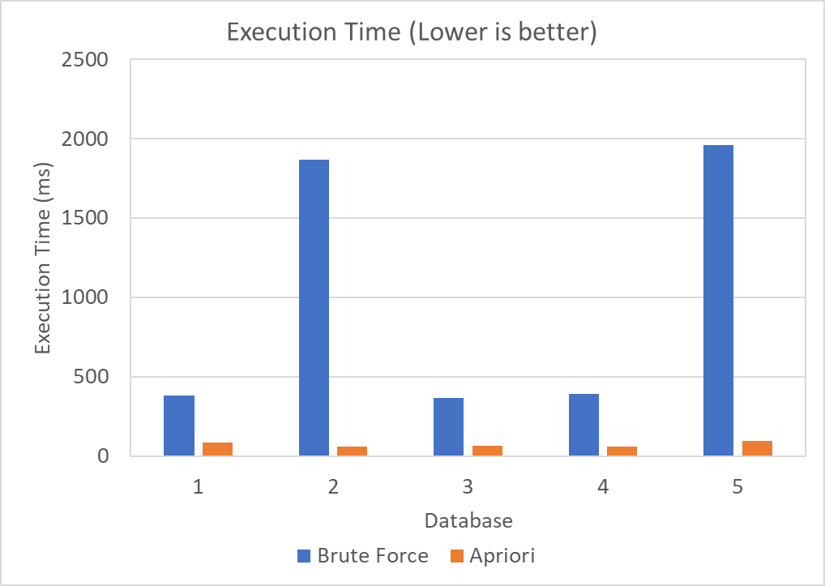

Screenshots
Screenshots are provided of several runs with various user inputs below.
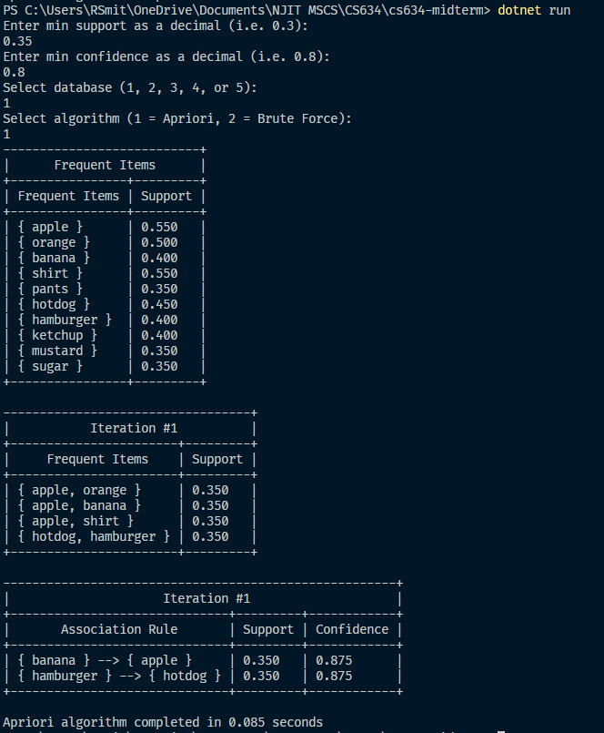
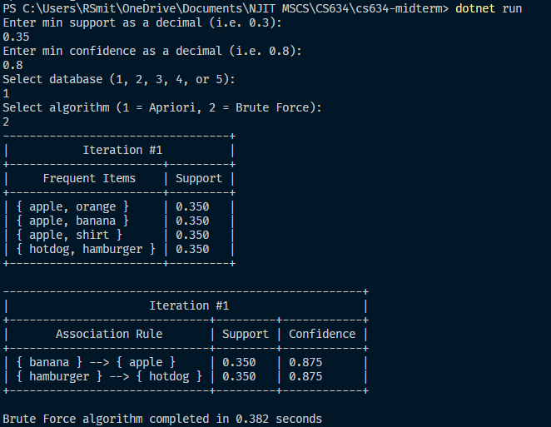
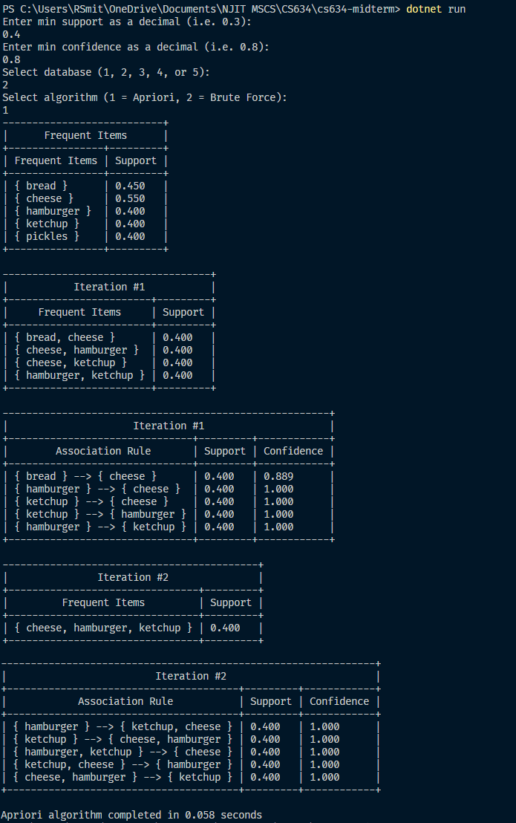
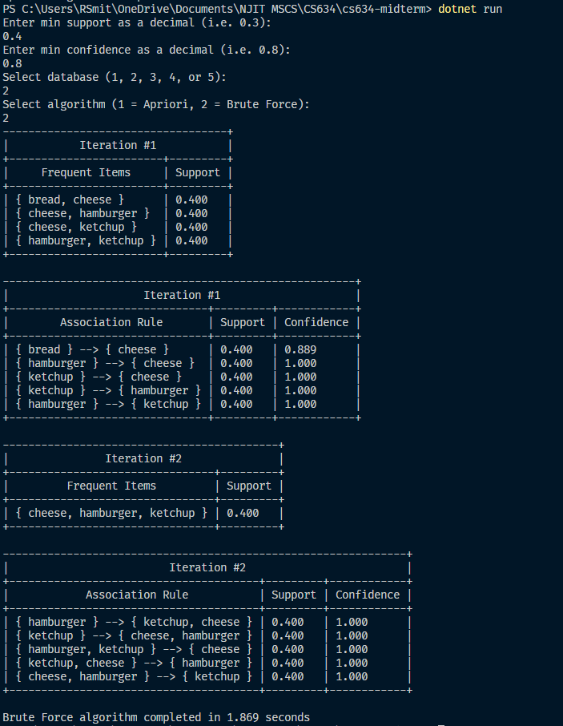
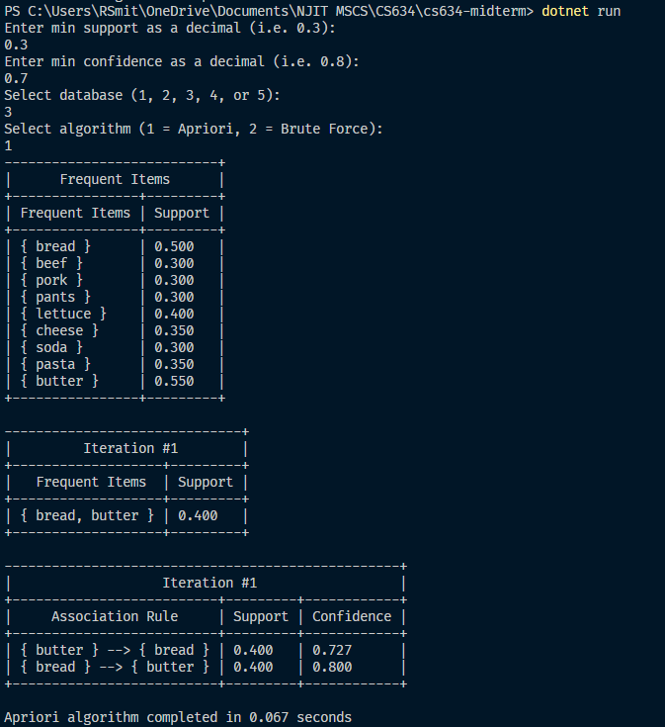
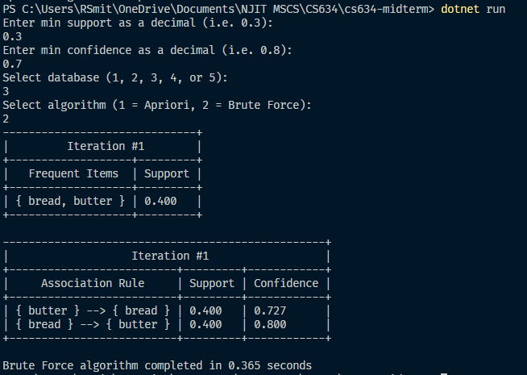
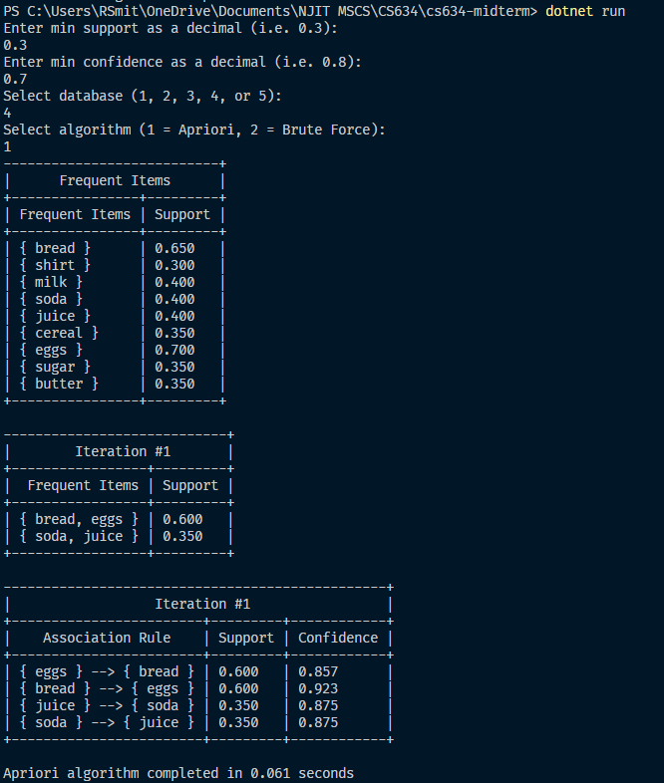
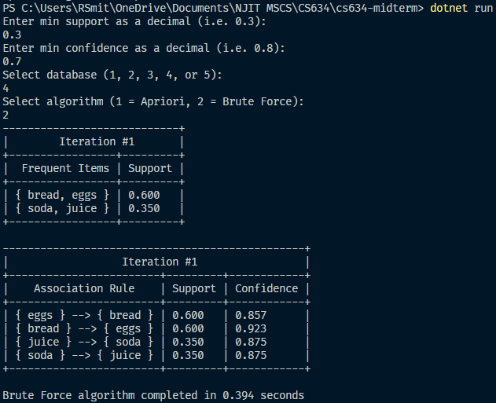
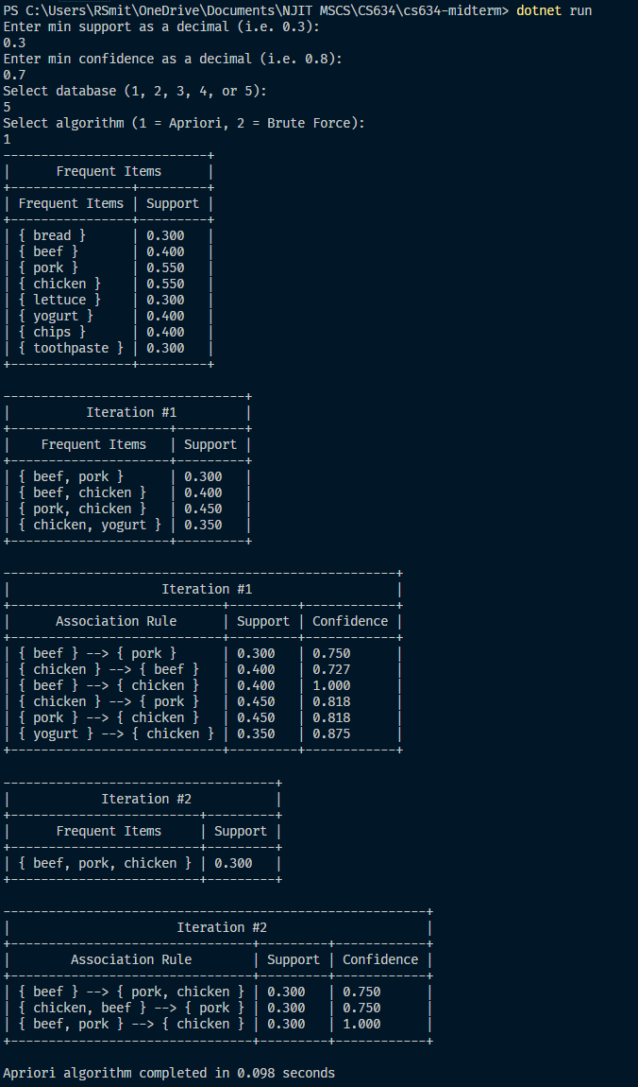
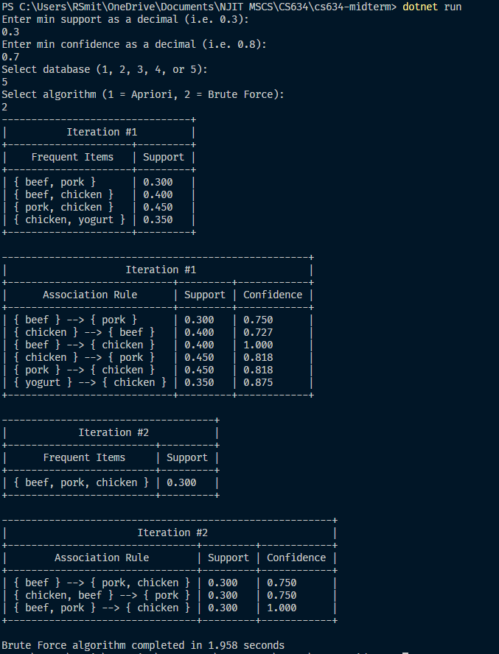

Source Code

.\Program.cs
using System;
using System.Collections.Generic;
using System.Diagnostics;
using System.IO;
using System.Linq;

namespace cs634_midterm
{
static class Program
{
static List<ItemSet> infrequentItemSets = new List<ItemSet>();

static void Main(string[] args)
{
// Get user input parameters
Console.WriteLine("Enter min support as a decimal (i.e. 0.3):");
double minSupport = Convert.ToDouble(Console.ReadLine());

Console.WriteLine("Enter min confidence as a decimal (i.e. 0.8):");
double minConfidence = Convert.ToDouble(Console.ReadLine());

Console.WriteLine("Select database (1, 2, 3, 4, or 5):");
string[] transactions = File.ReadAllLines($"transactions\\{Console.ReadLine()}.txt");

Console.WriteLine("Select algorithm (1 = Apriori, 2 = Brute Force):");
int algorithm = Convert.ToInt32(Console.ReadLine());

Stopwatch sw = new Stopwatch();
sw.Start();
if (algorithm == 1)
{
Apriori(transactions, minSupport, minConfidence);
sw.Stop();
double elapsed = (double)sw.ElapsedMilliseconds / 1000;
Console.WriteLine($"Apriori algorithm completed in {elapsed} seconds");
}
else
{
BruteForce(transactions, minSupport, minConfidence);
sw.Stop();
double elapsed = (double)sw.ElapsedMilliseconds / 1000;
Console.WriteLine($"Brute Force algorithm completed in {elapsed} seconds");
}

}

private static void BruteForce(string[] transactions, double minSupport, double minConf)
{
int iteration = 0;
string[] items = File.ReadAllLines("items.txt");

List<ItemSet> startingItemSets = items.Select(item => new ItemSet()
{
items = new List<string>() { item }
}).ToList();

var joined = startingItemSets.ToList();
var frequentItemSets = joined;

while (frequentItemSets.Count() > 0)
{
iteration += 1;
joined = JoinItemSets(joined).ToList();
frequentItemSets = GetFrequentItemSets(joined, transactions, minSupport);
PrintItemSets(frequentItemSets, $"Iteration #{iteration}");
PrintAssociationRules(frequentItemSets, transactions, minConf, $"Iteration #{iteration}");
}
}

private static void Apriori(string[] transactions, double minSupport, double minConfidence)
{
string[] items = File.ReadAllLines("items.txt");

List<ItemSet> startingItemSets = items.Select(item => new ItemSet()
{
items = new List<string>() { item }
}).ToList();
// Calculate support of starting items
startingItemSets = GetFrequentItemSets(startingItemSets, transactions, 0);

List<ItemSet> frequentItemSets = new List<ItemSet>();

int iter = 0;

frequentItemSets = GetFrequentItemSets(startingItemSets, transactions, minSupport);
PrintItemSets(frequentItemSets, $"Frequent Items");
var joined = JoinItemSets(frequentItemSets);
joined = PruneItemSets(joined);

while (frequentItemSets.Count() > 0)
{
iter += 1;
frequentItemSets = GetFrequentItemSets(joined, transactions, minSupport);
PrintItemSets(frequentItemSets, $"Iteration #{iter}");
PrintAssociationRules(frequentItemSets, transactions, minConfidence, $"Iteration #{iter}");
joined = JoinItemSets(frequentItemSets);
joined = PruneItemSets(joined);
}
}

private static void PrintAssociationRules(IEnumerable<ItemSet> joined, string[] transactions, double minConf, string title)
{
if (joined.Count() > 0)
{
Table t = new Table(new List<string>() { "Association Rule", "Support", "Confidence" }, title);

foreach (var itemSet in joined)
{
// Shift arrow to the right
for (int firstGroupSize = 1; firstGroupSize < itemSet.items.Count(); firstGroupSize++)
{
// Shift elements to the left
for (int j = 0; j < itemSet.items.Count(); j++)
{
itemSet.items = RotateItems(itemSet);

// Split items at arrow position
var firstGroupItems = itemSet.items.Take(firstGroupSize).ToList();
var restOfItems = itemSet.items.Skip(firstGroupSize).ToList();

var firstGroupItemSet = new List<ItemSet>() { new ItemSet() { items = firstGroupItems } };

var supportOfFirstGroup = GetItemSetsSupport(firstGroupItemSet, transactions).First().support;

var confidence = itemSet.support / supportOfFirstGroup;
if (confidence >= minConf)
{
string rule = $"{firstGroupItems.ItemSetToString()} --> {restOfItems.ItemSetToString()}";

t.Rows.Add(new List<string>() { rule, itemSet.support.ToString("0.000"), confidence.ToString("0.000") });
}
}
}
}

t.Print();
Console.WriteLine("");
}
}

private static string[] RotateItems(ItemSet itemSet)
{
return itemSet.items.Skip(1).Concat(itemSet.items.Take(1)).ToArray();
}

private static void PrintItemSets(List<ItemSet> frequentItemSets, string title, bool includeSupport = true)
{
if (frequentItemSets.Count() > 0)
{
var headers = new List<string>() { "Frequent Items" };
if (includeSupport)
{
headers.Add("Support");
}
Table t = new Table(headers, title);

foreach (var itemSet in frequentItemSets)
{
var items = new List<string>() { itemSet.ToString() };
if (includeSupport)
{
items.Add(itemSet.support.ToString("0.000"));
}
t.Rows.Add(items);
}

t.Print();
Console.WriteLine("");
}
}

private static List<ItemSet> GetFrequentItemSets(IEnumerable<ItemSet> itemSets, string[] transactions, double minSupport)
{
IEnumerable<ItemSet> itemSetsWithSupport = GetItemSetsSupport(itemSets, transactions);

// Remeber infrequent item sets for future pruning
infrequentItemSets.AddRange(itemSetsWithSupport.Where(itemSet => itemSet.support < minSupport));

return itemSetsWithSupport.Where(itemSet => itemSet.support >= minSupport).ToList();
}

private static IEnumerable<ItemSet> GetItemSetsSupport(IEnumerable<ItemSet> itemSets, string[] transactions)
{
double numTransactions = transactions.Count();

var itemSetsWithSupport = itemSets.Select(itemSet => new ItemSet()
{
support = transactions.Where(t => !itemSet.items
.Except(t.Split(","))
.Any())
.Count() / numTransactions,
items = itemSet.items,
});
return itemSetsWithSupport;
}

static IEnumerable<ItemSet> JoinItemSets(IEnumerable<ItemSet> itemSets)
{
List<ItemSet> joinedItemSets = new List<ItemSet>();
List<string> items = itemSets.SelectMany(itemSet => itemSet.items).Distinct().ToList();

foreach (var itemSet in itemSets)
{
foreach (var item in items)
{
// Check that the item is not a duplicate
if (!itemSet.items.Contains(item))
{
var joinedItems = new List<string>();
foreach (var i in itemSet.items)
{
joinedItems.Add(i);
}
joinedItems.Add(item);

joinedItemSets.Add(new ItemSet()
{
items = joinedItems,
});
}
}
}

// Remove duplicates that are in a different order
return joinedItemSets.Distinct();
}

static IEnumerable<ItemSet> PruneItemSets(IEnumerable<ItemSet> itemSets)
{
// Filter out item sets that are supersets of infrequent subsets
return itemSets.Where(itemSet => !infrequentItemSets
.Where(infreq => itemSet.Contains(infreq)).Any()).ToList();
}

public static string ItemSetToString(this List<string> items)
{
if (items != null && items.Count() > 0)
{
return "{ " + String.Join(", ", items) + " }";
}
else
{
return "{}";
}
}
}

// Data class that contains a collection of items
class ItemSet : IEquatable<ItemSet>
{
public double support { get; set; }
public IEnumerable<string> items { get; set; }

public override string ToString()
{
if (items != null && items.Count() > 0)
{
return "{ " + String.Join(", ", items) + " }";
}
else
{
return base.ToString();
}
}

public bool Equals(ItemSet other)
{

//Check whether the compared object is null.
if (Object.ReferenceEquals(other, null)) return false;

//Check whether the compared object references the same data.
if (Object.ReferenceEquals(this, other)) return true;

//Check whether the products' properties are equal.
return this.GetHashCode() == other.GetHashCode();
}

public override int GetHashCode()
{
return String.Join(",", this.items.OrderBy(x => x)).GetHashCode();
}

// Check if this item set is a superset of the other
public bool Contains(ItemSet itemSet)
{
return !itemSet.items.Except(items).Any();
}
}

// Helper class to print tables to the console
public class Table
{
public string title { get; set; }
public List<List<string>> Rows { get; set; }

private List<int> columnWidths;
private List<string> headers;

public Table(List<string> headers, string title)
{
this.headers = headers;
this.Rows = new List<List<string>>();
this.title = title;
}

public void Print()
{
columnWidths = new List<int>();

for (int i = 0; i < headers.Count(); i++)
{
int maxLength = Math.Max(MaxRowLength(i), headers.ElementAt(i).Length);
columnWidths.Add(maxLength + 2);
}

PrintTitle();
PrintHeaders();
PrintRows();
}

private int MaxRowLength(int i)
{
if (Rows.Count() > 0)
{
return Rows.Select(r => r.ElementAt(i).Length).Max();
}
else
{
return 0;
}
}

private void PrintRows()
{
foreach (var row in Rows)
{
PrintRow(row);
}
PrintLine();
}

private void PrintTitle()
{
PrintLine(false, false);
PrintCell(title, true, columnWidths.Sum() + columnWidths.Count() - 1);
Console.WriteLine("|");
PrintLine();
}

private void PrintHeaders()
{
PrintRow(headers, true);
PrintLine();
}

private void PrintRow(IEnumerable<string> row, bool centered = false)
{
int column = 0;
foreach (var columnWidth in columnWidths)
{
string element = row.ElementAt(column);
PrintCell(element, centered, columnWidth);
column = column + 1;
}
Console.WriteLine("|");
}

private static void PrintCell(string element, bool centered, int columnWidth)
{
int numSpaces = columnWidth - element.Length - 1;
Console.Write("| ");

if (centered)
{
int numStartSpaces = numSpaces / 2;
int numEndSpaces = numSpaces - numStartSpaces;
PrintSpaces(numStartSpaces);
Console.Write(element);
PrintSpaces(numEndSpaces);
}
else
{
Console.Write(element);
PrintSpaces(numSpaces);
}
}

private static void PrintSpaces(int numSpaces)
{
string startSpaces = "";
for (int i = 0; i < numSpaces; i++)
{
startSpaces += " ";
}
Console.Write(startSpaces);
}

private void PrintLine(bool bold = false, bool separators = true)
{
foreach (var columnWidth in columnWidths)
{
Console.Write(separators ? "+" : bold ? "=" : "-");
for (int i = 0; i < columnWidth; i++)
{

Console.Write(bold ? "=" : "-");
}
}
Console.WriteLine("+");
}
}
}

.\items.txt
apple
orange
banana
bread
potato
beef
pork
chicken
shirt
pants
lettuce
yogurt
milk
cheese
soda
juice
hotdog
hamburger
chips
pasta
cereal
fish
eggs
peppers
ketchup
mustard
toothpaste
sugar
butter
pickles

.\transactions\1.txt
yogurt,pants,orange,banana,pasta,shirt,sugar,apple
apple,cereal,mustard
chicken,banana,shirt,orange,beef,apple,butter,eggs,pants
peppers,mustard,hotdog,sugar,shirt,bread,eggs,hamburger,ketchup
toothpaste,soda,pickles,chips,potato,banana,pants
peppers,soda,shirt,juice,apple,pants,sugar,banana,hotdog,lettuce,cereal
shirt,banana,lettuce,apple,ketchup,pickles,orange
orange,butter,pasta,shirt,ketchup
hamburger,pickles,cheese,pasta,hotdog
pasta,chicken,eggs,apple,orange,cheese,sugar
shirt,peppers,pants,hamburger,ketchup,bread,hotdog
beef,mustard,orange,cheese,pasta,pork,bread,soda,shirt
pants,bread,lettuce,apple,hotdog,banana,hamburger,orange,mustard,shirt
cheese,pork,apple,potato,shirt,soda
toothpaste,sugar,ketchup,mustard,fish,potato,hotdog
bread,yogurt,pasta,pants,butter,sugar,potato,apple,shirt
hotdog,apple,chicken,banana,hamburger,orange,ketchup,mustard
milk,potato,beef,bread,hamburger,soda,sugar,pickles
yogurt,pickles,orange,ketchup,hotdog,hamburger
apple,hotdog,pickles,banana,beef,cheese,ketchup,orange,hamburger,mustard

.\transactions\2.txt
hamburger,cheese,bread,yogurt,ketchup,pickles
hotdog,peppers,mustard,milk,soda
ketchup,cheese,hamburger,bread,pickles,lettuce,potato
apple,banana,pork
pasta,hotdog,potato,mustard
bread,pickles,cheese,hamburger,ketchup,lettuce
cereal,juice,milk
hamburger,cheese,bread,ketchup,pickles
sugar,cheese
pickles,bread,cheese,ketchup,hamburger
apple,toothpaste,mustard,yogurt,fish,hotdog
orange,banana,lettuce
ketchup,pickles,bread,cheese,hamburger
chicken,eggs,cheese
hamburger,cheese,ketchup,lettuce,shirt
mustard,bread,soda,hotdog
soda,juice,bread,cheese
pants,mustard,hotdog,pickles
orange,beef,pasta
bread,hamburger,pickles,lettuce,ketchup,cheese,soda

.\transactions\3.txt
cheese,butter,beef,sugar,soda,potato,chips
sugar,lettuce,bread,juice,milk,toothpaste,butter,soda,pants,beef
lettuce,peppers,cereal,orange
pork,pasta,chips
cheese,soda,lettuce,mustard,milk,banana,pickles,yogurt
lettuce,butter,hotdog,fish,bread
peppers,fish,lettuce,bread,pork,pasta,pants
orange,bread,mustard,soda,toothpaste,hamburger,butter
pork,butter,chips,yogurt,bread
mustard,apple,pasta,lettuce,soda,shirt,beef
pork,pasta,juice,bread,butter
pasta,milk,bread,soda,potato,shirt,ketchup,juice,pants
toothpaste,beef,banana,milk,cereal,cheese,chicken
pork,shirt,eggs,chicken,hamburger,pants,pasta,butter,lettuce,cereal
pickles,cheese
fish,cheese,bread,butter
pork,lettuce,pasta,beef,apple,shirt,butter
mustard,chicken,juice,pickles,sugar
hamburger,orange,cheese,bread,pants,butter,apple
chicken,cheese,bread,toothpaste,potato,butter,shirt,beef,pants,apple

.\transactions\4.txt
toothpaste,hotdog,eggs,cereal,bread
cereal,juice,potato,soda,chicken,beef,milk
yogurt,ketchup,cereal,hamburger,eggs,bread
sugar,eggs,pork,fish,bread,banana
shirt,soda,pickles,mustard,chicken,juice,lettuce,beef,hamburger,butter
lettuce,chips,eggs,beef,apple,cheese,pork,bread,shirt
sugar,juice,milk,cheese,fish,soda,peppers,eggs,hotdog,cereal,bread
mustard,shirt,pork,ketchup,sugar,banana,soda,bread
chicken,butter,eggs,pork,milk,sugar,pasta,apple
bread,peppers,lettuce,juice,soda,eggs
sugar,milk,butter,beef,chips,cereal
bread,toothpaste,beef,soda,juice,eggs
eggs,bread,butter
butter,cereal,bread,eggs,milk
eggs,peppers,bread
lettuce,ketchup,milk,peppers,banana,shirt,sugar,potato,toothpaste,mustard
cereal,cheese,juice,pork,chips,shirt,milk,pants
hotdog,shirt,bread,apple,eggs,lettuce,milk,pants,toothpaste,butter
soda,hotdog,butter,eggs,juice
juice,soda,pickles,bread,soda,sugar,eggs

.\transactions\5.txt
pork,juice,beef,peppers,yogurt,chicken,chips
pickles,pants,potato,ketchup
bread,hamburger,shirt,eggs,yogurt,chicken,lettuce,peppers,toothpaste,beef
hamburger,shirt,hotdog,apple,chips
hamburger,pork,lettuce,chicken,pasta,beef
bread,ketchup,apple,beef,toothpaste,yogurt,chicken,lettuce
apple,butter,lettuce,hotdog
eggs,hotdog,toothpaste,peppers,pickles,yogurt
yogurt,pork,sugar,cereal,beef,pickles,chicken,bread
bread,pork,toothpaste,chips,juice,apple,cereal,mustard,chicken
pork,butter,milk,orange,chicken,yogurt,chips,peppers,pasta
bread,mustard,cheese,butter,juice,pasta,cereal
bread,yogurt,chicken,soda,toothpaste,beef,lettuce,pork
ketchup,chips
peppers,juice,cheese,pork
orange,fish,cheese,lettuce,chips,soda
sugar,beef,ketchup,chicken,mustard,chips,pork,toothpaste
pork,pickles,mustard,pasta,shirt,ketchup
milk,pork,chips,shirt,beef,chicken
pork,sugar,yogurt,chicken

