DML Creator 0.1

Quick Start Guide

# Overview

DML Creator makes the creation/edition of DML files easy.

The software comes with a scan feature, which enables you to create the DML file of any existing show.

To learn more about DML: (missing url)

To learn more about AFDI: <http://www.imersa.org/afdi-dome-standards-group>

# Installation

Install DMLCreator-Setup.exe.

If you get an error when trying to run DMLCreator, please try to install the “Microsoft Visual C++ 2010 SP1 (x64) redistributable.exe”.

# First launch

Run C:\Program Files\DML Creator\DMLCreator.exe by clicking the DML Creator shortcut in your Start Menu.

At first launch, DMLCreator will ask to select :

* The configuration file (XML) which contains all the patterns used in the detection
* The schema (XSD) which allow the DML validation check at each I/O.

Select both matching files (configuration.xml and afdi-standards.xsd) in the same folder than DMLCreator.exe.

# UI overview

Here is the main view:

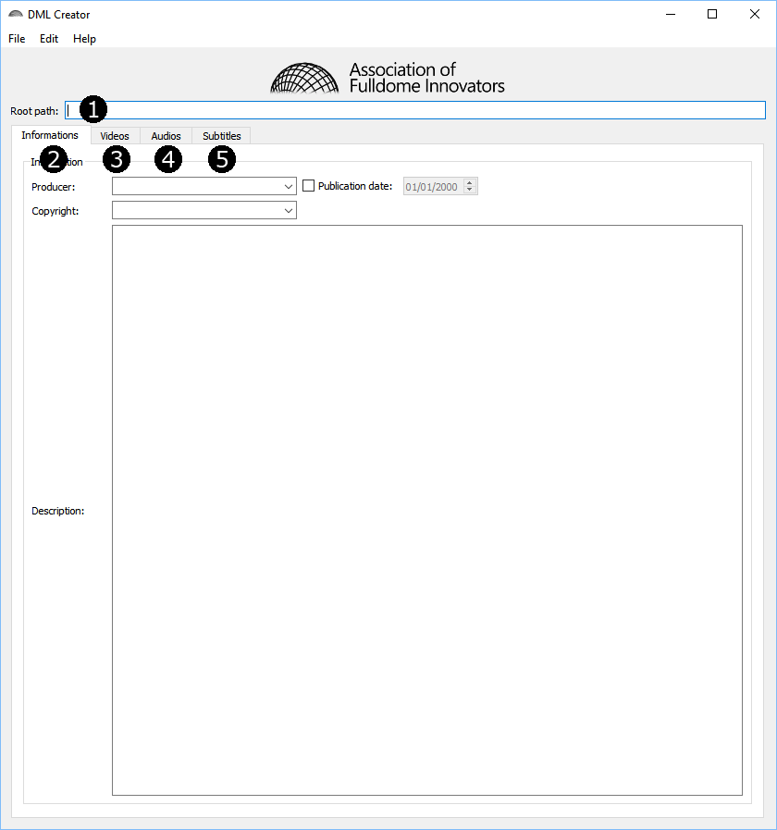

Figure : Main view

1. Root of the scanned directory. Relative paths will start from here. This is also where the DML file will be suggested to be saved. This field will not be saved in the DML file. If you load a DML file, this “root path” is the one of the loaded DML file.
2. Information tab: everything which isn’t a content
3. Video tab, with the image sequences
4. Audio tab
5. Subtitles tab

# Basic I/O

You can open any DML file and you can save at any time.

# Scan a hard drive

Click “*File > Import”* to import a show.

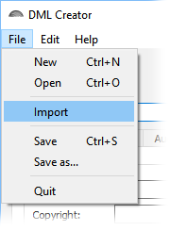

Figure 2 : Import a show

This software will take a few time to scan all the contents.

The field “Root path” will be filled with the selected path.

Usually, no “information” will be detected. The generated stuff is in the other tabs.

You can edit and customize every field to enhance the DML file. You can obviously remove every superfluous files to make the DML file easier to read and understand.