Mentco PO Manager
Administrator Guide
How to run the PO Manager day to day
Item | Detail
Audience | Administrators (people with the Admin role). Anyone who runs the system, creates logins, fixes mistakes or looks after master data.
App version | 1.7.9 (the version number is shown at the top right of every screen)
Document date | 8 October 2026
Companion documents | Staff Guide · Viewer Guide · Owner’s Runbook (setup, hosting, backups, troubleshooting, handover)
Document owner | [Fill in: name and email of the person who keeps this guide up to date]

How to use this guide
This guide explains every screen an Administrator uses and what each button really does, including the rules the app follows behind the scenes. It is written so that a new Administrator can run the system without having seen it before. Sections 1–4 are the basics. Sections 5–9 are step-by-step instructions. Section 10 is a set of checklists you can print.
Note
The Administrator role can do everything, including deleting orders, shipments, customers and users. Most actions ask you to confirm, but a deleted order cannot be brought back from inside the app. Read the “Careful” boxes before you delete or re-link anything.

1. What the PO Manager does
The PO Manager keeps track of customer purchase orders (POs) and the shipments sent against them. For every PO line it shows how many pieces were ordered, how many are on the way (In Transit), how many have arrived (Delivered) and how many are still open. It also shows whether a line is late, and it keeps a history (the audit log) of who changed what.
People sign in with an email address and a password that an Administrator creates. They do not need a Microsoft account. The data itself is stored in SharePoint, but nobody uses SharePoint directly: the app talks to SharePoint through one Power Automate flow that checks the person’s login and role on every request.

The three things you must understand
- Delivered and In Transit are never typed in. They are calculated from the shipments. When you save a shipment line with the status In Transit, that quantity appears as In Transit on the matching order line. When you set it to Delivered, it moves to Delivered. This is why the link between a shipment line and an order line (Customer PO No + Part No + Order Line No) matters so much.
- An order line closes by itself. A line is Open while Delivered is less than the effective quantity. When Delivered reaches the effective quantity the line becomes Closed. (Effective quantity = PO Qty minus any Short Close Qty; a Cancelled line has an effective quantity of 0.) An order is Open while any of its lines is Open, Closed when all lines are closed, and Cancelled only when every line is cancelled.
- Staff and Viewers have limits that you control. You create their logins and choose their roles. Section 4 lists what each role can do.

2. Signing in and out
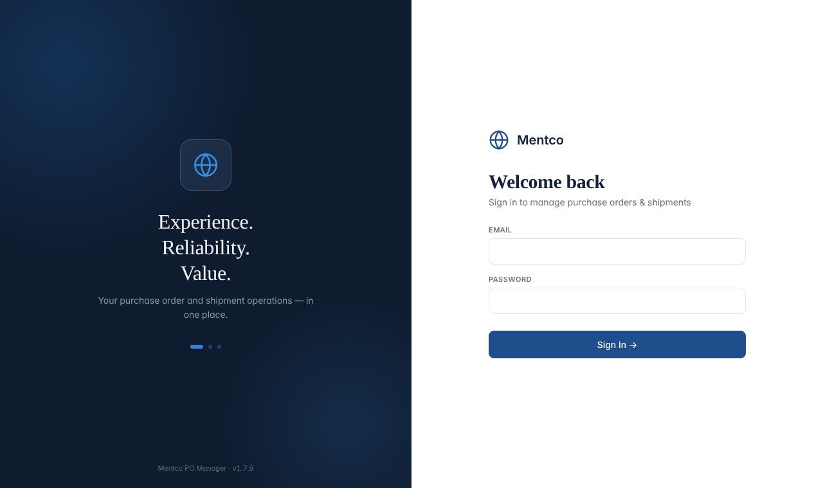
The sign-in screen
- Open the app address given to you by the owner of the system. Type your email (this is your login ID) and your password, then click Sign In.
- Your sign-in lasts 12 hours. If you refresh the page you stay signed in. If you close the browser tab or window you are signed out (the sign-in is kept per tab). To leave on purpose, click the arrow-out icon next to your name at the bottom of the left menu.
- After 5 wrong passwords in a row the account is locked for 15 minutes, even if the right password is typed afterwards. An Administrator resetting the person’s password in the Users screen unlocks the account immediately (see 8.3).
- If you see “Your session expired. Please sign in again.” the 12 hours are over or an Administrator changed your account. Sign in again; nothing is lost, but anything that was not saved yet must be entered again.
Important
Keep at least two working Administrator logins and keep their passwords in a password manager. If the only Administrator is locked out or leaves, nobody inside the app can create users or fix master data. (The system owner could still recover access through SharePoint; see the Owner’s Runbook.)

3. Finding your way around
The left menu has Dashboard, Orders, Shipments for everyone, plus Master Data and Users for Administrators. The Collapse button at the bottom of the menu shrinks it to icons (on a phone it starts collapsed). The top bar shows the page title and, on the right:
Item at top right | Meaning
Red “N overdue” badge | The number of open PO lines whose committed ship date has passed (see 4.3). Only appears when N is more than zero.
Version number (e.g. v1.7.9) | The app version. Quote this when you report a problem.
Green “SharePoint” label | The app is connected to the data store. Hidden on phones to save space.
Role label | Your role (Administrator, Staff, Viewer Type 1 or Viewer Type 2).

Saving feedback
- A small pill at the bottom right says Saving… and then Saved ✓ whenever the app writes to SharePoint.
- If a save fails, a red bar at the top says “N change(s) NOT saved”. See section 9 for what to do.
- The app warns you if you try to close the tab while something is unsaved. Believe the warning.
- The screen does not update by itself. The app loads the data when you sign in or refresh the page. Changes made by colleagues after that do not appear until you refresh the page (F5). Refresh before you start editing a record that others may be working on.

4. Roles, and what “overdue” means

4.1 What each role can do
 | Admin | Staff | Viewer 1 | Viewer 2
See orders, shipments, dashboard, audit history | Yes | Yes | Yes | Yes
See rates and values (India Rate, US Rate, extended sales, finance cards and charts) | Yes | Yes | No | Yes
Create orders and shipments | Yes | Yes | No | No
Edit a saved order | All fields | Only: Shipment Type, In Transit Days, Ship Date 1, Revised Ship Date 2, US Sales Order #, US QB PO #, India Rate, US Rate, Short Close Qty, Cancel Line | No | No
Edit a saved shipment | All fields | Only: Tracking #, and per line Delivery Status, Delivery Date, US Invoice No, Heat No | No | No
Cancel a PO, Reopen a PO / line, Delete orders or shipments, Re-link | Yes | No (Staff can Cancel a Line) | No | No
Master Data (customers, parts, dropdown lists) and Users | Yes | No | No | No
Export to CSV | All reports | All reports | Orders: no Financial report; no rate/value columns | All reports

Note
Viewer 1 never receives rates from the server at all; it is not just hidden on screen. For Staff, the limits on which fields can be edited are applied by the screen, and the server only checks the role. Treat Staff as trusted colleagues.

4.2 How the numbers on an order line are worked out
Field | How it is calculated
Delivered (auto) | Sum of the shipped quantities of shipment lines linked to this order line whose Delivery Status is Delivered.
In Transit (auto) | Sum of the shipped quantities of linked shipment lines whose Delivery Status is In Transit.
Effective quantity | PO Qty, minus Short Close Qty if the line is Short Closed. A Cancelled line counts as 0.
Open Qty (auto) | Effective quantity minus Delivered (never below 0). The line is Open while this is more than 0.
PO Open Qty (auto) | Open Qty minus In Transit: the quantity not yet shipped (never below 0). Informational; it does not decide the status.
PO Status (auto) | Open while Open Qty is more than 0; otherwise Closed (a Cancelled line is Closed).
Must Ship Date (auto) | On Dock Date (Original) minus In Transit Days.
On Dock Date Revised (auto) | The later of Ship Date 1 and Revised Ship Date 2, plus In Transit Days.
India / US Ext Sales (auto) | Effective quantity × India Rate / US Rate.

4.3 Overdue and upcoming
A line counts as overdue when it is still Open and its committed ship date is before today. The committed ship date is the later of Ship Date 1 and Revised Ship Date 2. If neither date has been filled in, the line is never counted as overdue or upcoming. This is why entering Ship Date 1 as soon as a date is promised matters: it is what feeds the overdue badge, the dashboard lists and the “Due Today / 7 Days / 30 Days” chips. Upcoming Must-Ship on the dashboard lists open lines whose committed ship date falls in the next 7 days.

5. The Dashboard
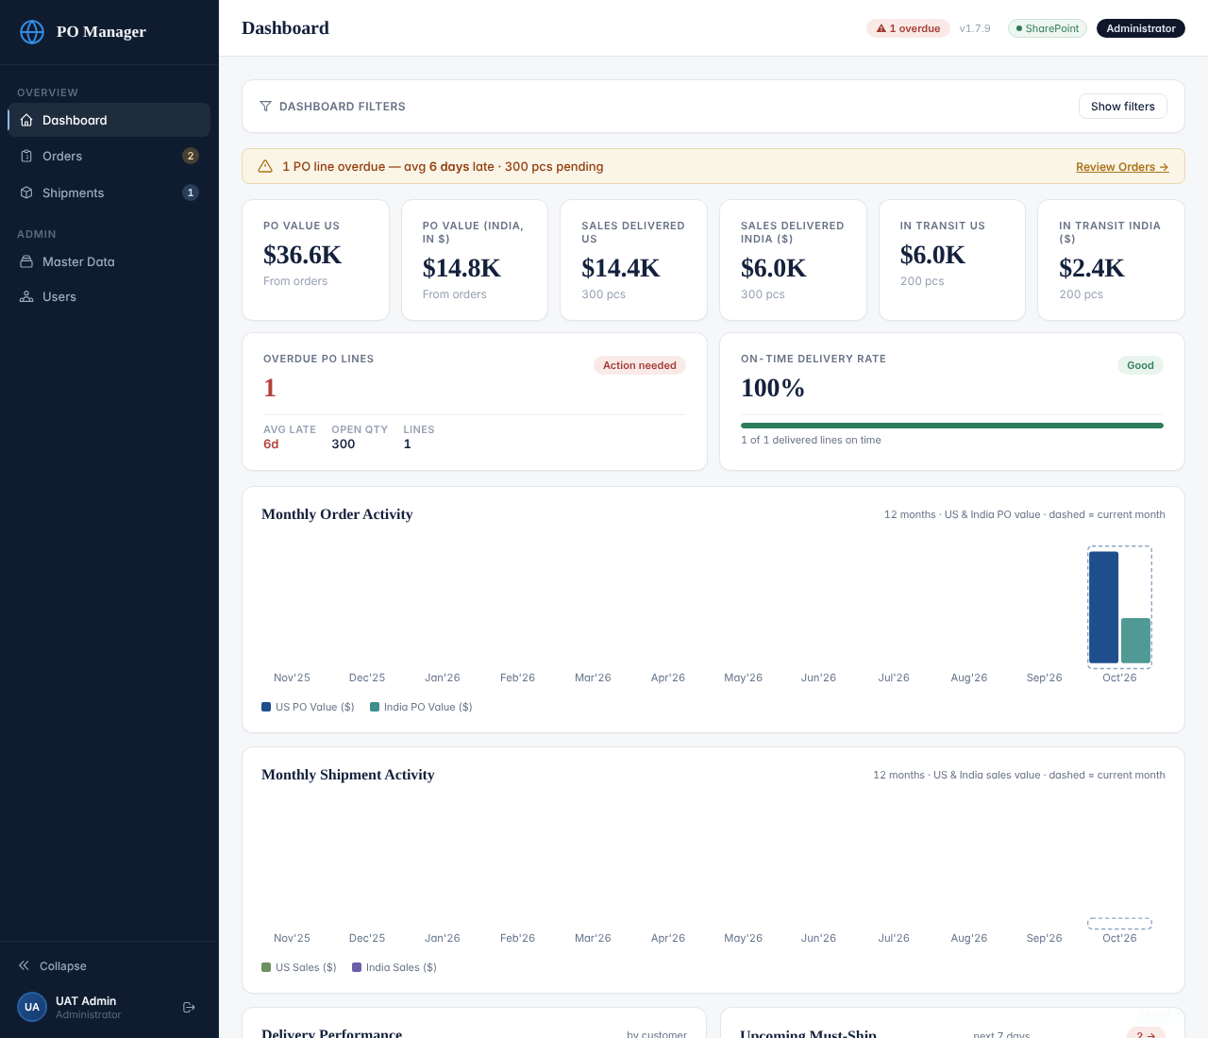
Dashboard (Administrator view, sample data)
- Dashboard Filters (click “Show filters”): Customer, Part No, Date From / Date To, PO Status (Open or Closed), Shipment Type and Location. The date range applies to the order date for orders and to the shipping date for shipments. Click Apply; click Clear to reset.
- Value cards (Admin, Staff, Viewer 2 only): PO Value US and PO Value India (all orders matching the filters, at effective quantity); Sales Delivered US / India (delivered shipment quantity × rate); In Transit US / India (in-transit shipment quantity × rate). The India figures are labelled in dollars as shown in the app.
- Overdue PO Lines: how many lines are overdue, the average days late and the open quantity. On-Time Delivery Rate: of the delivered shipment lines, the share whose Delivery Date is on or before the order line’s On Dock Date (Original). A delivered line with no Delivery Date counts as not on time.
- Monthly Order / Shipment Activity: the last 12 months, US and India values (finance roles only). The dashed bar is the current month.
- Delivery Performance, Upcoming Must-Ship, Overdue PO Lines, Recent Shipments: quick lists. Click a row to open that order.
- Everything is clickable: the Overdue card opens Orders filtered to overdue; the In Transit cards open Shipments filtered to In Transit; the PO Value cards open the open orders.
Note
The dashboard only covers data that is loaded: open orders plus the last 24 months, and anything you loaded with “Load older history”. See 6.2.

6. Orders

6.1 The Orders list
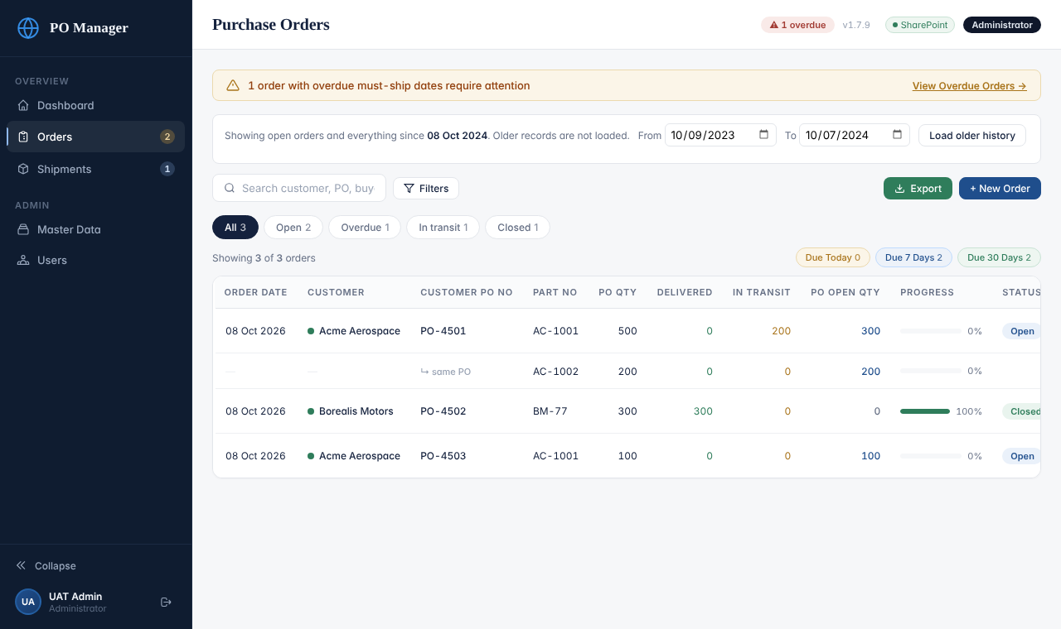
The Orders list
- Search box: type part of a customer name, PO number, buyer name or part number. Not case sensitive.
- Status chips under the search box: All, Open, Overdue, In transit, Closed. Each shows a count. Click one to see only those orders; click All to reset.
- Due Today / Due 7 Days / Due 30 Days (top right of the table): open lines whose committed ship date is that soon. Click again to switch off.
- Column headings: click Order Date, Customer, Customer PO No, PO Open Qty or Status to sort. Click again to reverse, a third time to remove the sorting.
- Filters button: opens the advanced filters (below). Active filters show as small tags with an × and a Clear button.
- One row per order line. The date, customer, PO number, status and the action buttons appear on the first line of each order; later lines show “↳ same PO”.
- Buttons on each order: View (everyone), Edit (Admin) / Update (Staff), Delete (Admin only).
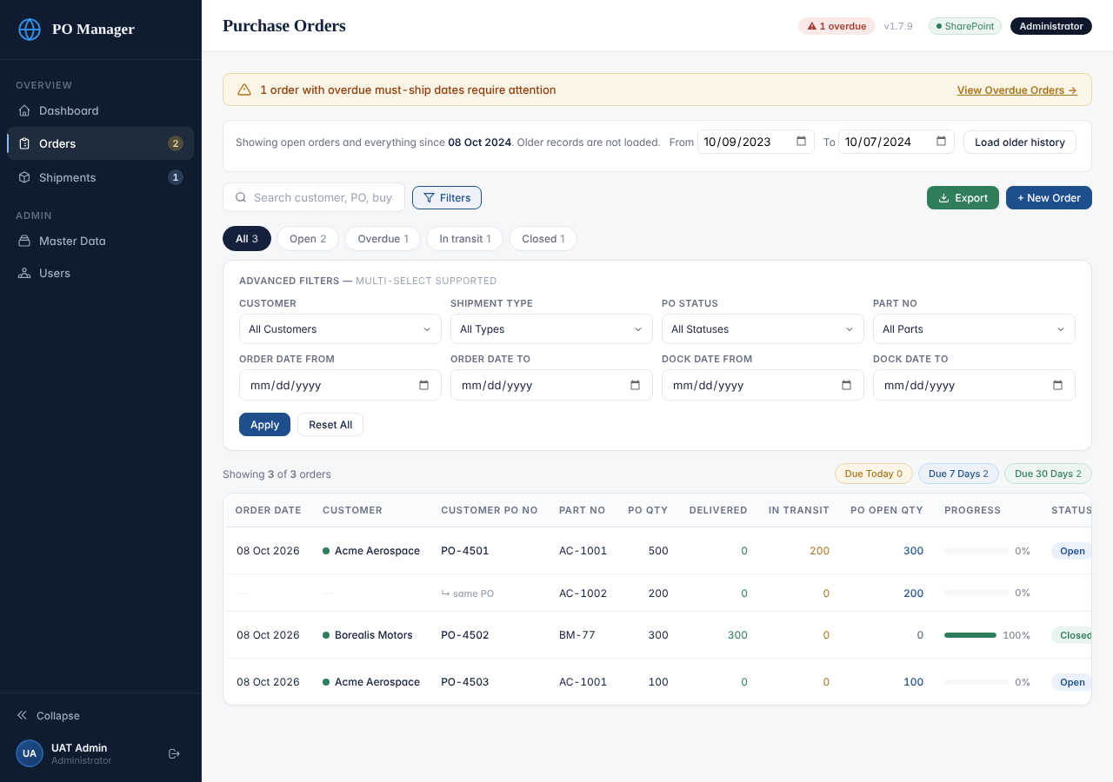
Advanced filters
- Customer, Shipment Type, PO Status and Part No allow several selections at once. Order Date From/To and Dock Date From/To narrow by date. Click Apply; Reset All clears everything.

6.2 Older orders: the “Load older history” bar
To keep the app fast, at sign-in it loads all open orders plus every order from the last 24 months. Older closed orders are not loaded. The blue bar above the list says what is loaded. To see older orders, choose a From and To date and click Load older history. They are added to the screen for this session only. If the page shows nothing for an old order you expect, load the date range first.

6.3 Create an order (three steps)
- Go to Orders and click + New Order.
- Step 1: Order Header. Pick the Customer (from the Master Data list). Order Date defaults to today. Type the Customer PO No and the Buyer’s Name. Blanket Order No is optional. Switch Consignment Order on if it applies. Click Next Step.
- Step 2: Line Items. For each line: Part No (the list shows only that customer’s parts), PO Qty, Shipment Type, In Transit Days, On Dock Date (Original) and, once known, Ship Date 1. Add India Rate and US Rate if you have them. Use + Add Line Item for more lines. Fields marked AUTO fill themselves.
- Step 3: Review & Save. Check the summary, then click Save Order. A confirmation box appears; it warns you if this customer already has an order with the same PO number. Click Confirm & Save.
- Watch the bottom-right pill: it must say Saved ✓.
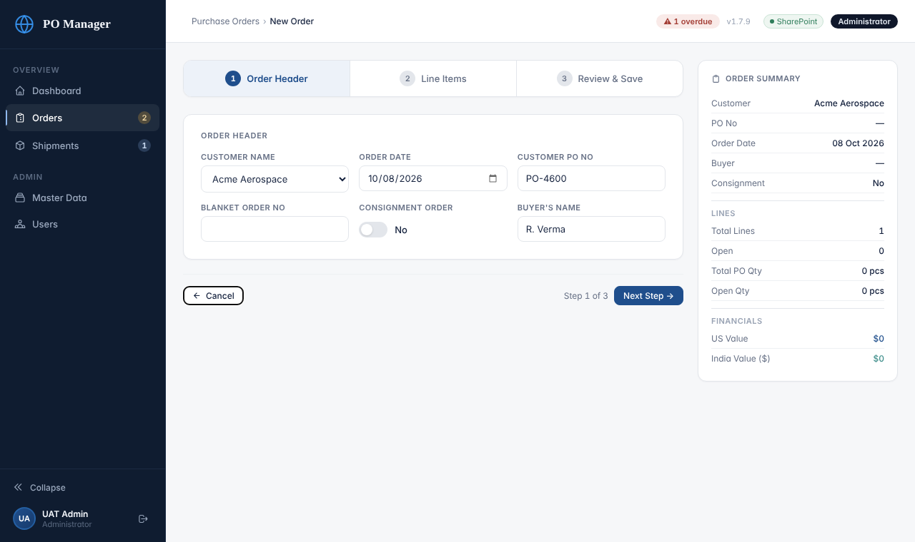
Step 1: Order Header
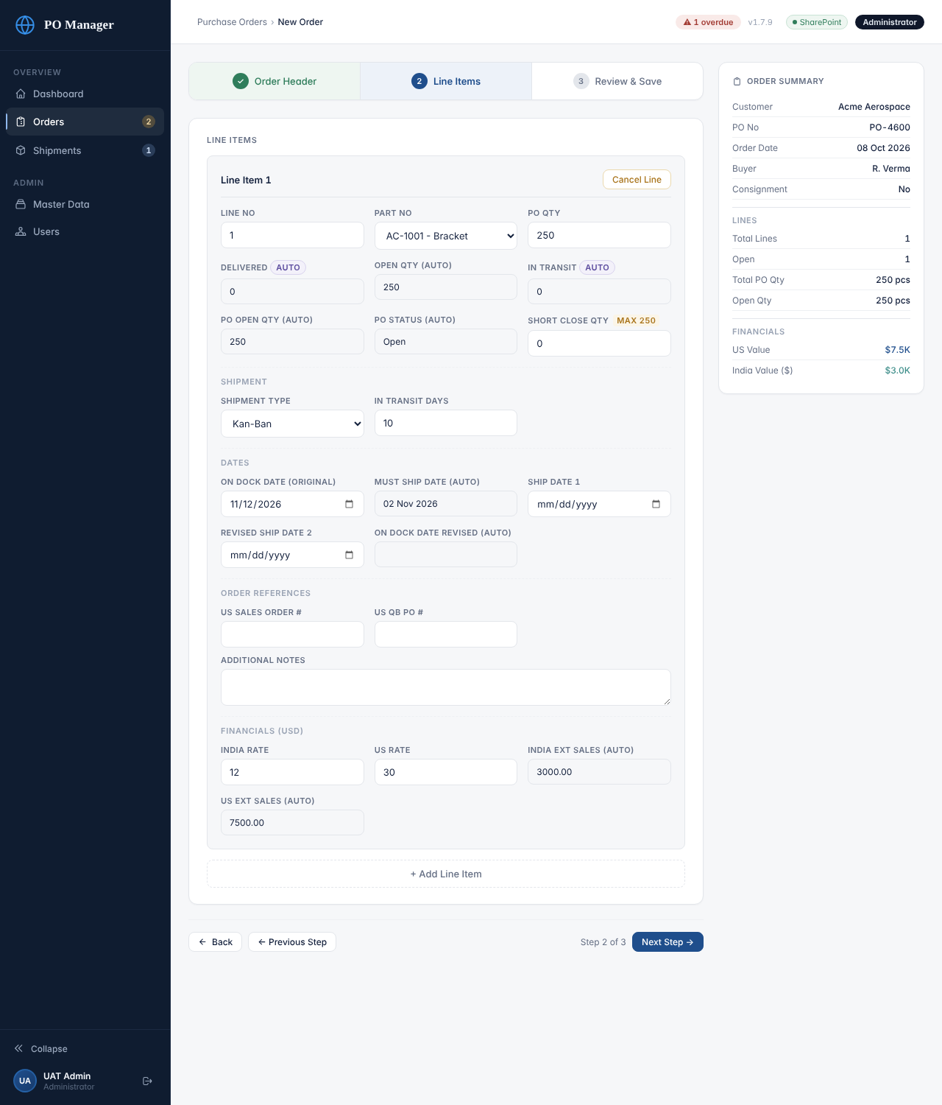
Step 2: Line Items (the right-hand panel keeps a running summary)
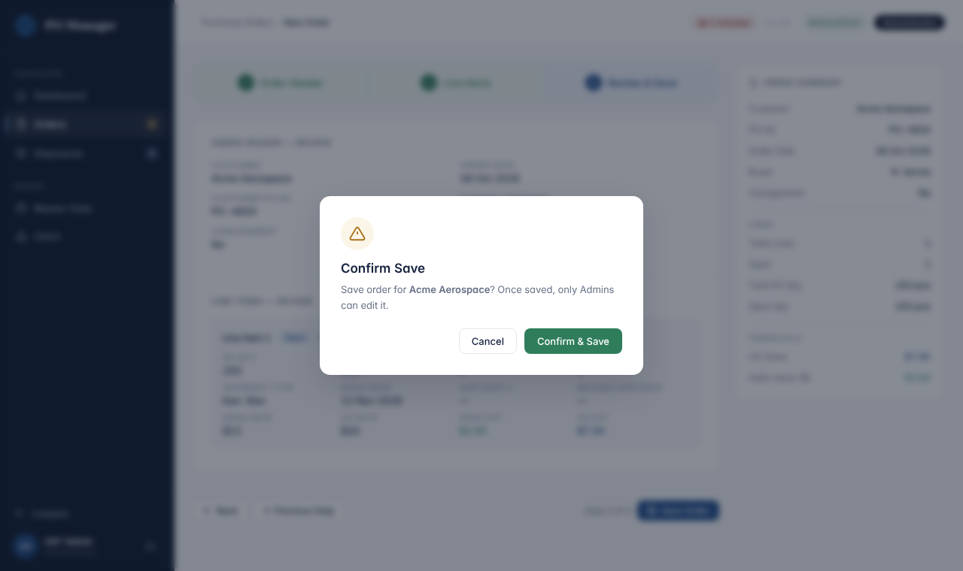
The confirmation box
Important
The app does not force you to fill in the Customer, PO number, Part No or quantity before saving. An order saved without a PO number is very hard to link to shipments later. Always check Step 3 before you confirm.

6.4 View an order
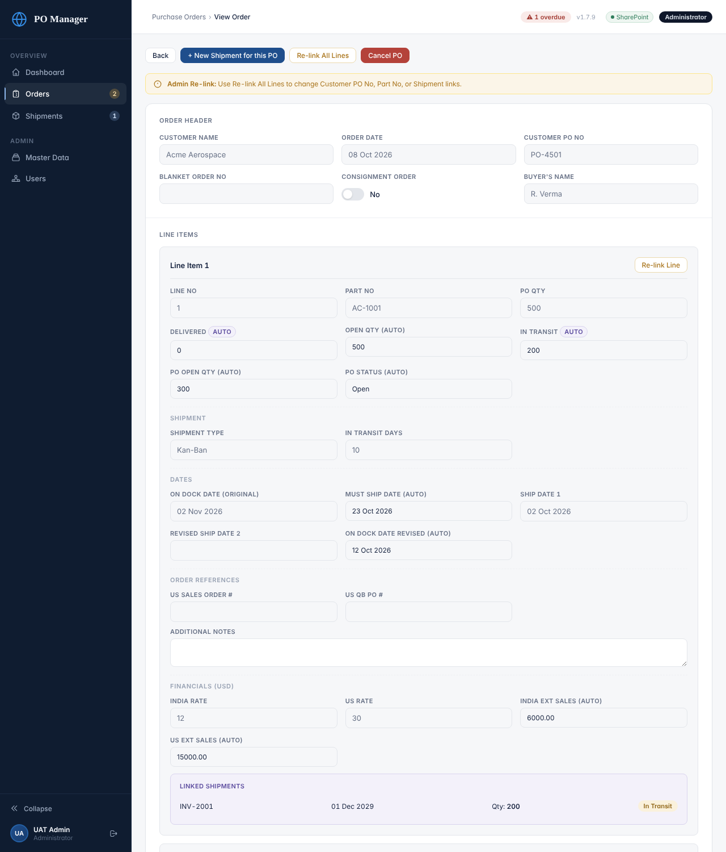
Viewing an order as an Administrator
Click View on any order. You see all fields (greyed out because nothing can be changed here), the Linked Shipments under each line, and an Audit History panel at the bottom listing every create/update/cancel/reopen with the person, the time and what changed. The buttons at the top are: Back; + New Shipment for this PO (starts a shipment with this PO filled in); Re-link All Lines and Cancel PO (Administrators).

6.5 Edit an order
- On the Orders list click Edit. The same three steps open with the saved values.
- Change what you need. You may change any field except the automatic ones. To change the customer’s part on a line use the Part No list; to change the PO number type a new one (see the warning below).
- Click through to Step 3 and Save Order; confirm. The audit history records exactly which fields changed from what to what.
Important
Changing a Customer PO No or Part No on an order breaks its links to shipments, because shipment lines remember the old PO and part. After changing either, open the affected shipments and use Re-link (7.5) so the quantities follow the order again.

6.6 Short close, cancel and reopen a line
Action | Where | What it does
Short Close | Edit order, Step 2: type a quantity in Short Close Qty (the maximum offered is PO Qty minus Delivered). | Reduces the quantity the customer still has to receive: Effective quantity = PO Qty − Short Close Qty. The line shows “Short Closed”. A hint under the field shows the new Open Qty. Clearing the field (0) reopens the line.
Cancel Line | Edit order, Step 2, button on the line (Administrators and Staff). | Marks that line Cancelled (effective quantity 0). The change is only stored when you finish with Save Order, although the audit entry is written at once. If you click Cancel Line by mistake, leave without saving.
Reopen Line | Edit order, Step 2, on a cancelled line (Administrators only). | Sets the line back to Open and clears its Short Close Qty. Save the order afterwards.

6.7 Cancel and reopen a whole PO
- Open the order with View.
- Click Cancel PO (red). Confirm “Cancel all open lines…”. Every open line becomes Cancelled and the page shows CANCELLED.
- To undo it, click Reopen PO and confirm. Every cancelled line becomes Open again (Short Close quantities on those lines are cleared).
Both actions are saved immediately and appear in the audit history. If you only want to cancel some lines, use Cancel Line in Edit instead.

6.8 Delete an order
On the Orders list click Delete (red text) next to the order and confirm. This removes the order record and its rates record from SharePoint. Shipments that mention that PO are not deleted; they simply no longer count towards any order. Prefer Cancel PO unless the order was entered by mistake.
Never do this
The app has no undo. A deleted record might be recoverable from SharePoint, but this is not guaranteed (see the Owner’s Runbook, section “Restoring data”). Tell the system owner at once if you delete the wrong order or shipment, before anyone does more work on it.

6.9 Re-link an order
On an order’s View page, Re-link Line (one line) or Re-link All Lines opens a box with two sections per line: (1) Change Part No to another part of the same customer, and (2) Re-link to a Different Shipment Invoice. The invoice box starts on “— No change —”; invoices already linked are marked “✓ linked”. Choosing an invoice moves the link for that PO and part to the chosen invoice and clears the PO/part on that part’s lines in the other invoices.
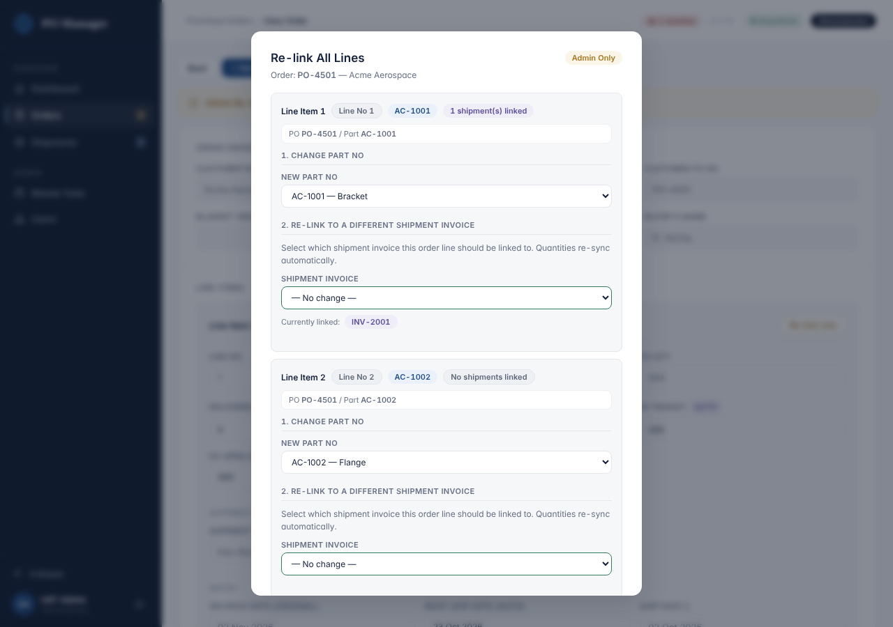
Re-link box on an order
Important
For fixing which shipment counts against which order line, the shipment’s own Re-link (7.5) is safer and clearer. Use the order Re-link mainly to change a part number. If you open the box by accident, click Cancel.

7. Shipments

7.1 The Shipments list
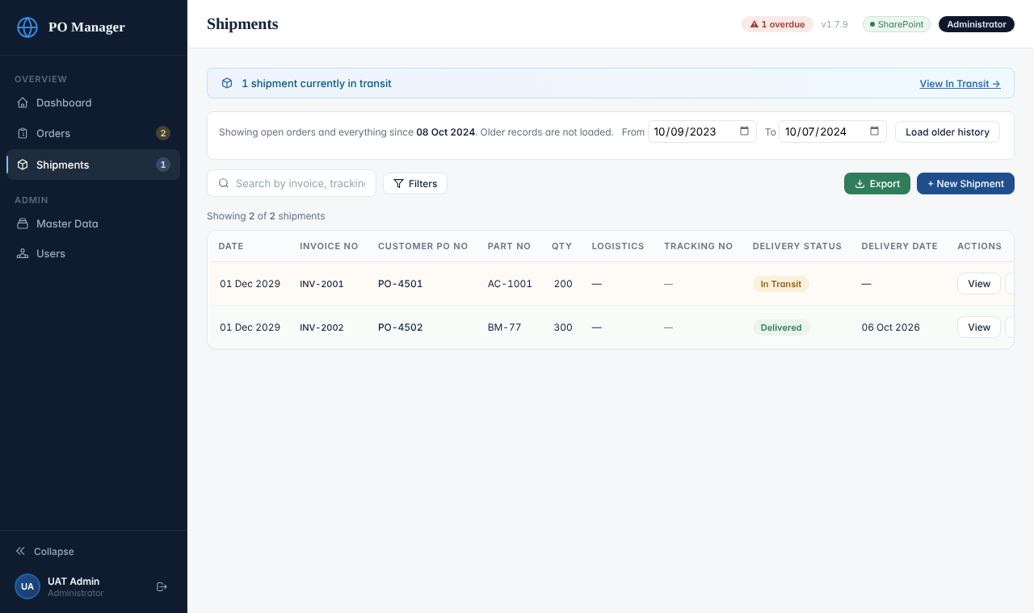
The Shipments list
- The blue strip at the top says how many shipments are currently in transit; “View In Transit” filters the list.
- Search finds Invoice No, Tracking No, customer, part number or PO number. Filters: customer, delivery status, Kan-Ban yes/no, location, part, PO, ship date range and delivery date range. Click Date, Invoice No or Delivery Status to sort.
- Buttons on each row: View; Edit (Administrators) or Update (Staff); Re-link and Delete (Administrators).
- The same “Load older history” bar as on Orders is shown. Shipments are loaded from 30 days before the 24-month limit and from earlier for any still-open order.

7.2 Create a shipment (three steps)
- Go to Shipments and click + New Shipment (or use + New Shipment for this PO on an order).
- Step 1: Shipment Header. Shipping Invoice No is required. Fill in GST Invoice No, Date of Invoice, Date of Shipping, Transport Method, Logistics, Tracking # / Airwaybill No, Customs House Agent, Kan-Ban and Location.
- Step 2: Line Items. For each line choose in this order: Customer PO No, then Part No, then Order Line No (the key that prevents the same shipment being counted against several order lines that have the same part). Enter Shipped Qty, Shipped To (the customer) and Delivery Status (In Transit or Delivered). For a delivered line also enter the Delivery Date. US Invoice No and Heat No are optional.
- Step 3: Review & Save. Check, then Save Shipment and Confirm & Save. If the quantities you are shipping, added to what was already shipped for the same PO and part, are more than was ordered, the confirmation box shows an Over-shipping warning. You may still save if it is intended.
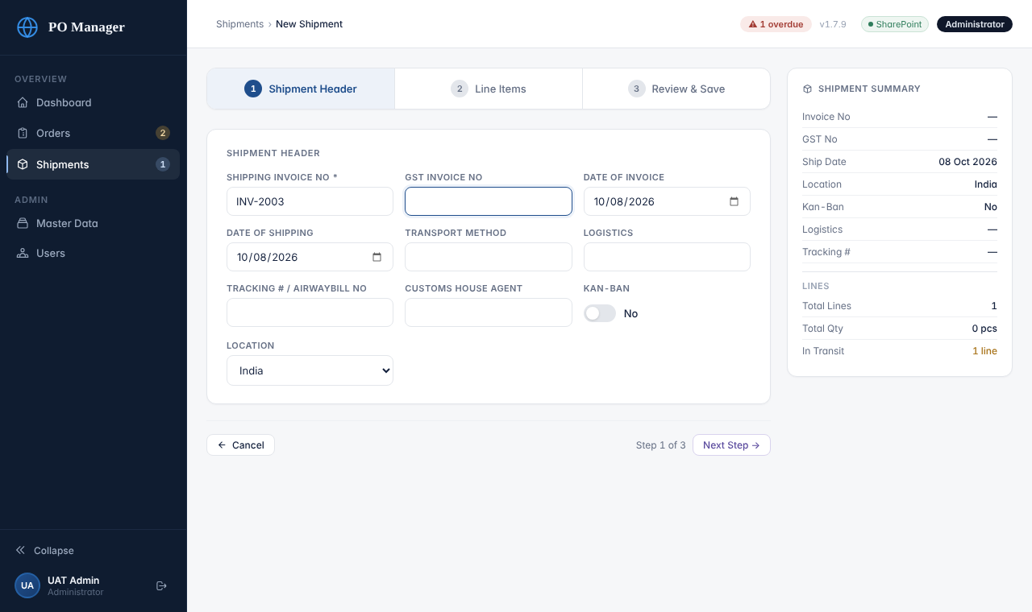
Step 1: Shipment Header
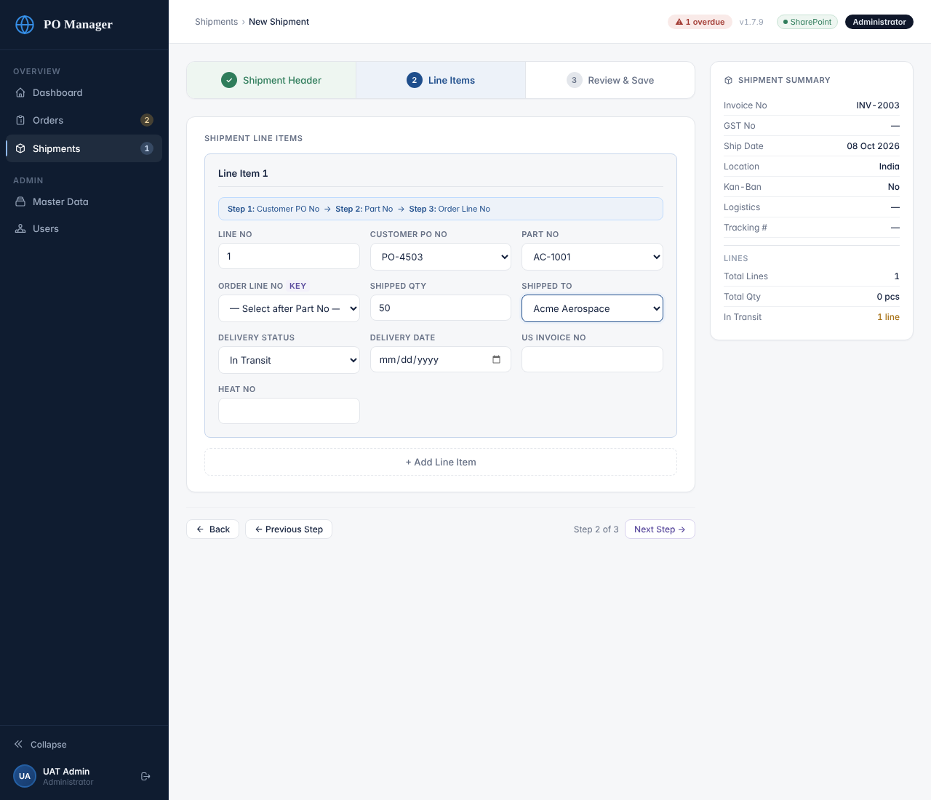
Step 2: Line Items (choose PO, then Part, then Order Line)
Important
If you leave Order Line No empty, the app spreads the quantity across the order’s lines for that part, filling them in order. That is fine when a PO has one line per part, but set the Order Line No whenever the same part appears on more than one line of the PO.

7.3 Update delivery (the usual follow-up)
When goods arrive, open the shipment with Edit (or Update), go to Step 2, change the line’s Delivery Status to Delivered, enter the Delivery Date, then save. The order line’s Delivered quantity goes up, In Transit goes down, and the line closes when everything has been delivered. A shipment is shown as Delivered when all its lines are delivered, otherwise In Transit.

7.4 Edit a shipment
Administrators can change every field, add or remove lines and change the PO/part links. After any change the order quantities are recalculated automatically.

7.5 Re-link a shipment
Use this when a shipment line points at the wrong PO, part or order line (for example after an order’s PO number changed). On the Shipments list click Re-link. For each line choose the correct Customer PO No, then Part No, then Order Line No, and click Save & Re-sync Orders. Quantities move to the new order line at once.
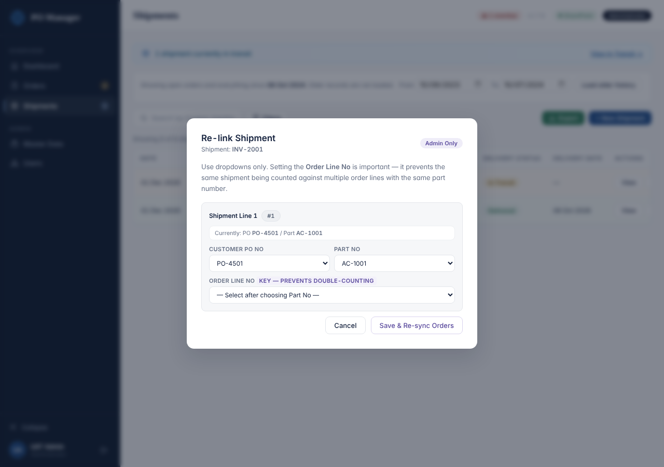
Re-link box on a shipment

7.6 Delete a shipment
Click Delete on the Shipments list and confirm. The quantities that shipment contributed are removed from the order lines automatically. As with orders, there is no undo inside the app.

8. Master Data and Users

8.1 Customers and part numbers
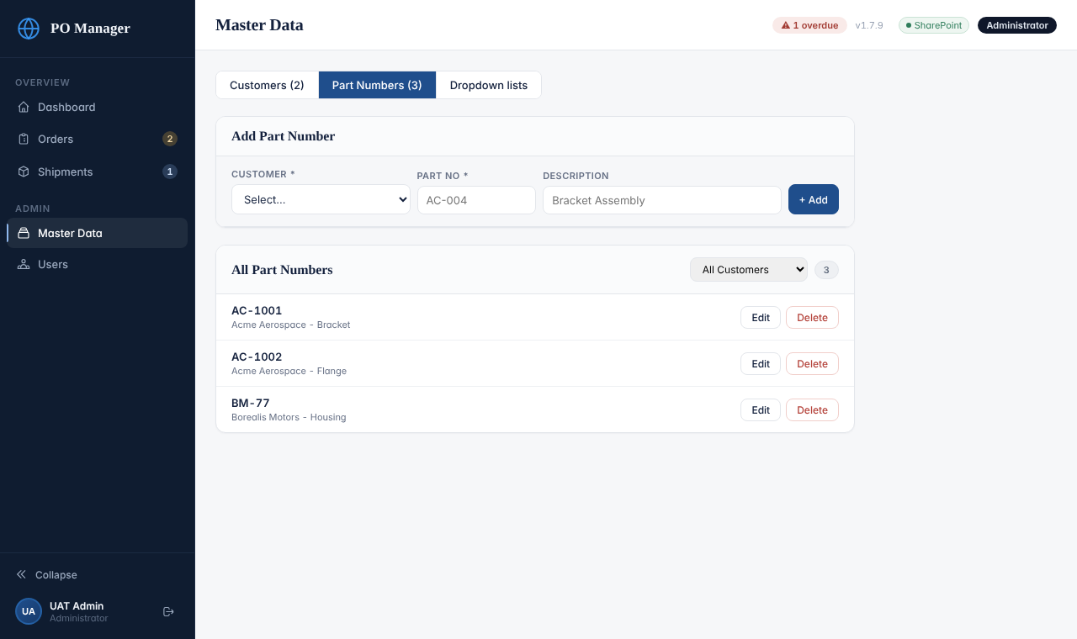
Master Data
- Master Data → Customers: add a customer with Name (required, must be unique), Contact and Email. Edit or Delete each row.
- Master Data → Part Numbers: add a part by choosing the Customer, typing the Part No (required, unique per customer) and a Description. The “Part No” list in orders and shipments shows only the parts of the chosen customer.
- Before the first order for a new customer: add the customer, then its parts, then create the order.
Important
Renaming a customer or part changes the master list only. Orders and shipments already saved keep the old name or number as typed. Deleting a customer also deletes all of its parts (the confirmation says how many). Existing orders are not deleted.

8.2 Dropdown lists and maintenance
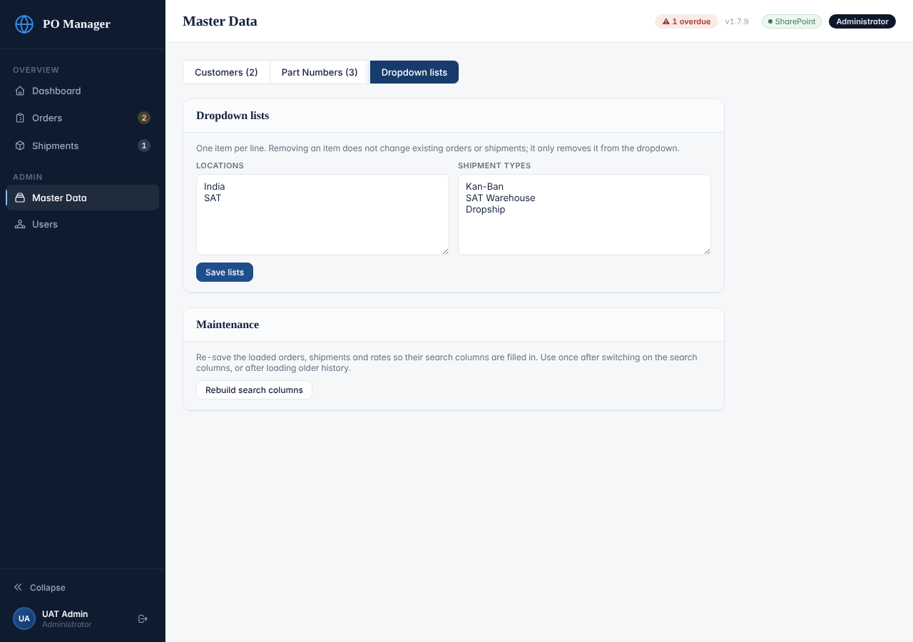
Dropdown lists
- Locations and Shipment types: one item per line. Each list needs at least one item. Click Save lists. Removing an item only removes it from the dropdown; records that already use it keep it.
- Defaults: Locations India, SAT. Shipment types Kan-Ban, SAT Warehouse, Dropship. Delivery status (In Transit, Delivered) is fixed.
- Rebuild search columns (Maintenance box): re-saves every order, shipment and rate record that is currently loaded so that the SharePoint search columns are filled in. Needed only after the search columns were first switched on or after loading older history that was saved before then. It can take a few minutes; do not close the page while it runs.

8.3 Users
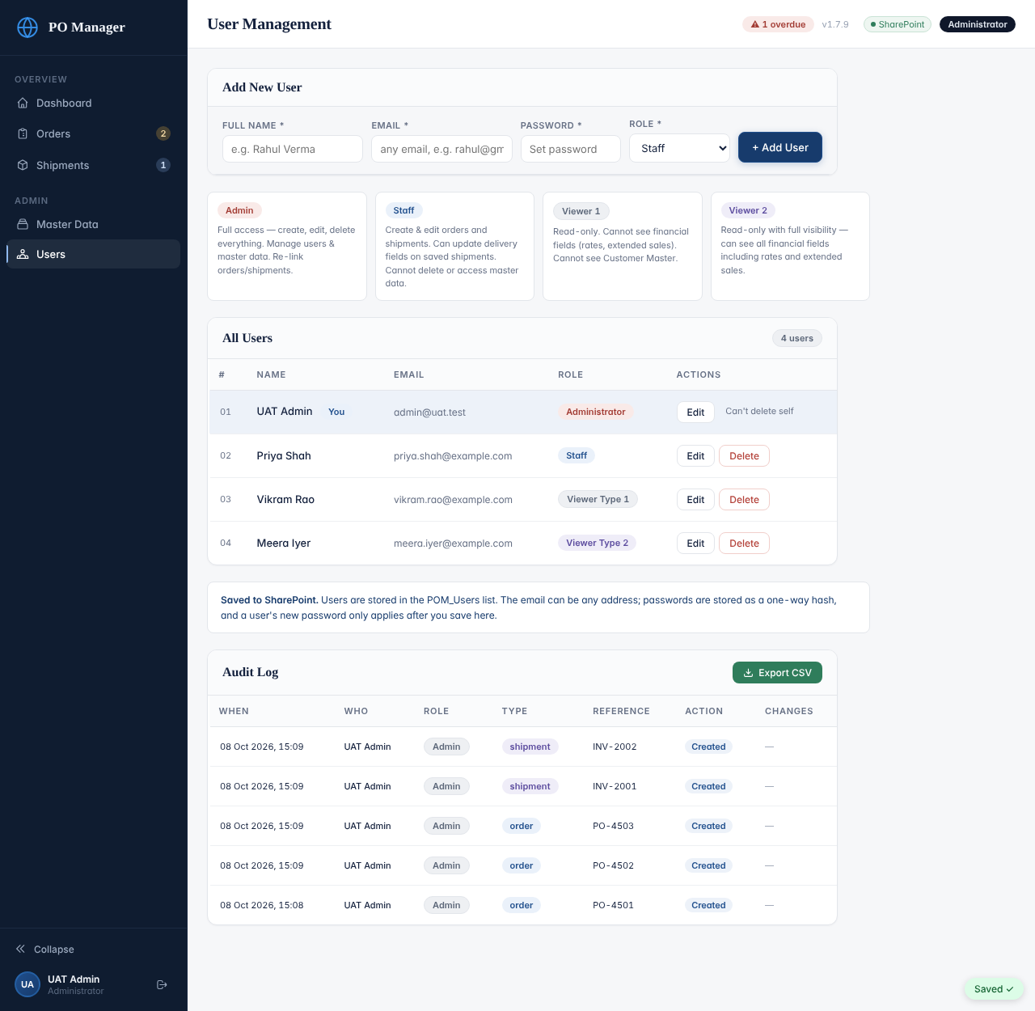
Users (Add New User, role cards, All Users, Audit Log)

Add a user
- Go to Users. Under Add New User type the Full Name, the Email (this is the login ID; any email address works), a Password and choose the Role.
- Click + Add User. The person can sign in straight away.
- Give the password to the person safely (not in a group chat). Ask them to keep it private. The app does not enforce a minimum length, so insist on at least 12 characters.

Change a user, reset a password, unlock an account
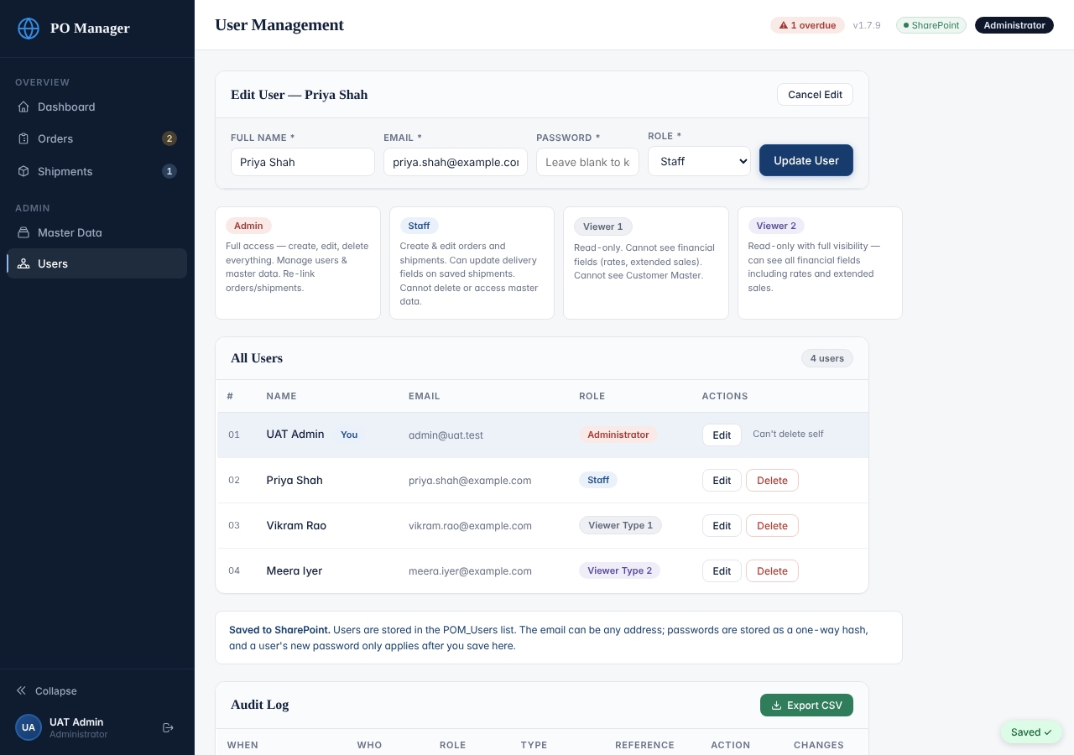
Editing a user
- Click Edit on the person’s row. Change Full Name, Email or Role. Leave the Password box empty to keep the current password, or type a new one to reset it.
- If you change the Email you must also type a new password (the password is tied to the email).
- Resetting a password also unlocks an account that was locked after wrong attempts.
- When you change a person’s password, email or role, or delete them, any session they have open stops working immediately and they must sign in again.
- To stop someone using the app, click Delete on their row and confirm. You cannot delete your own login (“Can’t delete self”).
Never do this
Never remove or demote the last Administrator. There is no safety check for this. Always create the replacement Administrator first and test the sign-in, then change the old one.

The audit log
At the bottom of the Users page the Audit Log lists every create, update, cancel and reopen of orders and shipments: when, who, their role, the type, the reference (PO or invoice number), the action and what changed. It loads the newest 200 entries; click Load older entries for more. Export CSV downloads the loaded entries. Individual orders show their own history at the bottom of the View page.

9. Exports and when something goes wrong

9.1 Exports
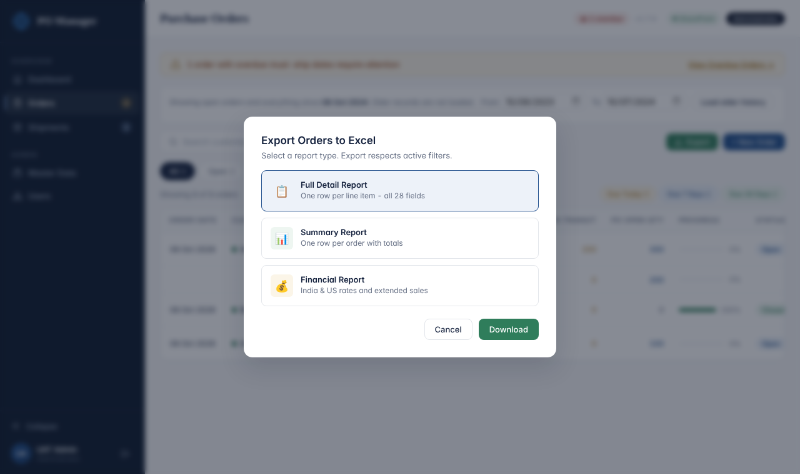
Export dialog on the Orders page
- Orders → Export: Full Detail (one row per line), Summary (one row per order with totals) or Financial (India and US rates and extended sales; finance roles only).
- Shipments → Export: Full Detail (one row per shipment line), Summary (one row per invoice) or Delivery Status (tracking, logistics, delivery dates).
- An export includes only the rows that match the current search and filters, and only the orders/shipments that are loaded. Clear the filters first for a complete export.
- The file downloads as .csv (for example PO_Full_Report.csv) and opens in Excel. The Audit log has its own Export CSV.

9.2 Messages you may see
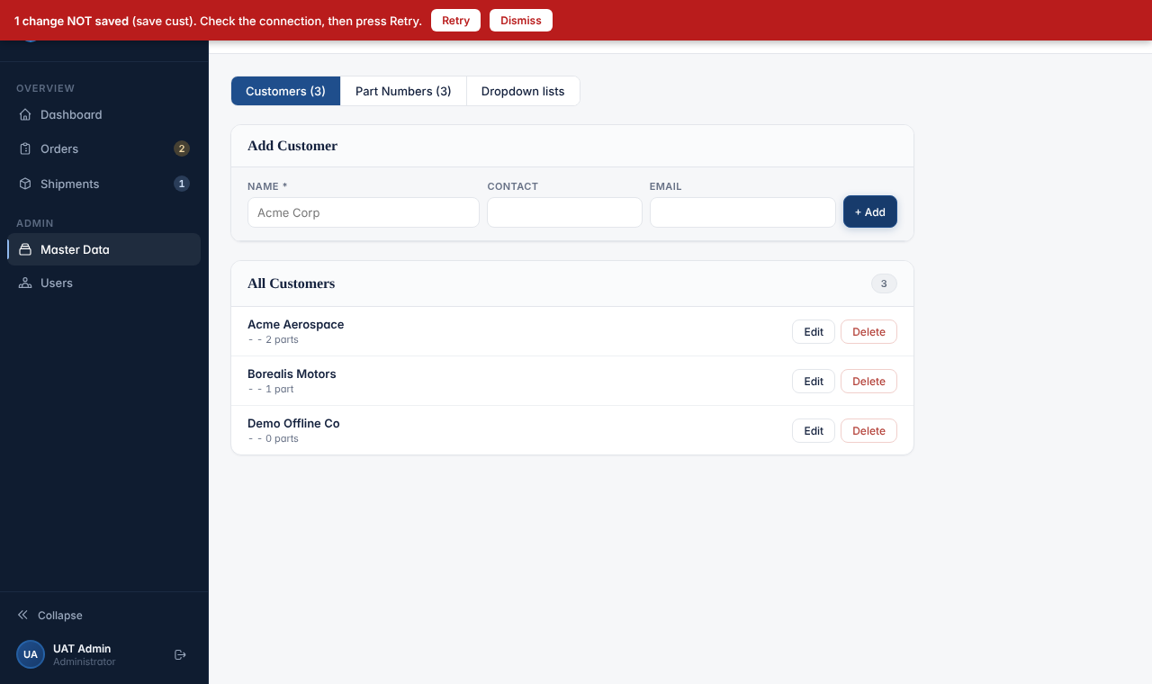
A failed save: the red bar
What you see | What it means | What to do
Red bar: “N change(s) NOT saved … Check the connection, then press Retry.” | The change did not reach SharePoint (connection problem or the flow was busy). | Check your internet connection and click Retry. Do not close the page until the bar disappears and the pill says Saved ✓.
Red bar: “Someone else changed the same record.” with Overwrite / Reload buttons | Another person saved this order or shipment after you opened it. | Click Reload latest data to see their version and redo your change. Use Overwrite with my version only if you are sure yours is the right one.
Red bar: “Your sign-in expired — sign in again, then press Retry.” | Your 12 hours ended. | Sign in again; then press Retry if the bar is still there.
“Your session expired. Please sign in again.” | Same as above, or an Administrator changed your account. | Sign in again.
“Invalid email or password.” | Wrong email or password. | Retype carefully. After 5 wrong attempts the account locks for 15 minutes.
A message containing “Too many failed attempts” | The account is locked. | Wait 15 minutes, or ask an Administrator to reset your password (unlocks at once).
“Sign-in failed: …” followed by other text | The app could not reach, or was refused by, the flow. | Try again in a minute. If it persists, follow the Owner’s Runbook troubleshooting section and send the exact text to the system owner.

10. Checklists you can print

Every day
- Open the dashboard. Look at Overdue and Upcoming Must-Ship. Click through and make sure every open line has a Ship Date 1.
- Open Shipments → View In Transit. Update any shipment that has arrived to Delivered with its Delivery Date.
- Check there is no red “NOT saved” bar before you finish for the day.

Every week
- Skim the Audit Log for unexpected changes or deletions.
- Check that the number of Open orders looks right against your own records.
- Ask whether anyone has forgotten a password or is locked out.

Every month
- Review the Users list. Delete anyone who has left. Confirm there are still at least two Administrators.
- Ask the system owner to confirm the flow has no failed runs and a recent backup exists (Owner’s Runbook, section 9).

Adding a new customer
- Master Data → Customers → add the customer.
- Master Data → Part Numbers → add every part for that customer.
- Orders → + New Order.

Someone joins the team
- Decide the role: Staff (enters and updates), Viewer 2 (sees everything, changes nothing), Viewer 1 (as Viewer 2 but without prices).
- Users → Add New User with their work email and a strong password; give them the right guide (Staff Guide or Viewer Guide).
- Ask them to sign in, open an order and confirm they see what they should. Ask them to keep the password private.

Someone leaves the team
- Users → Delete their row on their last day. Their open sessions end immediately.
- If they were an Administrator, make sure at least two Administrators remain first.
- Their name stays in the audit history.

Appendix A: Order fields
Field | Who edits it | Notes
Customer Name | Admin (new orders) | Chosen from Master Data. Cannot be changed after the order is saved except by editing as Admin.
Order Date | Admin | Defaults to today when creating.
Customer PO No | Admin | The customer’s PO number. Shipment lines link to it by this text.
Blanket Order No | Admin | Optional.
Consignment Order | Admin | Yes / No toggle.
Buyer’s Name | Admin | Free text.
Line No | Admin | Numbers the lines 1, 2, 3…
Part No | Admin | From the customer’s parts in Master Data.
PO Qty | Admin | Quantity ordered.
Short Close Qty | Admin, Staff | Reduces the quantity still to be delivered; the line shows Short Closed.
Shipment Type | Admin, Staff | From the Shipment types list.
In Transit Days | Admin, Staff | Transit time in days; drives Must Ship Date and On Dock Date Revised.
On Dock Date (Original) | Admin | Date the goods are due at the customer’s dock.
Ship Date 1 | Admin, Staff | First committed ship date. Feeds overdue and upcoming.
Revised Ship Date 2 | Admin, Staff | New committed ship date if the first one moved. The later of the two counts.
US Sales Order #, US QB PO # | Admin, Staff | Internal references.
Additional Notes | Admin | Free text per line.
India Rate, US Rate | Admin, Staff | Visible to Admin, Staff, Viewer 2 only.
Delivered, In Transit, Open Qty, PO Open Qty, PO Status, Must Ship Date, On Dock Date Revised, Ext Sales | Nobody (automatic) | Calculated; see 4.2.

Appendix B: Shipment fields
Field | Who edits it | Notes
Shipping Invoice No * | Admin (required) | Required to save. Shown everywhere as the shipment’s name.
GST Invoice No, Date of Invoice, Date of Shipping, Transport Method, Logistics, Customs House Agent, Kan-Ban, Location | Admin | Date of Shipping drives the monthly shipment chart and the ship-date filters.
Tracking # / Airwaybill No | Admin, Staff | Staff may update this on a saved shipment.
Customer PO No, Part No, Order Line No | Admin | The link to the order line. Choose PO, then Part, then Order Line.
Shipped Qty, Shipped To | Admin | Quantity on this line and the customer receiving it.
Delivery Status | Admin, Staff | In Transit or Delivered; drives the order quantities.
Delivery Date | Admin, Staff | Needed for the on-time rate.
US Invoice No, Heat No | Admin, Staff | Optional references.

