Mentco PO Manager
Staff Guide
Entering orders and shipments, and keeping delivery information up to date
Item | Detail
Audience | Staff: people who enter orders and shipments and update delivery information.
App version | 1.7.9 (shown at the top right of every screen)
Document date | 8 October 2026
If you need help | Ask an Administrator. Name: [fill in] · Email: [fill in]
Companion documents | Viewer Guide · Administrator Guide (for Administrators) · Owner’s Runbook

What you can and cannot do
You can | You cannot (ask an Administrator)
Create new orders and new shipments. | Change a customer, part number or quantity (PO Qty) on a saved order.
Update saved orders: Shipment Type, In Transit Days, Ship Date 1, Revised Ship Date 2, US Sales Order #, US QB PO #, India Rate, US Rate, Short Close Qty, and cancel a line. | Cancel a whole PO, reopen a cancelled line or PO, delete an order or a shipment.
Update saved shipments: Tracking #, and per line Delivery Status, Delivery Date, US Invoice No, Heat No. | Re-link shipments or orders (move a shipment line to a different PO, part or order line), add or remove lines on a saved order or shipment.
See rates and values, the dashboard, the audit history, and export reports. | Add customers or part numbers, create users, change dropdown lists.

Note
The screens in this guide were captured with sample data (customers “Acme Aerospace” and “Borealis Motors”). Screens that were captured as an Administrator show a few extra buttons (such as Delete) that you will not see.

1. Signing in and out
- Open the address your Administrator gave you. Type your email and password and click Sign In.
- You stay signed in for 12 hours, and a page refresh keeps you signed in. Closing the tab or the browser signs you out. To sign out yourself click the arrow-out icon next to your name at the bottom of the left menu.
- After 5 wrong passwords in a row your account locks for 15 minutes. Ask an Administrator to reset your password if you cannot wait; that unlocks it at once.
- If you forget your password you cannot reset it yourself: ask an Administrator. Never share your password.

Finding your way around
The left menu has Dashboard, Orders and Shipments. The top right shows a red “N overdue” badge (open order lines whose committed ship date has passed), the app version and your role. A small pill at the bottom right says Saving… and then Saved ✓ every time the app stores something.
Important
Always wait for Saved ✓ before you close the page or move on. If a red bar appears at the top saying a change was NOT saved, read section 8 straight away.

Good to know
The screen does not update by itself. The app loads the data when you sign in or refresh the page. If a colleague has just entered or changed something, refresh the page (F5) to see it, and refresh before you edit a record that others may also be working on.

2. Finding an order or a shipment
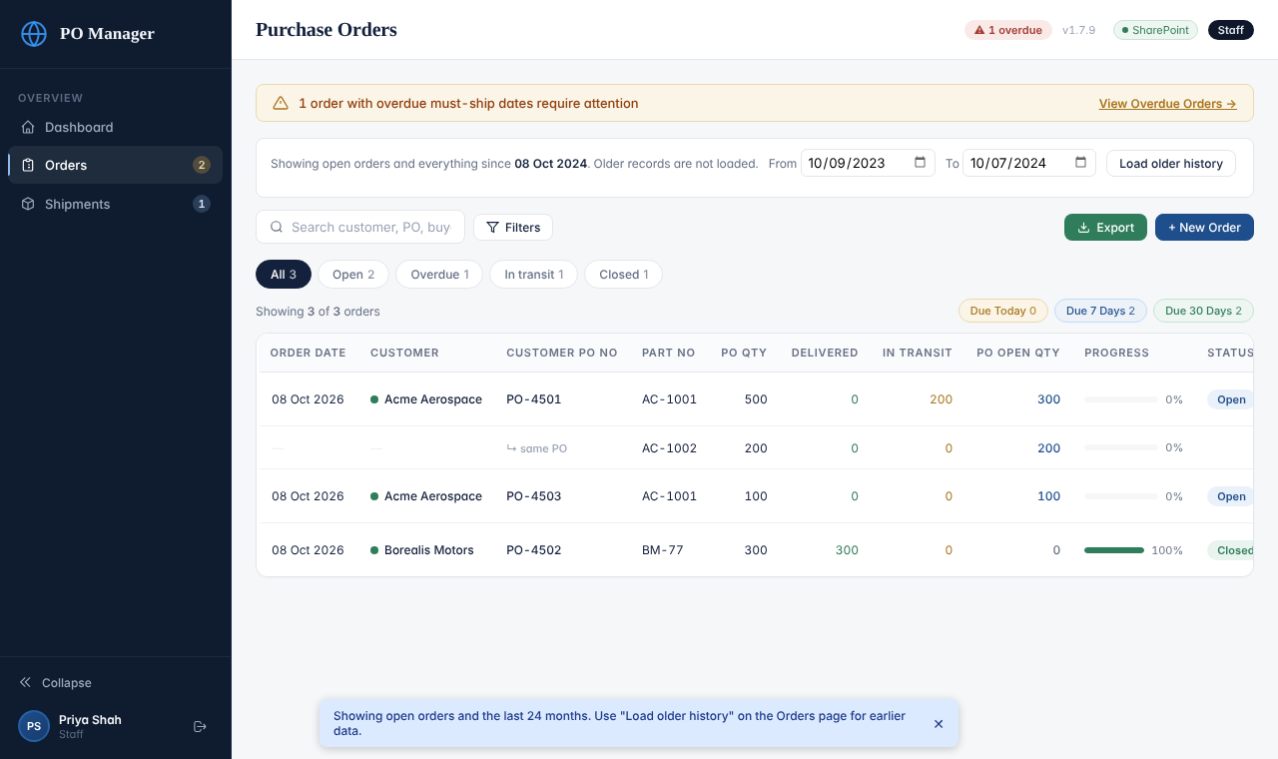
The Orders list as seen by Staff
- Search box: type part of a customer name, PO number, buyer name or part number.
- Chips under the search box: All, Open, Overdue, In transit, Closed, each with a count. Due Today / Due 7 Days / Due 30 Days at the right show open lines whose committed ship date is near.
- Filters button: choose customer, shipment type, status, part number, order date range and dock date range. Clear removes them.
- Click a column heading (Order Date, Customer, Customer PO No, PO Open Qty, Status) to sort; click again to reverse; a third click removes the sort.
- Each order is shown with one row per line. The buttons View and Update are on the first row of the order.
- Shipments work the same way: search by invoice number, tracking number, customer, part or PO.
Note
The app loads open orders and everything from the last 24 months. If you cannot find an older, closed order, choose dates in the blue Load older history bar and click the button.

3. Creating a new order
Before you start check that the customer and its part numbers exist. If a customer or part is missing from the lists, ask an Administrator to add it. Only then create the order.
- Click Orders, then + New Order.
- Step 1, Order Header. Choose the Customer. The Order Date is today’s date; change it if needed. Type the Customer PO No exactly as written on the customer’s PO and the Buyer’s Name. Blanket Order No is optional. Switch Consignment Order on only if it applies. Click Next Step.
- Step 2, Line Items. For every line choose the Part No, type the PO Qty, choose the Shipment Type, type the In Transit Days and the On Dock Date (Original) (the date the customer wants the goods at their dock). If you already know the promised ship date, type Ship Date 1. Add India Rate and US Rate if you have them. Click + Add Line Item for more lines. Fields marked AUTO are filled in by the app and cannot be typed.
- Step 3, Review & Save. Read the summary carefully, then click Save Order. A box asks you to confirm. If the same customer already has an order with this PO number, the box shows a red warning: stop and check before you save a duplicate.
- Click Confirm & Save and wait for Saved ✓.
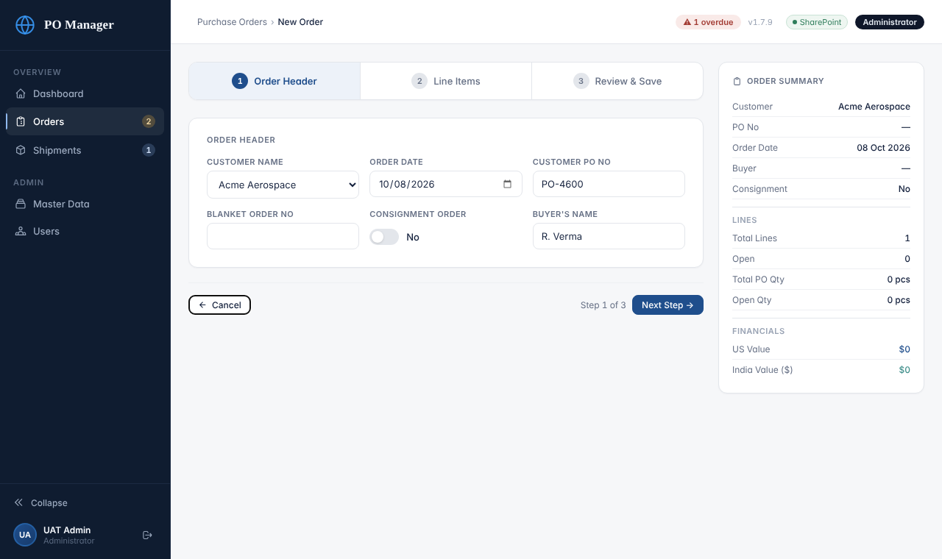
Step 1: Order Header
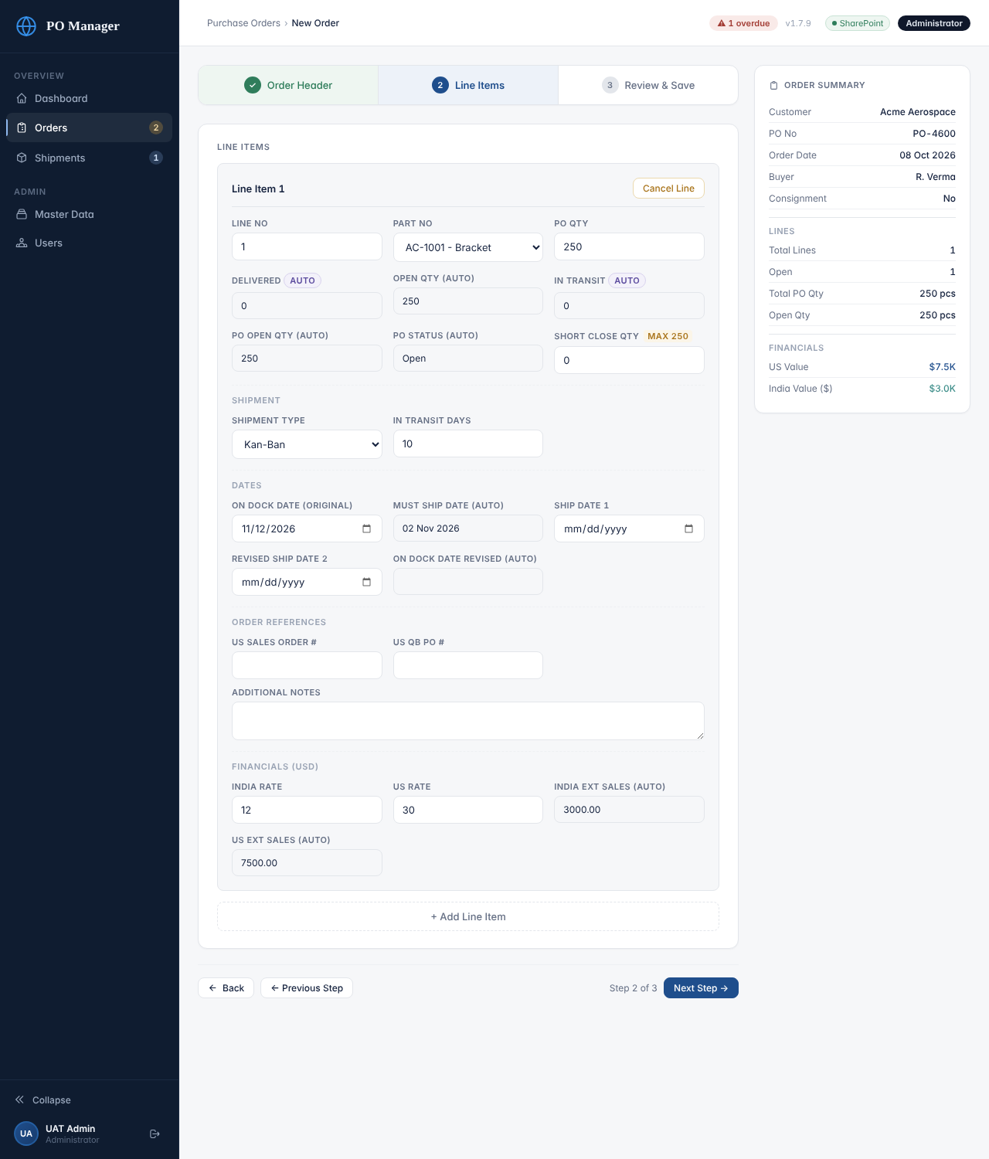
Step 2: Line Items
Never do this
Check before you save. The app does not stop you saving an order with an empty PO number, no part or a quantity of zero. After saving you cannot fix the customer, part or quantity yourself; only an Administrator can. Check Step 3 every time.

Why Ship Date 1 matters
A line is only reported as overdue (and only appears under “Upcoming Must-Ship”) once it has a Ship Date 1 or Revised Ship Date 2. If you leave both empty the line is never flagged. When a date changes, type the new one in Revised Ship Date 2; the later of the two dates is the one that counts.

4. Updating a saved order
- On the Orders list click Update next to the order.
- You will see a blue banner: Staff Update Mode. Only the fields listed in the banner can be changed; the rest are greyed out.
- Go through the steps, change what you need and click Save Order (Update) on Step 3. Confirm. Wait for Saved ✓.
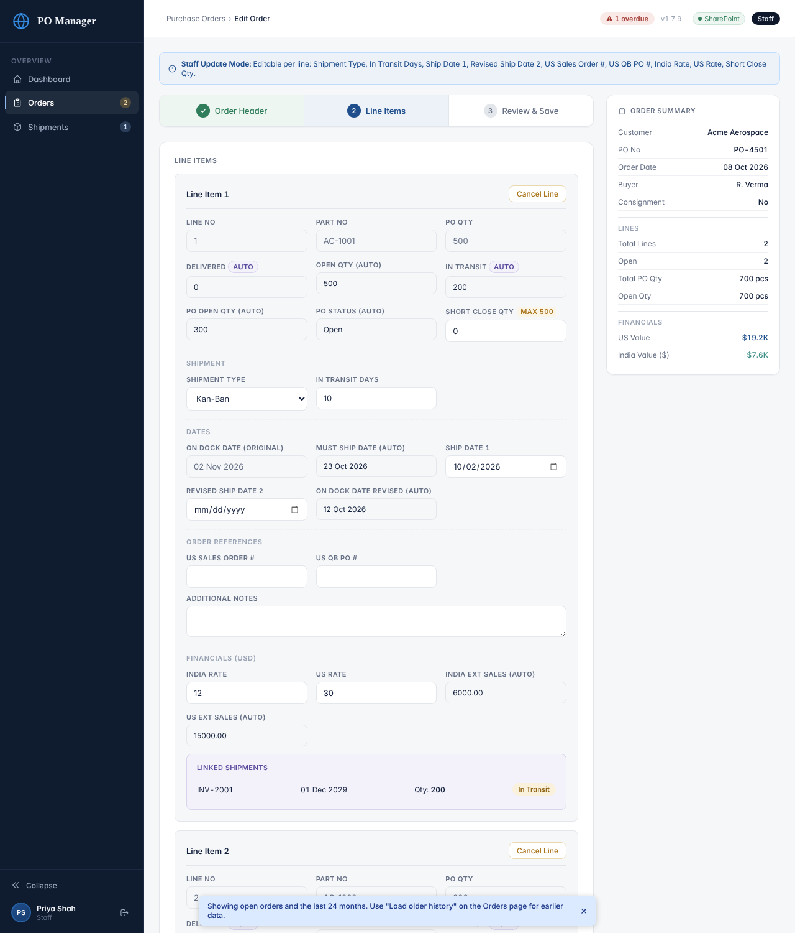
Staff Update Mode: only some fields are editable

Short close a line
If the customer agrees to receive fewer pieces than ordered, type the quantity you are not going to deliver into Short Close Qty on that line (the largest allowed is PO Qty minus what has already been delivered). A hint under the field shows the new Open Qty. The line then shows Short Closed and closes once the reduced quantity has been delivered. Setting the field back to 0 reopens the line.

Cancel a line
Click Cancel Line on the line in Step 2, then continue to Step 3 and click Save Order (Update). The cancellation is only stored when you save. If you clicked Cancel Line by mistake, leave the page without saving. Staff cannot undo a cancelled line afterwards: ask an Administrator to reopen it.

Look at the history
At the bottom of an order’s View page the Audit History lists every change with the person, time and details. Use it to find out who changed something.

5. Creating a shipment
- Click Shipments, then + New Shipment. (From an order’s View page you can click + New Shipment for this PO to start with the PO filled in.)
- Step 1, Shipment Header. The Shipping Invoice No is required. Fill in the GST Invoice No, Date of Invoice, Date of Shipping, Transport Method, Logistics, Tracking # / Airwaybill No, Customs House Agent, Kan-Ban and Location. Click Next Step.
- Step 2, Line Items. For each line choose in this order: Customer PO No, then Part No, then Order Line No. Then type Shipped Qty, choose Shipped To (the customer) and Delivery Status: In Transit if it has left, Delivered if it has already arrived (then also type the Delivery Date). US Invoice No and Heat No are optional.
- Step 3, Review & Save. Click Save Shipment and Confirm & Save. If you are shipping more than was ordered, the box shows an Over-shipping warning with the PO, part and numbers. Stop and check; save only if it is intended.
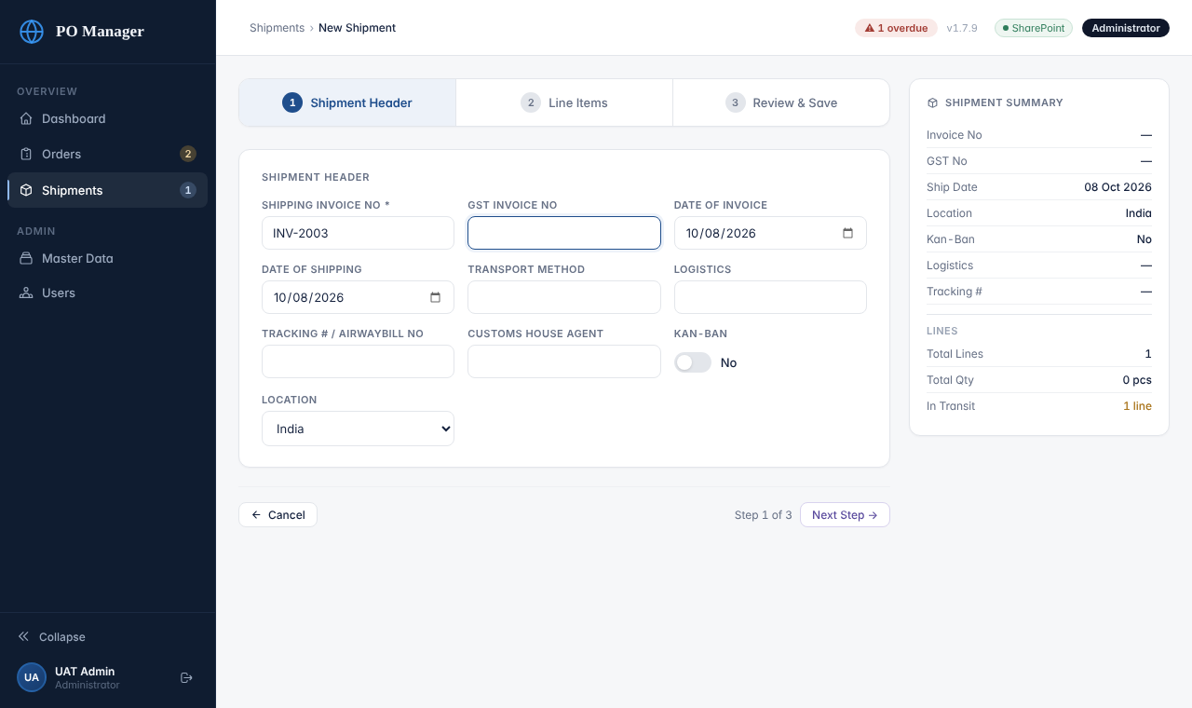
Step 1: Shipment Header
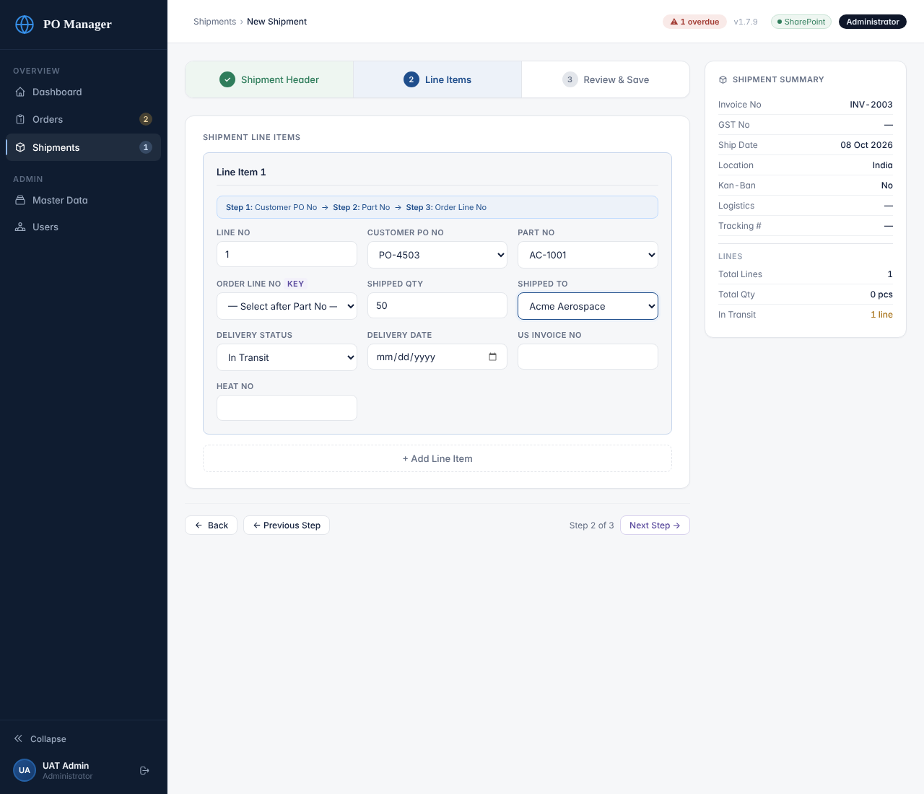
Step 2: choose PO, then Part, then Order Line
Important
Order Line No is the key. If a PO has the same part on more than one line, choose the correct Order Line No. If you leave it empty the app fills the PO’s lines for that part in order, which may not be what you intend.

Saving a shipment updates the order automatically: In Transit and Delivered on the order lines follow your shipment lines, and an order line closes when everything ordered has been delivered.

6. Recording a delivery
- Click Shipments and find the invoice (search by invoice number, or click “View In Transit”).
- Click Update on the shipment.
- Click Next Step to the line items. Change Delivery Status to Delivered and type the Delivery Date. You may also add US Invoice No and Heat No, and update Tracking # on Step 1.
- Click through to Step 3 and Save Shipment (Delivery Update). Confirm and wait for Saved ✓.
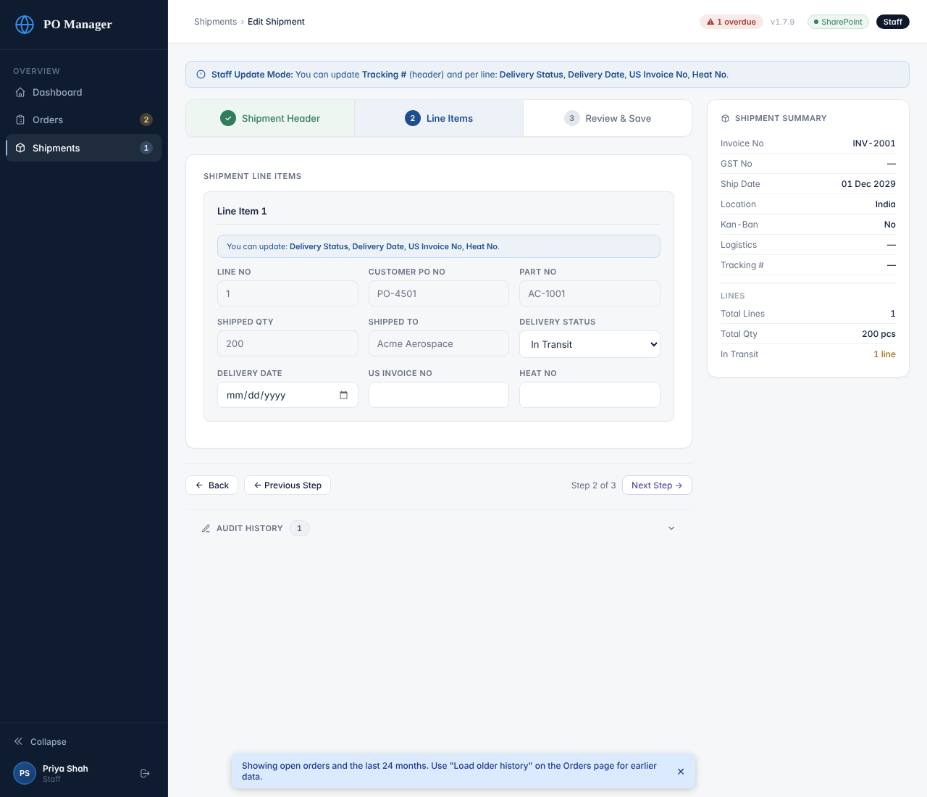
Staff Update Mode on a shipment
Note
The Delivery Date feeds the on-time delivery rate on the dashboard: a delivery counts as on time when its date is on or before the order line’s On Dock Date (Original). Always type it.

A shipment is shown as Delivered when all its lines are delivered; otherwise In Transit. If part of a shipment has arrived, set only those lines to Delivered.

7. Reports (export)
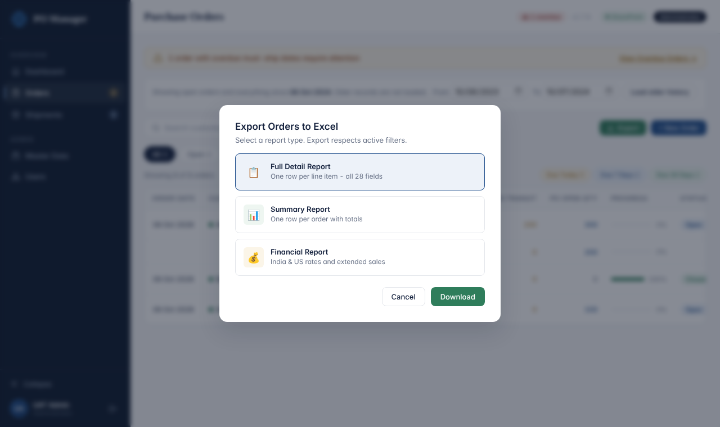
Export dialog
- Click Export on the Orders or Shipments page and pick a report: Orders: Full Detail (one row per line), Summary (one row per order), Financial (rates and extended sales). Shipments: Full Detail, Summary, Delivery Status.
- The report contains only what the screen currently shows: the same search and filters, and only loaded orders. Click Clear first if you want everything.
- The file downloads as a .csv that opens in Excel. Treat it as confidential company data: do not email it outside the company.

8. If something goes wrong
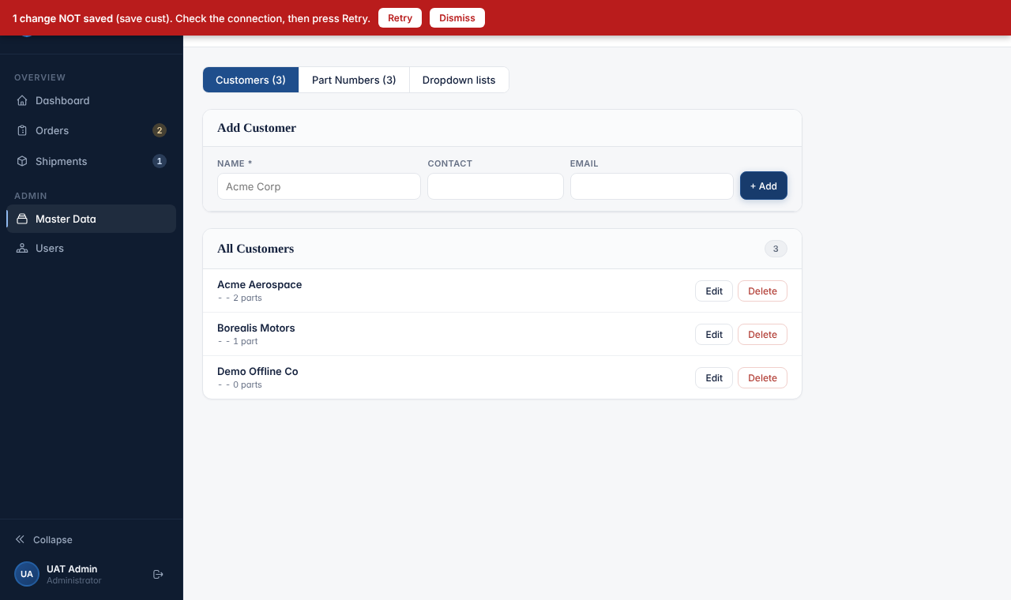
The red bar for a failed save
What you see | What to do
Red bar: “N change(s) NOT saved … Check the connection, then press Retry.” | Check your internet, click Retry. Do not close the page until the bar is gone and the pill says Saved ✓. If Retry keeps failing, tell an Administrator and keep the page open.
Red bar: “Someone else changed the same record.” (buttons Overwrite / Reload latest data) | Another person saved the same order or shipment. Click Reload latest data, look at their version, and redo only your change. Use Overwrite only if you are certain.
Red bar: “Your sign-in expired — sign in again, then press Retry.” | Sign in again, then click Retry.
“Your session expired. Please sign in again.” | Sign in again. Anything you had not saved must be typed again.
“Invalid email or password.” | Check Caps Lock and retype. Five wrong tries lock the account for 15 minutes.
A message with “Too many failed attempts” | Wait 15 minutes or ask an Administrator to reset your password.
I saved something wrong and the fields are greyed out | Ask an Administrator to correct it. Tell them the PO or invoice number and what is wrong.

Things to ask an Administrator to do
- Add a customer or part number that is missing from a list.
- Correct a PO number, part number or quantity on a saved order.
- Move a shipment line to a different PO, part or order line (Re-link).
- Cancel a whole PO, reopen a cancelled line or PO, or delete a wrong order or shipment.
- Reset your password.

9. Good habits (one page)
- One PO number, typed exactly as on the customer’s paper. Spaces and capital letters matter when shipments are linked.
- Fill in Ship Date 1 as soon as a date is promised. Without it nothing can be overdue.
- Choose PO, then Part, then Order Line when entering shipment lines.
- Set Delivery Status and Delivery Date the same day goods arrive.
- Wait for Saved ✓. Never close the page while the pill says Saving….
- Look at the dashboard each morning: Overdue and Upcoming Must-Ship tell you what needs attention.
- Do not share your login. The audit history records who did what under each login.

