Mentco PO Manager
Viewer Guide
Finding information, reading the dashboard and exporting reports (read-only access)
Item | Detail
Audience | Viewer Type 1 and Viewer Type 2: people who look at orders and shipments but do not enter or change data.
App version | 1.8.0 (shown at the top right of every screen)
Document date | 8 October 2026
If you need help | Ask an Administrator. Name: [fill in] · Email: [fill in]
Companion documents | Staff Guide · Administrator Guide · Owner’s Runbook

Which viewer type am I?
Your role is shown at the top right of every screen (“Viewer Type 1” or “Viewer Type 2”). Both roles can only look; neither can create, change or delete anything.
 | Viewer Type 1 | Viewer Type 2
Orders, shipments, dashboard (non-financial parts), audit history | Yes | Yes
Rates, extended sales, dollar values, finance cards and charts | No (shown as “No Access” or hidden) | Yes
Order “Financial Report” export | No | Yes
Order and shipment exports (other reports) | Yes, without the rate and value columns | Yes, complete
Create, edit, cancel, delete, re-link | No | No
Master Data and Users screens | Not shown | Not shown

Note
The rates are not sent to Viewer Type 1 at all, so there is no way to unhide them. If you need to see prices, ask an Administrator whether Viewer Type 2 is appropriate for your job.

1. Signing in and out
- Open the address your Administrator gave you. Type your email and password and click Sign In.
- You stay signed in for 12 hours. A page refresh keeps you signed in; closing the tab or the browser signs you out. To sign out yourself, click the arrow-out icon next to your name at the bottom of the left menu.
- After 5 wrong passwords in a row the account locks for 15 minutes. An Administrator can unlock it immediately by resetting your password. You cannot change your own password; ask an Administrator.
The left menu has Dashboard, Orders and Shipments. On a phone the menu starts collapsed as icons; tap the arrows at the bottom to open it.
Good to know
The screen does not update by itself. The app loads the data when you sign in or refresh the page. To see changes made by colleagues since then, refresh the page (F5) or sign in again.

2. The Dashboard
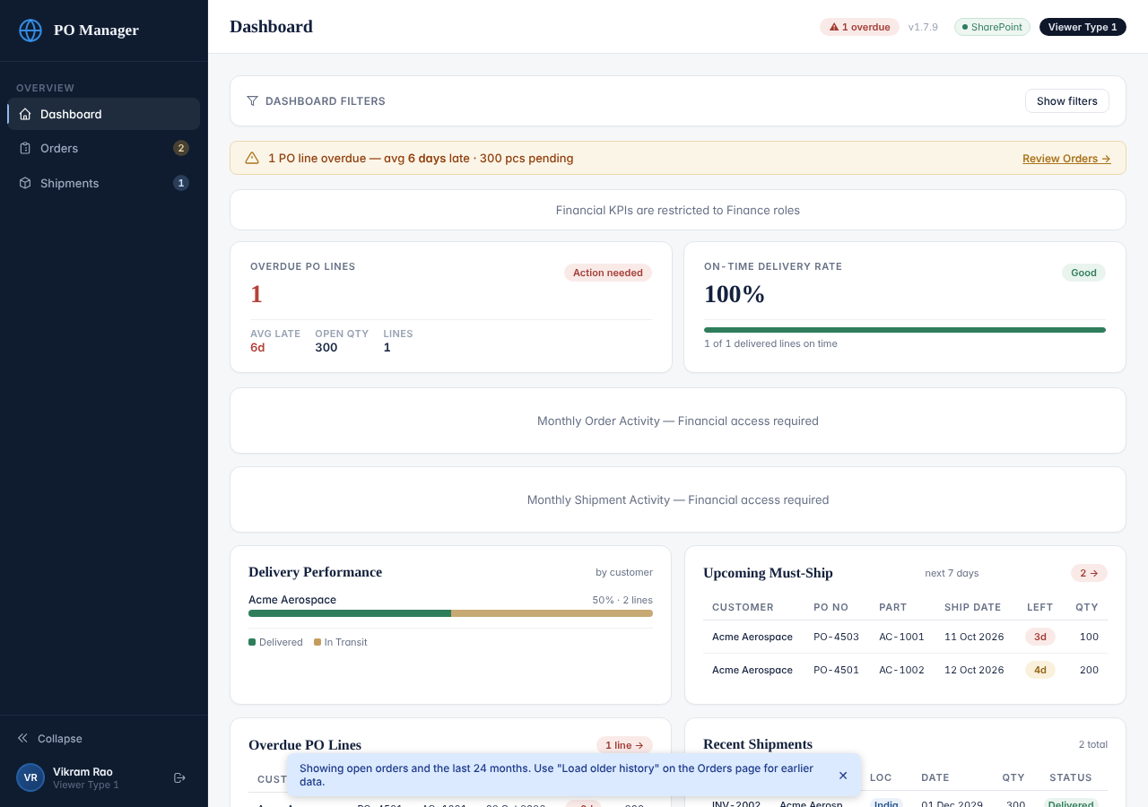
Dashboard as seen by Viewer Type 1 (no financial cards)
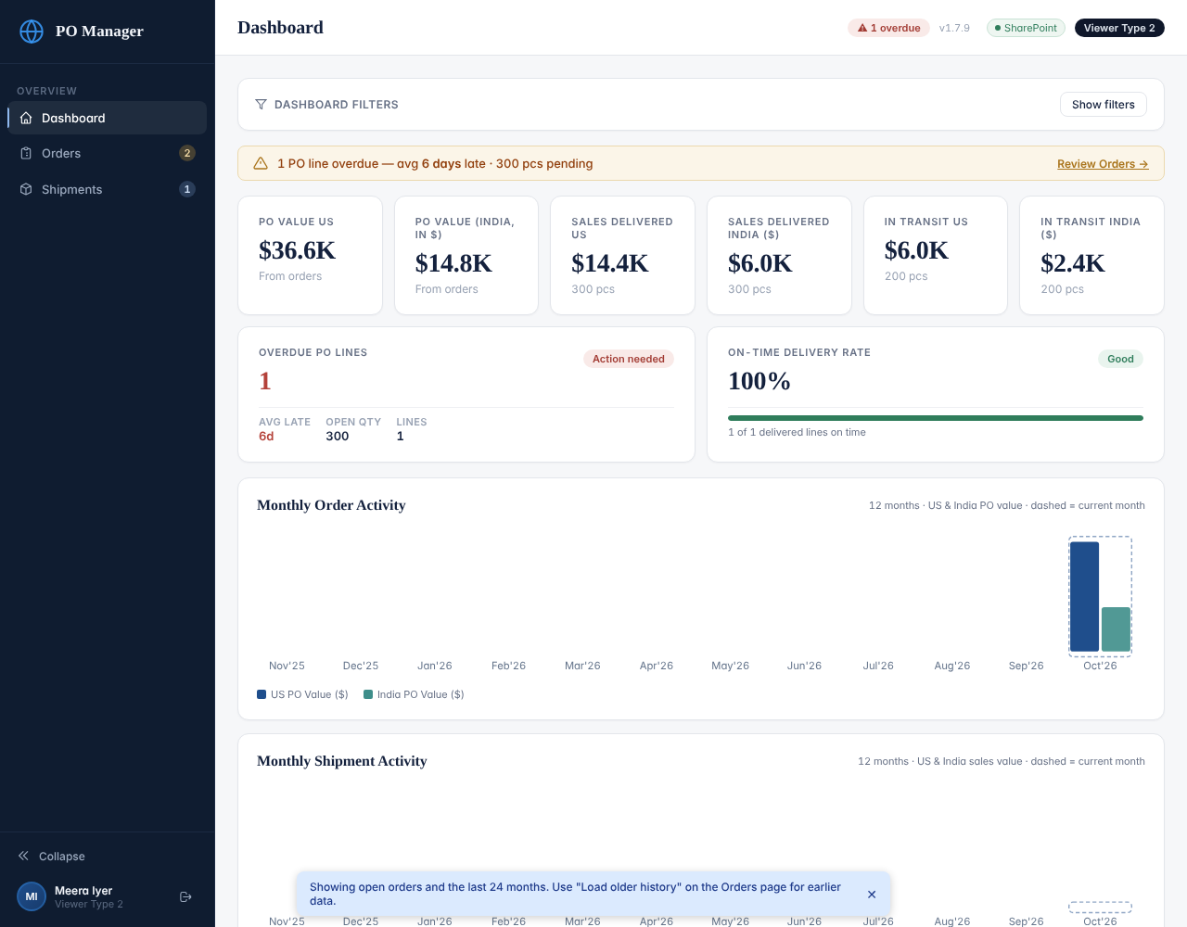
Dashboard as seen by Viewer Type 2 (includes the value cards and charts)
- Dashboard Filters (click “Show filters”): customer, part number, date range, PO status, shipment type and location. Click Apply, and Clear to reset.
- Overdue PO Lines: open order lines whose committed ship date has passed. The committed ship date is the later of Ship Date 1 and Revised Ship Date 2. A line with no ship date is never counted as overdue. Click the card to see the orders.
- On-Time Delivery Rate: of the delivered shipment lines, the share delivered on or before the order line’s dock date.
- Upcoming Must-Ship: open lines due to ship in the next 7 days. Overdue PO Lines and Recent Shipments list the newest items. Click a row to open that order.
- Viewer Type 2 only: value cards (PO value, sales delivered, in transit) and the monthly activity charts.
- Everything on the dashboard covers the data that is loaded: open orders plus the last 24 months.

3. Finding orders
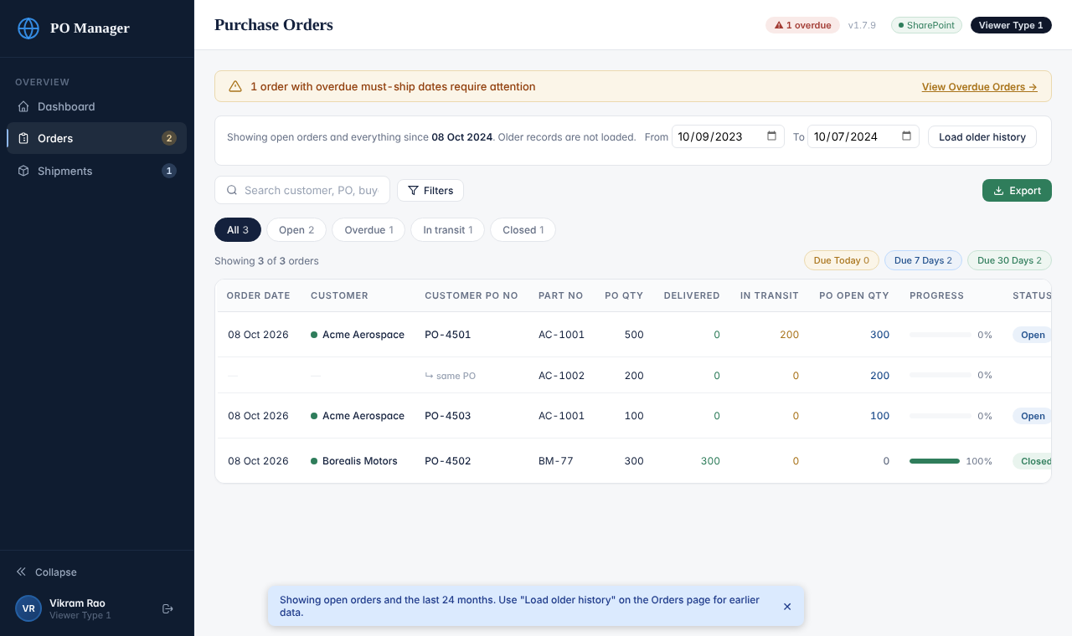
The Orders list
- Type in the search box to find a customer, PO number, buyer or part number. Not case sensitive.
- Click a chip: All, Open, Overdue, In transit, Closed (each shows a count). Due Today / 7 Days / 30 Days show open lines about to ship.
- Click Filters for customer, shipment type, status, part number, order date and dock date ranges. Tags with an × show active filters; Clear removes them.
- Click a column heading to sort (click again to reverse, a third time to remove the sorting).
- Click View on the first row of an order to open it.
Note
Status words: a line is Open until everything ordered (after any “Short Close”) has been Delivered; then it is Closed. An order is Open while any line is Open, Closed when all lines are closed, and Cancelled when every line was cancelled. In Transit means shipped but not yet delivered.

Older orders
The app loads open orders and everything from the last 24 months. To look at an older, closed order, choose a From and To date in the blue Load older history bar and click the button. The orders are added to your screen for this session.

4. Reading one order
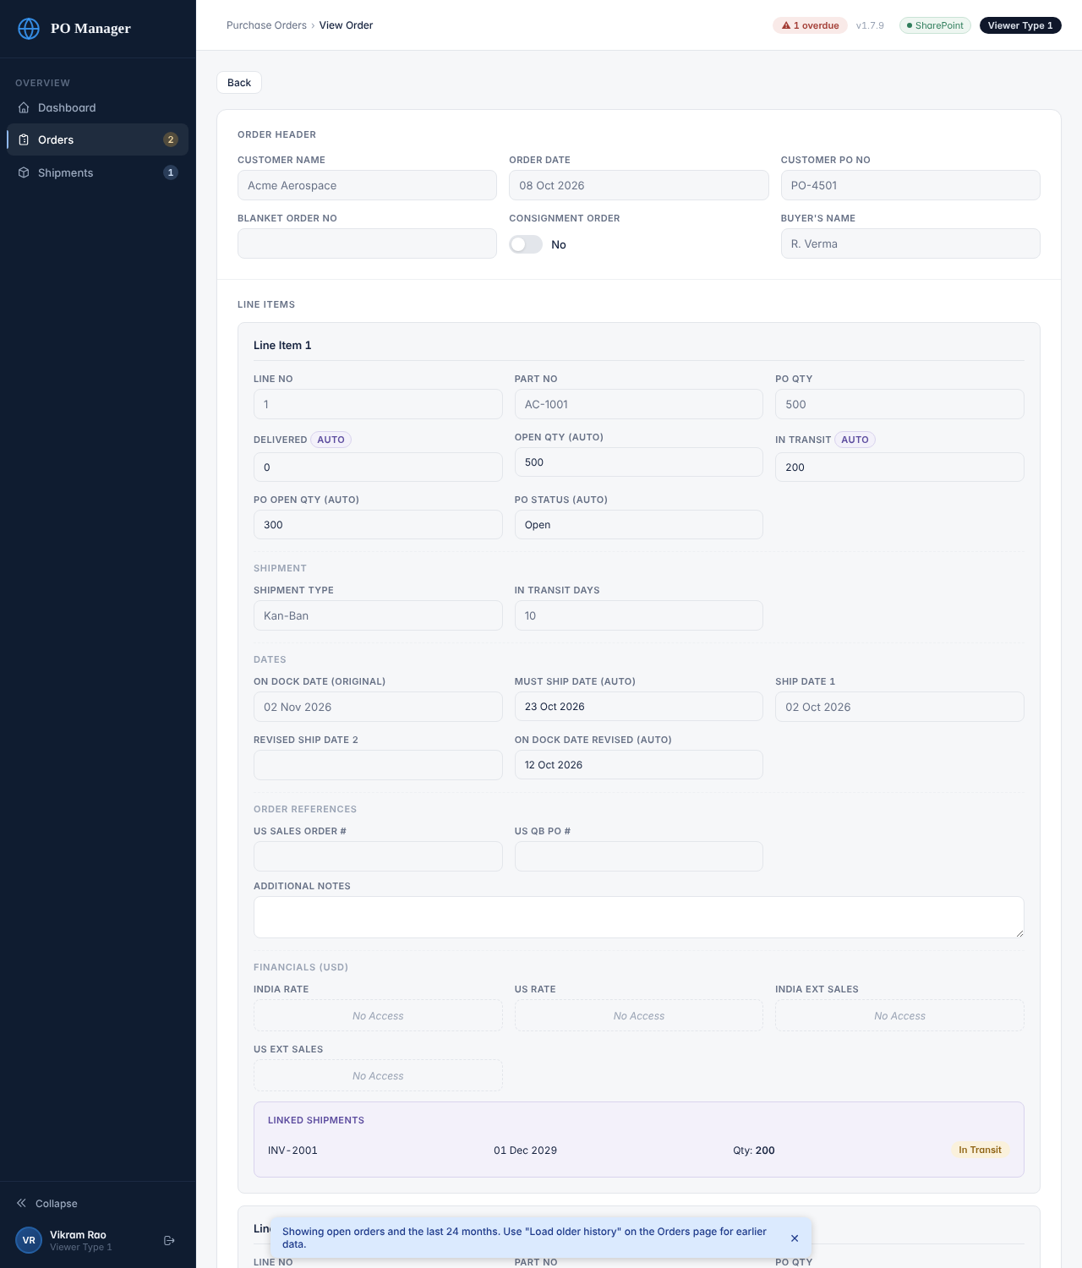
An order opened with View (Viewer Type 1: finance fields show “No Access”)
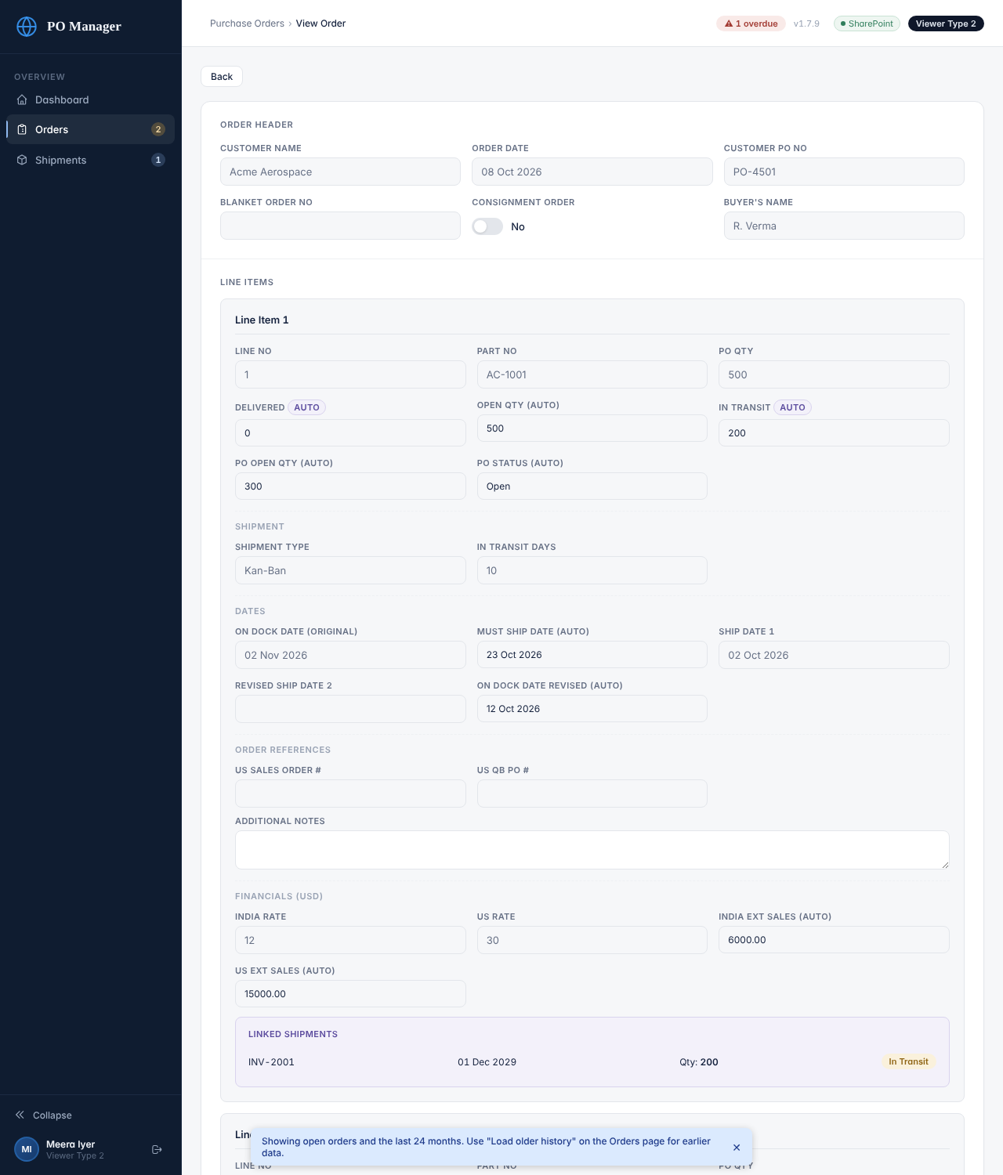
The same order for Viewer Type 2 (rates and extended sales visible)
- The page is read-only: the greyed fields cannot be changed.
- Delivered and In Transit are calculated from the shipments. They are listed under Linked Shipments at the bottom of each line with the invoice number, ship date, quantity and status.
- Open Qty is the quantity ordered (after any short close) minus Delivered. PO Open Qty is Open Qty minus In Transit, the quantity not yet shipped.
- Must Ship Date is the dock date minus the In Transit Days. Ship Date 1 and Revised Ship Date 2 are the committed dates; the later one is used for overdue.
- At the very bottom, Audit History lists every change to this order: who, when and what.
- Back returns to the list.

5. Shipments
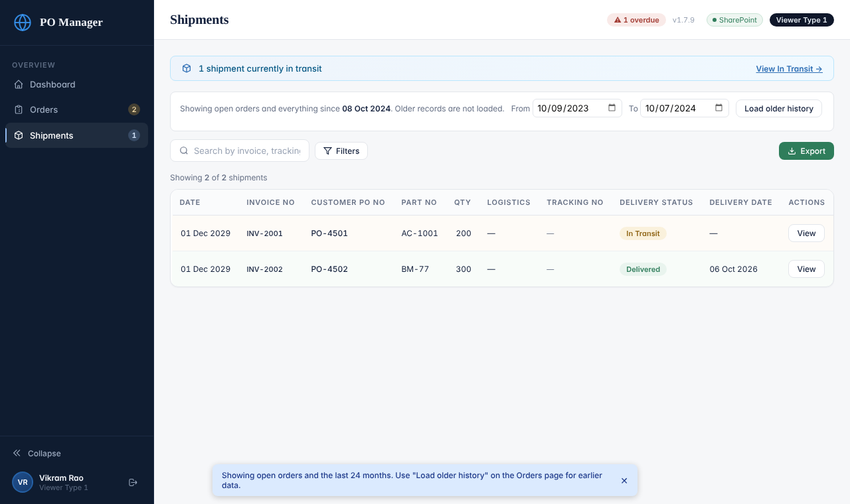
The Shipments list
- The blue strip says how many shipments are in transit; View In Transit filters the list.
- Search by invoice number, tracking number, customer, part number or PO number. Filters include delivery status, location, Kan-Ban, ship date and delivery date ranges.
- Click View to see a shipment’s header and lines: tracking number, logistics, quantities, delivery status and delivery date.
- A shipment is Delivered when all its lines are delivered, otherwise In Transit.

6. Exporting reports
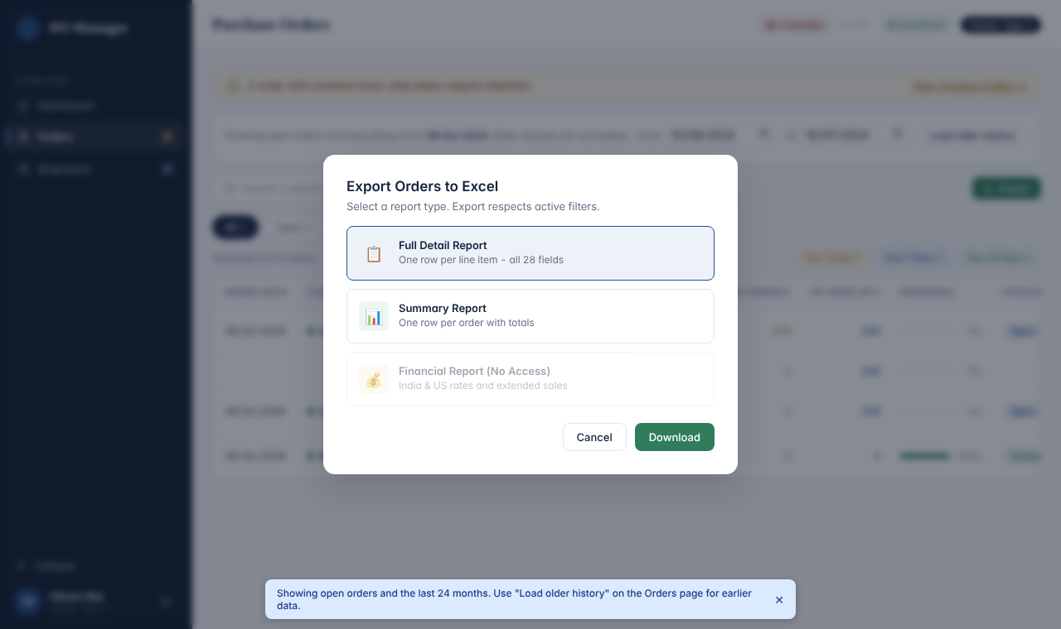
Export dialog for Viewer Type 1 (Financial Report is not available)
- Click Export on the Orders or Shipments page and choose a report. Orders: Full Detail, Summary and (Viewer Type 2 only) Financial. Shipments: Full Detail, Summary, Delivery Status.
- The report contains only what is on your screen: the current search and filters, and only loaded orders. Click Clear first for everything.
- Viewer Type 1: the exports do not contain the rate or value columns.
- The file downloads as a .csv and opens in Excel. It is confidential company data: do not forward it outside the company.

7. Using a phone
- Everything works on a phone, but wide tables need a sideways swipe inside the table box.
- The menu starts collapsed. Tap the icons to move between Dashboard, Orders and Shipments.
- Exports are saved as files; opening a .csv on a phone depends on which app it uses for spreadsheets.

8. If something does not work
What you see | What to do
“Invalid email or password.” | Retype carefully (check Caps Lock). Five wrong attempts lock the account for 15 minutes.
A message with “Too many failed attempts” | Wait 15 minutes or ask an Administrator to reset your password.
“Your session expired. Please sign in again.” | Your 12 hours are over. Sign in again.
I cannot find an order I know exists | Clear the search and filters. If it is an old closed order, use Load older history with a date range that includes it. Check the spelling of the PO number.
The numbers look wrong | Tell an Administrator the PO number and what you expected. Include the app version (top right).
A page is blank or says “Sign-in failed” | Refresh the page. If it persists, tell an Administrator and send the exact message and the time.

When you report a problem, always give: your name, the time, the PO or invoice number, what you did, what you saw (a screenshot helps) and the app version shown at the top right.

