Internship Project Report: PDF Protection Tool

Project Title: PDF Protection and Password Verification Tool Using Python
Name of Intern: Sahasra Chandhana Reddigari
Intern Number: ITID5926
Internship Duration: 15/11/2025 to 15/02/2026
Internship Organization: InLighnX Global Pvt. Ltd.

1. Project Objective:
The objective of this project is to develop a Python-based tool that adds password protection to PDF files and verifies the password securely. This project focuses on data security and document protection using ethical and legal methods.

2. Tools and Technologies Used:
- Python 3.13 – Programming language
- PyPDF2 – Python library for PDF encryption
- Windows 10 – Operating system
- PowerShell / CMD – For running the Python script

3. Installation Steps:
1. Install Python 3.13 from python.org and enable 'Add Python to PATH'.
2. Open CMD or PowerShell.
3. Install the required library using: pip install pypdf2
4. Prepare a sample PDF file for encryption.

4. Project Implementation:
The project reads an existing PDF file and encrypts it using a user-defined password. After encryption, the tool verifies whether the provided password is correct. This approach ensures document confidentiality without attempting unauthorized access.

Python Code Snippet:
from PyPDF2 import PdfReader, PdfWriter
def protect_pdf(input_file, output_file, password):
reader = PdfReader(input_file)
writer = PdfWriter()
for page in reader.pages:
writer.add_page(page)
writer.encrypt(password)
with open(output_file, 'wb') as f:
writer.write(f)
def verify_password(pdf_file, password):
reader = PdfReader(pdf_file)
if reader.decrypt(password):
print('Password is correct!')
else:
print('Incorrect password.')

5. Running the Project:
1. Save the script as pdf_protection_tool.py
2. Place sample.pdf in the same folder.
3. Open CMD or PowerShell in the project folder.
4. Run the command: python pdf_protection_tool.py
5. The encrypted PDF will be generated and password verified.

6. Observations and Results:
• The PDF file was successfully encrypted with a password.
• The verification process confirmed the correct password.
• The tool ensures document confidentiality.
Implementation Screenshots:
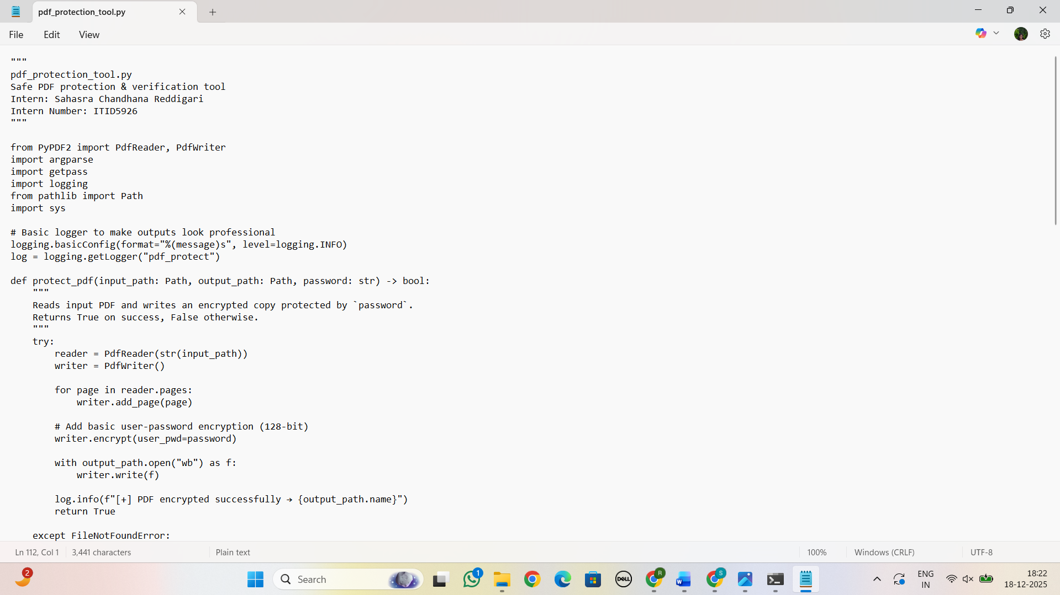
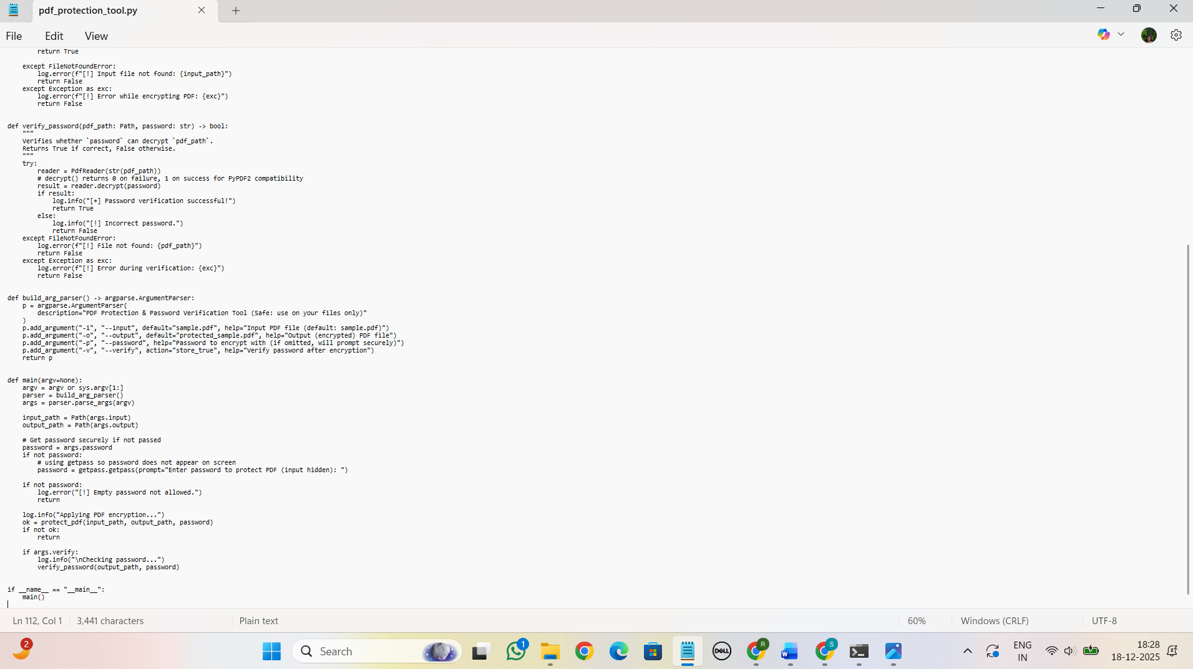
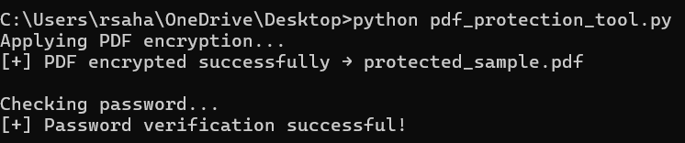
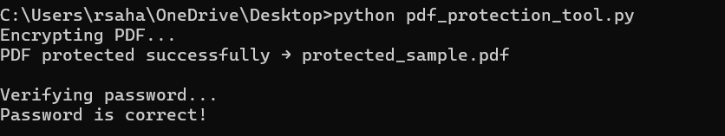

7. Conclusion:
This project demonstrates how Python can be used to protect sensitive documents using password-based encryption. It strengthens understanding of file handling and data security.

Ethical Consideration:
This project is ethical and legal as it focuses on protecting documents rather than breaking security mechanisms. It is used only for authorized and educational purposes.

