Internship Project Report: Port Scanner

Project Title: Port Scanner Using Python (Safe & Educational Version)
Name of Intern: Sahasra Chandhana Reddigari
Intern Number: ITID5926
Internship Duration: 15/11/2025 to 15/02/2026
Internship Organization: InLighnX Global Pvt. Ltd.

1. Project Objective:
The objective of this project is to develop a Python-based Port Scanner that scans only the user's own device (localhost) or their own Wi-Fi router. The program identifies open TCP ports in a safe, legal, and educational manner.
Note: This project does NOT scan external networks or unauthorized systems. It is performed strictly within the user’s own network for security learning purposes.

2. Tools and Technologies Used:
- Python 3.13 – Programming language
- Socket Module – For creating TCP connections
- Windows 10 – Operating System
- PowerShell / CMD – For running the Python script

3. Installation Steps:
1. Install Python 3.13 from python.org and enable 'Add Python to PATH'.
2. Open PowerShell or CMD.
3. Verify Python installation using the command: python --version
4. No external libraries are required for this project.

4. Project Implementation:
This project uses Python’s socket module to check whether specific ports on a target IP (localhost or router IP) are open. The scanner attempts to establish a TCP connection and records ports that respond.

Python Code Snippet:
Figure 1: Port Scanner Python Code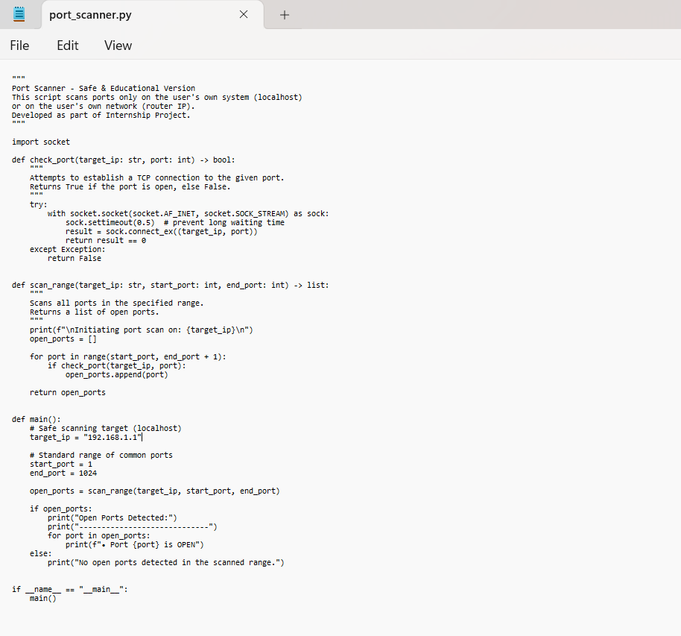

import socket
def check_port(target_ip: str, port: int) -> bool:
try:
with socket.socket(socket.AF_INET, socket.SOCK_STREAM) as sock:
sock.settimeout(0.5)
result = sock.connect_ex((target_ip, port))
return result == 0
except:
return False
def scan_range(target_ip: str, start_port: int, end_port: int) -> list:
print(f"\nInitiating port scan on: {target_ip}\n")
open_ports = []
for port in range(start_port, end_port + 1):
if check_port(target_ip, port):
open_ports.append(port)
return open_ports
def main():
target_ip = "127.0.0.1" # Localhost scan
start_port = 1
end_port = 1024
open_ports = scan_range(target_ip, start_port, end_port)
if open_ports:
print("Open Ports Detected:")
print("----------------------------")
for port in open_ports:
print(f"• Port {port} is OPEN")
else:
print("No open ports detected.")
if __name__ == "__main__":
main()

5. Running the Project:
1. Save the script as port_scanner.py
2. Open CMD or PowerShell in the folder where the file is saved.
3. Run the command: python port_scanner.py
4. The output will show the list of open ports on the target system.

6. Observations and Results:
Figure 2: Output of Port Scanner on Localhost (127.0.0.1)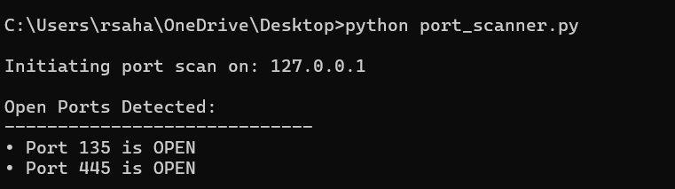

• The port scanner successfully identifies open ports on localhost (127.0.0.1).
• The scanner also works on the user’s router IP (e.g., 192.168.1.1).
• The results demonstrate how network services listen on different ports.

7. Conclusion:
This project demonstrates how Python can be used to analyze open ports on a device in a safe and controlled manner. It provides hands-on understanding of TCP connections, port scanning mechanisms, and basic cybersecurity concepts.

Ethical Consideration:
This project is strictly ethical and scans only the user's own device or router. No unauthorized system is accessed during the scanning process.

