Project 6: Simple Network Scanner (Safe & Ethical)
Name of Intern: Sahasra Chandhana Reddigari
Intern ID: ITID5926
Internship Organization: InLighnX Global Pvt. Ltd.

Internship Title: Offensive Cybersecurity Internship
Internship Duration: 15/11/2025 to 15/02/2026

Objective
The objective of this project is to develop a simple and safe Python-based network scanner that checks the availability of a local system and displays its hostname. This project is designed to understand basic networking concepts in a controlled and ethical environment.
Tools and Technologies Used
Programming Language: Python
Library Used: socket
Platform: Windows
Implementation
The project uses Python’s socket library to perform a basic network check on the localhost (127.0.0.1). The tool verifies whether the system is reachable and retrieves the hostname associated with the IP address. No external networks or devices are scanned, ensuring ethical usage.
PYTHON CODE SNIPPET:
Simple Network Scanner (Safe Version)
Internship Project 6
This script checks the availability of the local system only
using localhost (127.0.0.1).
import socket
print("=== Simple Network Scanner (Safe Version) ===")
host = "127.0.0.1"
try:
hostname = socket.gethostbyaddr(host)
print(f"Host is up: {host}")
print(f"Hostname: {hostname[0]}")
except socket.herror:
print(f"No response from {host}")
RUNNING THE PROJECT:
Save the script as network_scanner.py
Open Command Prompt / PowerShell
Navigate to the project directory
Run the command: python network_scanner.py
Observe the output
Implementation Screenshots:
- Code Implementation:
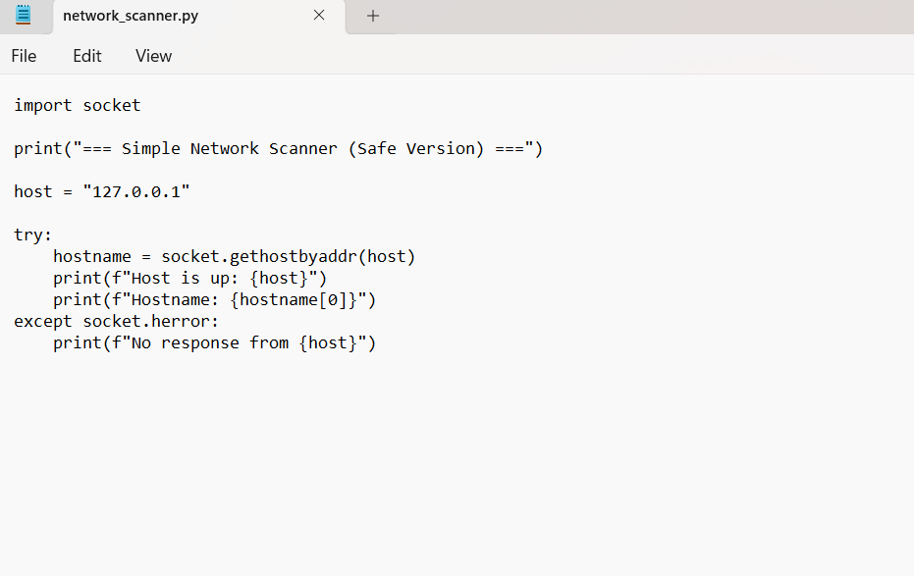
- Command Line Output:
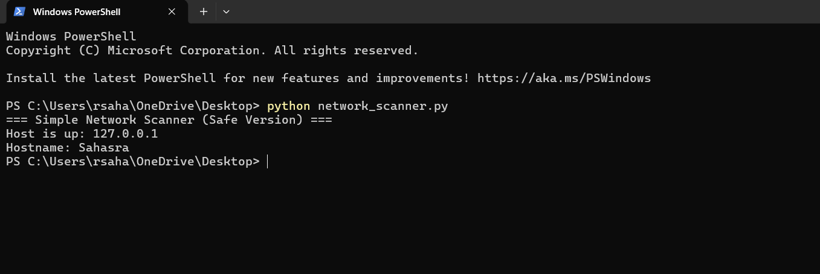
Result:
The program successfully detected the local system (127.0.0.1) and displayed the associated hostname, confirming that the network scanner works correctly in a safe and controlled environment.
ETHICAL CONSIDERATION:
This project strictly follows ethical cybersecurity guidelines. Only the localhost address (127.0.0.1) was scanned, ensuring no external systems, networks, or devices were accessed without authorization. The project is intended solely for educational purposes.
Conclusion:
This project provides a basic understanding of network scanning concepts using Python. It demonstrates how devices respond on a network and reinforces ethical practices in cybersecurity by limiting scanning to a safe environment.

