Project 5: Password Hash Generator & Verification Tool (SAFE & ETHICAL)
Name of Intern: Sahasra Chandhana Reddigari
Intern ID: ITID5926
Internship Organization: InLighnX Global Pvt. Ltd.

Internship Title: Offensive Cybersecurity Internship
Internship Duration: 15/11/2025 to 15/02/2026

Objective
The objective of this project is to understand how passwords are securely stored using cryptographic hashing techniques. This project demonstrates a safe and ethical approach to password security by generating a hash value and verifying user passwords without storing them in plain text.
Tools and Technologies Used
Programming Language: Python
Library Used: hashlib
Platform: Windows
Implementation
The project uses Python’s hashlib library to generate a secure SHA-256 hash of a user-provided password. The password is converted into a hash value using a one-way cryptographic function. During verification, the input password is hashed again and compared with the stored hash to confirm authenticity.
PYTHON CODE SNIPPET:
Password Hash Generator & Verification Tool (Safe Version)
Internship Project 5
This script demonstrates secure password hashing and verification
using SHA-256 algorithm.
import hashlib
def generate_hash(password):
hash_object = hashlib.sha256(password.encode())
return hash_object.hexdigest()
def verify_password(input_password, stored_hash):
return generate_hash(input_password) == stored_hash
print("=== Password Hash Generator & Verifier ===")
password = input("Enter password to hash: ")
hashed_password = generate_hash(password)
print("\nGenerated Hash:")
print(hashed_password)
check_password = input("\nRe-enter password to verify: ")
if verify_password(check_password, hashed_password):
print("Password Verified Successfully ✅")
else:
print("Password Verification Failed ❌")
RUNNING THE PROJECT:
Save the script as hash_tool.py
Open Command Prompt
Navigate to the project directory
Run the command: python hash_tool.py
Observe the output
Implementation Screenshots:
- Code Implementation:
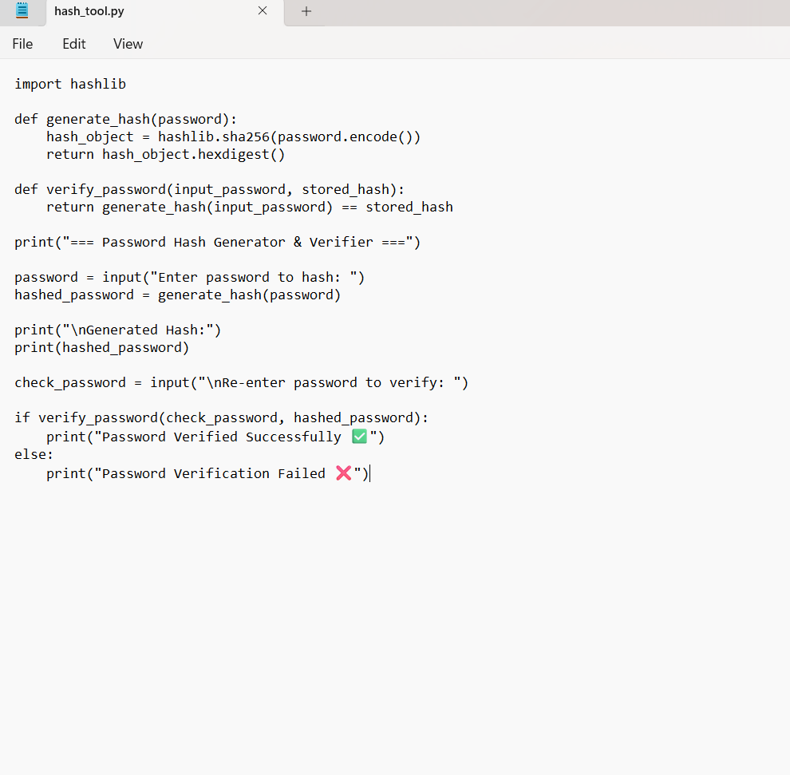
- Command Line Output:
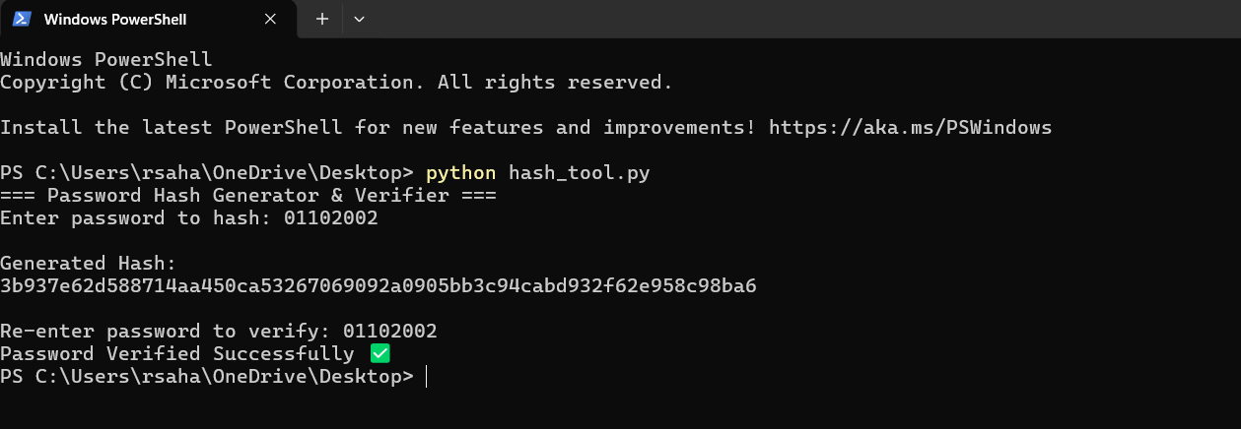
Result:
The program successfully generated a SHA-256 hash for the given password and verified the password correctly when re-entered, ensuring secure authentication.
ETHICAL CONSIDERATION:
This project strictly follows ethical cybersecurity practices. No real user credentials were stored or misused. The hashing process is performed locally and demonstrates defensive security concepts used in real-world applications.
Conclusion:
This project demonstrates the importance of secure password handling using cryptographic hashing techniques. It enhances understanding of password security mechanisms and reinforces ethical cybersecurity practices.

