 | SIMATS ENGINEERING  Department of Computer Science and Engineering  CSA15 Cloud Computing and Big Data Analytics  CO2 AT3 - Capstone Cloud Infrastructure Case Analysis and Defense  Editable student template for application-based cloud virtualization and SDDC/cloud operations defense
Assessment Metadata
Course Code | CSA15
Course Title | Cloud Computing and Big Data Analytics
Assessment | CO2 AT3 - Capstone Cloud Infrastructure Case Analysis and Defense
Submission Type | Individual digital case analysis and infrastructure defense based on the same capstone title used in CO1, CO2 AT1 and CO2 AT2
Faculty | Dr C. Rajesh Babu
Employee ID | SSETSCS415
Submission Mode | Completed DOCX template and GitHub repository link through Google Classroom
How This Template Works
- Use the same capstone title used in CO1, CO2 AT1 and CO2 AT2.
- Do not recalculate all VM sizing or repeat all configuration screenshots. Summarize the final AT1/AT2 evidence and use it for design defense.
- Answer all five questions with application-oriented reasoning connected to the capstone product.
- Include sustainable cloud operation decisions wherever relevant: right-sized resources, log retention, storage lifecycle, scheduled shutdown, API-call reduction and VM/container/serverless comparison.
- Paste the final topology diagram in the given response area. The sample diagram is only a structure; redraw it for the student's own product.
- Upload this completed document and supporting evidence to GitHub, then submit the repository link through Google Classroom.
Assessment Focus
AT1 answered what VM is required. AT2 showed configuration or simulation evidence. AT3 asks whether the student can defend the complete infrastructure design under application, security, operations and failure conditions.
Student and Capstone Details
Student Name
Register Number
Class / Slot | Slot B
Capstone Title
CO1 Evidence Link
CO2 AT1 VM Recommendation | vCPU: ____ RAM: ____ GB Storage: ____ GB VM Class: ____
CO2 AT2 Evidence Link
GitHub Repository Link
Submission Date
Evidence Carry-Forward Summary
Evidence Source | Student Entry | How It Supports AT3 Defense
CO1 concept map / presentation
CO2 AT1 sizing workbook
VM calibration sheet
CO2 AT2 practical evidence
Capstone architecture decision
Q1: Virtualization Value and Capstone Cloud Deployment Summary
Explain your capstone product, expected workload, cloud need and deployment context. Analyze how virtualization improves cost efficiency, resource utilization, workload isolation, infrastructure flexibility and cloud deployment readiness for your product.
Design Point | Student Response
Capstone product and users
Expected workload
Cloud need
Virtualization value
Cost and utilization benefit
Isolation and flexibility benefit
Case Analysis Response: Write 8-12 technical lines connecting virtualization value to your capstone product.

Q2: Rapid Provisioning, Testing and Virtual Machine Lifecycle Case
Using your CO2 AT1 VM recommendation and CO2 AT2 practical evidence, explain how virtual machines, VM images, templates, snapshots, clones or containers support rapid provisioning, testing, deployment, rollback and maintenance for your capstone product.
Lifecycle Element | AT1/AT2 Evidence Used | Capstone Use / Justification
VM image or base environment
Template or repeatable setup
Snapshot / rollback
Clone / testing copy
Container or VM decision
Maintenance and update plan
Case Analysis Response: Explain how lifecycle practices reduce deployment delay and risk.

Q3: Final Cloud Deployment Topology and SOA/API Service Integration Case
Draw and explain the final deployment topology for your capstone product. Show frontend, backend/API, database, storage, authentication, notification, analytics and any VM/container/managed cloud service components. Explain how SOA/API-based integration connects these modules and supports modular cloud service design.
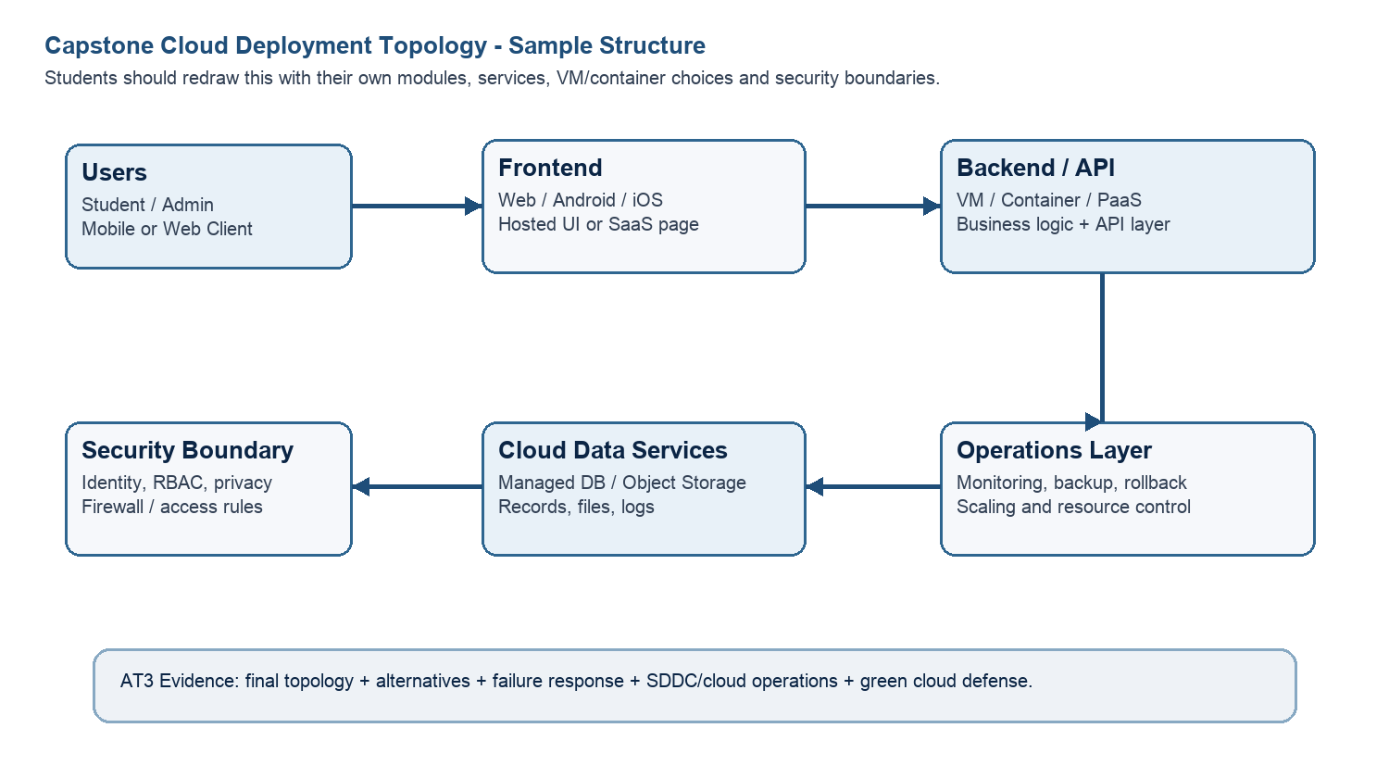
Architecture Component | Technology / Service | VM / Container / Managed Service / SaaS | Integration Method
Frontend
Backend/API
Database
Storage
Authentication
Notification
Analytics / AI module
Paste or draw the final capstone deployment topology diagram here.

SOA/API Integration Explanation: Explain how services communicate and why modular service design is useful.

Q4: Design Alternatives, Identity, Access and Federated Cloud Privacy Case
Compare at least two deployment alternatives for your capstone product, such as single VM, multi-tier VM, containerized deployment, managed backend, federated cloud or hybrid cloud model. Justify the selected design by analyzing identity management, role-based access control, federated access, data sharing, privacy protection and security risks.
Deployment Alternative | Advantages | Limitations / Risks | Identity and Privacy Impact
Alternative 1
Alternative 2
Selected design
Security Area | Student Decision
User roles
Authentication method
Role-based access control
Federated access / partner access
Sensitive data handled
Privacy protection decision
Case Analysis Response: Defend why the selected design is better for identity, access and privacy.

Q5: Software-Defined Datacenter and Cloud Operations Defense Case
Analyze how your infrastructure will respond to operational and failure scenarios such as VM failure, database growth, traffic spike, credential leakage, service outage, resource contention or cost increase. Explain how SDDC concepts and cloud operations practices such as automated provisioning, software-defined networking, software-defined storage, monitoring, logging, backup, rollback, scaling, resource control and maintenance improve the final infrastructure design. Include Green Computing decisions such as resource right-sizing, storage lifecycle control, log retention, API-call reduction, scheduled shutdown, VM/container/serverless comparison and carbon/energy proxy indicators where relevant.
Operational / Failure Scenario | Expected Impact | SDDC / Cloud Operations Response | Evidence or Control
VM failure
Database growth
Traffic spike
Credential leakage
Service outage
Resource contention
Cost increase
Operational Readiness Area | Student Plan
Automated provisioning
Software-defined networking
Software-defined storage
Monitoring and logging
Backup and rollback
Scaling and elasticity
Resource control and maintenance
Green Computing and sustainability control
Green Cloud Decision | Student Justification
VM right-sizing from CO2 AT1
VM vs container vs serverless choice
Scheduled shutdown / idle-resource control
Log and file retention policy
Storage lifecycle and backup cleanup
API-call or polling reduction
Carbon/energy proxy indicator to track
Final Infrastructure Defense Statement: State whether the design is ready for prototype, pilot or production. Defend reliability, security, SDDC/cloud operations and Green Computing improvements required next.

CO2 Reflection and Individual Defense
This section must be individually written. It should show what the student understands from the complete CO2 chain: infrastructure sizing, practical configuration evidence and final operations defense.
Reflection Prompt | Student Response
What is the strongest infrastructure decision in your capstone design?
Which CO2 concept became clearer after AT1, AT2 and AT3?
Which risk is most serious for your capstone: failure, cost, privacy, scaling or sustainability?
What evidence would you show during viva to defend your infrastructure design?
What will you improve before final capstone deployment?

Student-Facing Assessment Criteria
Criteria | Descriptor
Capstone continuity | The answer uses the same capstone title and connects CO1, CO2 AT1 and CO2 AT2 evidence.
Virtualization and lifecycle reasoning | VM, image, snapshot, clone, container or managed-service decisions are technically justified.
Topology and integration clarity | Architecture diagram and SOA/API explanation show clear module interaction.
Identity, access and privacy | Roles, authentication, RBAC, federated access, sensitive data and privacy decisions are defended.
SDDC/cloud operations | Failure response, monitoring, logging, scaling, backup, rollback and resource control are addressed.
Green Computing defense | Right-sizing, retention, API efficiency, idle-resource control and sustainable cloud choices are explained.
Submission quality | GitHub, template completion, evidence references and individual reflection are complete.
GitHub and Google Classroom Submission
Repository Item | Expected Content
README.md | Capstone title, student details, final VM recommendation, deployment topology summary and AT3 evidence index.
Completed AT3 document | This completed editable DOCX or exported PDF if instructed.
Diagram image | Final topology diagram if created separately.
Evidence references | Links or screenshots from CO1, CO2 AT1 and CO2 AT2 as needed.
Green Computing note | Short README section explaining sustainable cloud choices and resource-control decisions.
Google Classroom | Submit the GitHub repository link through GCR.
Student Assurance
I confirm that this case analysis, design reasoning, topology diagram and final defense statement were prepared individually by me for the stated capstone title. I have not uploaded passwords, tokens, private keys or sensitive account information.
Student Name
Register Number
Signature
Date

Faculty Verification
Faculty Name | Dr C. Rajesh Babu
Employee ID | SSETSCS415
Constructive Feedback / Remarks
Strength Observed
Improvement Suggested
Signature / Date

