17. Write a C program for DES algorithm for decryption, the 16 keys (K1, K2, c, K16) are used in reverse order. Design a key-generation scheme with the appropriate shift schedule for the decryption process.
PROGRAM :
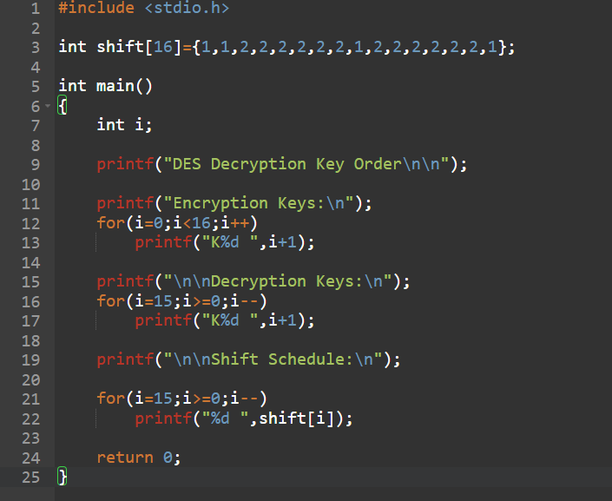
OUTPUT :
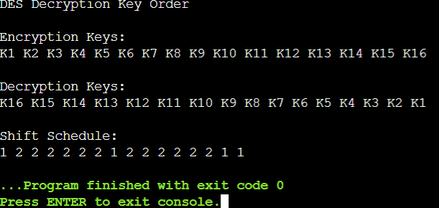

18. Write a C program for DES the first 24 bits of each subkey come from the same subset of 28 bits of the initial key and that the second 24 bits of each subkey come from a disjoint subset of 28 bits of the initial key.
PROGRAM :
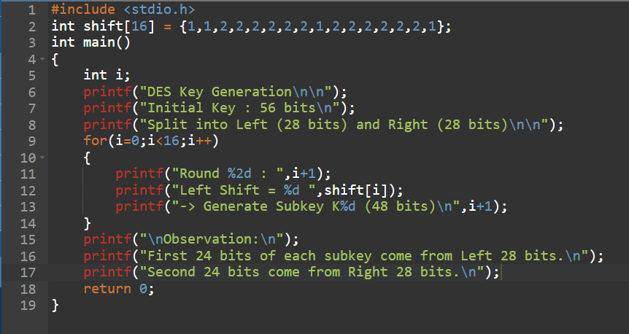
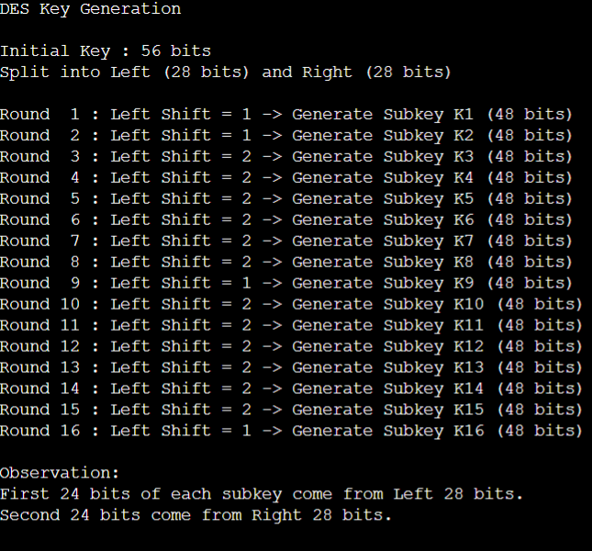

19. Write a C program for encryption in the cipher block chaining (CBC) mode using an algorithm stronger than DES. 3DES is a good candidate. Both of which follow from the definition of CBC. Which of the two would you choose:
PROGRAM :
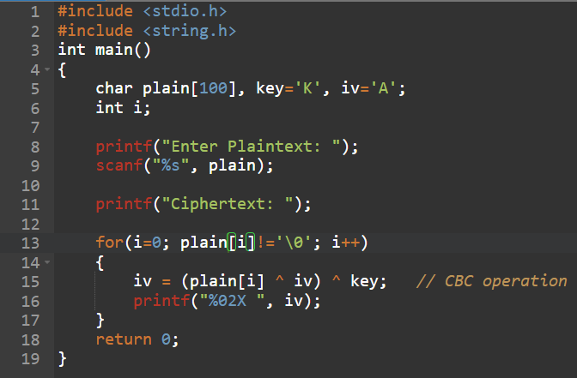
OUTPUT :
