**UNIT II**

**Demand:** The demand for a commodity is its quantity which consumers are able and willing to buy at various prices during a given period of time.

**Demand Function**

Demand function is a mathematical function showing relationship between the quantity demanded of a commodity and the factors influencing demand.

**Dx = f (Px, Py, T, Y, A, Pp, Ep, U)**

In the above equation,  
Dx = Quantity demanded of a commodity  
Px = Price of the commodity  
Py = Price of related goods  
T = Tastes and preferences of consumer  
Y = Income level  
A = Advertising and promotional activities  
Pp = Population (Size of the market)  
Ep = Consumer’s expectations about future prices  
U = Specific factors affecting demand for a commodity such as seasonal changes, taxation policy, availability of credit facilities, etc.

#### Determinants of Demand:

**1. Price of the Commodity:**

This is the basic factor influencing the demand. There is a close relationship between the quantity demanded and the price of the product. Normally a larger quantity is demanded at a lower price that at a higher price. There is inverse relationship between the price and quantity demanded. This is called the law of demand.

**2. Income of the Consumer:**

The income of the consumer is another important variable which influences demand. The ability to buy a commodity depends upon the income of the consumer. When the income of the consumers increases, they buy more and when income falls they buy less. A rich consumer demands more and more goods because his purchasing power is high.

**3. Tastes and Preferences:**

The demand for a product depends upon tastes and preferences of the consumers. If the con­sumers develop taste for a commodity they buy whatever may be the price. A favorable change in consumer preference will cause the demand to increase. Likewise an unfavorable change in consumer preferences will cause the demand to decrease.

**4. Prices of related goods or services**

* *Complementary products* – An increase in the price of one product will cause a decrease in the quantity demanded of a complementary product. Example: Rise in the price of bread will reduce the demand for butter. This arises because the products are complementary in nature.
* *Substitute Product* – An increase in the price of one product will cause an increase in the demand for a substitute product. Example: Rise in price of tea will increase the demand for coffee and decrease the demand for tea.

* **Law of Demand**

The law of demand states that there is an inverse relationship between quantity demanded of a commodity and its price, other factors being constant. In other words, higher the price, lower the demand and vice versa, other things remaining constant.

D = f (P) where, **P** is price and  is q **D** quantity demanded of a commodity

* **Demand Schedule** is a representation of various combinations of price and quantity demanded by a consumer during a particular period of time. An imaginary demand schedule is given below:

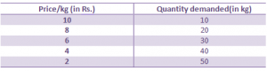

**Demand Curve**

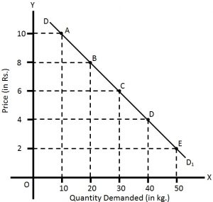In the figure price and quantity demanded are measured along the y-axis and x-axis respectively. By plotting various combinations of price and quantity demanded, we get a demand curve DD1derived from points A, B, C, D and E.

This is a downward sloping demand curve showing inverse relationship between price and quantity demanded.

## Assumptions

1. No change in price of related commodities.
2. No change in income of the consumer.
3. No change in taste and preferences, customs, habit and fashion of the consumer.
4. No change in size of population
5. No expectation regarding future change in price.

## Limitations/Exceptions of law of demand

**1. Giffen goods**: A Giffen good is considered to be an exception to the Law of Demand. The unique features of Giffen good results in quantity demanded increasing when there is an increase in price. Sir Robert Giffen observed that when the price of bread increased, the low-paid British workers in the early 19th century purchased more bread and not less of it. This phenomenon is a direct contradiction to the Law of Demand. The reason given for this is that these British workers consumed a diet of mostly bread and when the price of bread went up they were compelled to spend more on a fixed quantity of bread.

**2. Veblen goods**: Veblen goods are generally more visible in society than Giffen goods. For example, economists often view diamonds as a Veblen good because of the higher prestige value of a diamond; the higher is the desirability. Some people will also buy fewer diamonds when the price falls.

They are goods that people buy more of when or if the price increases. These goods tend to be status symbols and displays of wealth. For example, Rolls Royce cars and Patek Phillipe watches can be considered to be Veblen goods.

**3. Price expectation:** When the consumer expects that the price of the commodity is going to fall in the near future, they do not buy more even if the price is lower.

On the other hand, when they expect further rise in price of the commodity, they will buy more even if the price is higher. Both of these conditions are against the law of demand.

**4. Fear of shortage:** When people feel that a commodity is going to be scarce in the near future, they buy more of it even if there is a current rise in price.

For example: If the people feel that there will be shortage of L.P.G. gas in the near future, they will buy more of it, even if the price is high.

**6. Basic necessities of life:** In case of basic necessities of life such as salt, rice, medicine, etc. the law of demand is not applicable as the demand for such necessary goods does not change with the rise or fall in price.

## Meaning of Supply

Supply refers to the amount of a good or service that the producers/providers are willing and able to offer to the market at various prices during a period of time.

## Supply Function:

Thesupply function can also be expressed in symbols.

**QxS = F (Px Tech, Si, Fn, X,........)**

Here:

Qxs = Quantity supplied of commodity x by the producers.

F= Function

Px = Price of commodity x.

Tech = Technology.

S = Supplies of inputs.

F = Features of nature.

X = Taxes/Subsidies

## Determinants of Supply

**1. Price of the commodity:** When price increases, supply also increases because it motivates the firm to supply more in order to get more profit. When price decreases, smaller quantity will be supplied as profit decreases.

**2. Goals of the firm:** The goals of the firm may be “profit maximization"," sales maximization" or “risk minimization". If the aim is sales maximization, they will produce and supply more and if the aim is risk minimization, they will supply less.

3. Input prices: If the prices of inputs and factors used in production such as raw materials, labour, machine etc. are high, the cost of production will be high. Higher cost of production, at the given price, reduces the profit margin and will persuade the producer to produce and supply less.

**4. Prices of related commodities:** Producers always have the tendency of shifting from the production of one commodity to another commodity. If the prices of another commodity increase, especially substitute goods, producers will find it more profitable to produce that commodity by reducing the production of the existing commodity.

**5. Techniques of production**: An improvement in the technique of production reduces the cost of production and increases profit margin. Increased profitability motivates the producers to increase the supply.

**6. Expectations about future prices:** If a producer expects an increase in market price in future, then they will supply less today and hoard the stock to sell at a high price in future and vice versa.

**7. Natural factors:** In case of agricultural products, the natural factors like flood, draught etc. adversely affect the supply of commodities. On the other hand favourable climatic conditions may help in increasing the supply of agricultural commodities.

**8. Availability of transport and communication facilities:** An improvement in transport and communication facilities will expand the size of market and this will motivate the producers to produce and supply more.

# Law of Supply

The law of supply states that, other things remaining the same, the quantity supplied of a commodity is directly or positively related to its price. In other words, when there is a rise in the price of a commodity the quantity supplied of it in the market increases and when there is a fall in the price of a commodity, its quantity supplied decreases, other things remaining the same.

#### Supply Schedule is a presentation of various price and quantity supplied by the seller or producer during a period of time. We can show the supply schedule through the following table.

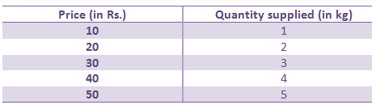

**Supply curve** The supply curve is a graphical representation of a supply schedule. By plotting various combinations of price and quantity supplied of the table, we can derive an upward sloping demand curve as shown in the figure.

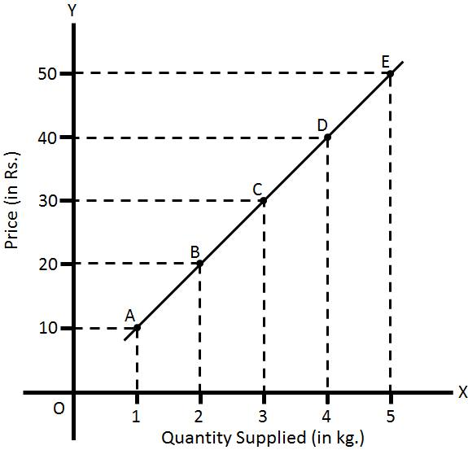

* **Elasticity of Demand:**  The **Elasticity of Demand** is a measure of change in the quantity demanded in response to the change in the price of the commodity. Simply, the effect of a change of price on the quantity demanded is called as the elasticity of demand.

# Price Elasticity of Demand

The price elasticity of demand is defined as the percentage change in quantity demanded due to certain percentage change in price.

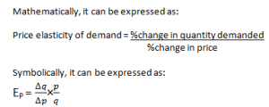

### Where, EP= Price elasticity of demand; q= Original quantity demanded; ∆q = Change in quantity demanded; p= Original price; ∆p = Change in price.

* **Types of price elasticity of demand**

**1. Perfectly Elastic Demand (EP = ∞)**

The demand is said to be perfectly elastic if the quantity demanded increases infinitely with a small fall in price.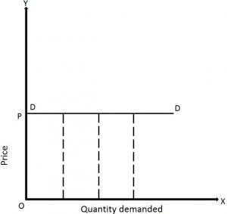

In the given figure, price and quantity demanded are measured along the Y-axis and X-axis respectively. The demand curve **DD** is a horizontal straight line parallel to the X-axis. It shows that negligible change in price causes infinite fall or rise in quantity demanded.

**2. Perfectly Inelastic Demand (EP = 0)**

The demand is said to be perfectly inelastic if the demand remains constant whatever may be the price (i.e. price may rise or fall).

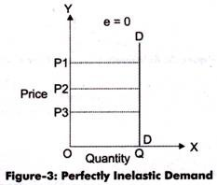In the given figure, price and quantity demanded are measured along the Y-axis and X-axis respectively. The demand curve **DD** is a vertical straight line parallel to the Y-axis. It shows that the demand remains constant whatever may be the change in price. For example: even after the increase in price from **OP2** to **OP1** and fall in price from **OP2** to **OP3**, the quantity demanded remains at **OQ**

**3. Relatively Elastic Demand (EP> 1)**

The demand is said to be relatively elastic if the percentage change in demand is greater than the percentage change in price.

In the given figure, price and quantity demanded are measured along the Y-axis and X-axis respectively. The demand curve **DD** is more flat, which shows that the demand is elastic. The small fall in price from **OP** 1to **OP2** has led to greater increase in demand from **OQ1** to **OQ2**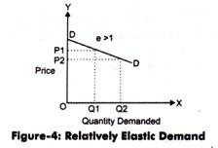.

**4. Relatively Inelastic Demand (Ep< 1)**

The demand is said to be relatively inelastic if the percentage change in quantity demanded is less than the percentage change in price.

In the given figure, price and quantity demanded are measured along the Y-axis and X-axis respectively. The demand curve **DD** is steeper, which shows that the demand is less elastic. The greater fall in price from **OP1** to **OP2** has led to small increase in demand from **OQ1** to **OQ2**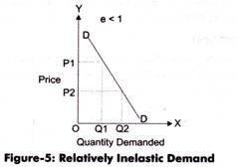

**5. Unitary Elastic Demand ( Ep = 1)**

The demand is said to be unitary elastic if the percentage change in quantity demanded is equal to the percentage change in price. It is also called unitary elasticity.

In the given figure, price and quantity demanded are measured along Y-axis and X-axis respectively. The demand curve **DD** is a rectangular hyperbola, which shows that the demand is unitary elastic. The fall in price from **OP**1 to **OP2** has caused equal proportionate increase in demand from **OQ1** to **OQ2.**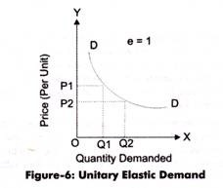

# Income Elasticity of Demand

The income elasticity of demand is defined as the percentage change in quantity demanded due to certain percent change in consumer’s income.

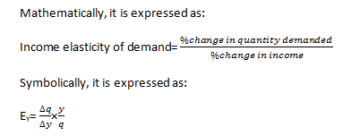

Where, EY= Elasticity of demand; q = Original quantity demanded; ∆q = Change in quantity demanded; y = Original consumer’s income;∆y= Change in consumer’s income.

* **Types of Income Elasticity of demand**

#### 1. Positive income elasticity of demand: If there is direct relationship between income of the consumer and demand for the commodity, then income elasticity will be positive.

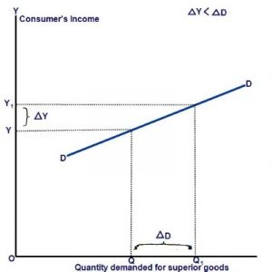

For example: as the income of consumer increases, they consume more of superior (luxurious) goods. On the contrary, as the income of consumer decreases, they consume less of luxurious goods.

#### 2. Negative income elasticity of demand

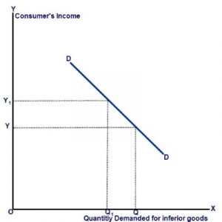If there is inverse relationship between income of the consumer and demand for the commodity, then income elasticity will be negative. As the income of consumer increases, they either stop or consume less of inferior goods.

**3. Zero income elasticity of demand**

If the quantity demanded for a commodity remains constant with any rise or fall in income of the consumer and, it is said to be zero income elasticity of demand. For example: In case of basic necessary goods such as salt, kerosene, electricity, etc. 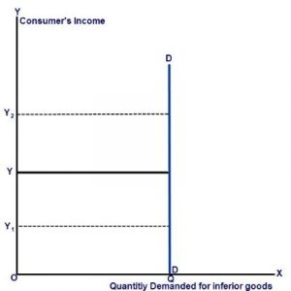there is zero income elasticity of demand

# Cross Elasticity of Demand

The cross-elasticity of demand is the degree of responsiveness of quantity demanded of a commodity due to the change in price of another commodity.

Mathematical Formula for Cross Elasticity of Demand

Cross elasticity of demand is the percentage change in the quantity demanded of good X due to certain percent change in the price of good Y.

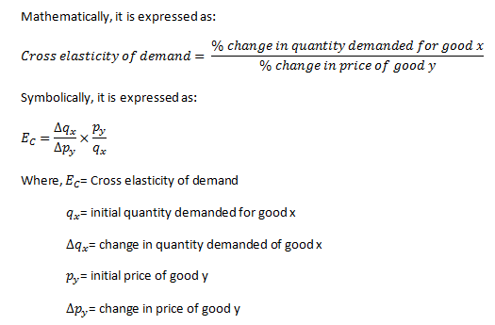

### Types of Cross Elasticity of Demand

#### Positive cross elasticity of demand (EC>0)

If rise in price of one good leads to rise in quantity demanded of other good of a similar nature and vice versa, it is known as positive cross elasticity of demand. Positive cross elasticity exists between two goods which are substitutes of each other.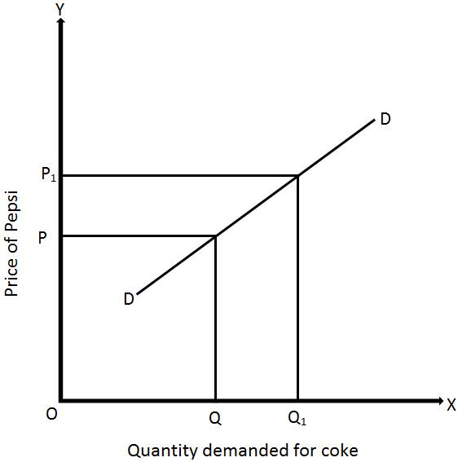

In the above figure, quantity demanded for Coke and price of Pepsi are measured along X-axis and Y-axis respectively. When the price of Pepsi increases from OP to OP1, quantity demanded for coke rises from OQ to OQ1 and vice versa. Thus, the demand curve DD shows positive cross elasticity of demand.

#### Negative cross elasticity of demand (EC<0)

Two goods which are complementary have negative cross elasticity of demand. If the rise in price of one good leads to fall in quantity demanded of its complementary good and vice versa, it is known as negative cross elasticity of demand.

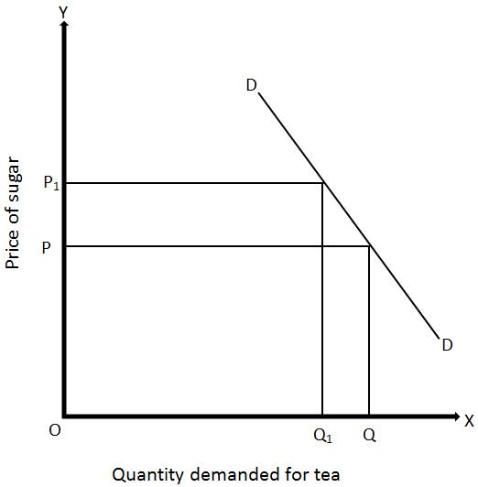

In the above figure, quantity demanded for Tea and price of Sugar are measured along X-axis and Y-axis respectively. When the price of Sugar increases from OP to OP1, quantity demanded for Tea falls from OQ to OQ1 and vice versa. Thus, the demand curve DD shows negative cross elasticity of demand.

**4. Advertising Elasticity of Demand:** Advertising elasticity of demand shows the change in quantity demanded as a result of a change in cost of Advertisement. Advertising elasticity of demand may be slated in the form of a formula.

Advertising Elasticity = Proportionate change in the quantity demand of commodity/ Proportionate change in the advertisement cost

* **Methods of Measuring Price Elasticity of Demand**

There are basically four ways by which we can measure price elasticity of demand. These methods are

**1. The Point Method:**This method is also suggested by Prof.marshall and it takes into consideration a straight line demand curve and measures elasticity at different points on the curve.

* 1. **Linear Demand Curve**

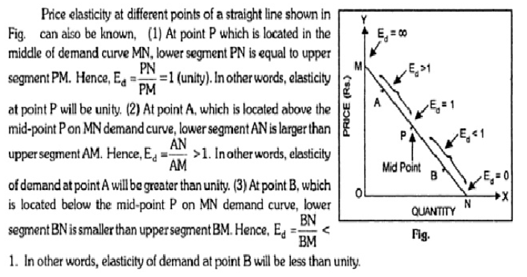

#### 2. The Arc Method:

When elasticity is measured between two points on the same demand curve, it is known as arc elasticity.

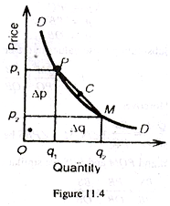

Any two points on a demand curve make an arc. The area between P and M on the DD curve.

**Demand Schedule:**

|  |  |  |
| --- | --- | --- |
| **Point** | **Price (Rs.)** | **Quantity (Kg)** |
| P | 8 | 10 |
| M | 6 | 12 |

If we move from P to M, the elasticity of demand is:

clip_image020

If we move in the reverse direction from M to P, then

clip_image022

Thus the point method of measuring elasticity at two points on a demand curve gives different elasticity coefficients because we used a different base in computing the percentage change in each case.

* **Determinant factors of elasticity of demand**

#### 1. Nature of the Commodity:

Generally, all commodities can be divided into three categories i.e.

(i) **Necessaries of Life:**

For necessaries of life the demand is inelastic because people buy the required amount of goods whatever their price. For example, necessaries such as rice, salt, cloth are purchased whether they are dear or cheap.

(ii) **Conventional Necessaries:**

The demand for conventional necessaries is less elastic or inelastic. People are accustomed to the use of goods like intoxicants which they purchase at any price. For example, drunkards consider opium and wine almost as a necessity as food and water. Therefore, they buy the same amount even when their prices are higher and highest.

(iii) **Luxury Commodities:** The demand for luxury is usually elastic as people buy more of them at a lower price and less at a higher price. For example, the demand of luxuries like silk, perfumes and ornaments increases at a lower price and diminishes at a higher price

#### 2. Substitutes:

Demand is elastic for those goods which have substitutes and inelastic for those goods which have no substitutes. The availability of substitutes, thus, determines the elasticity of demand. For instance, tea and coffee are substitutes. The change in the price of tea affects the demand for coffee. Hence, the demand for coffee and tea is elastic.

#### 3. Number of Uses:

Elasticity of demand for any commodity depends on its number of uses. Demand is elastic; if a commodity has more uses and inelastic if it has only one use. As coal has multiple uses, if its price falls, it will be demanded more for cooking, heating, industrial purposes etc. But if its price rises, minimum will be demanded for every purpose.

#### 4. Postponement:

Demand is more elastic for goods the use of which can be postponed. For example, if the price of silk rises, its consumption can be postponed. The demand for silk is, therefore, elastic. Demand is inelastic for those goods the use of which is urgent and, therefore, cannot be postponed. The use of medicines cannot be put off. Hence”, the demand for medicines is inelastic.

#### 5. Habits:

If consumers are habituated of some commodities, the demand for such commodities will be usually inelastic. It is because that the consumer will use them even their prices go up. For example, a smoker, generally, does not smoke less when the price of cigarette goes up.

#### 6. Time:

The demand for a commodity is always related to some period of time. This implies that elasticity of demand varies with the length of time periods. In case of long period, elasticity of demand will be elastic while in the short period, it will be inelastic.

* **significance of Elasticity of Demand**

**1.Price of factors of production:** The factors of production are land, labour, capital, organizations and technology. These have a cost; we have to pay rent, wages, interest, profits and price for these factors of production.

**b. Price fixation:** the manufacturer can decide the amount of price that can be fixed for his product based on the concept of elasticity, if there is no competition, in other words in the case of a monopoly, the manufacture is free to fix his price as long as it does not attract the attention of the government, when there are close substitutes, the product is such that its consumption can be postponed, it cannot be put to alternative uses and so on, then the price of the product cannot be fixed very highly.

**c. Government policies** 1. Tax policies: government extensively depends on this concept to finalize its polices relating to taxes and revenues. Where the product is such that the people cannot postpone its consumptions, the government tends to increase its, price, such as petrol and diesel, cigarettes, and so on.

2. Raising bank deposits: if the government wants to mobilize larger deposits from the consumer it proposes to raise the rates of fixed deposits marginally and vice versa.

3. Public utilities: government uses the concept of elasticity in fixing charges for the public utilities such as elasticity tariff, water charges, ticket fare in case of road or rail transport

**d. Forecasting demand:** Income elasticity is used to forecast demand for a particular product or services. The demand for the products can be forecast at a give income level. The trader can estimate the quantity of goods to be sold at different income levels to realize the targeted revenue.

**e. Planning the levels of output and price:** The knowledge of price elasticity is very useful to producers. The producer can evaluate whether a change in price will bring in adequate revenue or not. In general, for items whose demand is elastic, it would benefit him to charge relatively low price. On the other hand, if the demand for the product is inelastic, a little higher price may be helpful to him to get huge profits without losing sales.

* **Demand Forecasting**

**Meaning**: A forecast is a guess or anticipation or a prediction about any event which is likely to happen in the future. For example: An individual may forecast his job prospects, a consumer may forecast an increase in his income and therefore purchases, similarly a firm may forecast the sales of its product. Demand Forecasting means predicting or estimating the future demand for a firm’s product or products. Important aid in effective and efficient planning It is backbone of any business.

* **Features of Scientific demand forecasts:** Following things are essential to predict more scientific, ideal and more correct demand forecasts.

1) The object of demand forecasts should be clearly stated. It would clearly mention the purpose of demand forecasting.

2) In order to make correct demand forecasts, there should be suitable method's for demand forecasting. Appropriate methods are to be applied for the demand forecasting.

3) Information (Data) in respect of determinants of market demand is to be collected.

4) Collected data should be analyzed with the help of various statistical methods to determine the interrelationship between various factors, affecting the market demand.

5) By analysis of the data, the inferences are drawn and demand forecasts are to be made.

* **Factors Governing Demand Forecasting**

amarket demand for a particular product or service is not a single number but it is a function of a number of factors, for in**) Functional nature of demand:** stance, higher volumes of sales can be realized with higher levels of advertising or promotion efforts.

b) **Types of forecasting:** based on the period under forecast, the demand forecast can be of two types1) short – run forecasting and 2) long – run forecasting. Short run forecasts cover a period of one year whereas long- run forecasting any period ranging from one year to 20 years.

c) **Forecasting level:** the forecasting, at the firm level, industry level, national level or at the global level. **1. Firm level:** firm level means estimating the demand for the products and services offered by a single firm 2**. Industry level:** the aggregate demand estimated for the good and service of all the firms constitutes the industry level forecast. The total estimate of different trade associations can also be view as industry level forecast. **3. National level:** national level forecasting is for the whole economy, national level forecasts are worked out based on the levels of income, savings of the consumers.

4. Global level: globalization and de regulation , the entrepreneurs have started exploring the foreign markets for which the global level forecasts are utilized.

d) **Degree of orientation:** demand forecasts can be worked out based on total sales or product or service wise sales for a given time period. Forecasting in terms of total sales can be viewed as general forecast whereas product or service – wise or region or customer segment – wise forecast is referred is referred to as specific forecast.

e**) New product:** it is relatively easy to forecast demand for established products or products which are currently in use. The new product in consideration can be analyzed as a substitute for some existing product. Assess the demand through a sampled or total survey of consumers’ intentions over the new product features and price.

f) **Nature of good:** The goods are classified into producer goods, consumer goods, consumer durables and services. The patterns of forecasting in each of these differ.

g**) Degree of competition:** there may be a single trader or a few traders depending upon the nature of goods and services.

* **Kinds of Demand forecasting :**

There are two main kinds of demand forecasting. It is classified on the basis of time

Period and planning requirements of firms. They are classified as:

* + - 1. Short term demand forecasting 2) Long term demand forecasting.

**1) Short term demand forecasting:**

This type of demand forecasting is a short period forecasting of demand, for the product of a business firm. They are generally made for the period of one year. It is related with sales, inputs, price and finances of the business firm. Short term forecasting is essential for the formulation of suitable price policy, cost policy, sales policy and financial policy of a business firm.

**2) Long - term Demand forecasting:**

Every manager of business firm is interested in long term business forecasts of demand. These forecasts are made for the period of 5 years, 10 years, 20 years or more than that period. These forecasts are necessary for the expansion of the firm. Total demand for product of business firm can be estimated with the help of long term demand forecasts. Planning for a new plant and expansion of an existing plant depends upon long-term forecasting.

Long term demand forecasts are difficult to predict the demand, costs, sales, prices and competition. Because of very long time period. Various changes take place in economic variables. So, the forecasts made in one time can't be proved true in another time in long run.

* **Steps in Demand forecasting**

Step 1 Determine purpose of forecast

Step 2 Selection of products

Step 3 Select a forecasting technique

Step 4 Gather and analyze data

Step 5 estimating future events

* **Methods /Techniques of Demand Forecasting**

**I. Qualitative Techniques:** They mainly employ human judgment to predict future events. They are also called macroeconomic methods. This involves the prediction of economic aggregates such as, unemployment, GDP growth, short-term interest rates etc... This involves: 1) Expert opinion methods 2) Survey methods: a. Complete enumeration survey b.Sample survey 3.Sales force opinion

**1) Expert Opinion/ Delphi Method Method**: This technique of forecasting demand seeks the views of experts on the likely level of demand in the future. They have a rich experience of the behaviour of demand.

**2)Survey Methods :** In it we have four major survey methods : a) **Consumers Complete Enumeration Survey :** In this method data is collected from all the customers and then added up to arrive as the total expected demand of the product. The method is comprehensive and can give better forecasts of demand. This method is time consuming and costly.

b) **Consumers Sample Survey**: Only a few consumers are selected and their views on the probable demand are collected. Thus, it is a miniature form of Complete Enumeration Survey. The sample is considered to be a true representation of the entire population. This method is simple and cheaper. The results of survey can be obtained quickly and results are good.

**3) Sales Force Opinion Survey:** In this method sales persons are expected to estimate expected sales in their respective territories. The sales force, which has been selling the product to wholesalers / retailers / consumers over a period of time, is considered to know the product and the demand pattern very well. This method does not require intricate mathematical calculations. This method is based on the first hand knowledge of the salesman. It is useful to forecast the sales of new products.

**II.Quantative Techniques** This method involves various statistical tools to data for predicting future events. These methods are also called microeconomic methods. Involves the prediction of activity of particular firms, branded products, commodities, markets, and industries. They are much more reliable.

**1) Trend Projection Method:** This method is used when a detailed estimate has to be made. Time plays an important role in this method. This method uses historical and cross –sectional data for estimating demand. In this method data is arranged chronologically which yields a ‘time series’. The time series represent the past pattern of effective demand for a particular product and is used to project the trend of the time series. To do so there are two methods

**A) Graphical method:** A trend line can be fitted through a series graphically. Old values of sale for different areas are plotted on graph and a free hand curve is drawn passing through as many points as possible. Based on trend equation, we find ‘Line of Best Fit’ and then it is projected in a scatter diagram, dividing points equally on both sides.

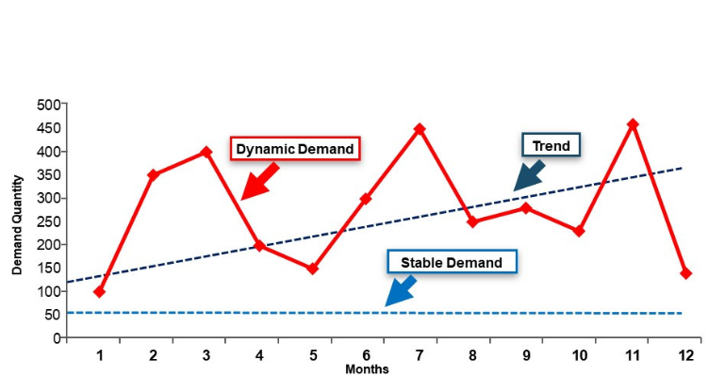

[**B)**](https://image.slidesharecdn.com/finale-131204085259-phpapp01/95/demand-forecasting-22-638.jpg?cb=1386147254)**Least Square Method:** It is a mathematical procedure for fitting a line to a set of observed data points in a manner that the sum of the squared differences between the calculated and observed value is minimized. The linear trend is the most widely used mode of time series analysis.

It is represented: Y= a + b x; Y=Demand; X= Time Period a & b are constants. For calculation of Y for any value of X requires the values of a & b.

**2. Barometric Method**: Method uses business barometers or indicators of various economic phenomena. The term Barometer is used to indicate the economic phenomena. The assumption behind this is that the past pattern tends to repeat them in future and future can be predicted with the help of certain happenings of the present. Forecasting Techniques that use the lead and lag relationship between Economic variable for predicting the directional changes in the concerned variables are known as Barometric Techniques.

• Some of the important indicators are: a. Employment b. Wholesale prices c. Industrial production d. Gross national product.

Example: The bhuj earthquake in January 2001, led to a massive destruction of Property and buildings in Gujarat. This necessitated constructions of building. The construction was followed by a spurt in demand for cement, fans, Tube lights etc. Thus one can say that the construction of buildings leads to the demand for cement. In this case the construction of building is the leading indicator or the barometer.

**3. Regression Method:** Linear regression analysis establishes a relationship between a dependent variable and one or more independent variables. In simple linear regression analysis there is only one independent variable. If the data is a time series, the independent variable is the time period. The dependent variable is whatever we wish to forecast.

 Regression Equation This model is of the form: Y = a + bX Where, Y = dependent variable X = independent variable

**4. Simultaneous Equations**: When the inter relationship between the economic variables becomes complex, the use of single equation regression method becomes difficult. In such cases forecasting of demand is done using multiple simultaneous equations. This is the complex statistical methods of forecasting. These variables are of two types: • endogenous, • exogenous.

Suppose a manufacturing plant produces a certain amount of white sugar. The amount of product (white sugar) is the endogenous variable and is dependent on any number of other variables which may include weather, pests; price of fuel etc.An exogenous variable is a [variable](https://www.statisticshowto.datasciencecentral.com/probability-and-statistics/types-of-variables/)that is not affected by other variables in the system. For example, take a simple causal system like farming. Variables like weather, farmer skill, pests, and availability of seed are all exogenous to crop production.