Defenders Analysis

Riu Sakaguchi

6/12/2020

Restricted to level 1/wave 1/no upgrades (15 red/5 blue viruses)

Df Sum Sq Mean Sq F value Pr(>F)

LocationCombination 5 2718 543.6 90.273 < 2e-16 ***

MedicineCombination 3 265 88.4 14.672 2.15e-09 ***

LocationCombination:MedicineCombination 15 342 22.8 3.787 1.29e-06 ***

Residuals 1243 7485 6.0

---

Signif. codes: 0 ‘***’ 0.001 ‘**’ 0.01 ‘*’ 0.05 ‘.’ 0.1 ‘ ’ 1

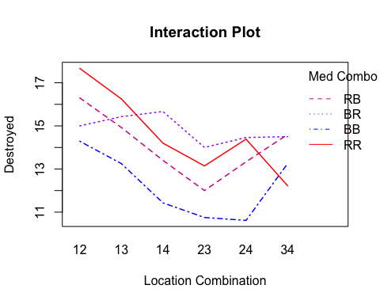

We can win this wave if we use red red and 12 only

This makes sense since turret 1 has the most distance to kill

Why is 12 better than 13 or 14?

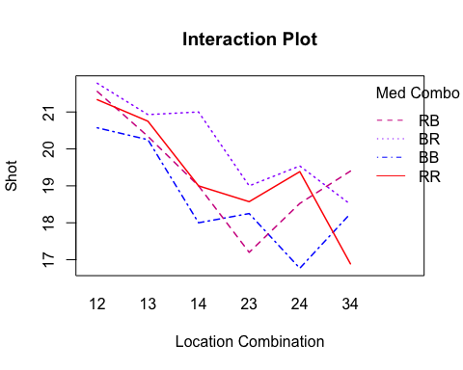

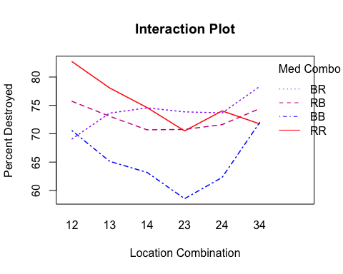

This makes sense since turret 1 has the most distance to kill. It makes sense because turrets 23 and 34 are very close together.

Why is 12 better than 13 or 14?

**Destroyed** BR (12, 13, 14) RR (24, 34) Turrets are too close to each other and since they are effective, many of the shots are not getting in and hence destroyed goes down as well.

**Shot** RR (24, 34) As explained above, turrets are too close to each other and since they are effective, the turret that shoots second won’t get their shot in.

**Percent Destroyed** RB and BR cross between 12 and 13. BB and RR cross at 34 (Sample size could be an issue).

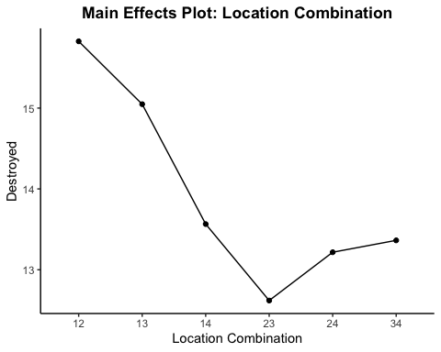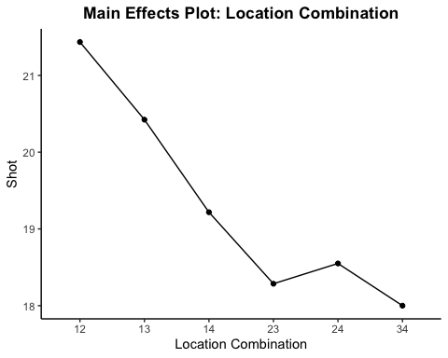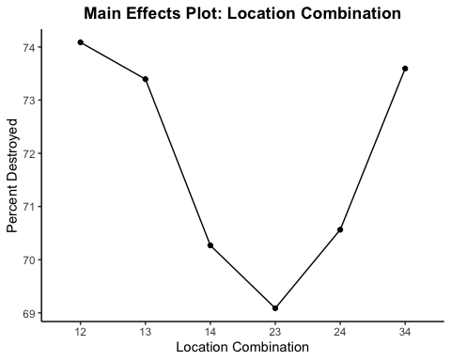

**Destroyed** Higher destroyed when turrets are closer to the entrance makes sense because we also get more shots in. 23 seems to be the worst location combination.

**Shots** Again, we get more shots in when the turrets are placed closer to the entrance, and less as they are placed closer to the exit.

**Percent Destroyed** We see a U shape pattern with higher percentages at locations closest to the entrace and closest to the exit. Could most likley be due to the ratios of medicine combination at each location.

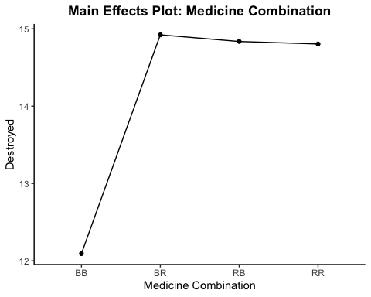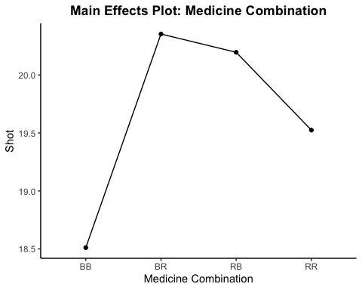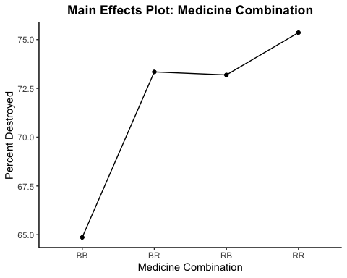

**Destroyed** BB being the worst makes sense because there are more red viruses. The rest seem to be similar in terms of the number of viruses destroyed.

**Shot** Perhaps RR is lower because it is supposed to be the most effective combination, and the second turrent might not be getting in shots. BB being the lowest might be a result of disproportionate location combinations

**Percent Destroyed** This plot makes sense, BB being the lowest, RB and BR being around the same, and RR being the highest.