SmartAppt
User Manual

Apartment Association Management System
Role-Based Feature Guide · With Screenshots

Manager | Treasurer
Committee | Resident
Gate Staff

August 2026

Table of Contents

Overview
Introduction 3

Roles
Manager 4
Web Application 4
Mobile Application 20
Treasurer 22
Web Application 22
Mobile Application 24
Committee 26
Web Application 26
Mobile Application 28
Resident 29
Web Application 29
Mobile Application 33
Gate Staff 35
Web Application 35

Reference
Quick Reference — Feature Matrix 37

Introduction
SmartAppt is a comprehensive apartment association management platform that helps residents, committee members, and administrative staff manage dues, maintenance, visitors, announcements, and finances — all from one place.

This manual covers how to use SmartAppt based on your assigned role. Each role has a tailored set of features available on both the Web Application and the Mobile App.

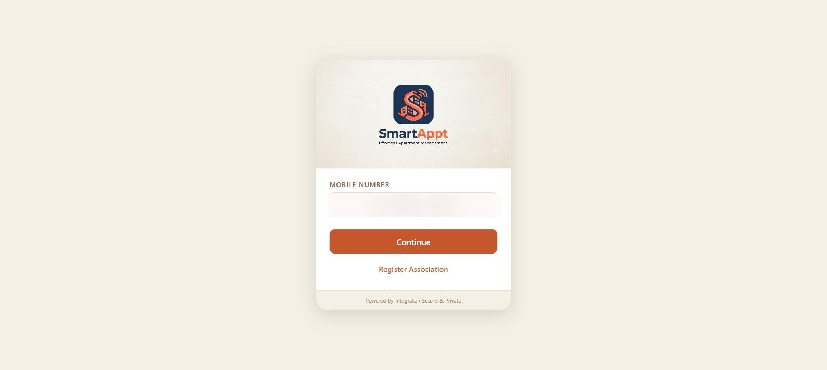
Login page — enter your registered mobile number and OTP or M-PIN to sign in

Role Overview
Feature | What You Can Do
Manager | Full administrative access. Manages users, units, service requests, visitor logs, and accounting. Also has all resident features.
Treasurer | Financial authority. Manages dues configuration, billing, expenses, receipts, and accounting. Also has all resident features.
Committee | Oversight role. Views financial data, bills, and accounting reports. Also has all resident features.
Resident | Day-to-day living features: pay bills, raise service requests, pre-approve visitors, and read announcements.
Gate Staff | Operational gate management: record visitor entry/exit, scan QR codes, handle walk-ins.

Note: Manager, Treasurer, and Committee members are also residents of the complex. They have access to all resident features in addition to their administrative capabilities.

Manager
Full administrative access + all resident features

The Manager has the broadest access in SmartAppt. They oversee residents, units, maintenance, visitors, and financial reporting. They also have all resident features since they live in the complex.

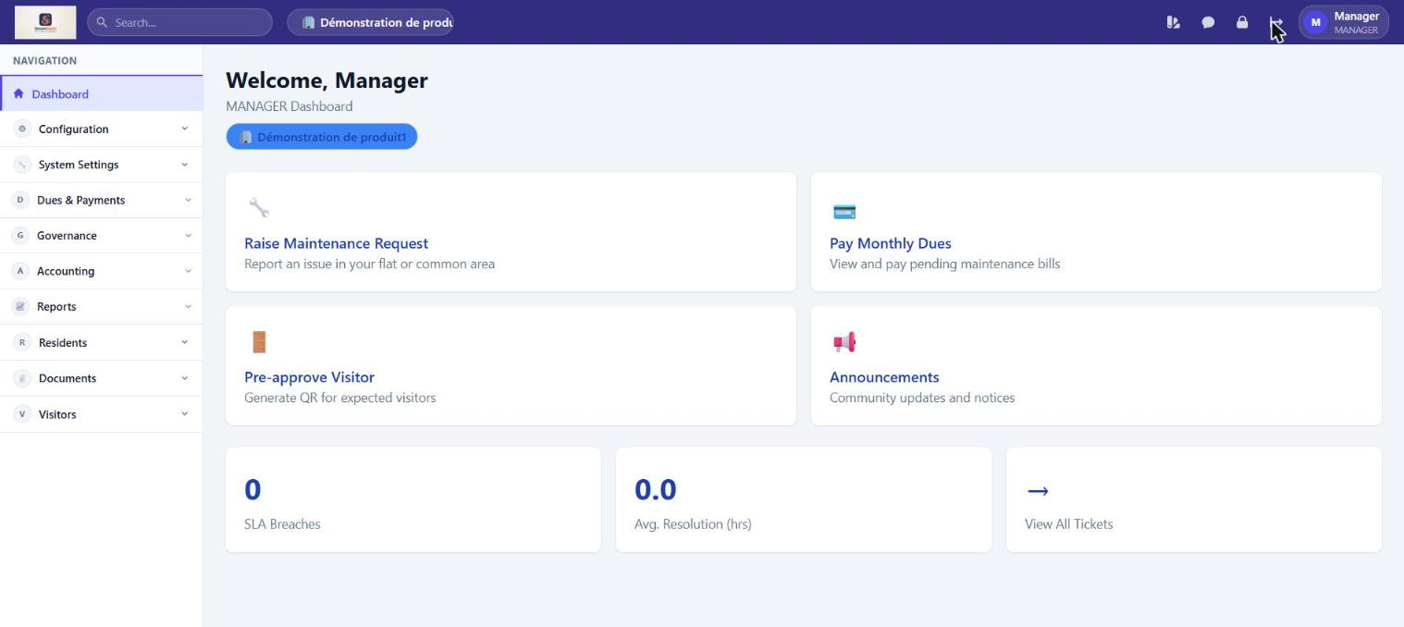
Manager Dashboard — quick-action cards and full navigation (Configuration, System Settings, Dues & Payments, Governance, Accounting, Reports, Residents, Documents, Visitors)

Web Application

Configuration
Feature | What You Can Do
Manage Users | Add new users, edit details, deactivate accounts, assign roles. Bulk import residents via Excel template.
Manage Units | Add, edit, and delete residential units. Invite owners and tenants to units. Bulk import units via Excel.
Chart of Accounts | Define and organise the accounting accounts used in the general ledger. Reachable from Configuration.
Business Partners | Maintain a directory of vendors, contractors and service providers used when recording expenses and payables.

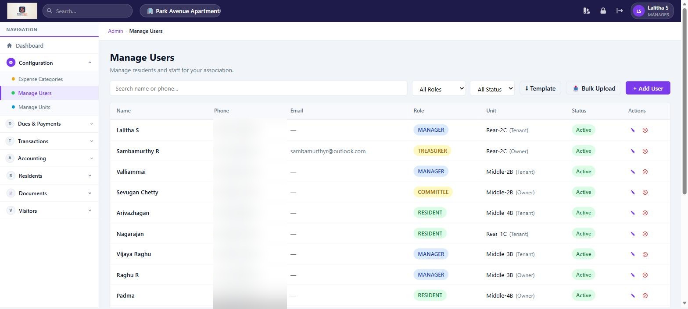
Manage Users — view all registered users, add new members, assign roles

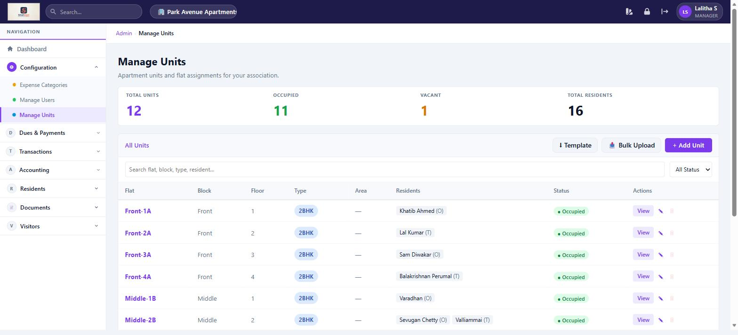
Manage Units — add, edit and link residents to residential units

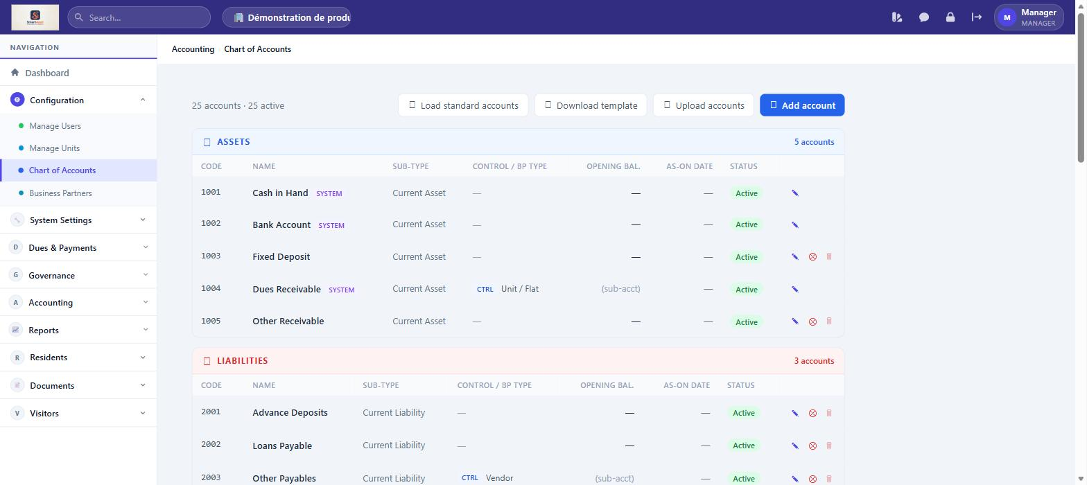
Chart of Accounts — Define and organise the accounting accounts used in the general ledger. Reachable from Configuration.

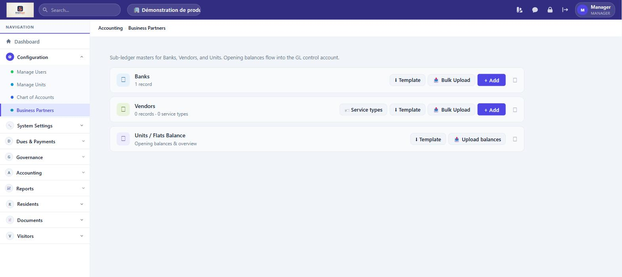
Business Partners — Maintain a directory of vendors, contractors and service providers used when recording expenses and payables.

System Settings
Feature | What You Can Do
Web Menu by Role | Control which items each role sees in the web sidebar, scoped to your own association.
Mobile Menu by Role | Control which screens each role sees in the mobile app, scoped to your own association.
Audit Trail | View a read-only log of financial, configuration, authentication and deletion events for your association.
Branding | Set the association's logo, app name and colour theme. Off by default — a Super User must grant this access right; reachable directly at Admin → Branding.

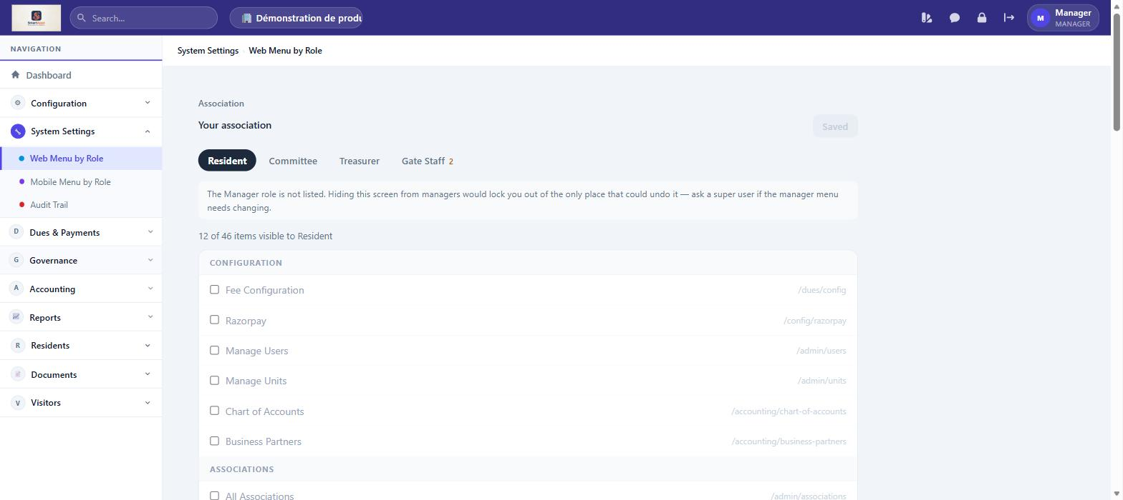
Web Menu by Role — Control which items each role sees in the web sidebar, scoped to your own association.

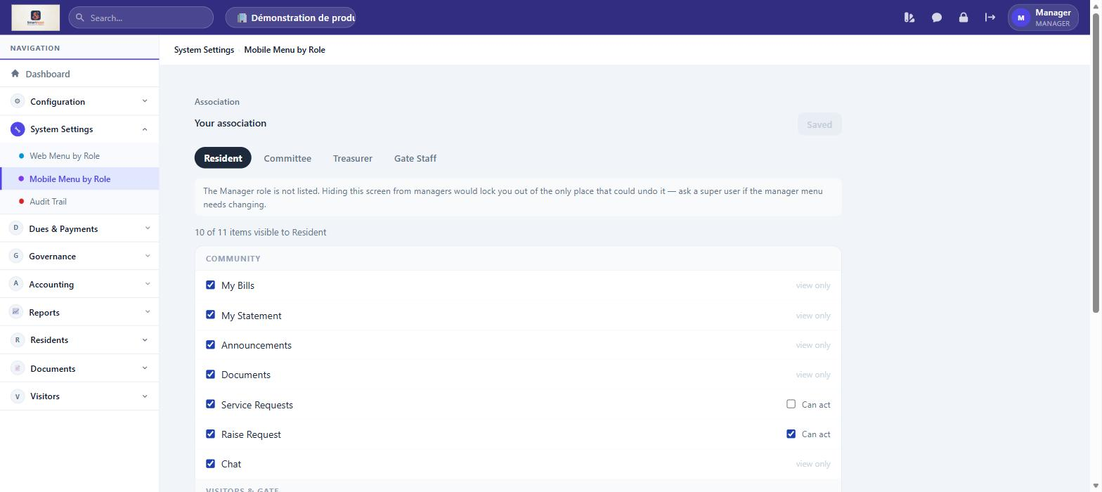
Mobile Menu by Role — Control which screens each role sees in the mobile app, scoped to your own association.

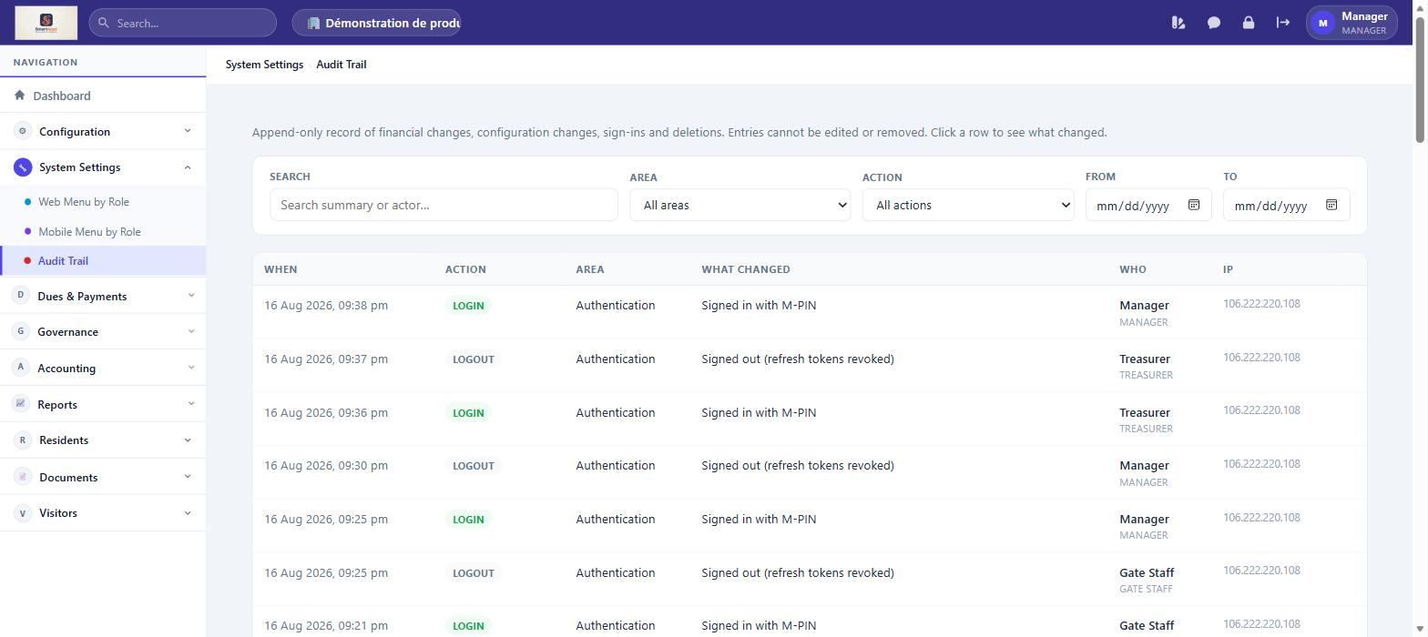
Audit Trail — View a read-only log of financial, configuration, authentication and deletion events for your association.

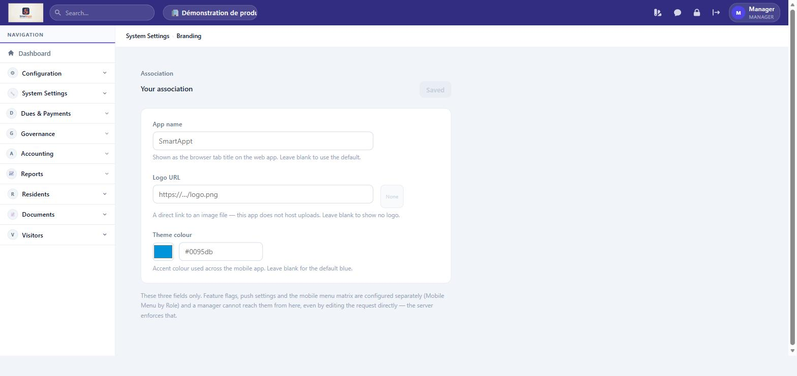
Branding — Set the association's logo, app name and colour theme. Off by default — a Super User must grant this access right; reachable directly at Admin → Branding.

Dues & Payments
Feature | What You Can Do
Dues Overview | Dashboard showing collection stats: total billed, collected, outstanding, and pending units for the current month.
Bills & Payments | View all bills generated for the association. Track payment status (Unpaid, Partial, Paid, Waived). Record offline payments on behalf of residents.
One-Time Dues | Create special one-time charges targeting specific units (e.g. parking deposit, maintenance levy). Generate and manage the bills for these charges.
UPI Payments | Residents may also pay via UPI. The Treasurer confirms each UPI claim before it posts to the ledger.
Arrears | View units with overdue balances, ageing buckets, and total amount outstanding across the association.
Statement of Account | Generate a unit's full transaction history — bills, payments, and running balance — for any date range.
Late Payment Penalty | Configure penalty rules (flat or percentage) applied automatically to overdue bills, and review penalties charged.

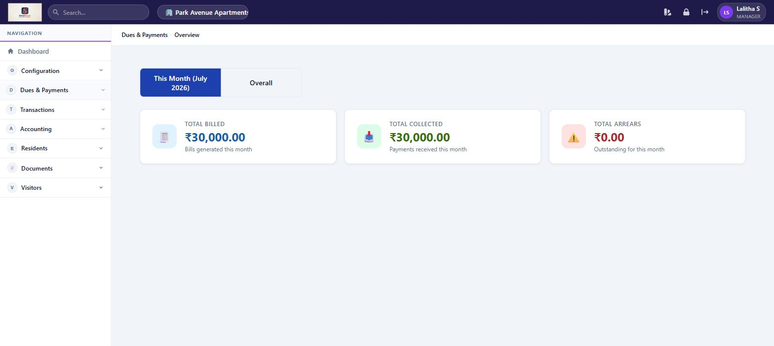
Dues & Payments Dashboard — monthly collection overview with unit-wise status

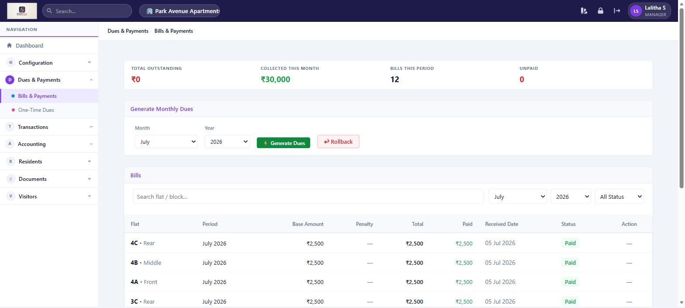
Bills & Payments — track all resident bills, record offline payments

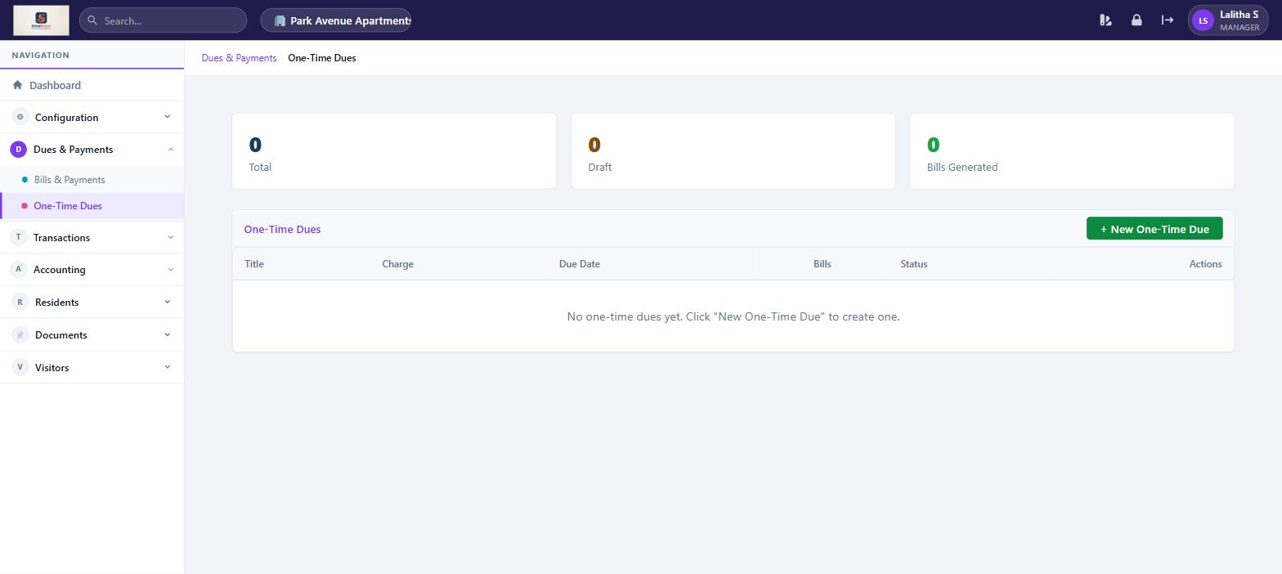
One-Time Dues — create and manage targeted special charges

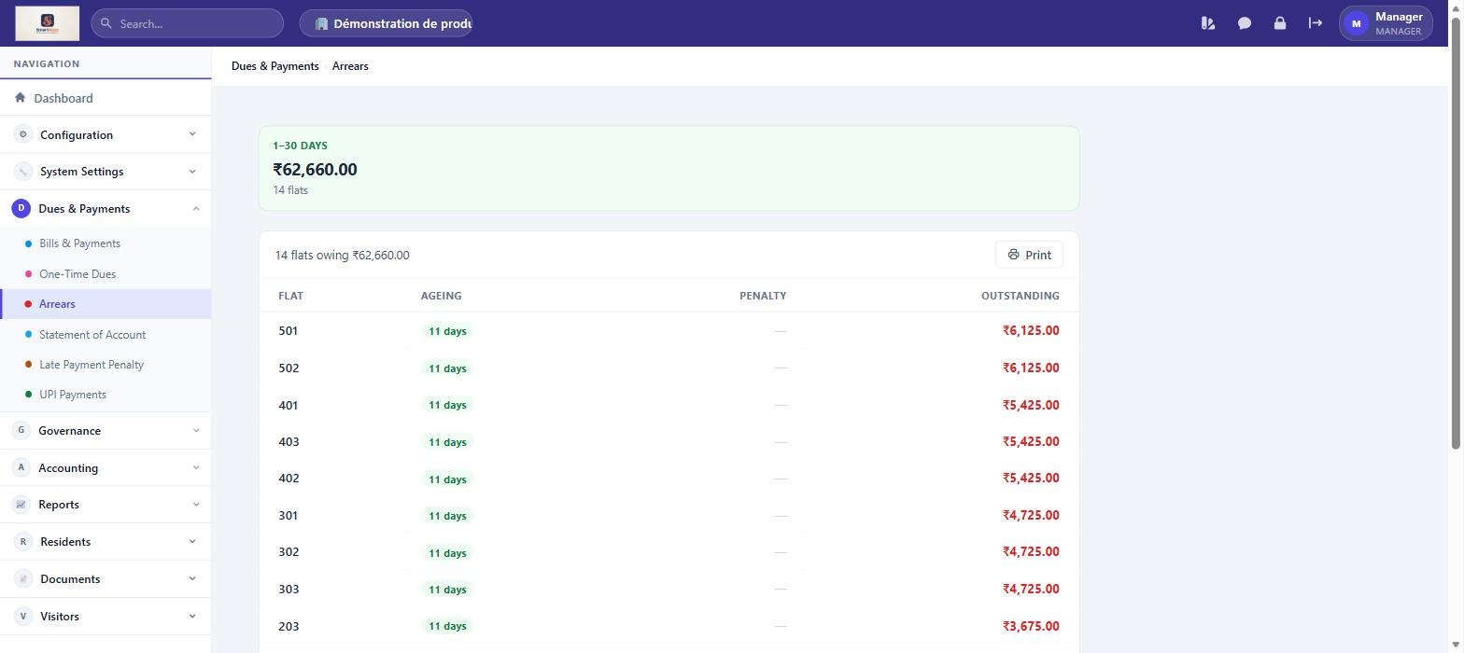
Arrears — View units with overdue balances, ageing buckets, and total amount outstanding across the association.

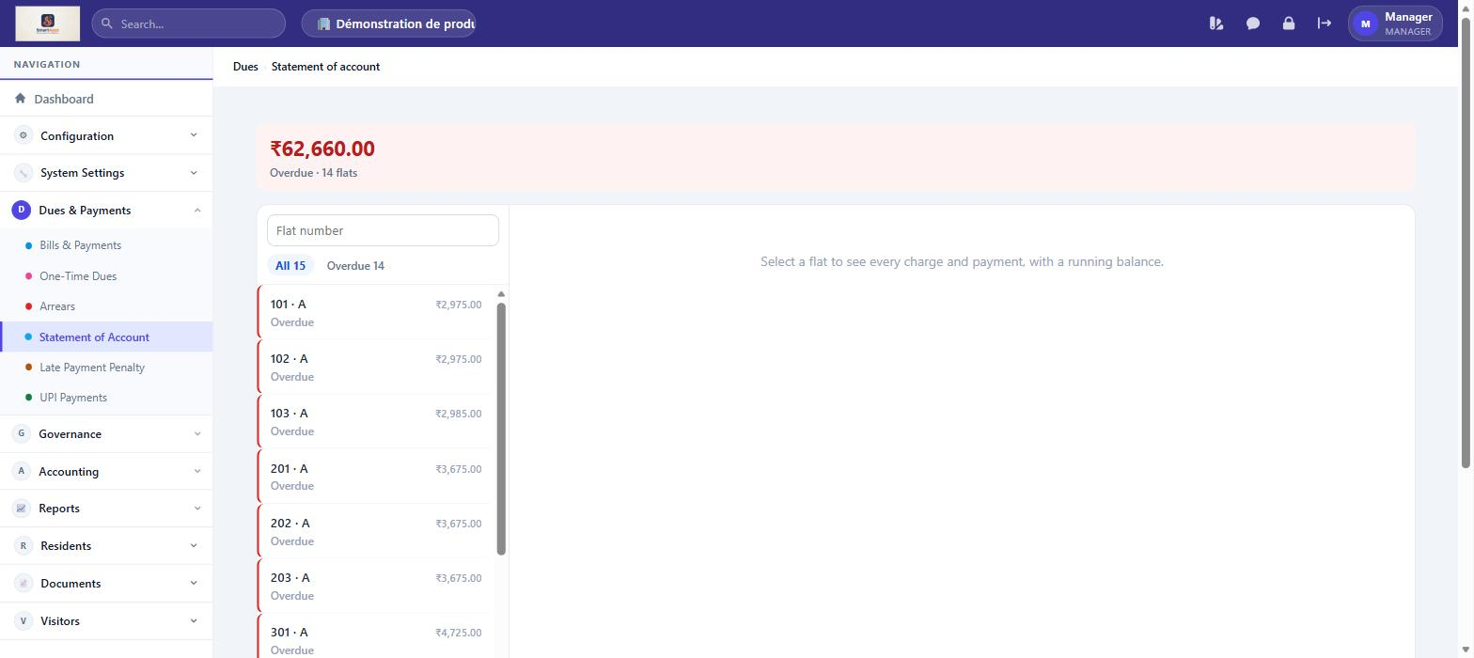
Statement of Account — Generate a unit's full transaction history — bills, payments, and running balance — for any date range.

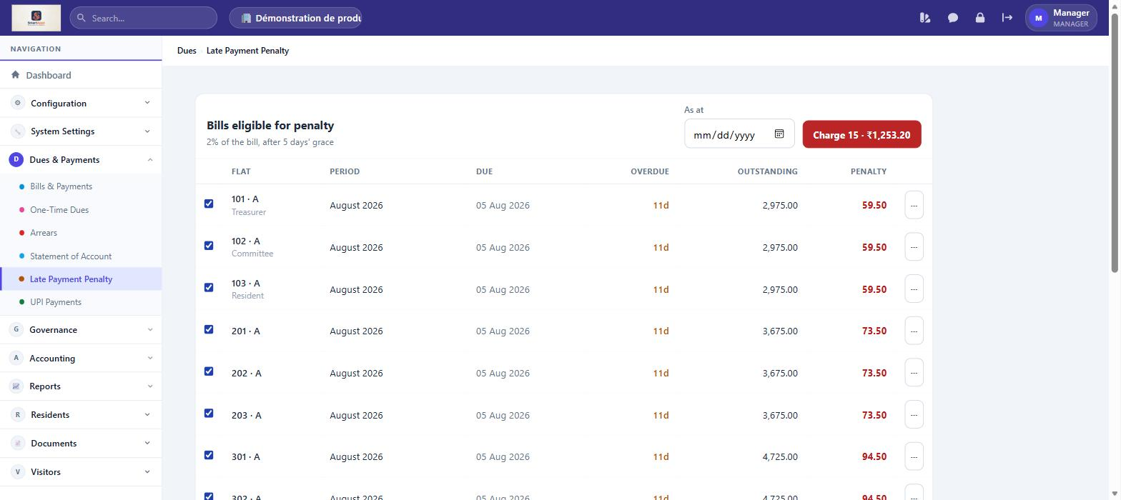
Late Payment Penalty — Configure penalty rules (flat or percentage) applied automatically to overdue bills, and review penalties charged.

Governance
Feature | What You Can Do
Meetings | Schedule AGMs and committee meetings, set agenda items, track quorum, and record minutes.
Committees | Form committees, assign members and roles (Chair/Secretary/Member), and track committee terms.
Register of Members | Maintain the statutory register of unit owners and members, with voting-share and membership details.
Elections | Run committee elections — define positions, nominate candidates, and record results.
Compliance Calendar | Track statutory filing deadlines and compliance tasks for the association, with due dates and status.

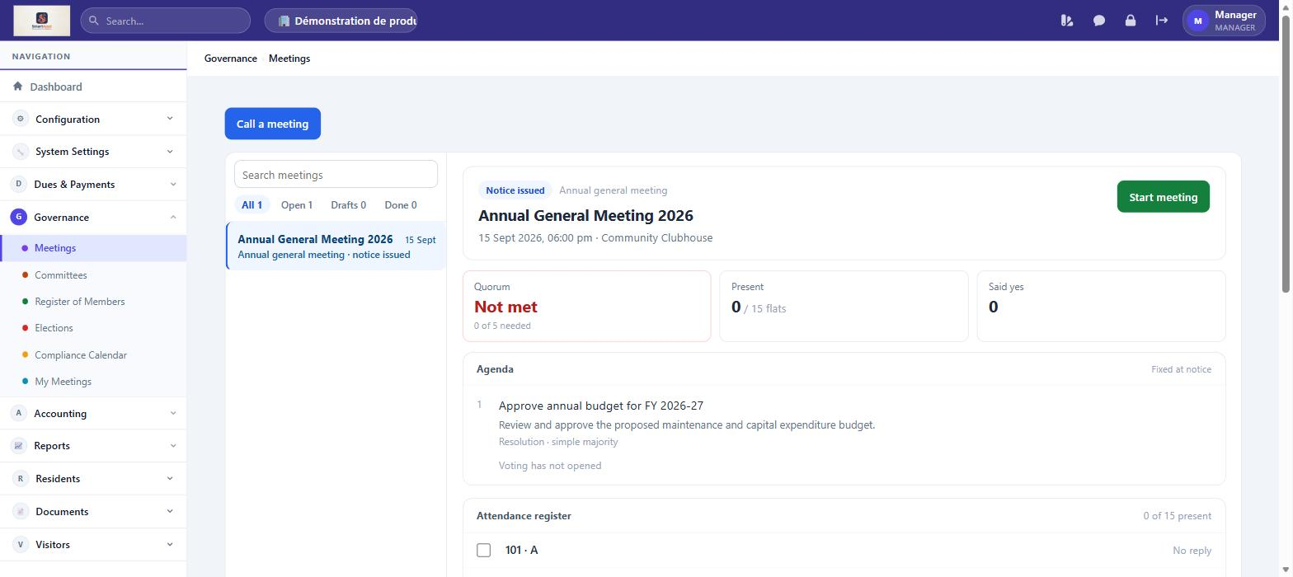
Meetings — Schedule AGMs and committee meetings, set agenda items, track quorum, and record minutes.

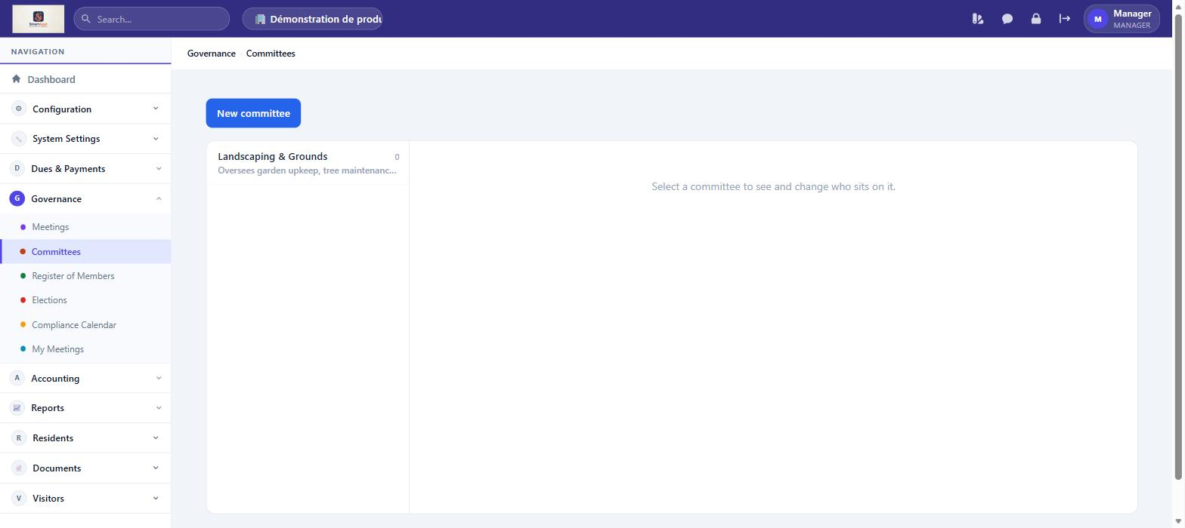
Committees — Form committees, assign members and roles (Chair/Secretary/Member), and track committee terms.

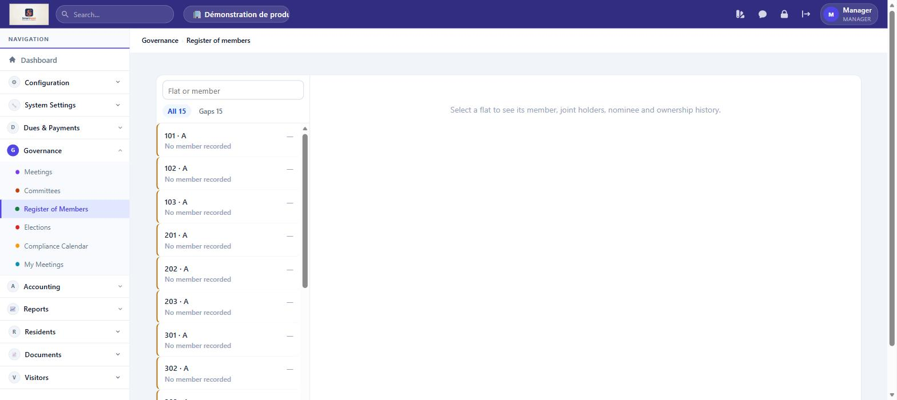
Register of Members — Maintain the statutory register of unit owners and members, with voting-share and membership details.

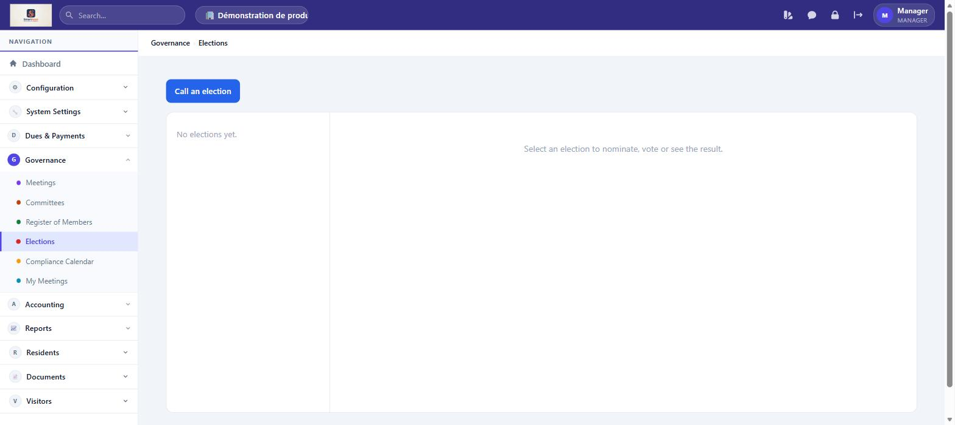
Elections — Run committee elections — define positions, nominate candidates, and record results.

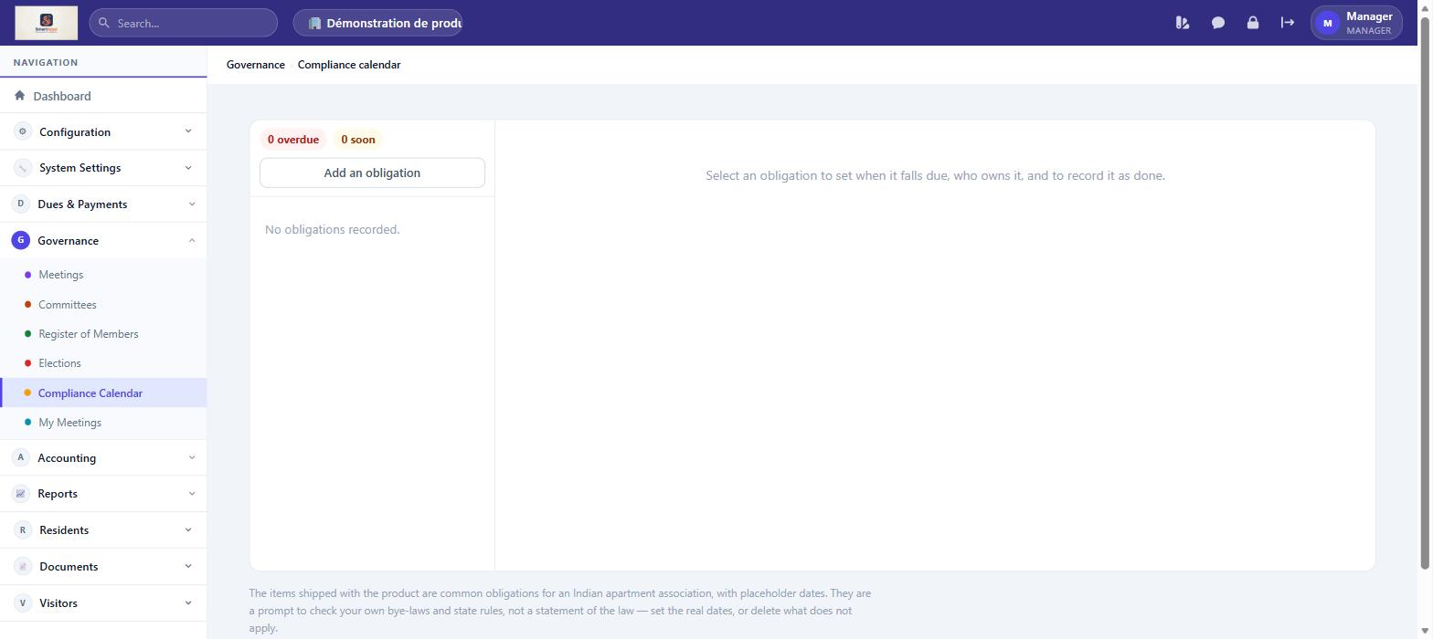
Compliance Calendar — Track statutory filing deadlines and compliance tasks for the association, with due dates and status.

Accounting
Feature | What You Can Do
Chart of Accounts | Define and organise the accounting accounts used in the general ledger. Sync historical dues, expense, and receipt transactions into journal entries.
Journal Entries | View all double-entry bookkeeping records auto-posted by billing, payments, and expense events.
Ledger | Filter and view account-wise transaction history across any date range.
Profit & Loss | View the income versus expense statement for any period (Financial Year or custom range).
Balance Sheet | View the association's financial position showing assets, liabilities, and equity as of a chosen date.
Trial Balance | View debit/credit totals for every account as of a chosen date, to confirm the ledger is in balance.
Cash / Bank Book | View a chronological record of all cash and bank account transactions for a chosen period.
Day Book | View every accounting entry posted on a given day or range, across all accounts.
Receipts & Payments | Summarise all cash and bank receipts and payments for a period — a cash-basis view of the association's activity.
Income & Expenditure | View the accrual-basis income and expenditure statement for a Financial Year or custom range.
FY Closure | Close out a Financial Year — lock prior-year entries and carry forward opening balances to the new year.

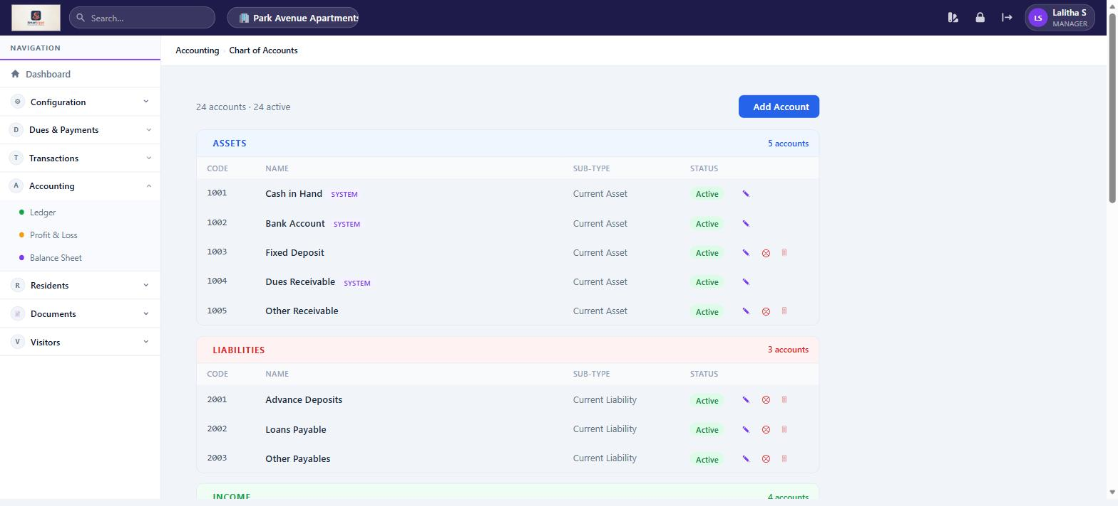
Chart of Accounts — 24 accounts across Assets, Liabilities, Income, and Expenses

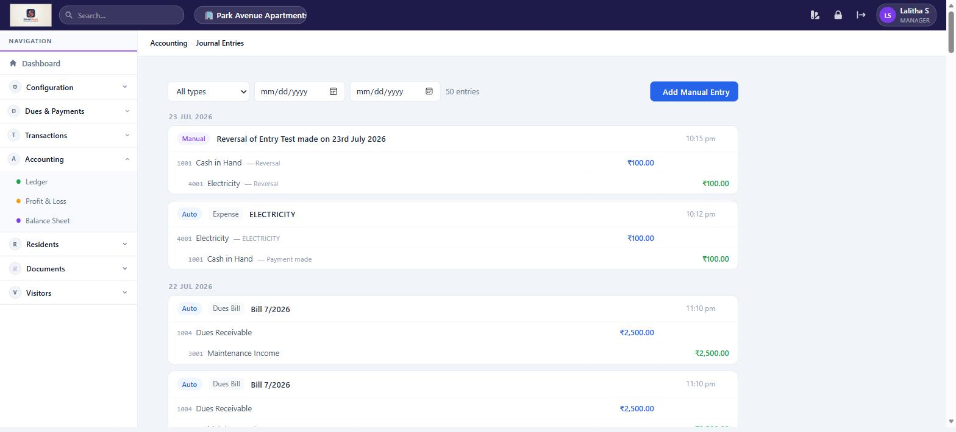
Journal Entries — auto-posted double-entry records for all financial events

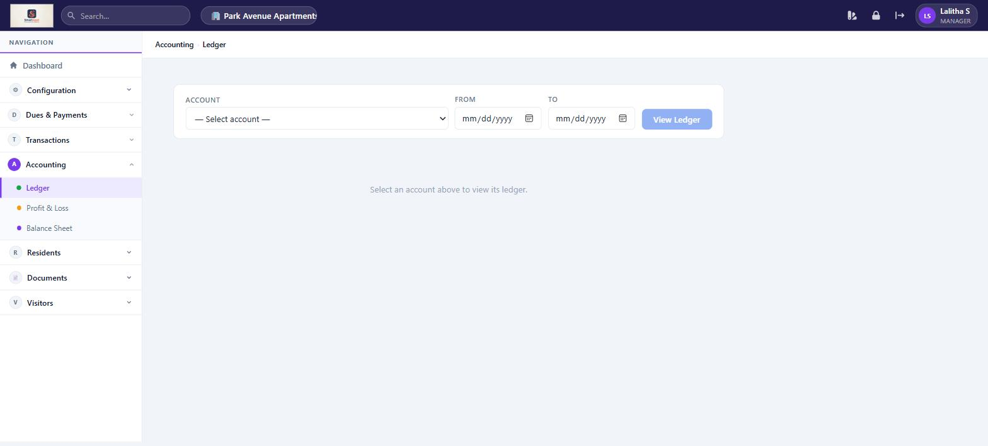
Ledger — select an account and date range to view its transaction history

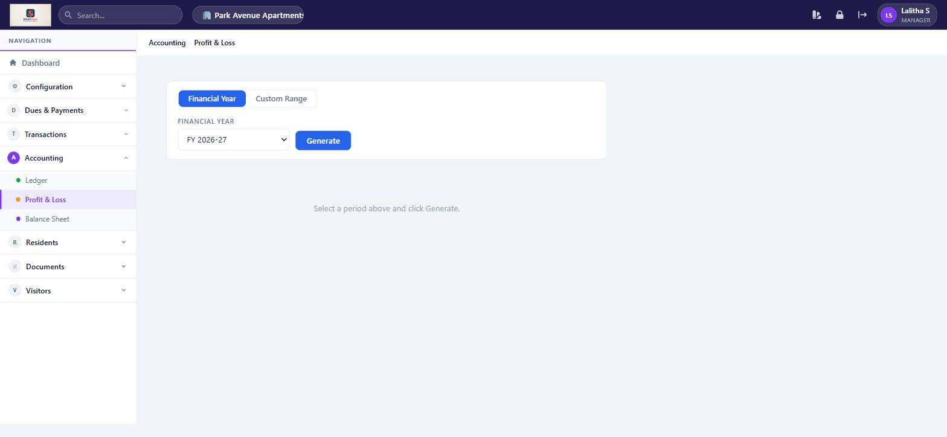
Profit & Loss — generate income vs expense statement by financial year or custom range

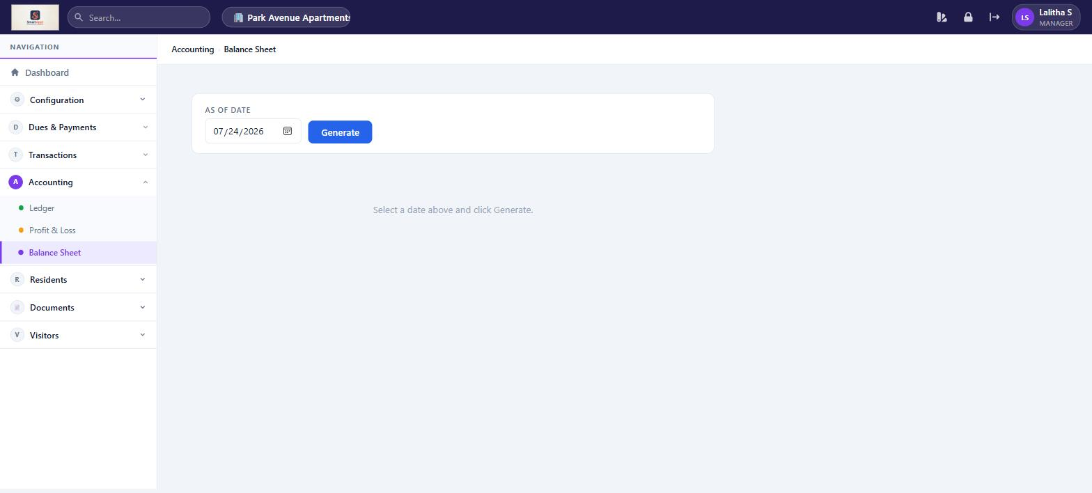
Balance Sheet — view financial position as of any date

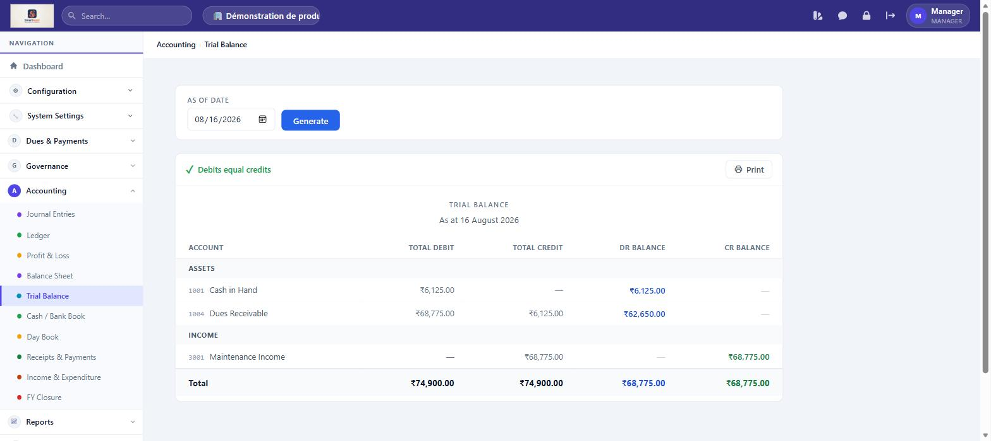
Trial Balance — View debit/credit totals for every account as of a chosen date, to confirm the ledger is in balance.

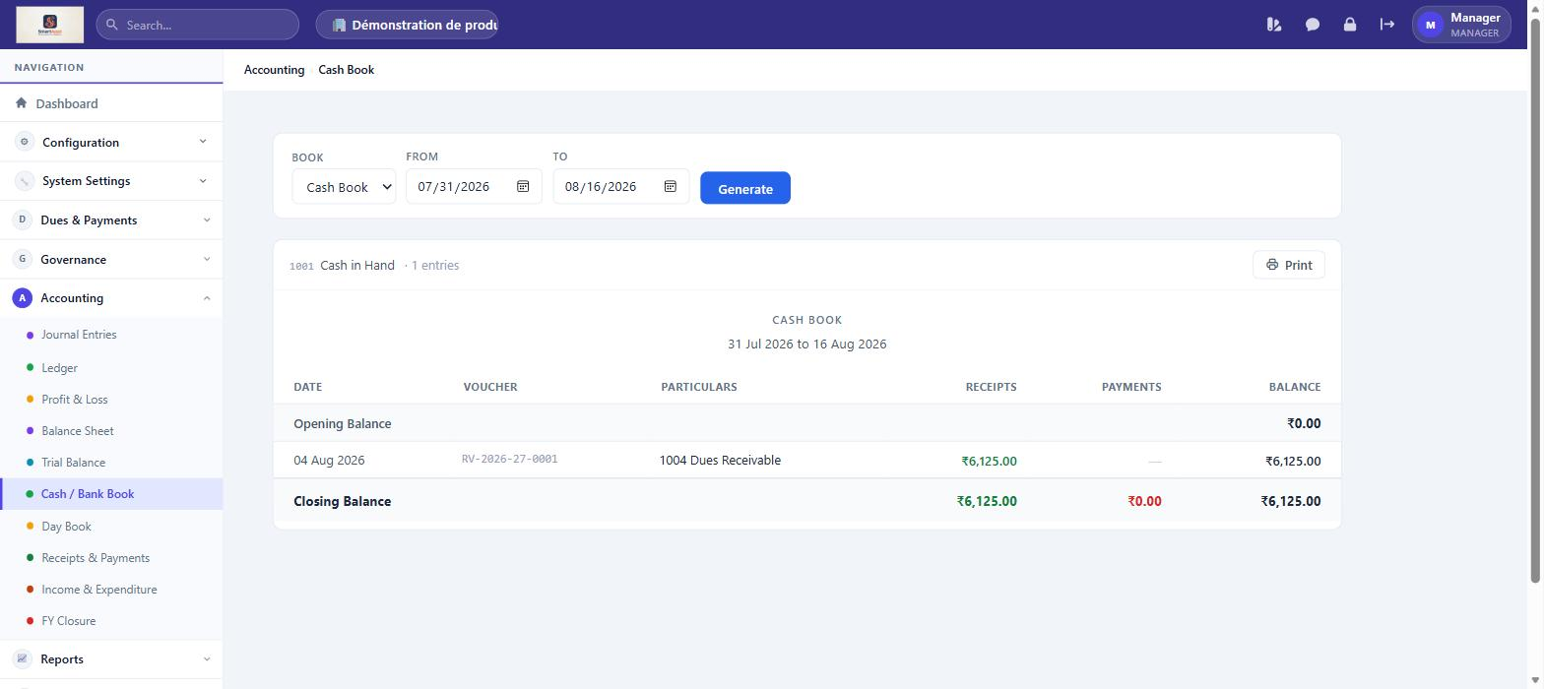
Cash / Bank Book — View a chronological record of all cash and bank account transactions for a chosen period.

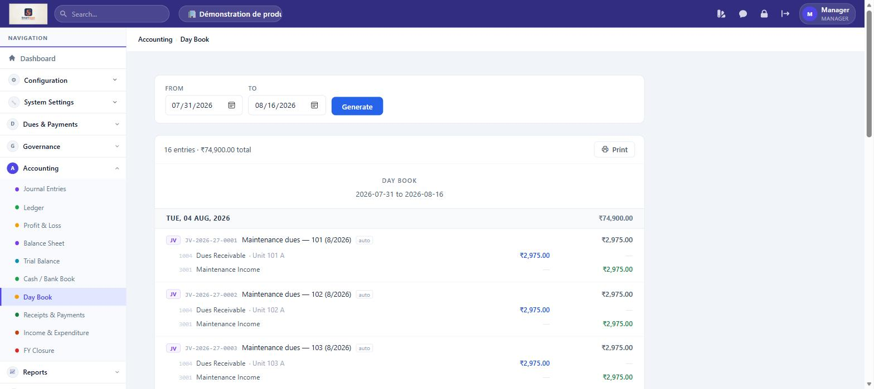
Day Book — View every accounting entry posted on a given day or range, across all accounts.

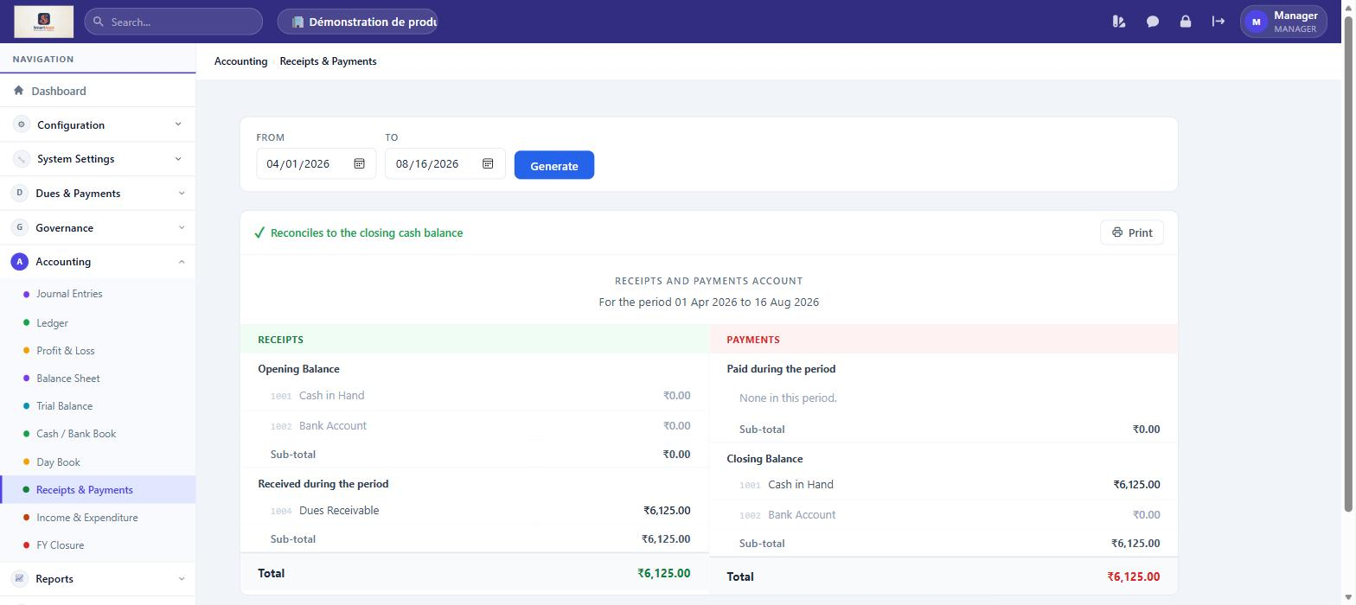
Receipts & Payments — Summarise all cash and bank receipts and payments for a period — a cash-basis view of the association's activity.

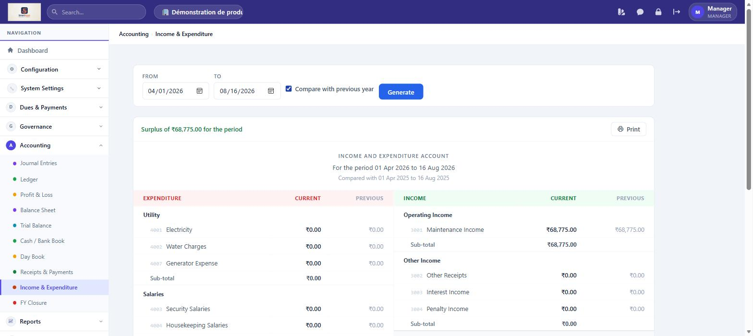
Income & Expenditure — View the accrual-basis income and expenditure statement for a Financial Year or custom range.

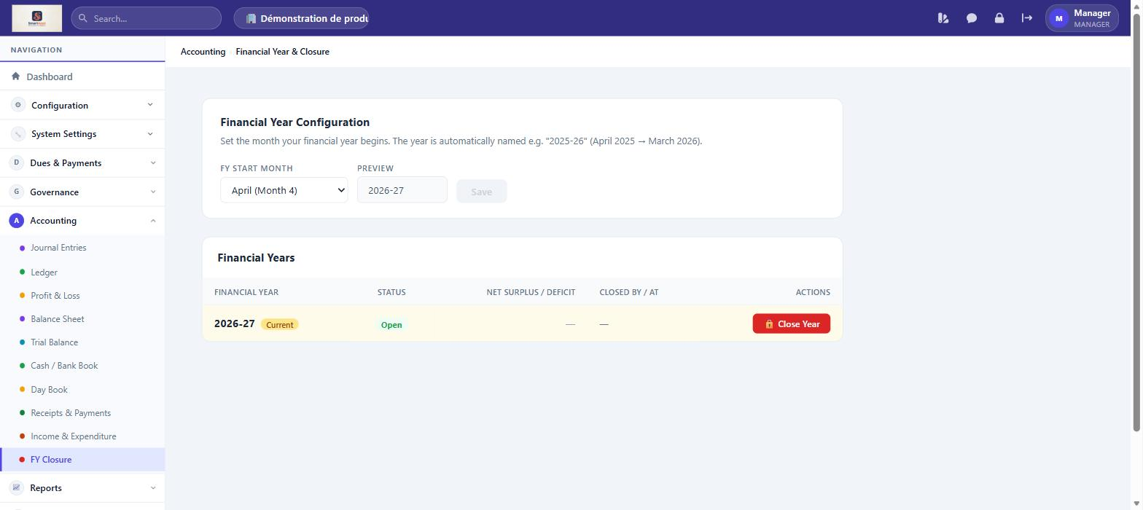
FY Closure — Close out a Financial Year — lock prior-year entries and carry forward opening balances to the new year.

Reports & Insights
Feature | What You Can Do
Insights | View dashboards summarising collections, dues ageing, expense trends and occupancy across the association.

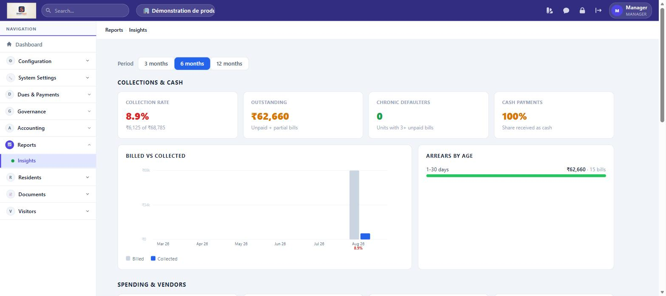
Insights — View dashboards summarising collections, dues ageing, expense trends and occupancy across the association.

Residents Section (also available as Resident)
Feature | What You Can Do
My Bills | View your own maintenance bills and pay outstanding dues online via Razorpay.
Service Requests | View ALL service requests across the association. Filter by status. Assign tickets to staff. Update ticket status. Raise your own request.
Announcements | Read community announcements, view polls. Post new announcements or polls for residents.
Expense Transparency | View the expense breakdown visible to all residents — a public view of how community funds are spent.
Documents | Upload and view community documents (circulars, notices, meeting minutes).
Chat | Message residents and staff directly, or broadcast to groups, from within the web app.

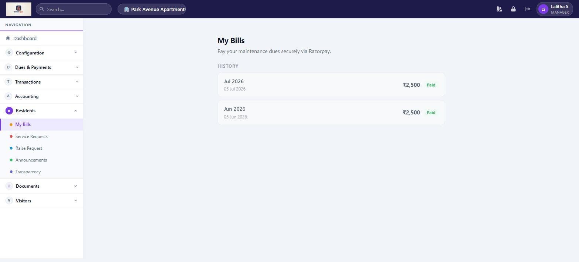
My Bills — view your own maintenance bills with payment history

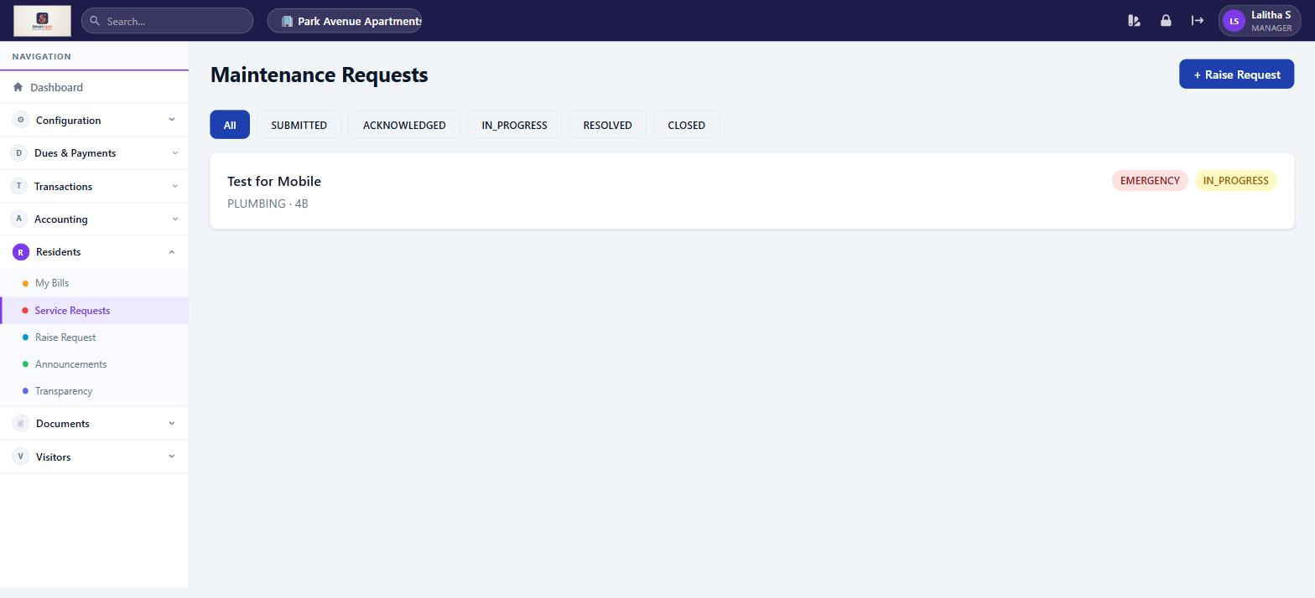
Service Requests — Manager sees ALL tickets across the association with status filter

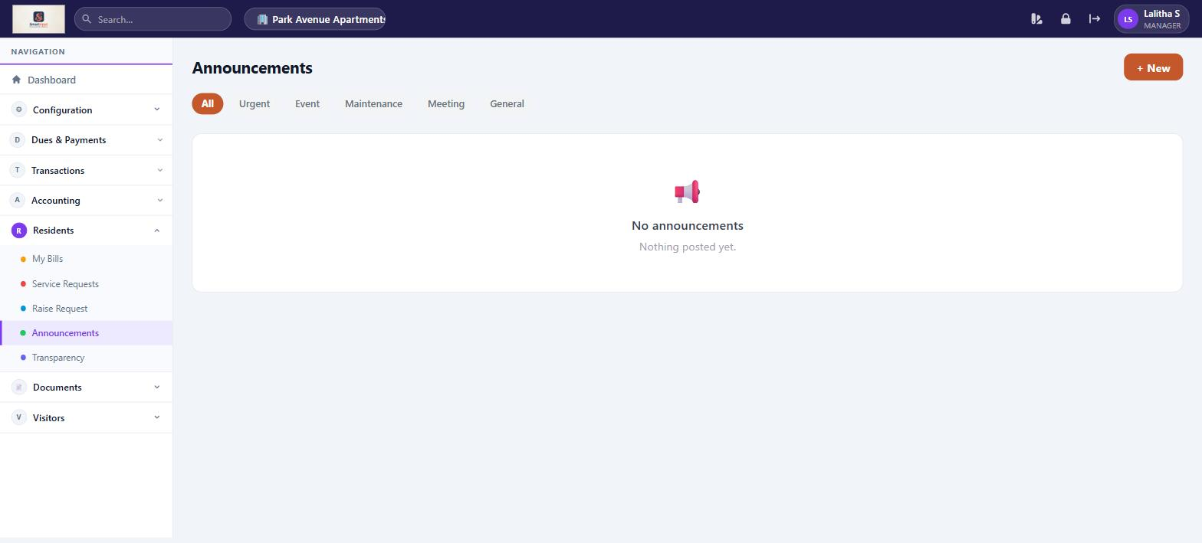
Announcements — post and read community notices, create polls

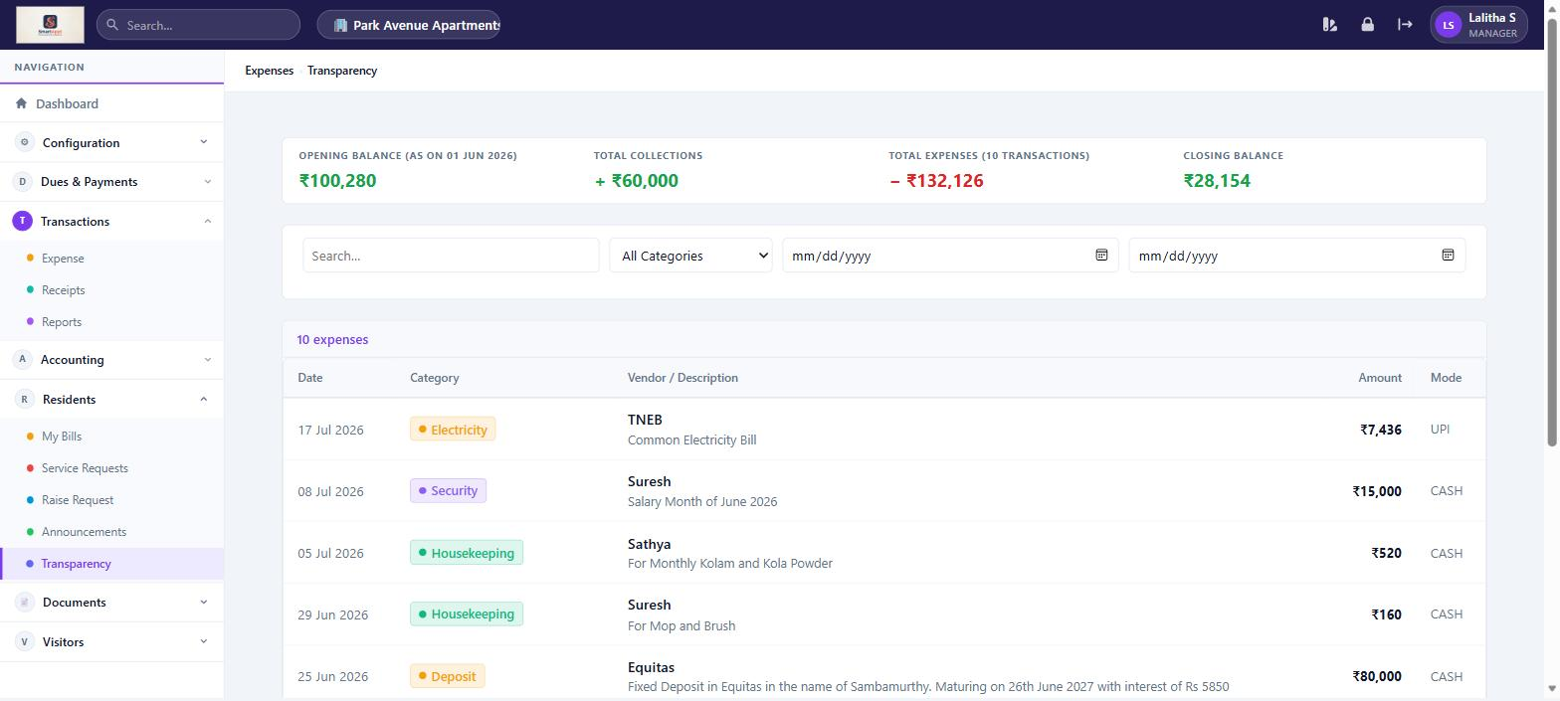
Expense Transparency — public expense breakdown for all residents to view

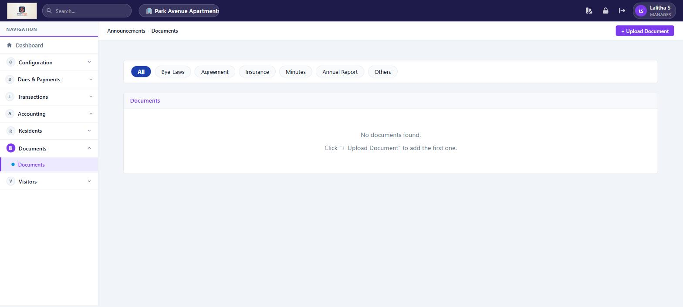
Documents — repository for community circulars, meeting minutes, and notices

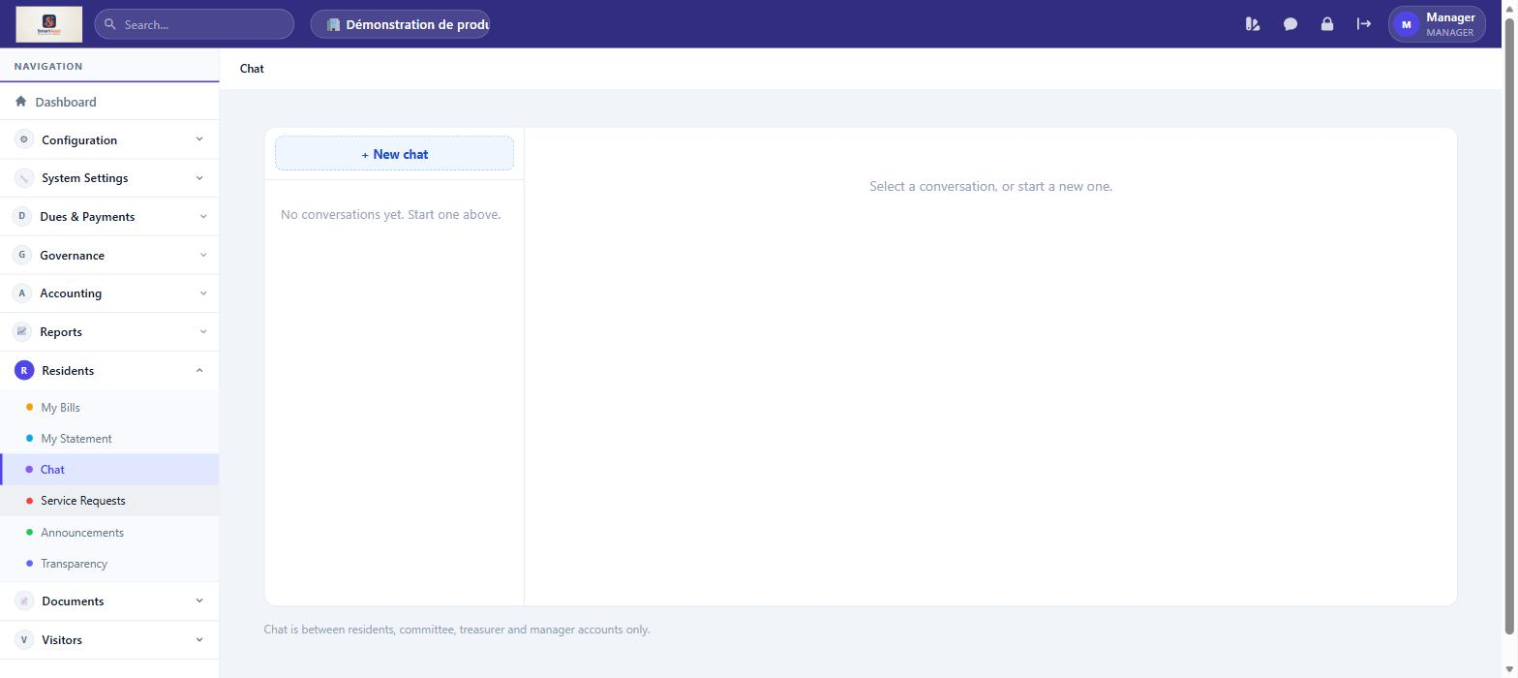
Chat — Message residents and staff directly, or broadcast to groups, from within the web app.

Visitors
Feature | What You Can Do
Visitor Log | View the complete visitor history for the association — name, unit visited, entry/exit times, and status.
Pre-Approve Visitors | Pre-approve an expected visitor and generate an OTP or QR code for gate entry. Manage your list of frequent visitors.

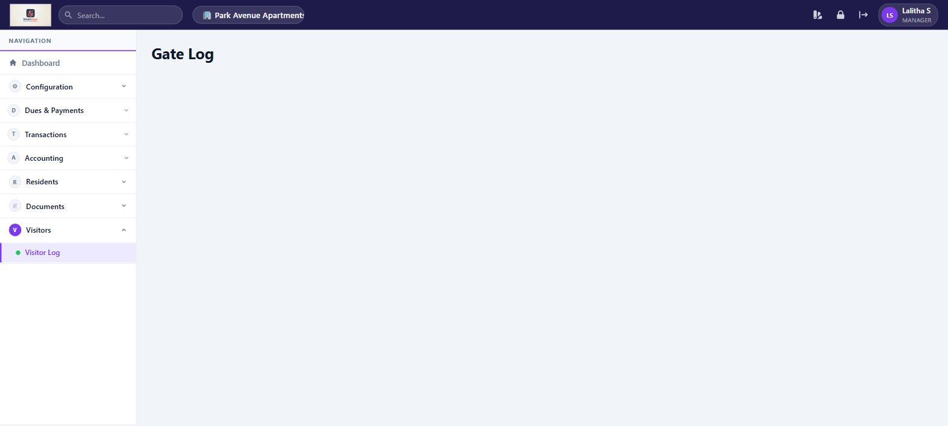
Gate Log — complete visitor history with entry/exit times and status

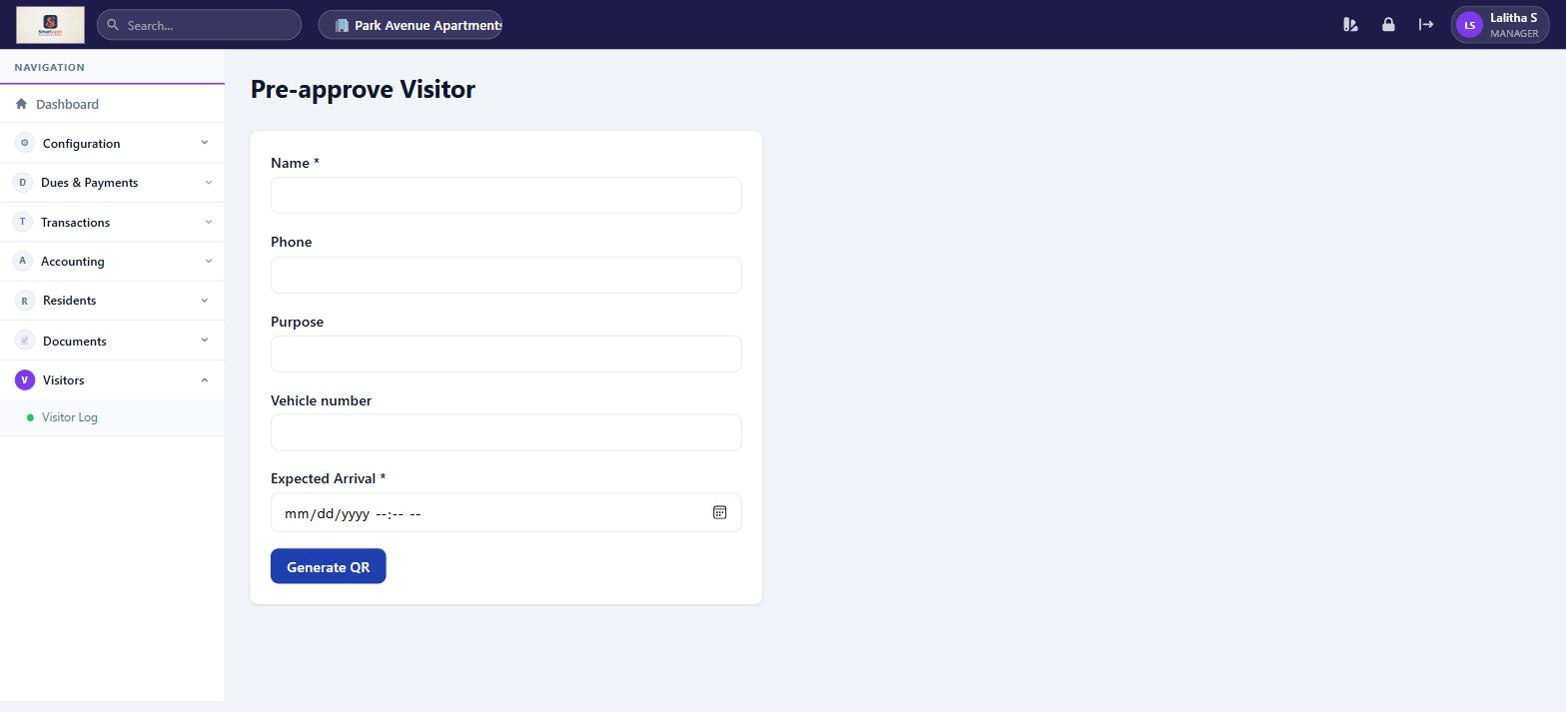
Pre-approve Visitor — fill in visitor details to generate a QR code for gate entry

Mobile Application
On mobile, the Manager has a split experience: resident features for personal use, and full management access for service requests.

Screen | What You Can Do
Home | Personalised greeting with your name, association name, and unit. Quick-action tiles for Bills, Service, Announcements, Visitors, and Chat — each shows a small counter badge when there is something new. Sits in front of the association’s logo, shown as a full-screen background watermark.
Bills | View and pay your own maintenance bills. Pending bills show outstanding amount with Pay Now button. History shows all paid bills.
Feed | Read community announcements and vote on polls.
Service | View ALL service requests with status filter (All / Submitted / In Progress / Resolved…). Tap a ticket to update its status. Raise your own new request via the + button.
Visitors | Choose Visitor Dashboard (full activity log) or Pre-Approvals (pre-approve visitors, manage frequent visitors).
More | View your profile (name, unit, association, role). Change M-PIN. Quick links to all features. Logout.
Chat | Message other residents, committee, treasurer, manager or gate staff directly, or join a group channel. Opened from the Home screen; unread messages show as a badge.
Statement | View and download a running statement of your dues, payments and balance, from More → Statement.

Treasurer
Financial management authority + all resident features

The Treasurer manages the full financial lifecycle of the association: configuring fees, generating bills, recording expenses, tracking receipts, and maintaining accounting books. They also have all resident features.

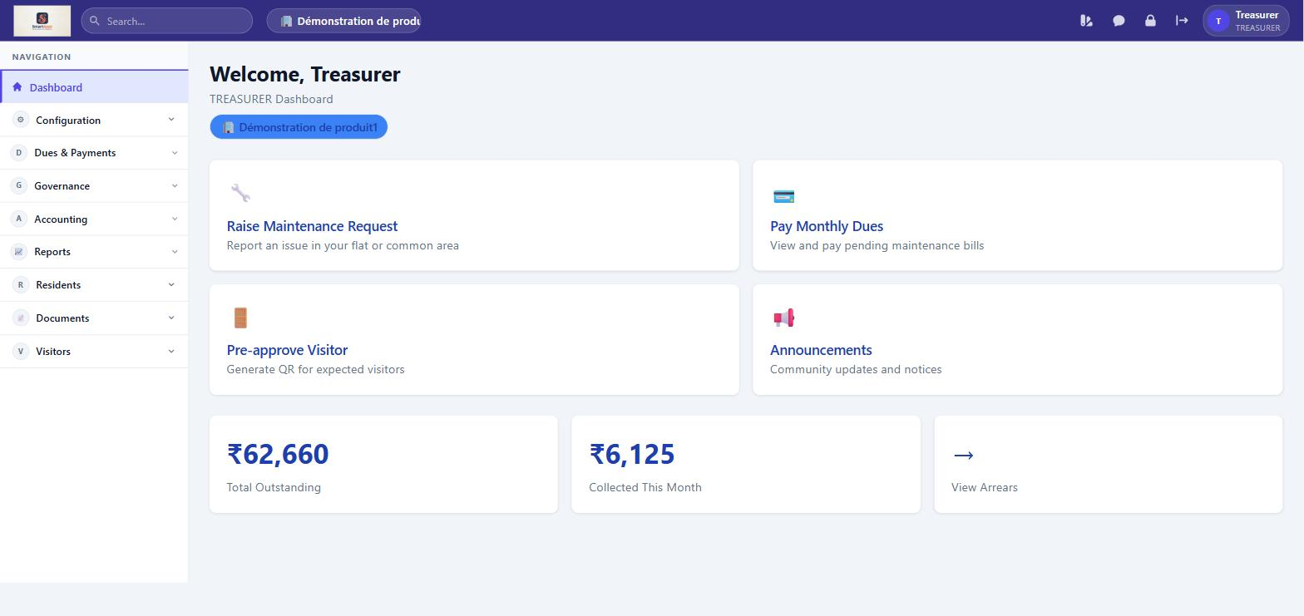
Treasurer Dashboard — outstanding dues summary, collected this month, and quick actions

Web Application

Configuration
Feature | What You Can Do
Fee Configuration | Set monthly maintenance fee amounts per unit type. Configure penalty slabs and charge types. Enable automatic bill generation on a chosen day of the month.
Razorpay Setup | Enter the Razorpay Key ID and Key Secret to enable online payment collection from residents.
Expense Categories | Create and manage categories for community expense tracking.
Audit Trail | View a read-only log of financial and configuration events for your association.

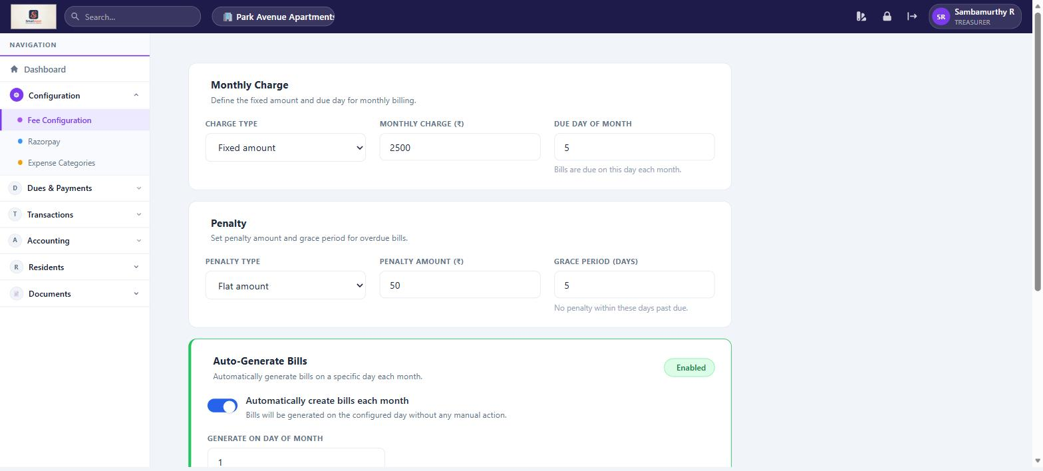
Fee Configuration — set monthly charge, penalty rules, and auto-billing schedule

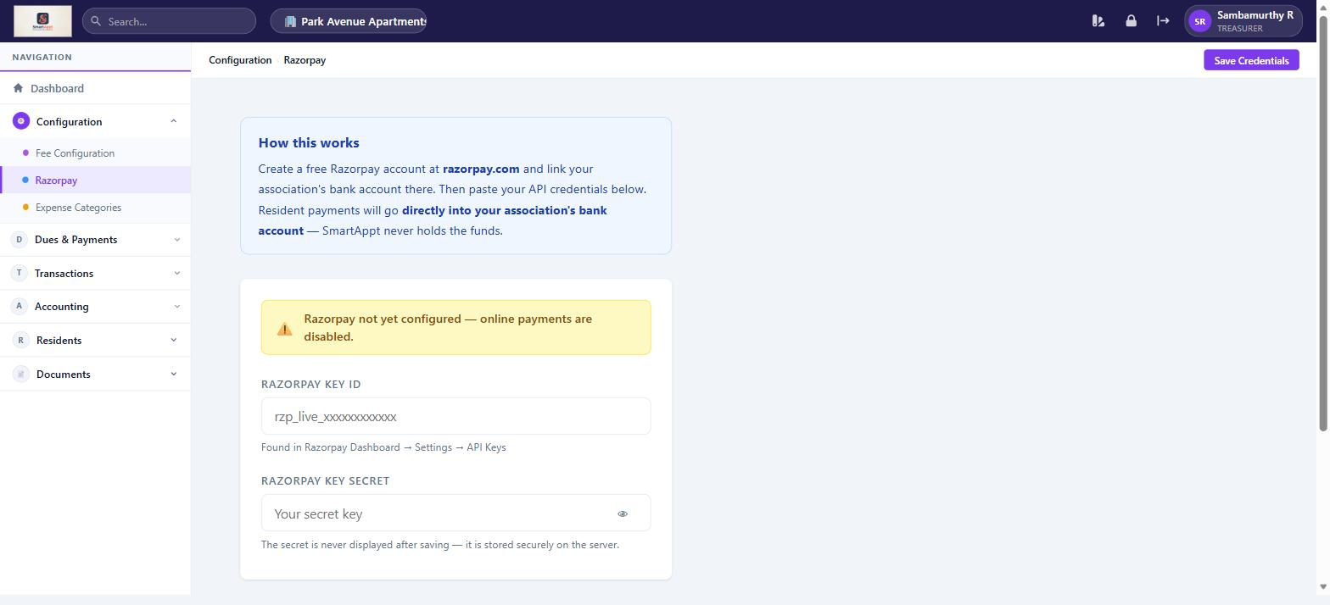
Razorpay Setup — paste API credentials to enable online resident payments

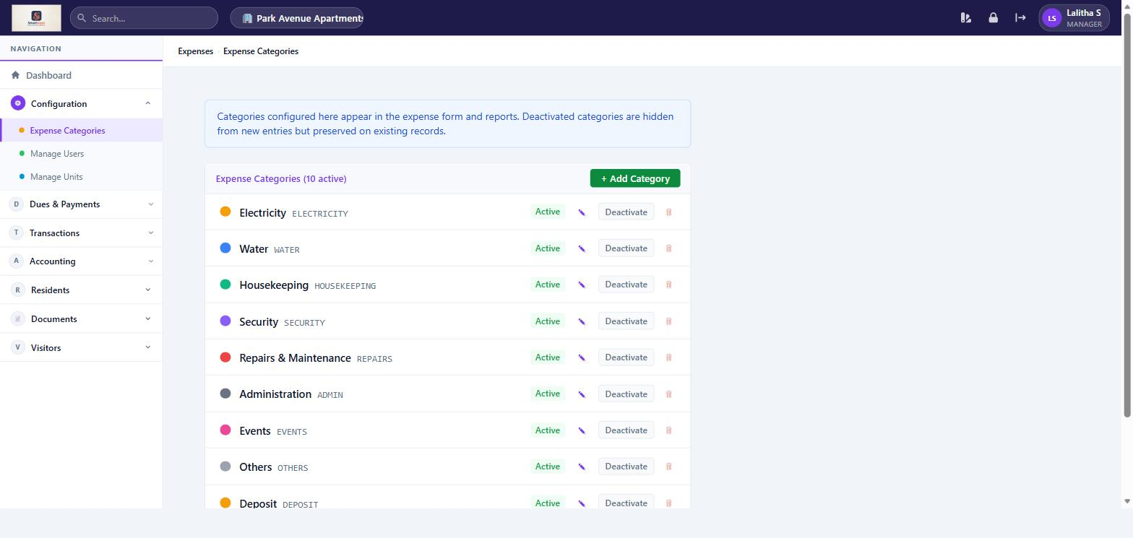
Expense Categories — define categories for community expense tracking

Dues & Payments
Feature | What You Can Do
Bills & Payments | View all generated bills. Generate monthly bills for all units. Rollback a billing period if needed (only if no payments exist). Record offline cash/cheque payments. Track partial payments and arrears.
One-Time Dues | Create targeted special charges (e.g. special assessment, corpus fund) for selected units. Generate bills and track collections separately.
UPI Payments | Confirm or reject residents' UPI payment claims before they post to the ledger. Configure the association's bank-level VPA for UPI collection.

Note: Treasurer also has full Governance (Meetings, Committees, Register of Members, Elections, Compliance Calendar) and Reports & Insights access, identical to the Manager view — see the Manager section above for screenshots.

Accounting (Full Access)
Feature | What You Can Do
Chart of Accounts | Define accounting accounts and sync historical transactions into journal entries.
Journal Entries | View auto-posted double-entry records for billing, payments, and expenses.
Ledger | Account-wise transaction history with date range filters.
Profit & Loss | Income vs expense statement for any period.
Balance Sheet | Association financial position — assets, liabilities, equity.

Residents Section (also available as Resident)
Feature | What You Can Do
My Bills | View and pay your own maintenance bills via Razorpay.
Service Requests | View your own tickets. Raise a new maintenance request.
Pre-Approve Visitors | Pre-approve expected visitors and manage frequent visitors.
Announcements | Read community notices and vote on polls.
Expense Transparency | View community expense breakdown.
Documents | View community documents.

Mobile Application
On mobile, the Treasurer has the same resident experience as other members. Web application screenshots shown in the Manager section apply equally to Treasurer features.

Screen | What You Can Do
Home | Greeting with association name and unit. Quick-action tiles for Bills, Service, Announcements, Visitors, and Chat, each with an unread-count badge. Association logo shown as a background watermark.
Bills | View all your bills (pending and history). Pay via Razorpay.
Feed | Read announcements and vote on polls.
Service | View and track your own service requests. Raise a new request.
Visitors | Visitor Dashboard and Pre-Approvals.
More | Profile info, Change M-PIN, shortcuts, Logout.
Chat | Message other residents, committee, treasurer, manager or gate staff directly, or join a group channel. Opened from the Home screen; unread messages show as a badge.
Statement | View and download a running statement of your dues, payments and balance, from More → Statement.

Committee
Oversight and review access + all resident features

Committee members have read access to financial data, dues, and accounting reports. They can post announcements and have all resident features. They do not configure fees or generate bills.

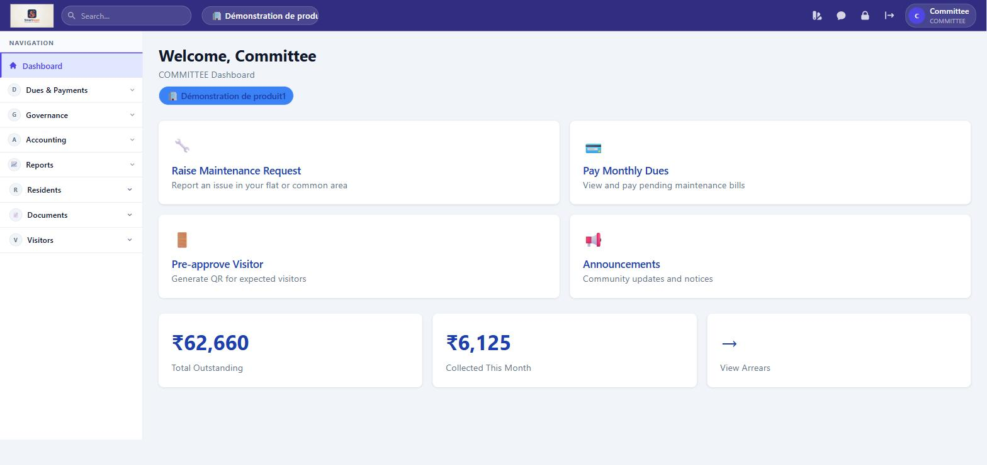
Committee Dashboard — same financial summary as Treasurer, with quick actions for residents

Web Application

Dues & Payments (View Access)
Feature | What You Can Do
Bills & Payments | View all bills across the association, payment status, and collection stats. Cannot record offline payments.
One-Time Dues | View one-time due entries and their collection status. Cannot create or modify.

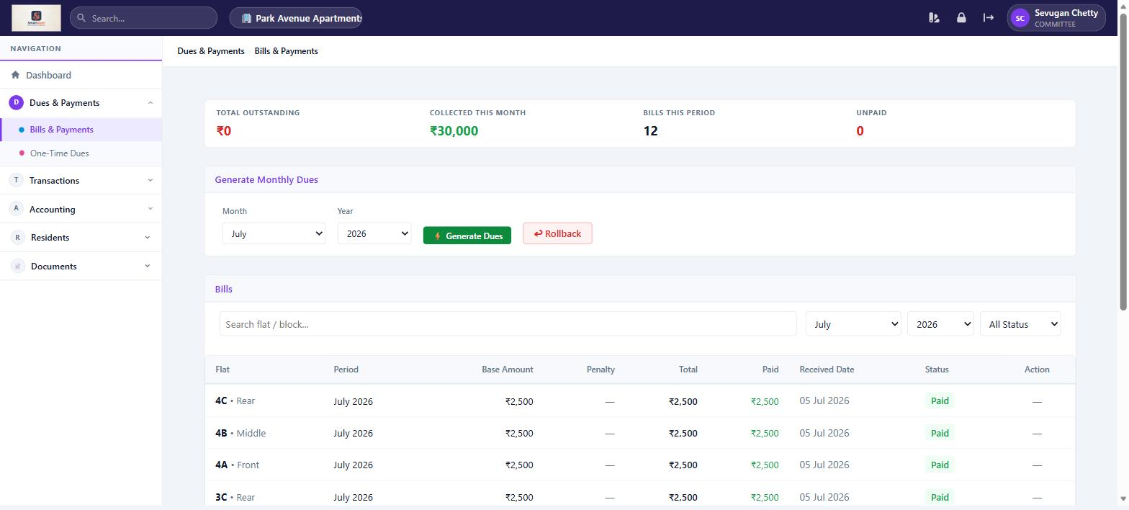
Bills & Payments — Committee sees all bills and stats but cannot record payments

Note: Committee members also have Governance access (Meetings, Committees, Register of Members, Elections, Compliance Calendar) — see the Manager section above for screenshots.

Accounting (View Access)
Feature | What You Can Do
Ledger | View account-wise ledger with date range filtering.
Profit & Loss | Generate income and expense statement by financial year or custom range.
Balance Sheet | View the association's financial position — assets, liabilities, equity.

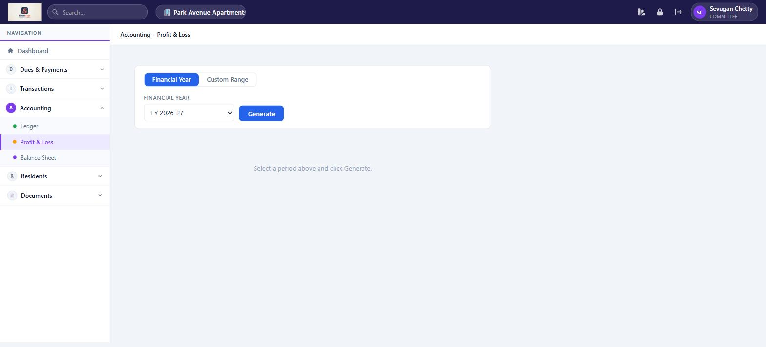
Profit & Loss — Committee can generate the P&L statement; accounting nav shows Ledger, P&L, Balance Sheet

Residents Section (also available as Resident)
Feature | What You Can Do
My Bills | View and pay your own maintenance bills via Razorpay.
Service Requests | View your own tickets. Raise a new maintenance request and submit feedback after resolution.
Pre-Approve Visitors | Pre-approve expected visitors and manage frequent visitors.
Announcements | Read and post community announcements. Create polls.
Expense Transparency | View community expense breakdown.
Documents | View community documents.

Mobile Application
On mobile, the Committee member has the full resident experience. Web application screenshots shown in the Manager section apply equally to Committee view-only features.

Screen | What You Can Do
Home | Greeting with association name and unit. Quick-action tiles for Bills, Service, Announcements, Visitors, and Chat, each with an unread-count badge. Association logo shown as a background watermark.
Bills | View all your bills (pending and history). Pay via Razorpay.
Feed | Read announcements and vote on polls.
Service | View and track your own service requests. Raise a new request. Submit feedback once resolved.
Visitors | Visitor Dashboard and Pre-Approvals.
More | Profile info, Change M-PIN, shortcuts, Logout.
Chat | Message other residents, committee, treasurer, manager or gate staff directly, or join a group channel. Opened from the Home screen; unread messages show as a badge.
Statement | View and download a running statement of your dues, payments and balance, from More → Statement.

Resident
Personal living features — bills, service, visitors, announcements

Residents are the primary end-users of SmartAppt. The platform is designed to make day-to-day living easier — pay dues online, report issues, manage visitors, and stay informed about community news.

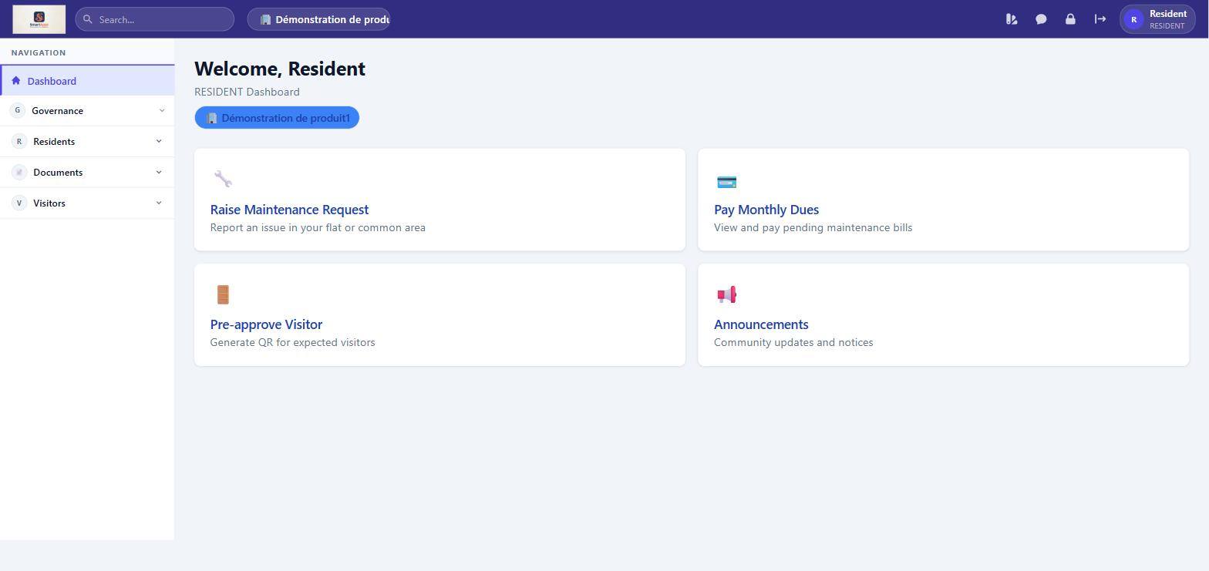
Resident Dashboard — simple four-card layout with Raise Request, Pay Dues, Pre-approve Visitor, and Announcements

Web Application

My Bills
Feature | What You Can Do
View Bills | See all bills raised for your unit — both pending (Unpaid, Partial) and historical (Paid, Waived).
Pay Online | Pay outstanding dues securely via Razorpay. Partial payments are also accepted.
Outstanding Summary | A banner at the top shows your total outstanding amount and number of pending bills.

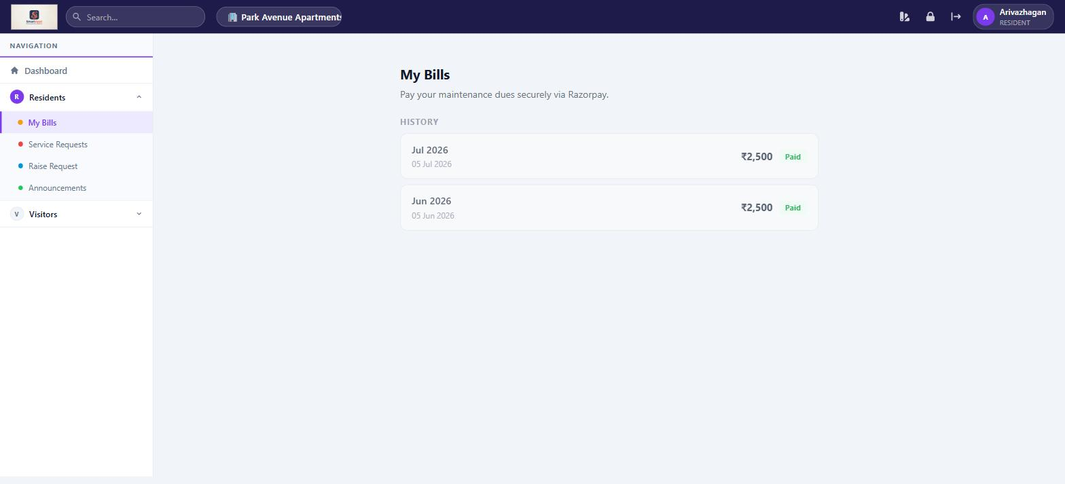
My Bills — bill history with amount and payment status; Pay Now button appears for unpaid bills

Service Requests
Feature | What You Can Do
View My Tickets | See all maintenance requests you have raised, with current status and history.
Raise a Request | Submit a new maintenance request with title, category, priority, description, and up to 3 photo attachments.
Track Status | Follow your ticket through Submitted → Acknowledged → In Progress → Resolved.
Submit Feedback | Once a ticket is marked Resolved, rate the resolution (1–5 stars) and add a comment. This closes the ticket.

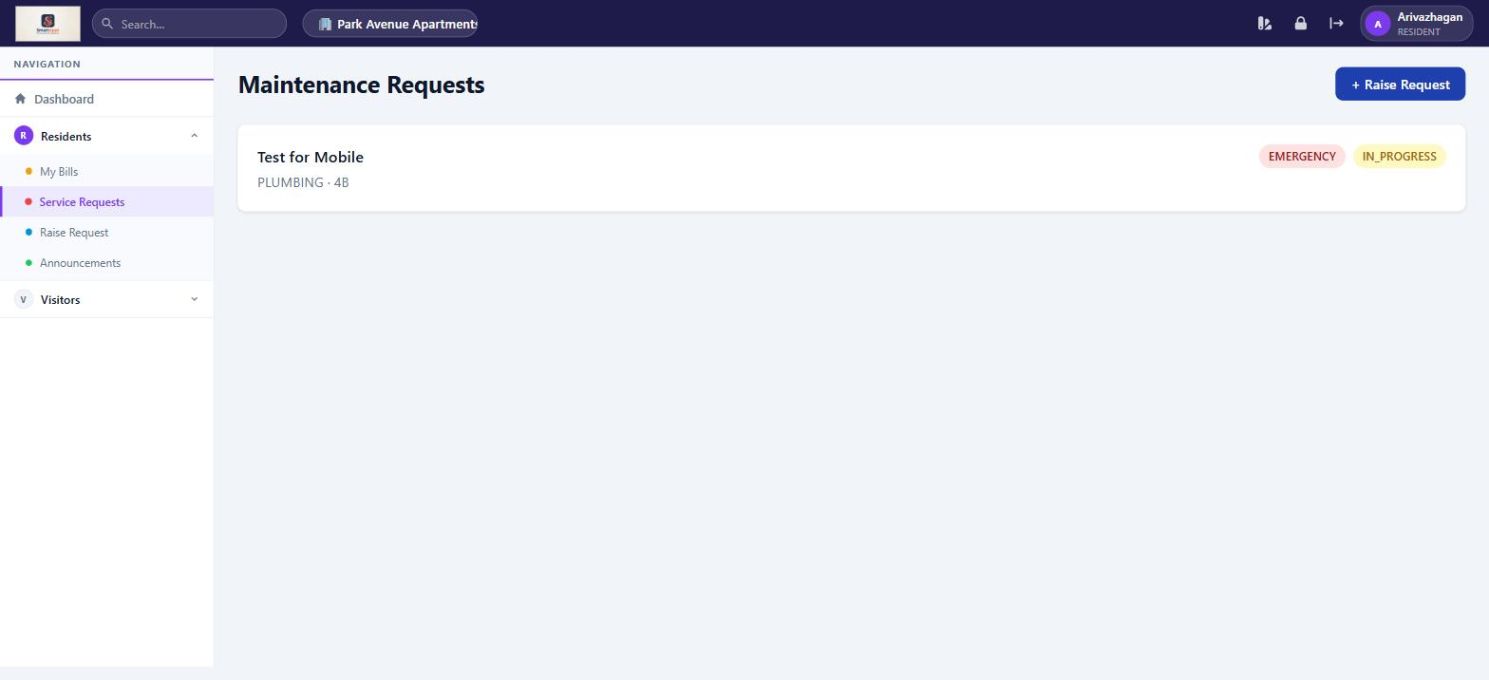
Maintenance Requests — resident sees only their own tickets with priority and status badges

Visitors — Pre-Approve
Feature | What You Can Do
Pre-Approve a Visitor | Enter visitor name and expected date/time to generate an OTP or QR code. Share this with your visitor for smooth gate entry.
Frequent Visitors | Save trusted visitors (e.g. domestic help, regular delivery) so you can pre-approve them quickly without re-entering details.
Approve Entry Requests | If the gate staff requests approval for an arriving visitor, you can approve or deny it from here.

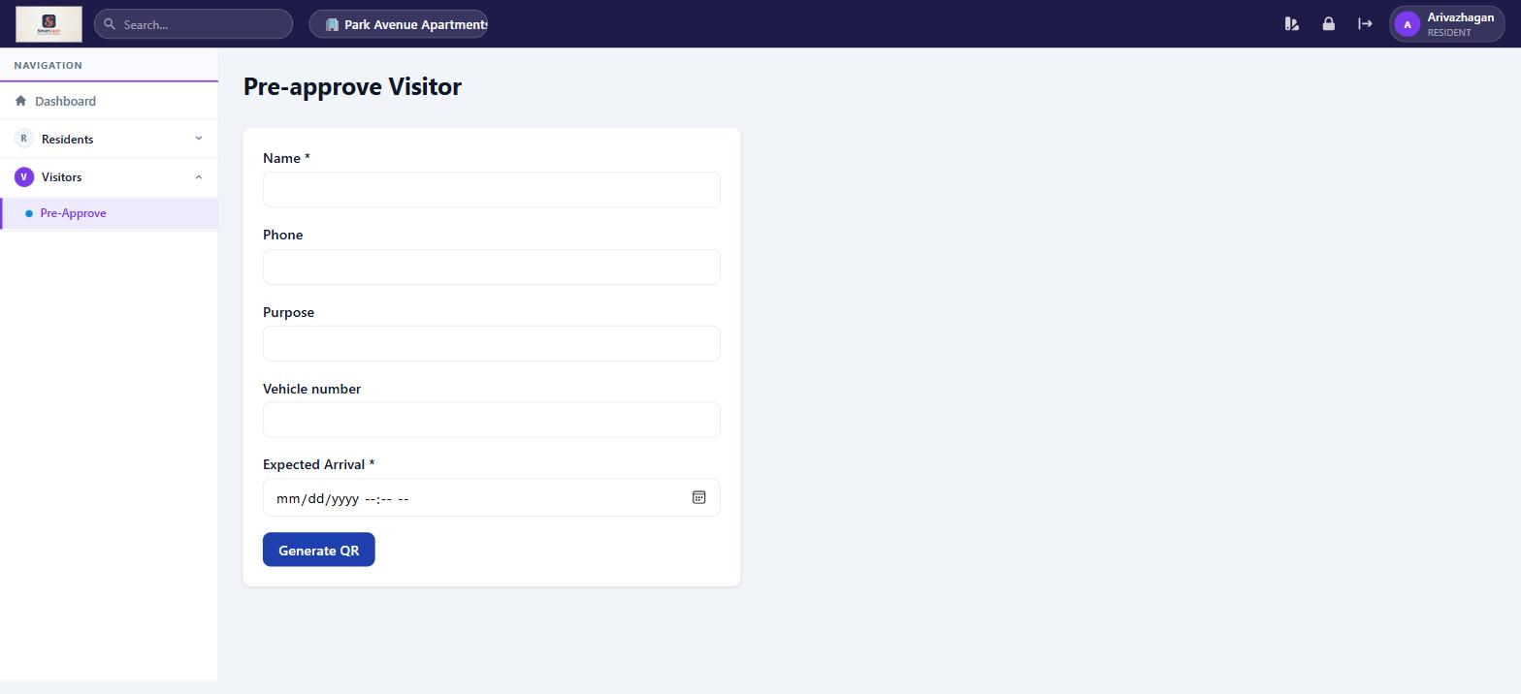
Pre-approve Visitor — fill visitor details and click Generate QR to get an entry pass

Other Features
Feature | What You Can Do
Announcements | View community announcements posted by management. Filter by category: Urgent, Event, Maintenance, Meeting, General.
Expense Transparency | View a full breakdown of how community funds are spent — opening balance, collections, expenses, and closing balance with itemised list.
Documents | Access uploaded community documents such as bye-laws, agreements, insurance papers, meeting minutes, and annual reports.
My Meetings | View upcoming and past AGMs and committee meetings, RSVP, and cast your vote on agenda items.

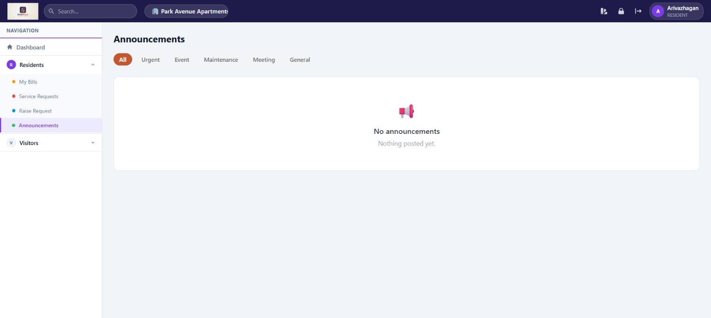
Announcements — filterable by category; residents can read but not post

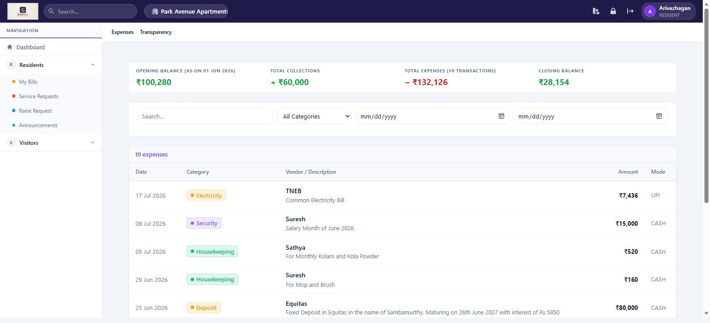
Expense Transparency — full financial summary visible to all residents (read-only)

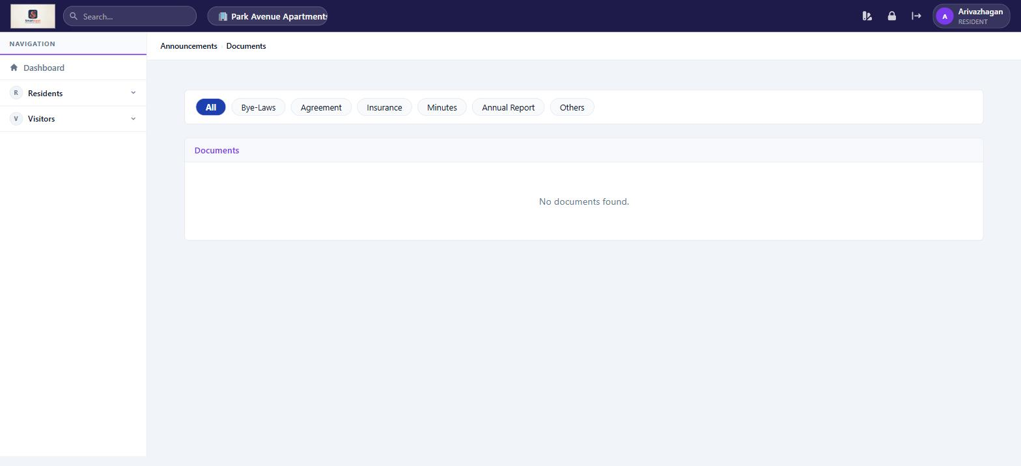
Documents — categorised repository: Bye-Laws, Agreement, Insurance, Minutes, Annual Report, Others

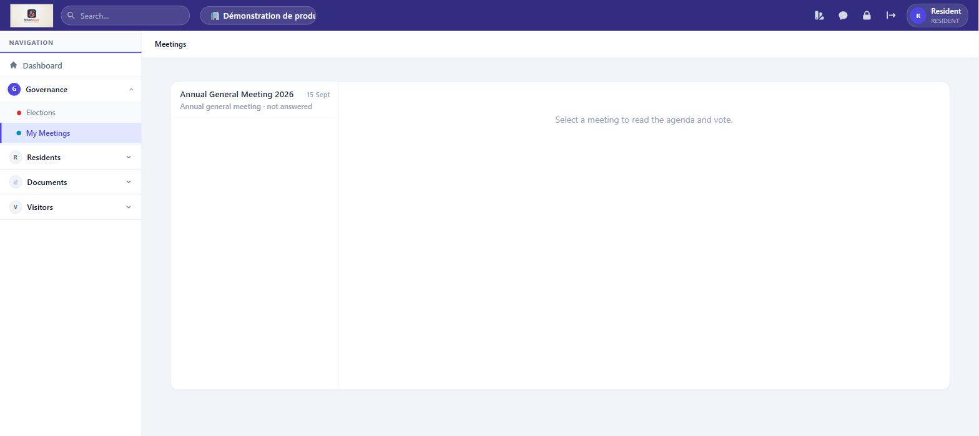
My Meetings — View upcoming and past AGMs and committee meetings, RSVP, and cast your vote on agenda items.

Mobile Application
The SmartAppt mobile app is designed for quick, on-the-go access to the most important resident features.

Screen | What You Can Do
Home | Personalised greeting with your name, association name, and unit number. Quick-action tiles for Bills, Service, Announcements, Visitors, and Chat, each with an unread-count badge. Association logo shown as a background watermark.
Bills | View all your bills — Pending section shows unpaid/partial bills with Pay Now button. History section shows paid and waived bills.
Feed | Browse all community announcements in a timeline. Vote on active polls.
Service | View the maintenance requests you have raised. Tap a ticket to see status history and submit feedback (if Resolved). Use the + Raise Request button to report a new issue with photos.
Visitors | Choose Visitor Dashboard to see recent gate activity, or Pre-Approvals to pre-approve an expected visitor and manage your frequent visitors list.
More | View your profile: name, association, unit, and role. Change M-PIN (4-digit security PIN). Quick links to all features. Tap Logout at the top to sign out.
Chat | Message other residents, committee, treasurer, manager or gate staff directly, or join a group channel. Opened from the Home screen; unread messages show as a badge.
Statement | View and download a running statement of your dues, payments and balance, from More → Statement.

Login Options
Feature | What You Can Do
OTP Login | Enter your registered mobile number and verify with a one-time password sent via SMS.
M-PIN Login | If M-PIN is enabled, log in with your mobile number and 4-digit M-PIN for faster access. Set your M-PIN from the More screen after your first OTP login.
Push Notifications | Once signed in on the mobile app, your device is registered to receive instant alerts for new bills, announcements, chat messages and visitor requests.
Simplified Login (if enabled by your association) | Some associations disable the OTP verification step. If so, after entering your mobile number you are taken straight to set your M-PIN, with no OTP prompt.

Gate Staff
Visitor management and gate operations

Gate Staff are responsible for managing visitor entry and exit at the main gate. SmartAppt gives Gate Staff the tools to verify pre-approved visitors, record walk-ins, and maintain a full visitor log.

Web Application

Gate Dashboard
Feature | What You Can Do
Scan QR / Verify OTP | Scan the QR code or enter the OTP that a resident shared with their pre-approved visitor to grant entry.
Record Entry | Mark a pre-approved visitor as Entered when they arrive at the gate.
Record Exit | Mark a visitor as Exited when they leave the premises.
Walk-In Entry | Record an unannounced visitor: enter their name, contact, and unit they are visiting. The resident receives a notification to approve or deny.
Emergency Alert | Trigger an emergency alert that notifies all managers and committee members immediately.

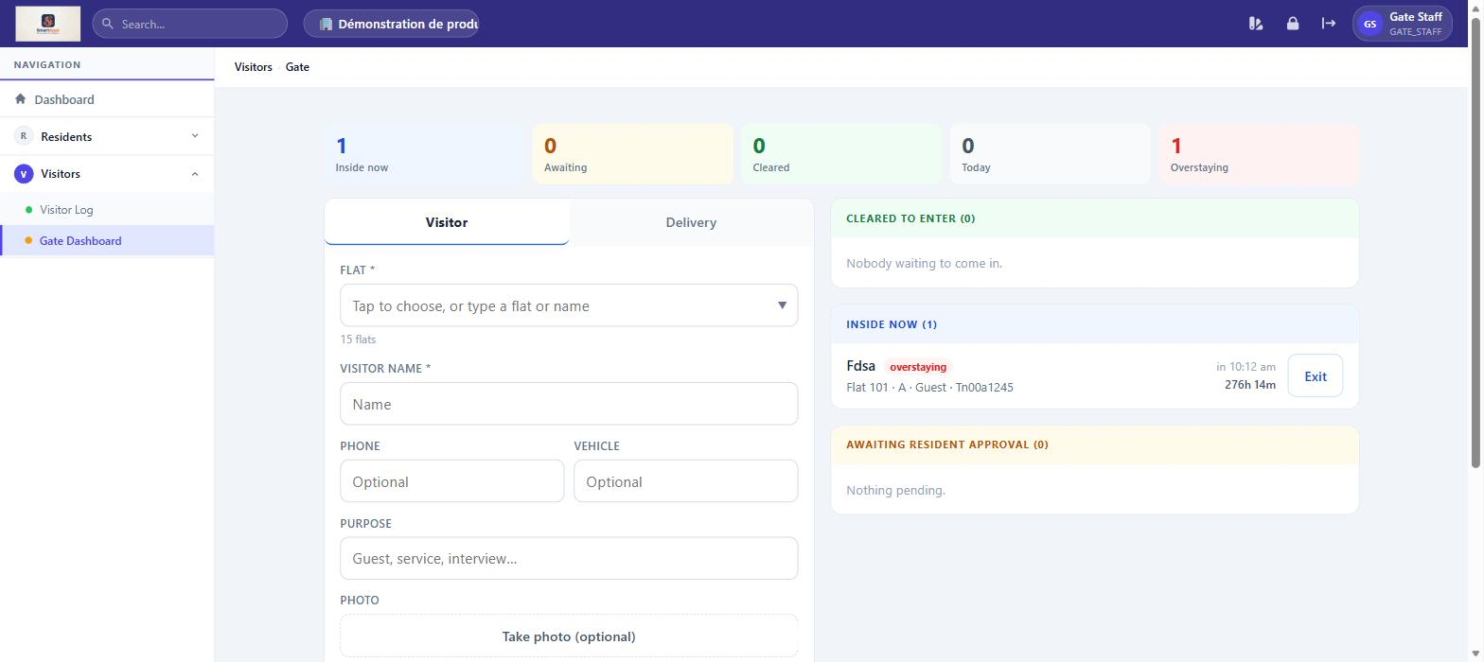
Gate Console — The gate staff console — scan QR/OTP, record entry and exit, log walk-ins, and trigger emergency alerts.

Visitor Log
Feature | What You Can Do
View All Visits | See the complete visitor history for the association: visitor name, unit visited, type (Pre-Approved, Walk-In), entry time, exit time, and current status.
Filter by Unit/Date | Narrow down the log by unit number or date to find a specific visit record quickly.

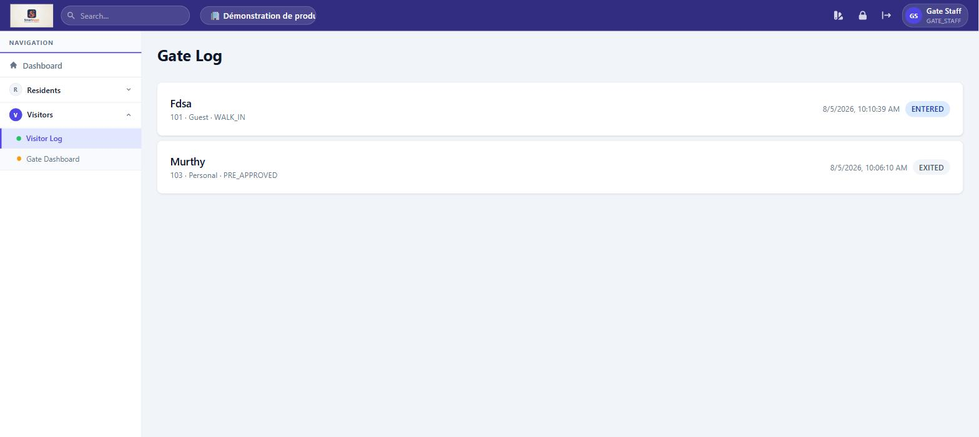
Visitor Log — The full visitor log — searchable history of every visit with type, entry/exit time, and status.

Residents Section
Feature | What You Can Do
Service Requests | View and update the status of maintenance tickets assigned to Gate Staff.
Announcements | Read community announcements.
Documents | View uploaded community documents.

Mobile Application
Gate Staff do not currently have a dedicated mobile experience in SmartAppt. Gate operations are best performed using the web application on a tablet or computer stationed at the gate.

Tip: The web application works on any mobile browser. Gate Staff can bookmark the SmartAppt URL on their phone or tablet for convenient access at the gate.

Quick Reference

Who Can Do What — Feature Matrix

Feature | Manager | Treasurer | Committee | Resident | Gate Staff
Pay Own Bills | ✓ | ✓ | ✓ | ✓
View All Bills | ✓ | ✓ | ✓
Generate / Rollback Bills |  | ✓
Configure Fees & Razorpay |  | ✓
Raise Service Request | ✓ | ✓ | ✓ | ✓
View All Service Requests | ✓
Update Ticket Status | ✓ |  |  |  | ✓
Pre-Approve Visitors | ✓ | ✓ | ✓ | ✓
View Visitor Log | ✓ |  |  |  | ✓
Gate Entry / Exit |  |  |  |  | ✓
Post Announcements | ✓ |  | ✓
View Announcements | ✓ | ✓ | ✓ | ✓ | ✓
Manage Users & Units | ✓
Manage Expenses |  | ✓
View Expense Reports | ✓ | ✓ | ✓ | ✓
Full Accounting Access | ✓ | ✓
View Accounting Reports | ✓ | ✓ | ✓
Receipts | ✓ | ✓ | ✓
One-Time Dues | ✓ | ✓ | ✓
Expense Transparency | ✓ | ✓ | ✓ | ✓
Documents | ✓ | ✓ | ✓ | ✓ | ✓
Internal Chat & Messaging | ✓ | ✓ | ✓ | ✓
View Account Statement | ✓ | ✓ | ✓ | ✓
Push Notifications | ✓ | ✓ | ✓ | ✓
Confirm UPI Payments |  | ✓
Manage Association Branding | ✓
Configure Web/Mobile Menu by Role | ✓
View Audit Trail | ✓
Governance (Meetings, Committees, Elections, Register, Compliance) | ✓ | ✓ | ✓
View & Vote in My Meetings | ✓ | ✓ | ✓ | ✓
Reports & Insights Dashboard | ✓ | ✓
Manage Chart of Accounts / Business Partners | ✓

