SmartAppt
User Manual

Apartment Association Management System
Role-Based Feature Guide · With Screenshots

Manager | Treasurer
Committee | Resident
Gate Staff

Version 1.0 · July 2026

Table of Contents

Overview
Introduction 3

Roles
Manager 4
Web Application 4
Mobile Application 9
Treasurer 10
Web Application 10
Mobile Application 11
Committee 12
Web Application 12
Mobile Application 13
Resident 14
Web Application 14
Mobile Application 15
Gate Staff 16
Web Application 16

Reference
Quick Reference — Feature Matrix 17

Introduction
SmartAppt is a comprehensive apartment association management platform that helps residents, committee members, and administrative staff manage dues, maintenance, visitors, announcements, and finances — all from one place.

This manual covers how to use SmartAppt based on your assigned role. Each role has a tailored set of features available on both the Web Application and the Mobile App.

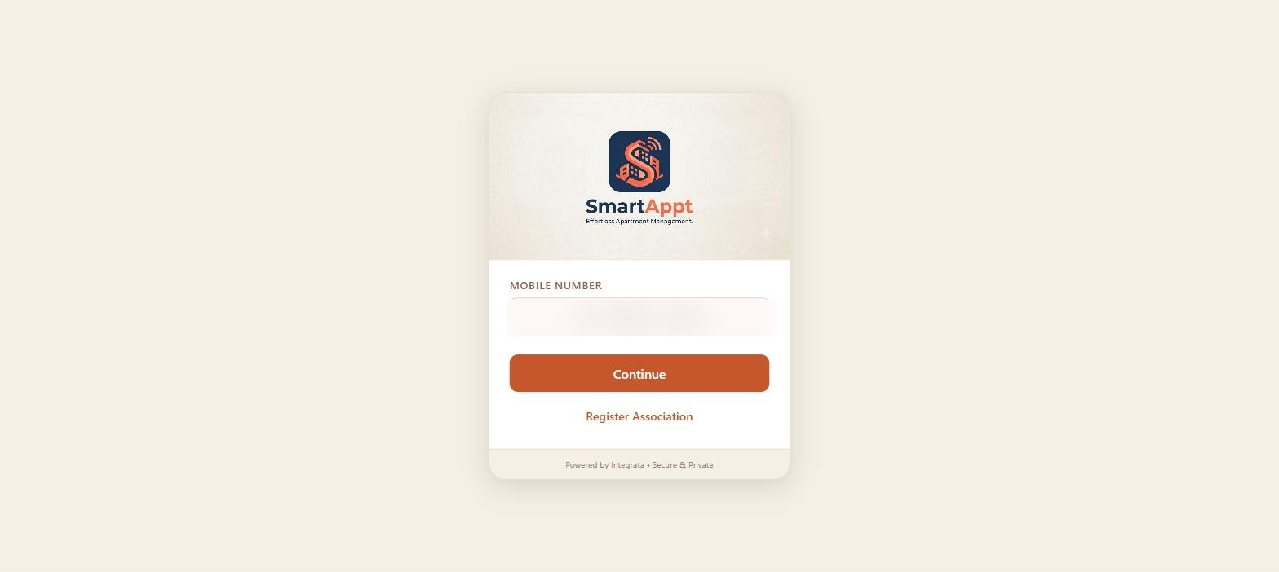
Login page — enter your registered mobile number and OTP or M-PIN to sign in

Role Overview
Feature | What You Can Do
Manager | Full administrative access. Manages users, units, service requests, visitor logs, and accounting. Also has all resident features.
Treasurer | Financial authority. Manages dues configuration, billing, expenses, receipts, and accounting. Also has all resident features.
Committee | Oversight role. Views financial data, bills, and accounting reports. Also has all resident features.
Resident | Day-to-day living features: pay bills, raise service requests, pre-approve visitors, and read announcements.
Gate Staff | Operational gate management: record visitor entry/exit, scan QR codes, handle walk-ins.

Note: Manager, Treasurer, and Committee members are also residents of the complex. They have access to all resident features in addition to their administrative capabilities.

Manager
Full administrative access + all resident features

The Manager has the broadest access in SmartAppt. They oversee residents, units, maintenance, visitors, and financial reporting. They also have all resident features since they live in the complex.

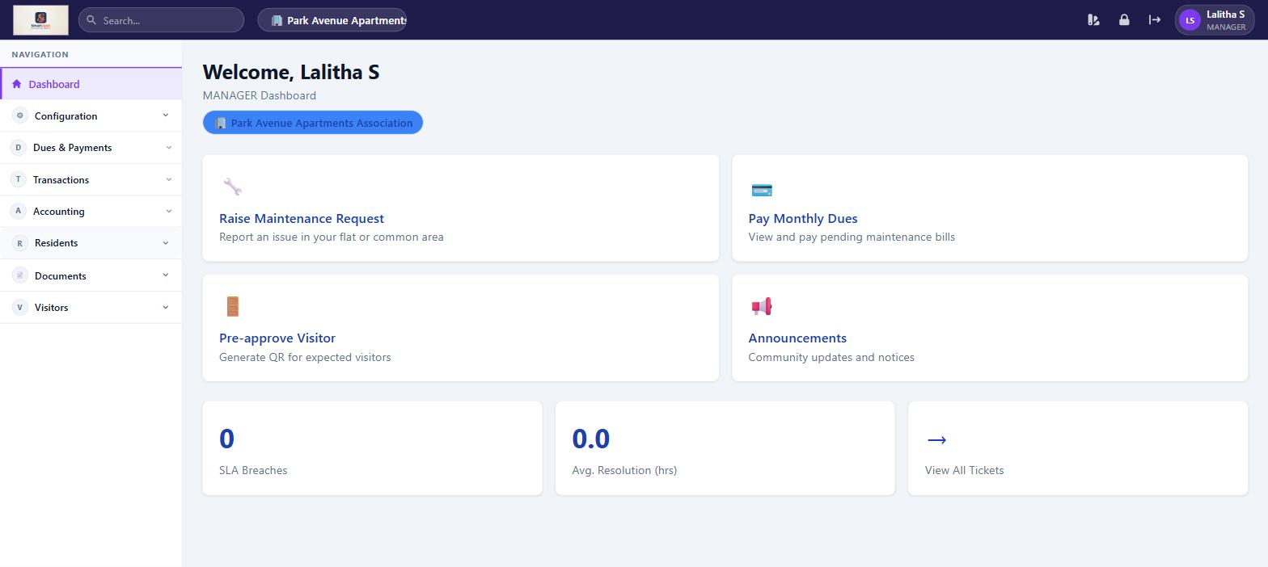
Manager Dashboard — quick-action cards and navigation overview

Web Application

Configuration
Feature | What You Can Do
Manage Users | Add new users, edit details, deactivate accounts, assign roles. Bulk import residents via Excel template.
Manage Units | Add, edit, and delete residential units. Invite owners and tenants to units. Bulk import units via Excel.
Expense Categories | Create and manage categories used when recording community expenses.

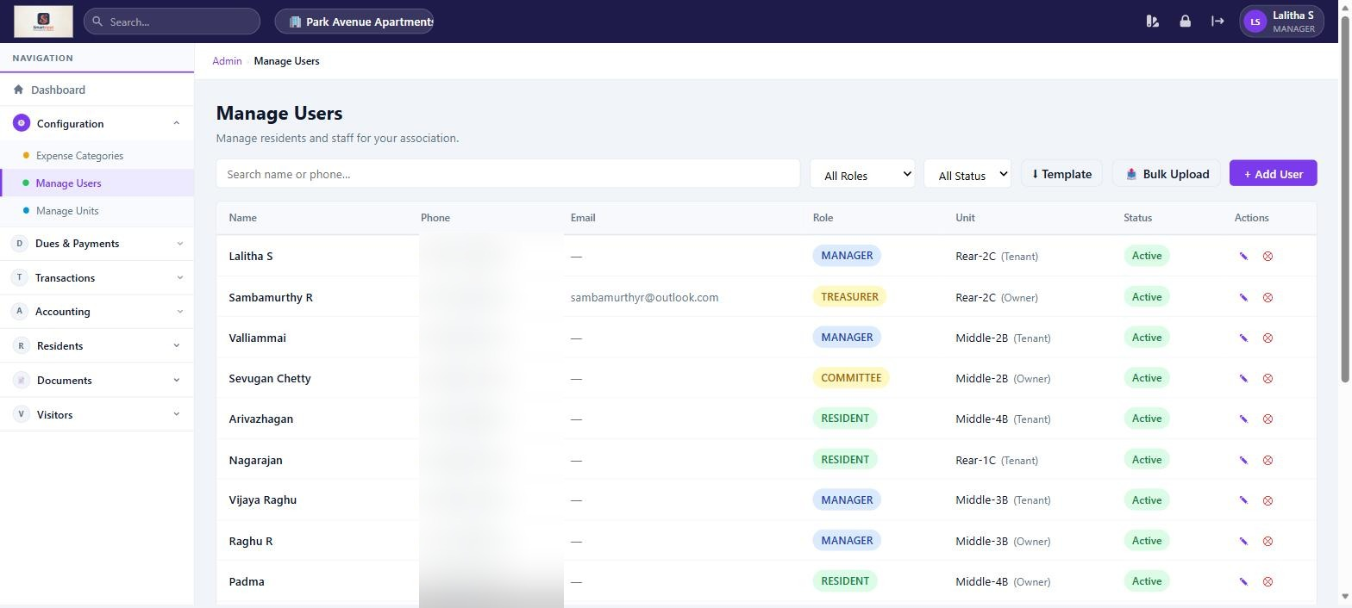
Manage Users — view all registered users, add new members, assign roles

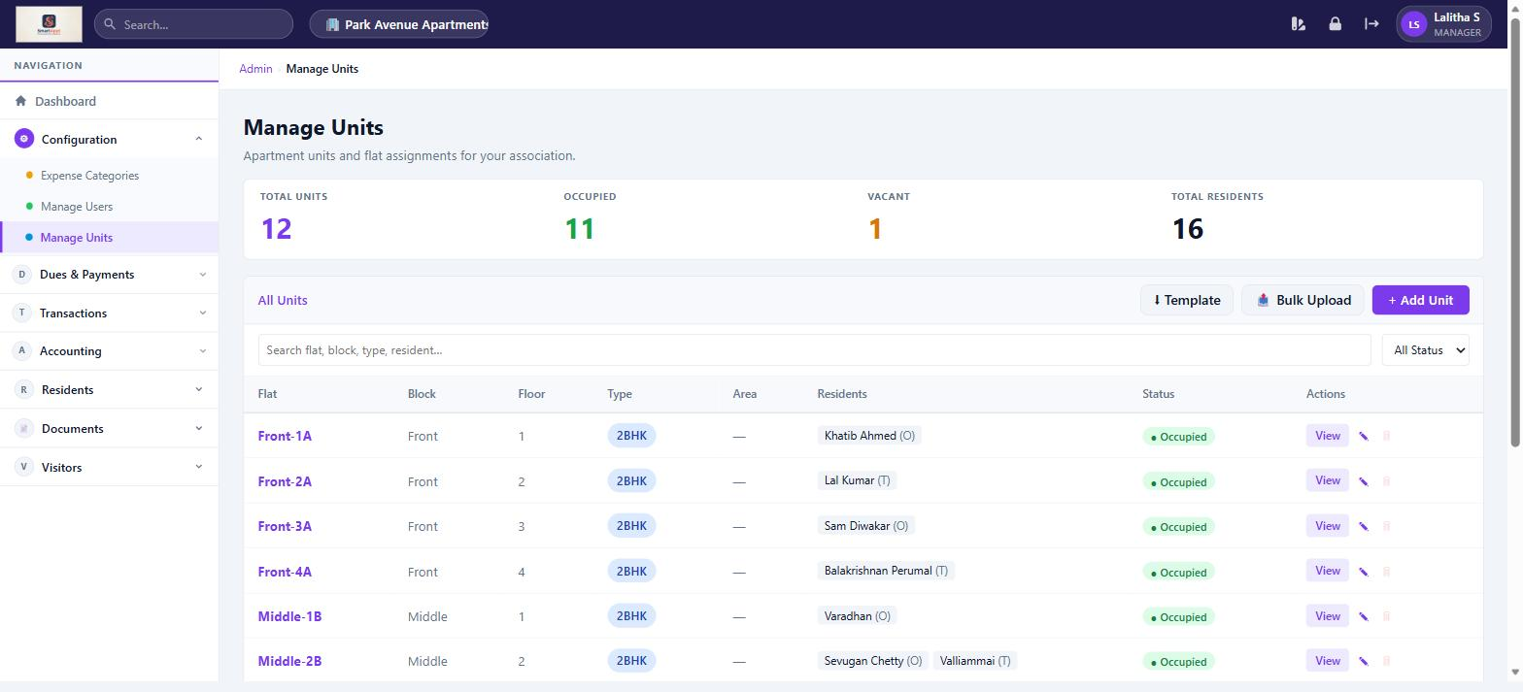
Manage Units — add, edit and link residents to residential units

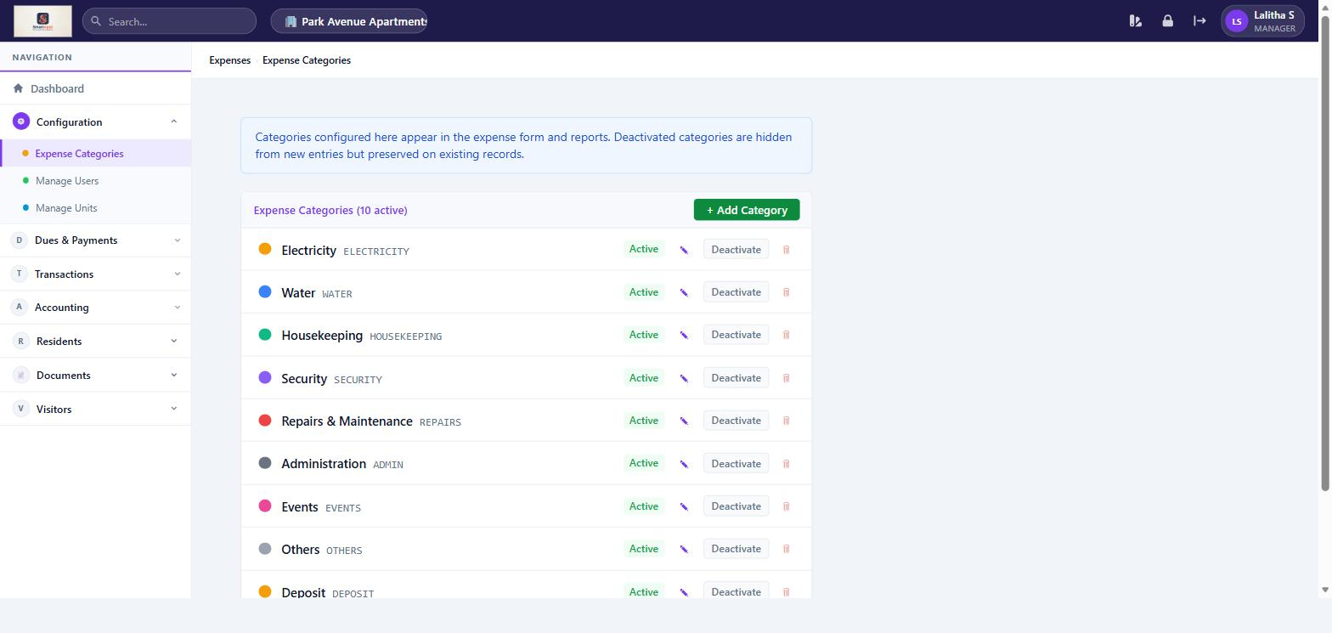
Expense Categories — define categories for community expense tracking

Dues & Payments
Feature | What You Can Do
Dues Overview | Dashboard showing collection stats: total billed, collected, outstanding, and pending units for the current month.
Bills & Payments | View all bills generated for the association. Track payment status (Unpaid, Partial, Paid, Waived). Record offline payments on behalf of residents.
One-Time Dues | Create special one-time charges targeting specific units (e.g. parking deposit, maintenance levy). Generate and manage the bills for these charges.

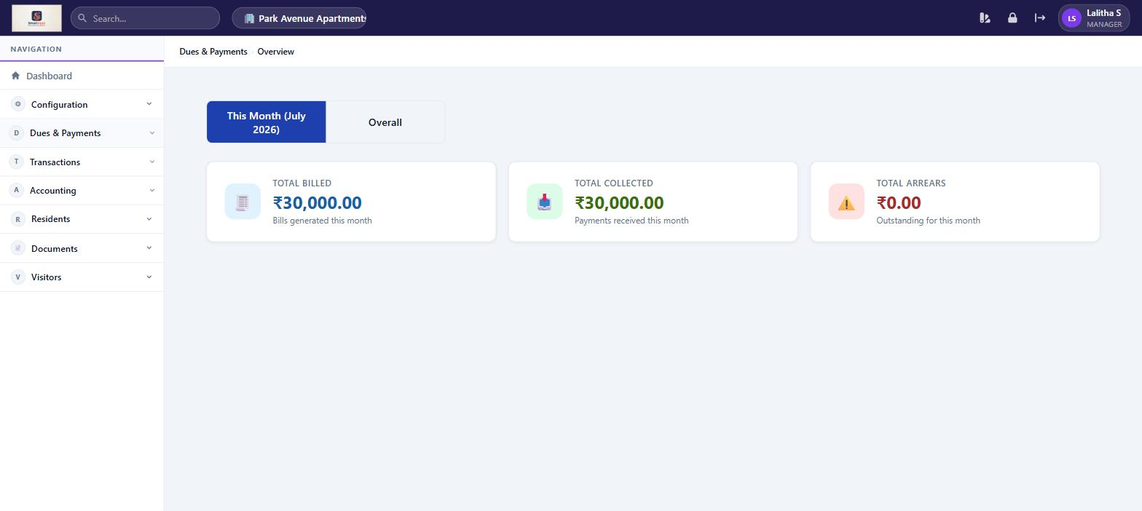
Dues & Payments Dashboard — monthly collection overview with unit-wise status

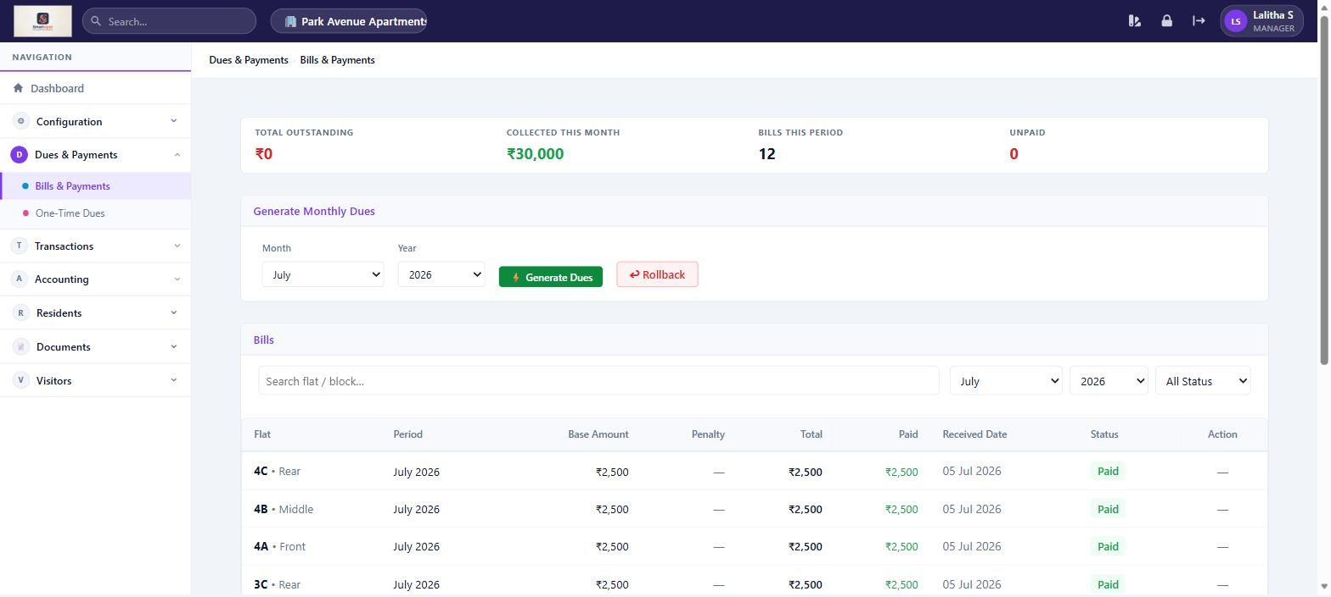
Bills & Payments — track all resident bills, record offline payments

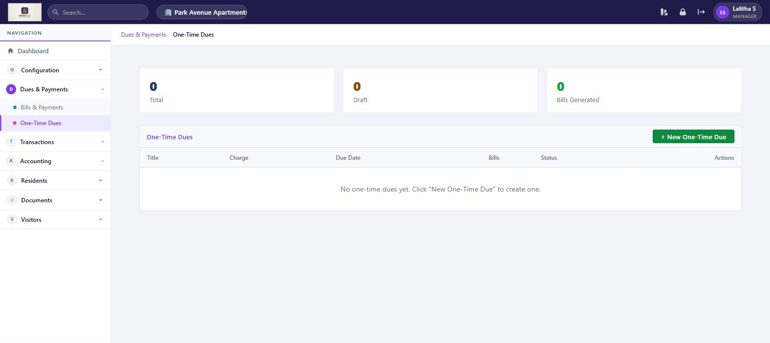
One-Time Dues — create and manage targeted special charges

Transactions
Feature | What You Can Do
Dashboard | Summary of opening balance, total collections, total expenses, and closing balance for the current month or overall.
Receipts | Record miscellaneous income that is not a maintenance dues payment (e.g. hall booking, penalty fee).
Reports | View and export financial transaction reports for the association.

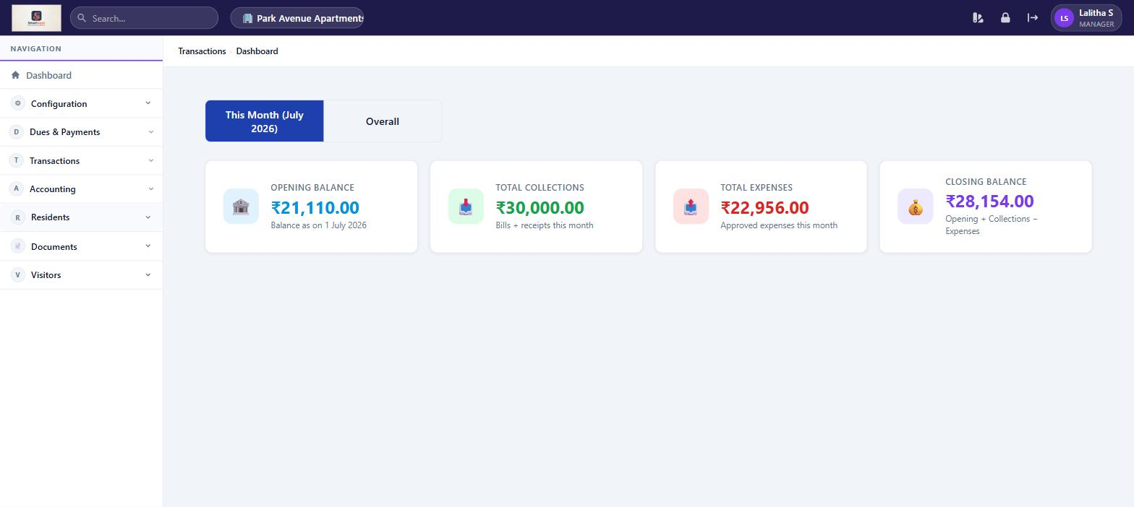
Transactions Dashboard — monthly financial summary with opening/closing balance

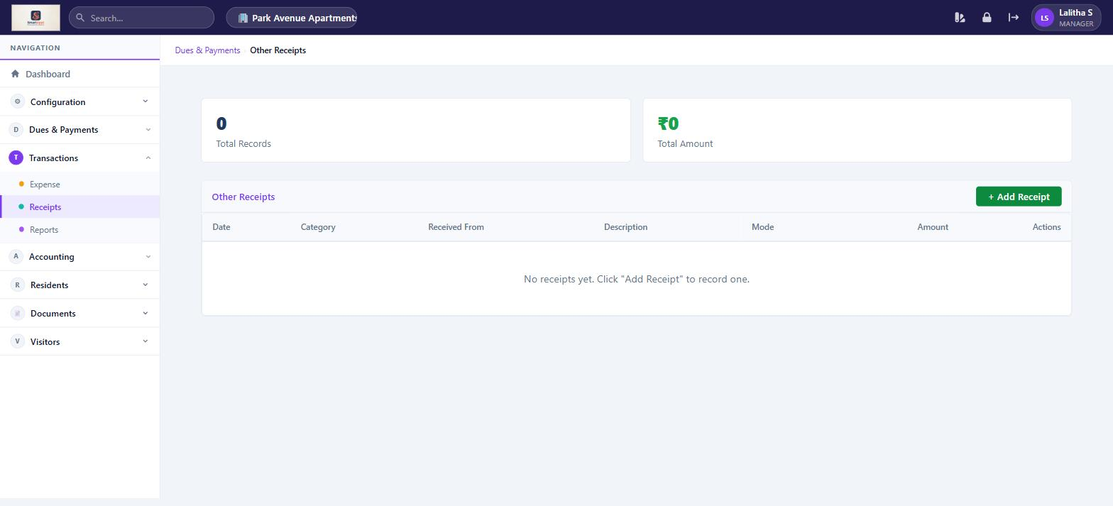
Other Receipts — record miscellaneous income beyond maintenance dues

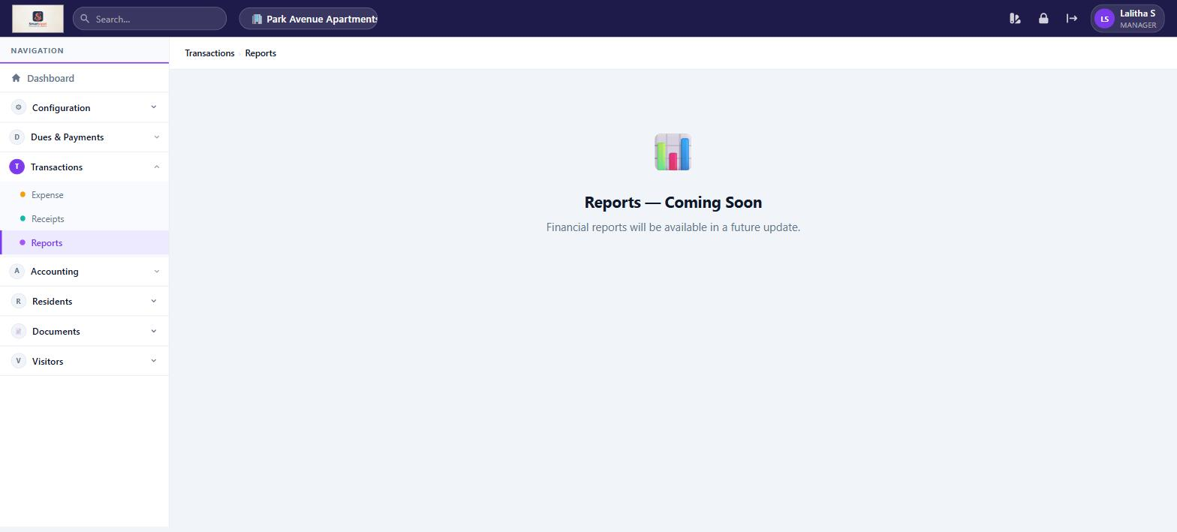
Transactions Reports — coming soon in a future update

Accounting
Feature | What You Can Do
Chart of Accounts | Define and organise the accounting accounts used in the general ledger. Sync historical dues, expense, and receipt transactions into journal entries.
Journal Entries | View all double-entry bookkeeping records auto-posted by billing, payments, and expense events.
Ledger | Filter and view account-wise transaction history across any date range.
Profit & Loss | View the income versus expense statement for any period (Financial Year or custom range).
Balance Sheet | View the association's financial position showing assets, liabilities, and equity as of a chosen date.

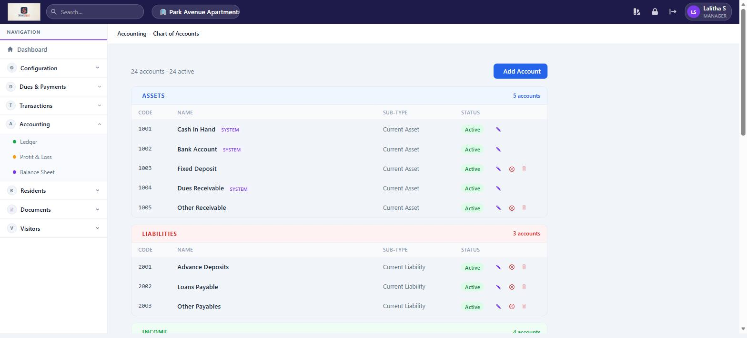
Chart of Accounts — 24 accounts across Assets, Liabilities, Income, and Expenses

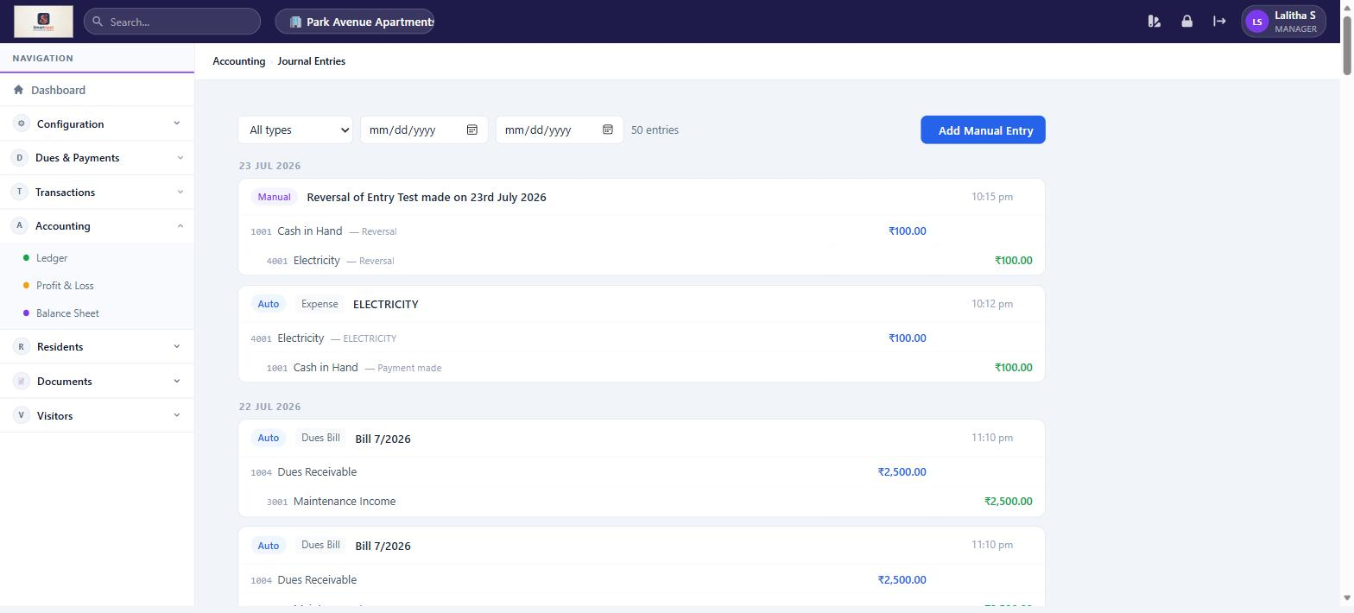
Journal Entries — auto-posted double-entry records for all financial events

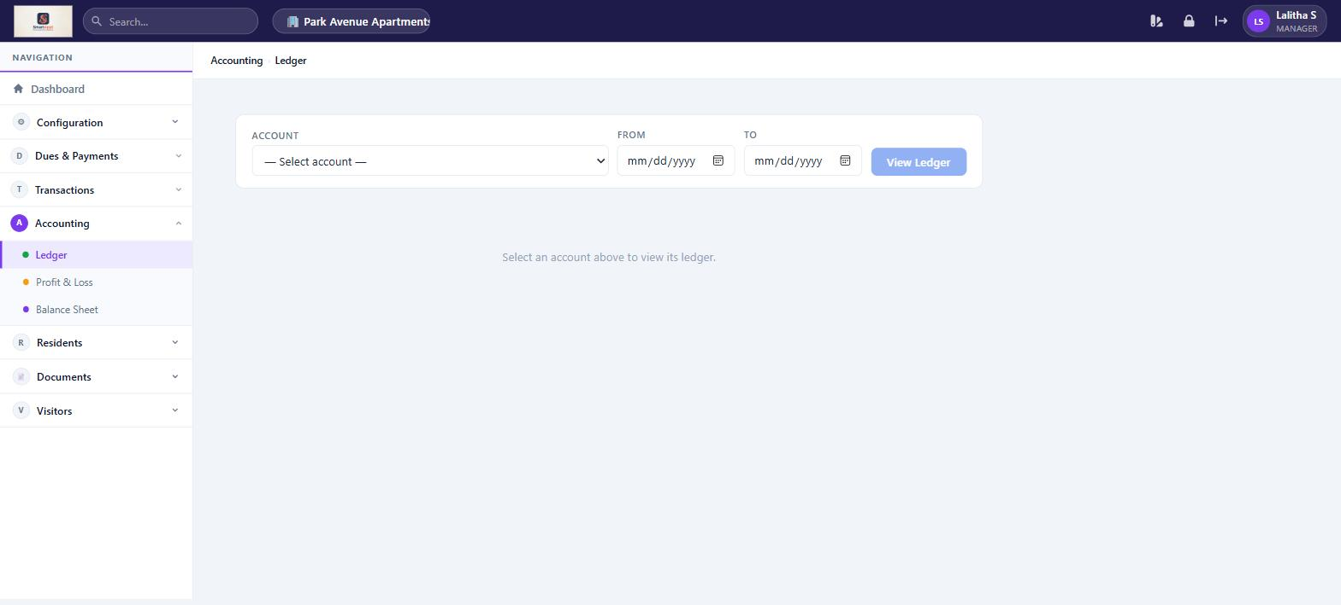
Ledger — select an account and date range to view its transaction history

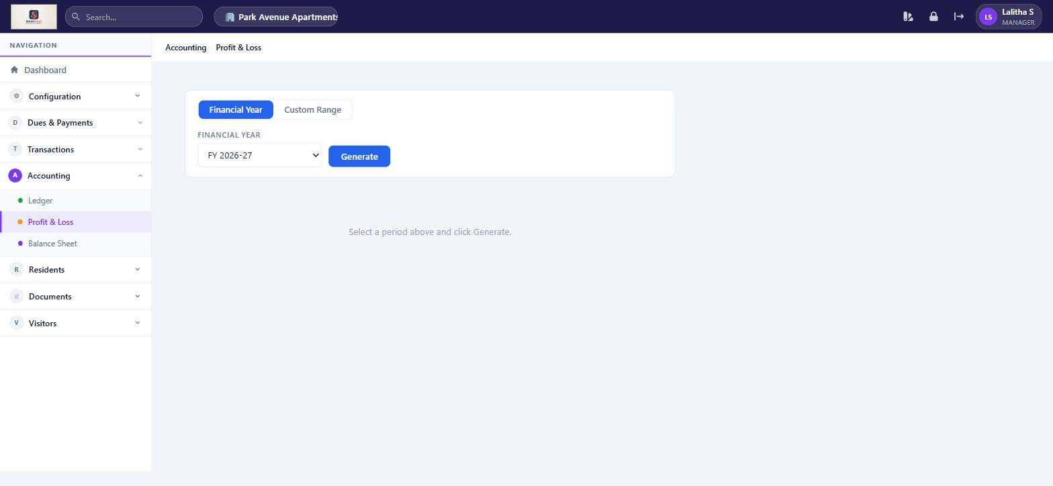
Profit & Loss — generate income vs expense statement by financial year or custom range

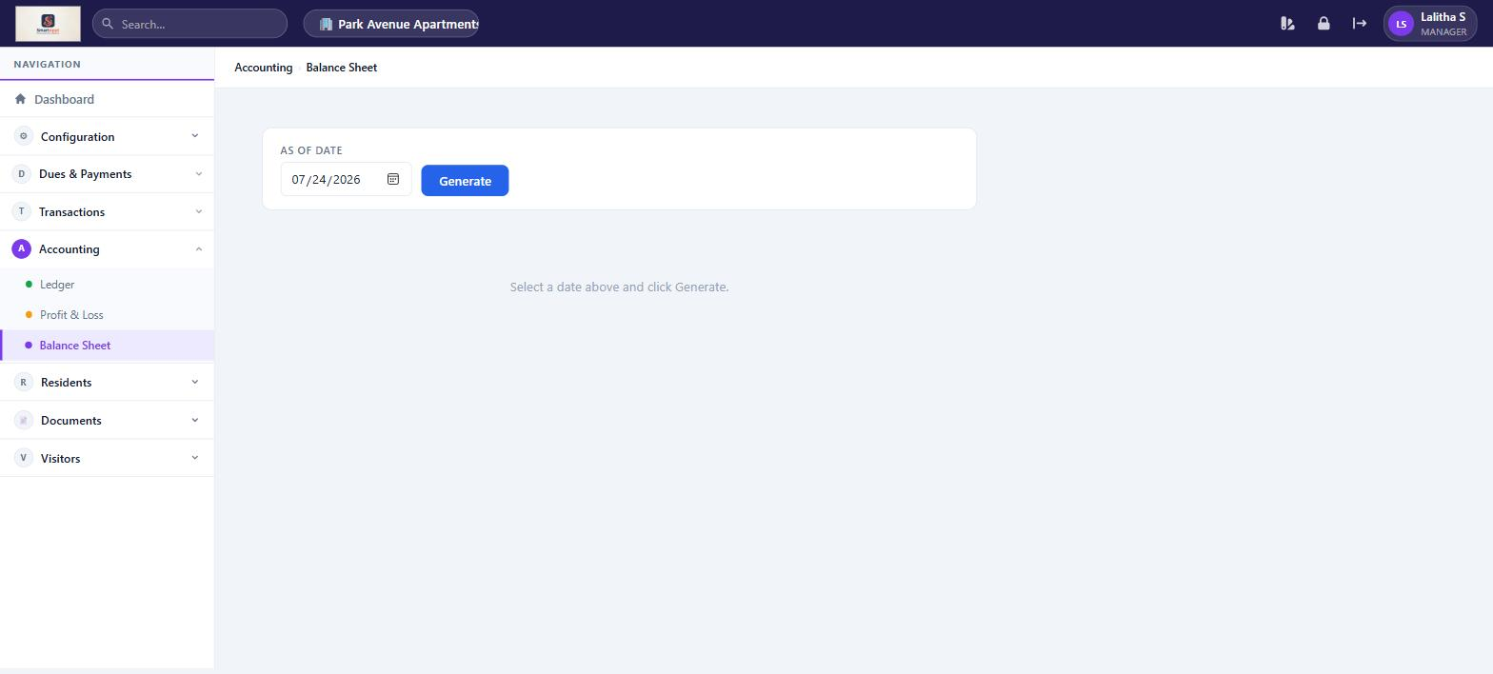
Balance Sheet — view financial position as of any date

Residents Section (also available as Resident)
Feature | What You Can Do
My Bills | View your own maintenance bills and pay outstanding dues online via Razorpay.
Service Requests | View ALL service requests across the association. Filter by status. Assign tickets to staff. Update ticket status. Raise your own request.
Announcements | Read community announcements, view polls. Post new announcements or polls for residents.
Expense Transparency | View the expense breakdown visible to all residents — a public view of how community funds are spent.
Documents | Upload and view community documents (circulars, notices, meeting minutes).

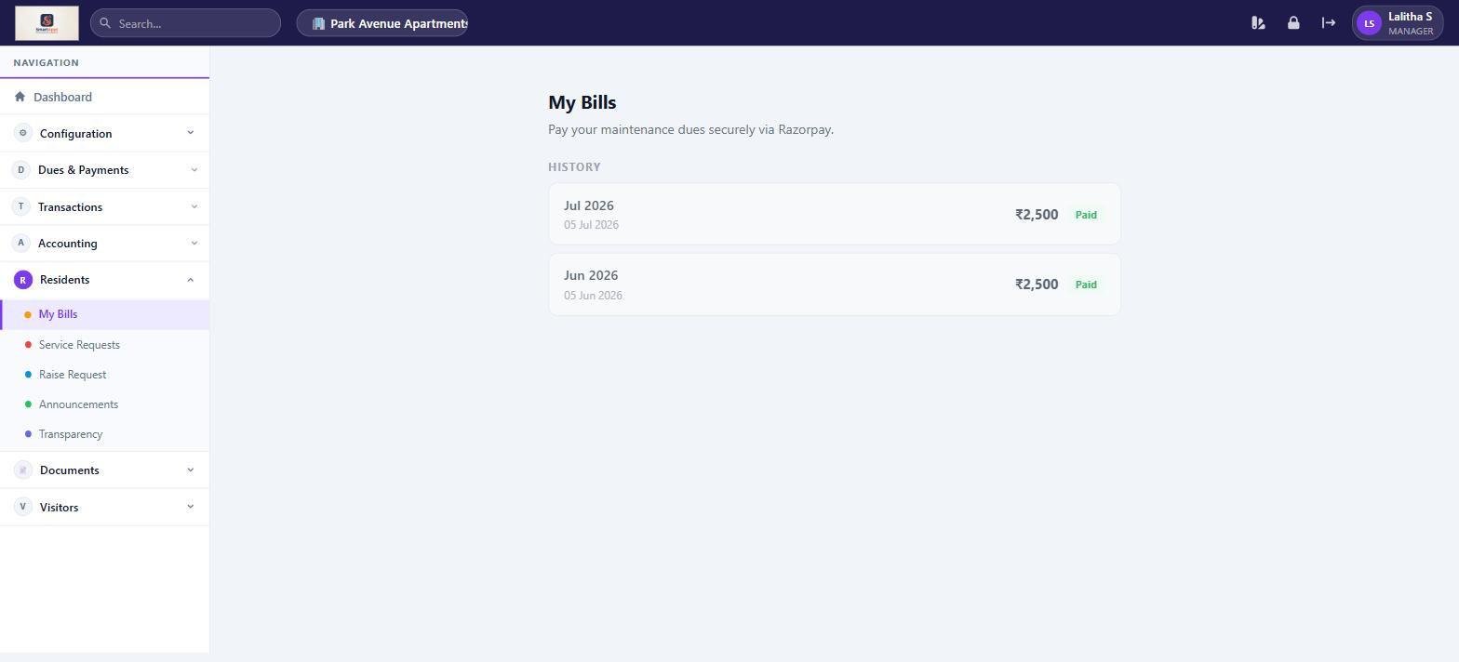
My Bills — view your own maintenance bills with payment history

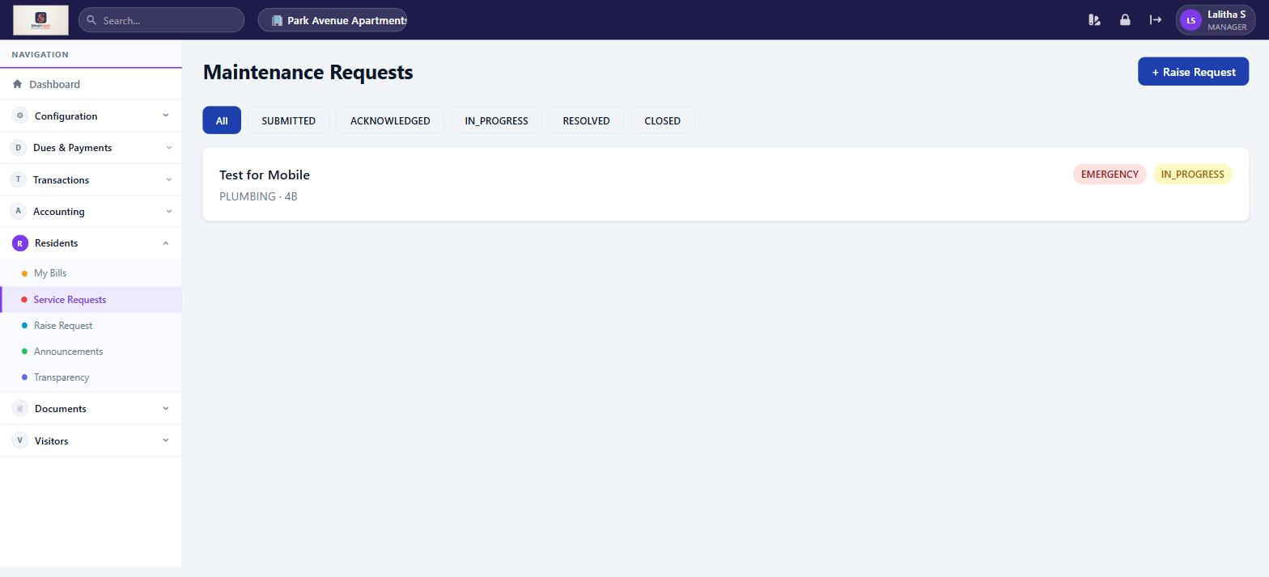
Service Requests — Manager sees ALL tickets across the association with status filter

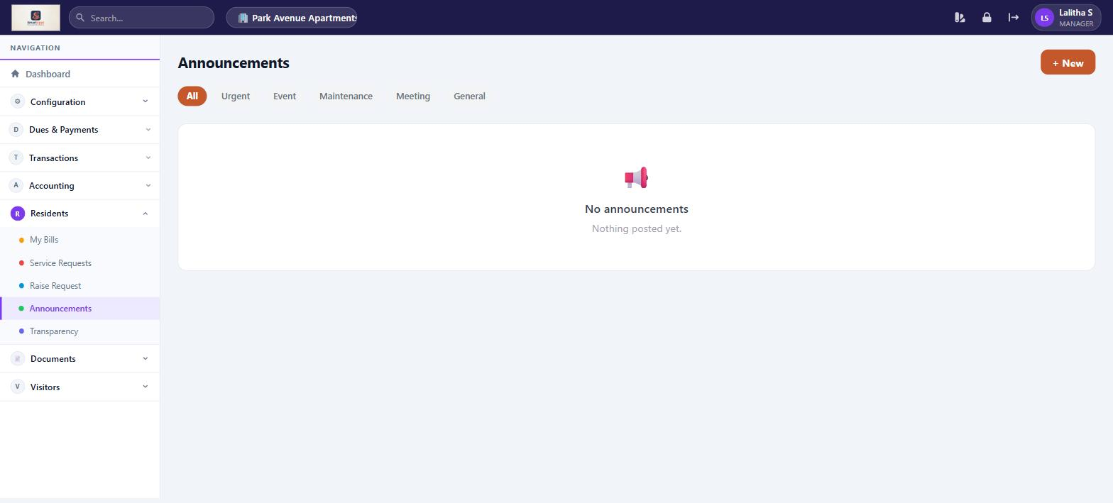
Announcements — post and read community notices, create polls

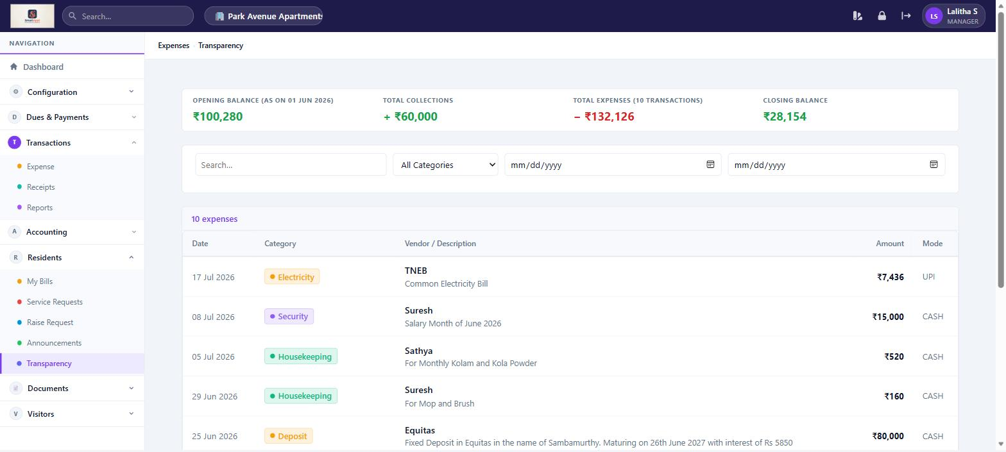
Expense Transparency — public expense breakdown for all residents to view

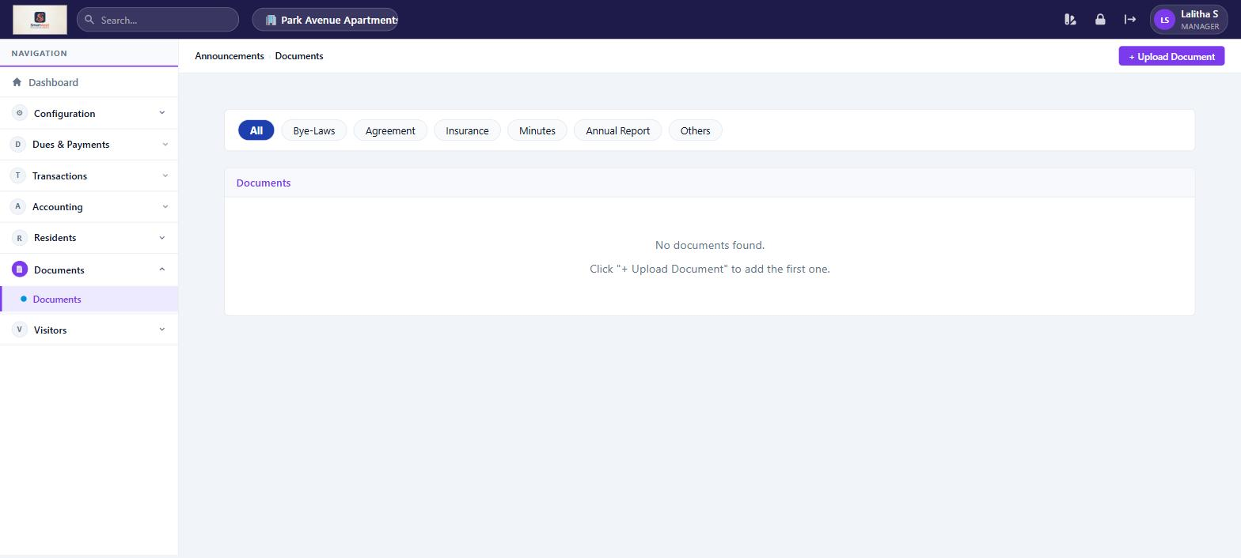
Documents — repository for community circulars, meeting minutes, and notices

Visitors
Feature | What You Can Do
Visitor Log | View the complete visitor history for the association — name, unit visited, entry/exit times, and status.
Pre-Approve Visitors | Pre-approve an expected visitor and generate an OTP or QR code for gate entry. Manage your list of frequent visitors.

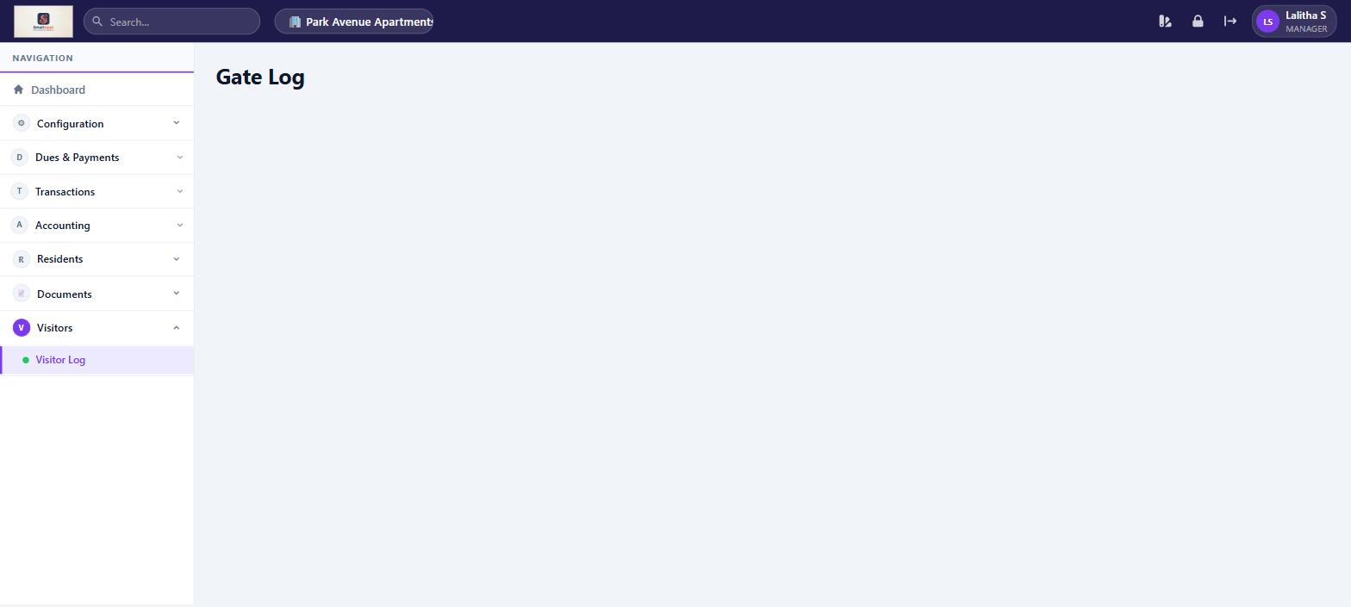
Gate Log — complete visitor history with entry/exit times and status

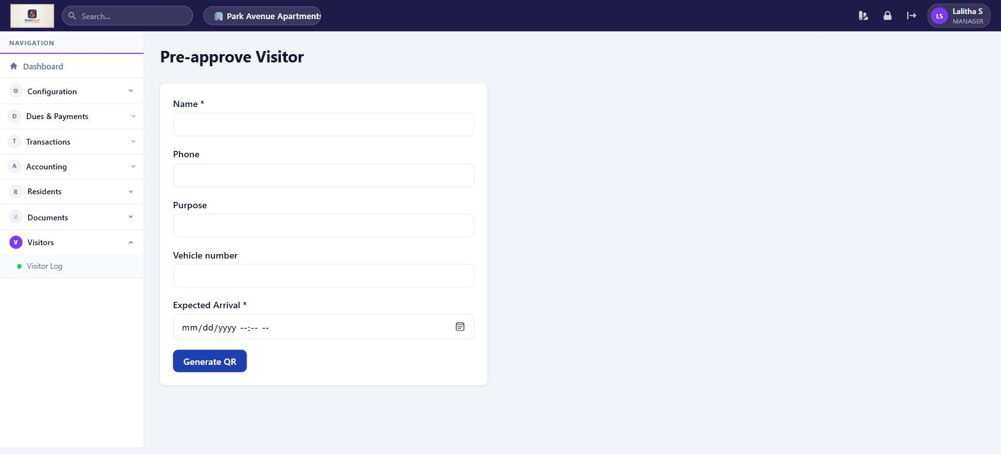
Pre-approve Visitor — fill in visitor details to generate a QR code for gate entry

Mobile Application
On mobile, the Manager has a split experience: resident features for personal use, and full management access for service requests.

Screen | What You Can Do
Home | Personalised greeting with your name, association name, and unit. Shows count of ALL pending service requests across the association. Quick-action cards for Bills, Service, Announcements, and Visitors. Recent announcements feed.
Bills | View and pay your own maintenance bills. Pending bills show outstanding amount with Pay Now button. History shows all paid bills.
Feed | Read community announcements and vote on polls.
Service | View ALL service requests with status filter (All / Submitted / In Progress / Resolved…). Tap a ticket to update its status. Raise your own new request via the + button.
Visitors | Choose Visitor Dashboard (full activity log) or Pre-Approvals (pre-approve visitors, manage frequent visitors).
More | View your profile (name, unit, association, role). Change M-PIN. Quick links to all features. Logout.

Treasurer
Financial management authority + all resident features

The Treasurer manages the full financial lifecycle of the association: configuring fees, generating bills, recording expenses, tracking receipts, and maintaining accounting books. They also have all resident features.

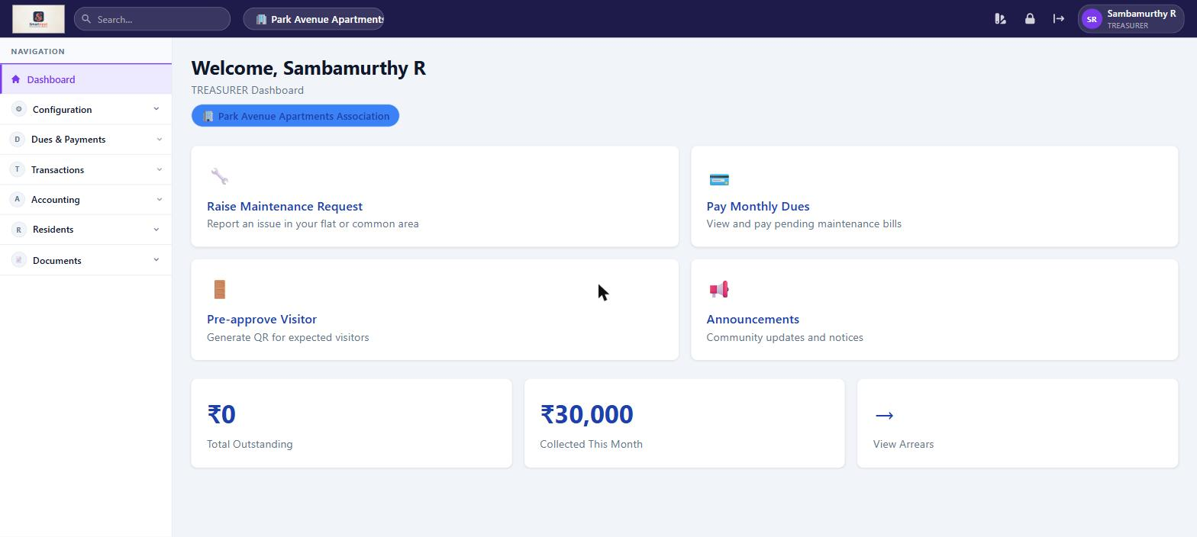
Treasurer Dashboard — outstanding dues summary, collected this month, and quick actions

Web Application

Configuration
Feature | What You Can Do
Fee Configuration | Set monthly maintenance fee amounts per unit type. Configure penalty slabs and charge types. Enable automatic bill generation on a chosen day of the month.
Razorpay Setup | Enter the Razorpay Key ID and Key Secret to enable online payment collection from residents.
Expense Categories | Create and manage categories for community expense tracking.

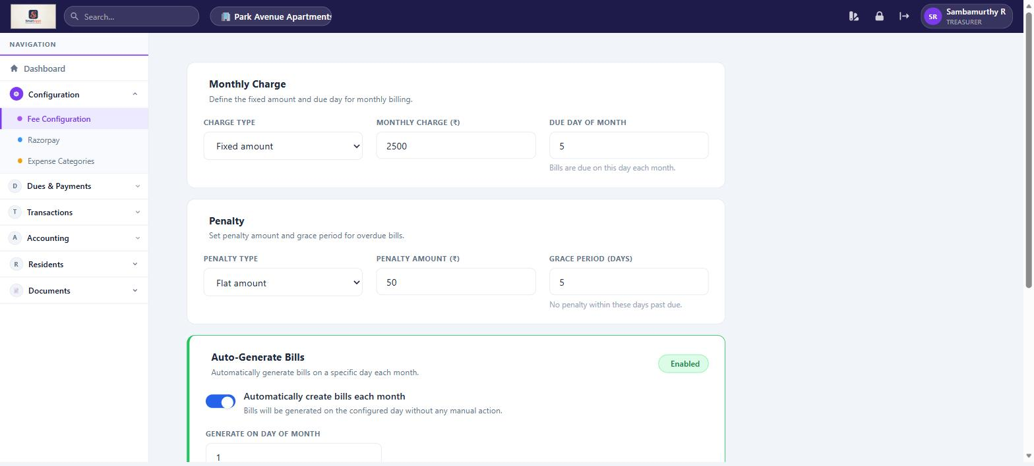
Fee Configuration — set monthly charge, penalty rules, and auto-billing schedule

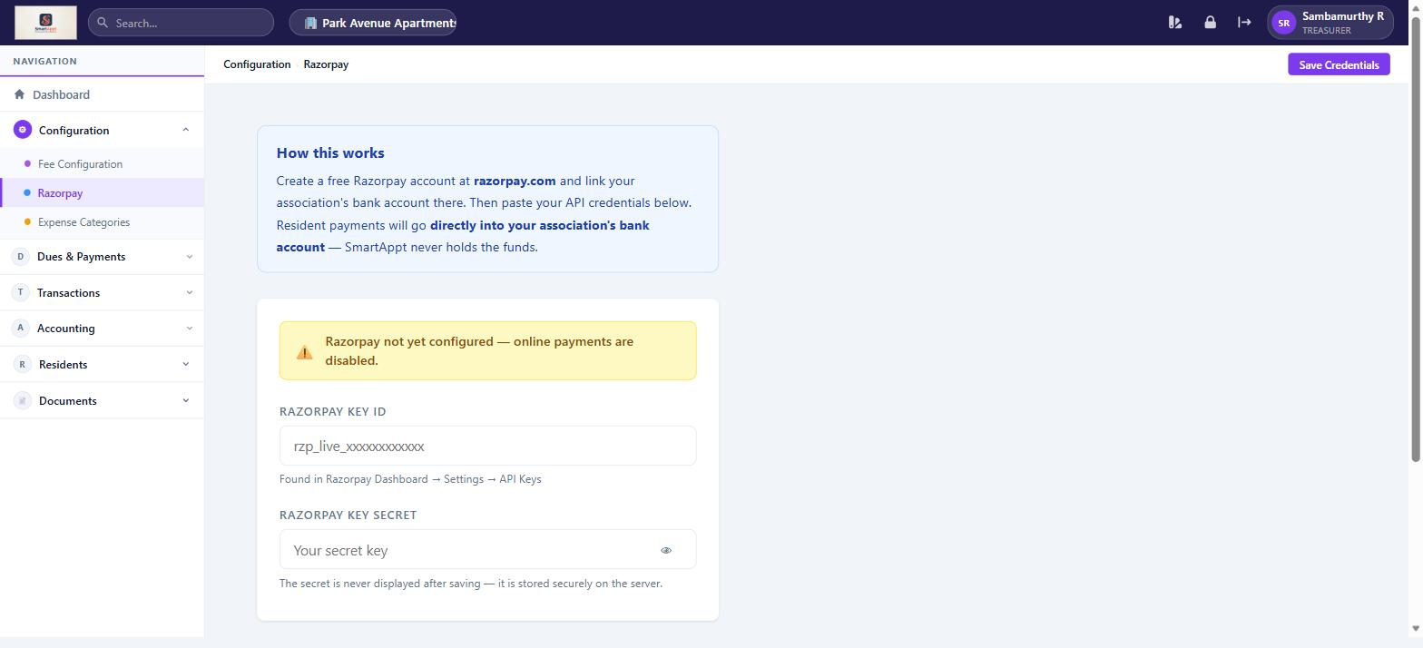
Razorpay Setup — paste API credentials to enable online resident payments


Expense Categories — define categories for community expense tracking

Dues & Payments
Feature | What You Can Do
Bills & Payments | View all generated bills. Generate monthly bills for all units. Rollback a billing period if needed (only if no payments exist). Record offline cash/cheque payments. Track partial payments and arrears.
One-Time Dues | Create targeted special charges (e.g. special assessment, corpus fund) for selected units. Generate bills and track collections separately.

Transactions
Feature | What You Can Do
Expenses | Add, edit, and delete community expenses with category, vendor, amount, and date. View the expense ledger with opening balance, total collections, total expenses, and closing balance.
Receipts | Record miscellaneous receipts not related to maintenance dues (e.g. hall hire, event fee).
Reports | View and export financial reports covering dues, expenses, and receipts.

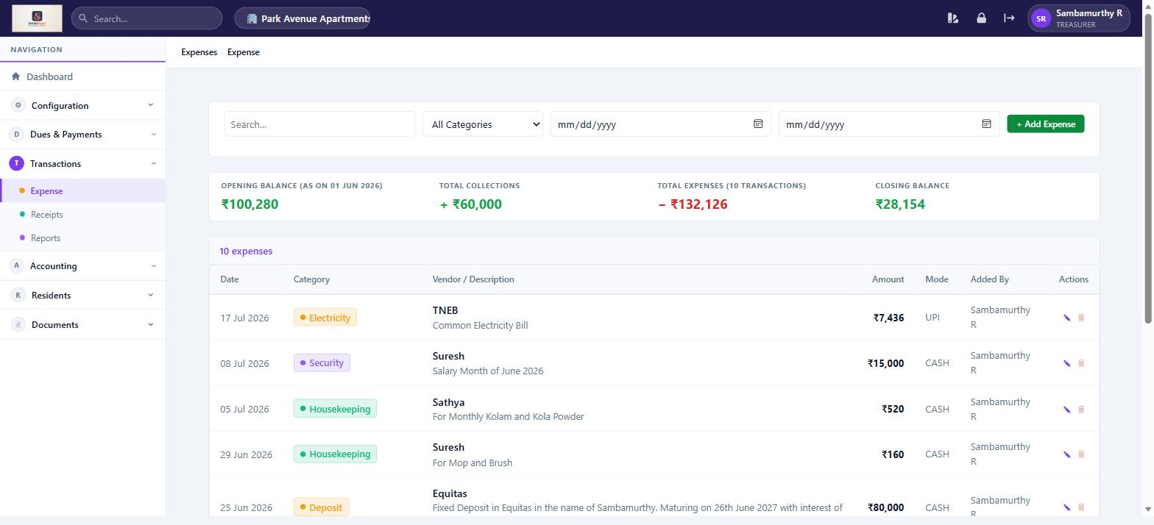
Expense Ledger — balance summary with itemised expense list; + Add Expense button to record new entries

Accounting (Full Access)
Feature | What You Can Do
Chart of Accounts | Define accounting accounts and sync historical transactions into journal entries.
Journal Entries | View auto-posted double-entry records for billing, payments, and expenses.
Ledger | Account-wise transaction history with date range filters.
Profit & Loss | Income vs expense statement for any period.
Balance Sheet | Association financial position — assets, liabilities, equity.

Residents Section (also available as Resident)
Feature | What You Can Do
My Bills | View and pay your own maintenance bills via Razorpay.
Service Requests | View your own tickets. Raise a new maintenance request.
Pre-Approve Visitors | Pre-approve expected visitors and manage frequent visitors.
Announcements | Read community notices and vote on polls.
Expense Transparency | View community expense breakdown.
Documents | View community documents.

Mobile Application
On mobile, the Treasurer has the same resident experience as other members. Web application screenshots shown in the Manager section apply equally to Treasurer features.

Screen | What You Can Do
Home | Greeting with association name and unit. Outstanding bill summary. Quick actions for Bills, Service, Announcements, Visitors.
Bills | View all your bills (pending and history). Pay via Razorpay.
Feed | Read announcements and vote on polls.
Service | View and track your own service requests. Raise a new request.
Visitors | Visitor Dashboard and Pre-Approvals.
More | Profile info, Change M-PIN, shortcuts, Logout.

Committee
Oversight and review access + all resident features

Committee members have read access to financial data, dues, and accounting reports. They can post announcements and have all resident features. They do not configure fees or generate bills.

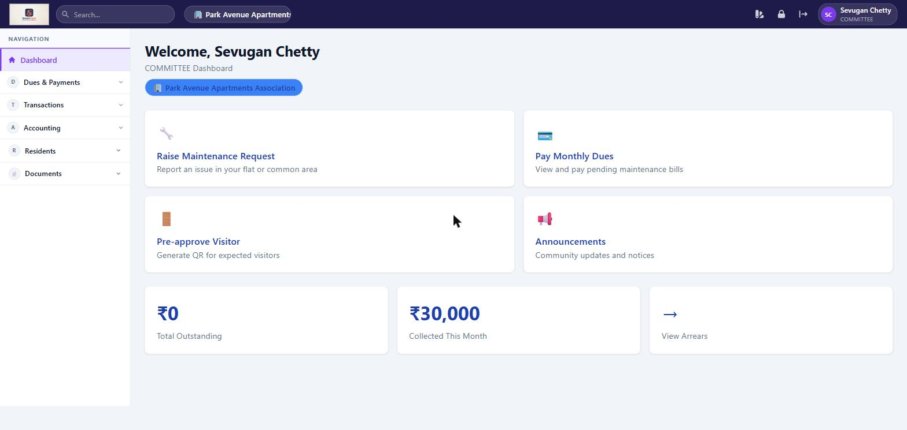
Committee Dashboard — same financial summary as Treasurer, with quick actions for residents

Web Application

Dues & Payments (View Access)
Feature | What You Can Do
Bills & Payments | View all bills across the association, payment status, and collection stats. Cannot record offline payments.
One-Time Dues | View one-time due entries and their collection status. Cannot create or modify.

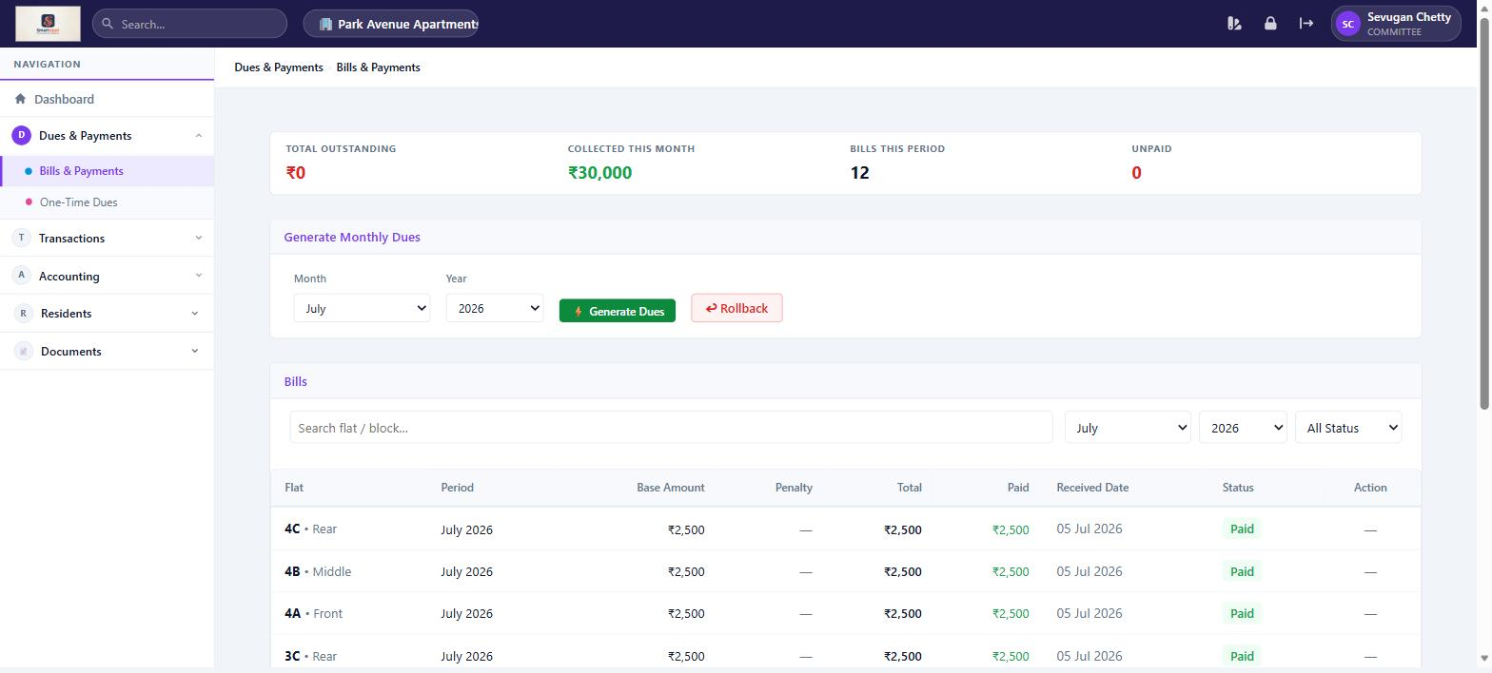
Bills & Payments — Committee sees all bills and stats but cannot record payments

Transactions
Feature | What You Can Do
Expenses | View all community expenses with category, vendor, amount, and balance summary. Cannot add or edit expenses.
Receipts | View miscellaneous receipts recorded by the Treasurer.
Reports | Access financial transaction reports.

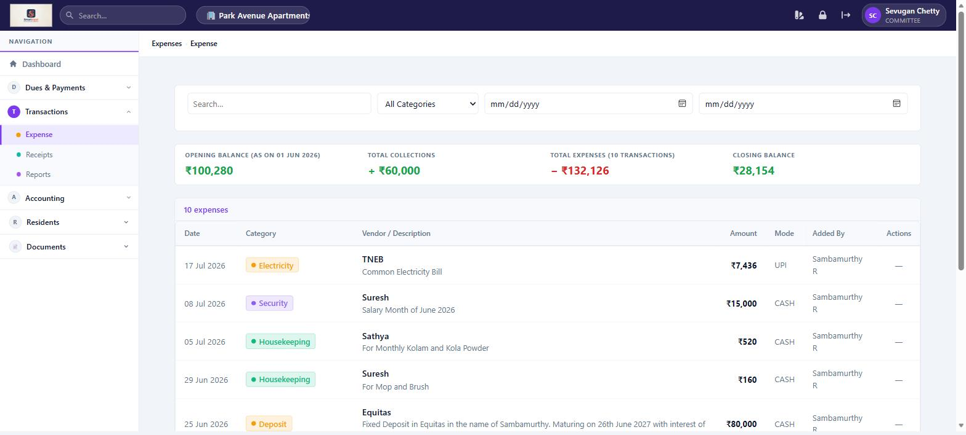
Expenses — read-only view for Committee; no Add Expense button or edit actions

Accounting (View Access)
Feature | What You Can Do
Ledger | View account-wise ledger with date range filtering.
Profit & Loss | Generate income and expense statement by financial year or custom range.
Balance Sheet | View the association's financial position — assets, liabilities, equity.

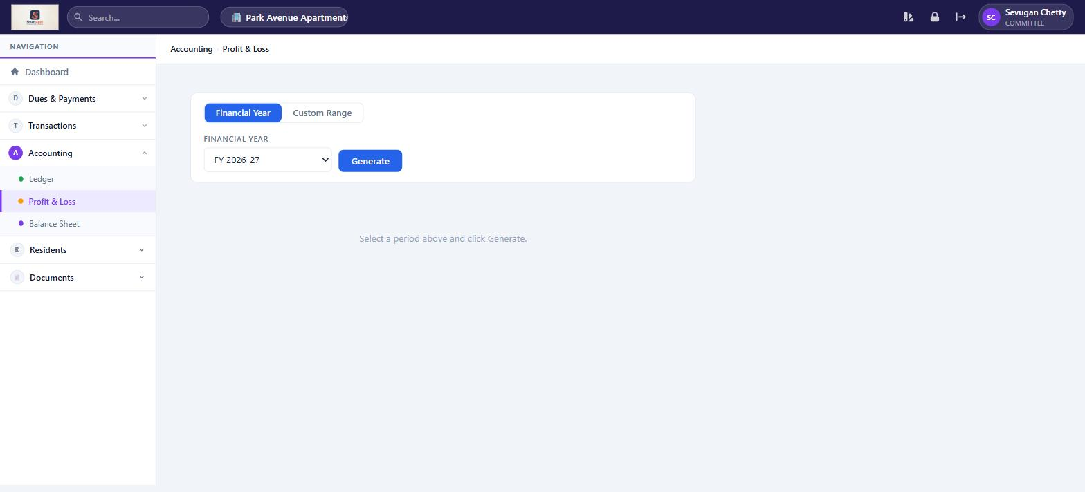
Profit & Loss — Committee can generate the P&L statement; accounting nav shows Ledger, P&L, Balance Sheet

Residents Section (also available as Resident)
Feature | What You Can Do
My Bills | View and pay your own maintenance bills via Razorpay.
Service Requests | View your own tickets. Raise a new maintenance request and submit feedback after resolution.
Pre-Approve Visitors | Pre-approve expected visitors and manage frequent visitors.
Announcements | Read and post community announcements. Create polls.
Expense Transparency | View community expense breakdown.
Documents | View community documents.

Mobile Application
On mobile, the Committee member has the full resident experience. Web application screenshots shown in the Manager section apply equally to Committee view-only features.

Screen | What You Can Do
Home | Greeting with association name and unit. Outstanding bill summary. Quick actions for Bills, Service, Announcements, Visitors.
Bills | View all your bills (pending and history). Pay via Razorpay.
Feed | Read announcements and vote on polls.
Service | View and track your own service requests. Raise a new request. Submit feedback once resolved.
Visitors | Visitor Dashboard and Pre-Approvals.
More | Profile info, Change M-PIN, shortcuts, Logout.

Resident
Personal living features — bills, service, visitors, announcements

Residents are the primary end-users of SmartAppt. The platform is designed to make day-to-day living easier — pay dues online, report issues, manage visitors, and stay informed about community news.

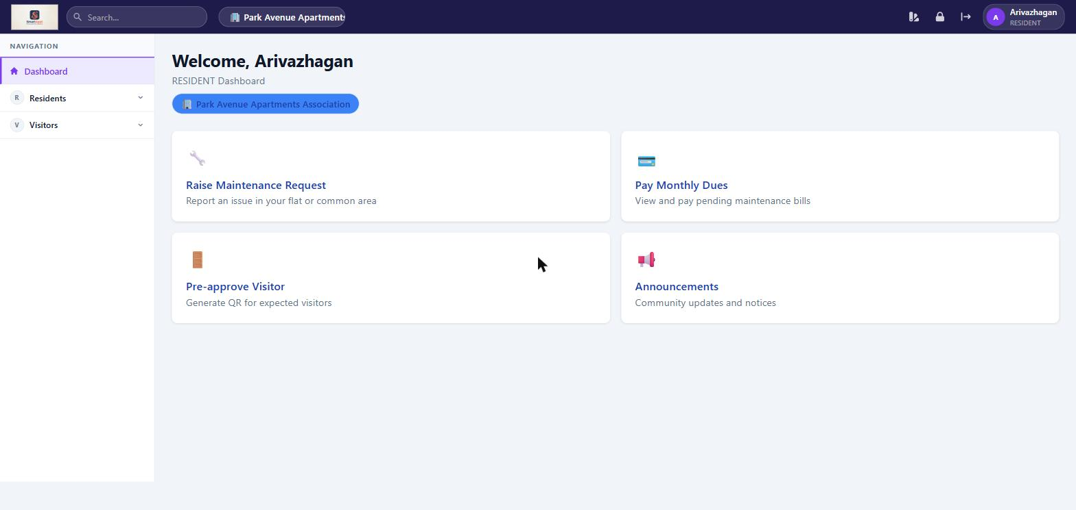
Resident Dashboard — simple four-card layout with Raise Request, Pay Dues, Pre-approve Visitor, and Announcements

Web Application

My Bills
Feature | What You Can Do
View Bills | See all bills raised for your unit — both pending (Unpaid, Partial) and historical (Paid, Waived).
Pay Online | Pay outstanding dues securely via Razorpay. Partial payments are also accepted.
Outstanding Summary | A banner at the top shows your total outstanding amount and number of pending bills.

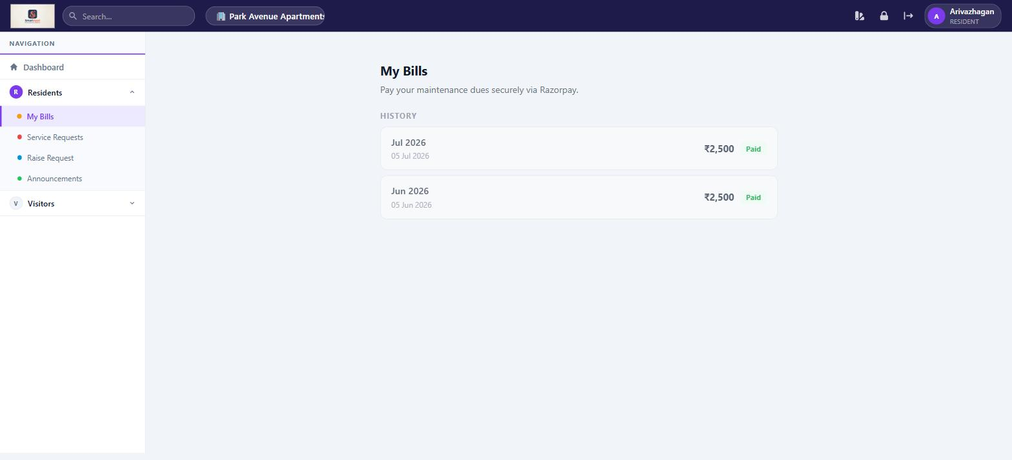
My Bills — bill history with amount and payment status; Pay Now button appears for unpaid bills

Service Requests
Feature | What You Can Do
View My Tickets | See all maintenance requests you have raised, with current status and history.
Raise a Request | Submit a new maintenance request with title, category, priority, description, and up to 3 photo attachments.
Track Status | Follow your ticket through Submitted → Acknowledged → In Progress → Resolved.
Submit Feedback | Once a ticket is marked Resolved, rate the resolution (1–5 stars) and add a comment. This closes the ticket.

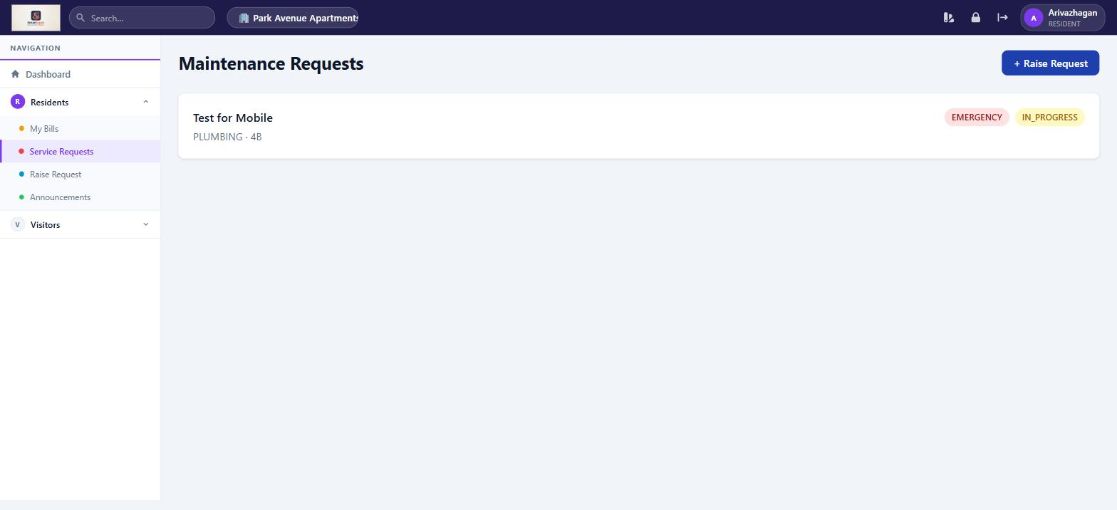
Maintenance Requests — resident sees only their own tickets with priority and status badges

Visitors — Pre-Approve
Feature | What You Can Do
Pre-Approve a Visitor | Enter visitor name and expected date/time to generate an OTP or QR code. Share this with your visitor for smooth gate entry.
Frequent Visitors | Save trusted visitors (e.g. domestic help, regular delivery) so you can pre-approve them quickly without re-entering details.
Approve Entry Requests | If the gate staff requests approval for an arriving visitor, you can approve or deny it from here.

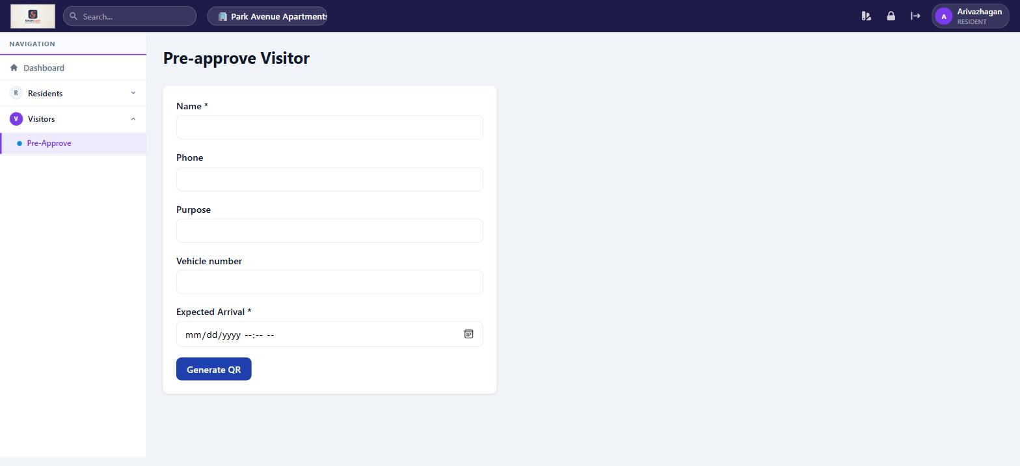
Pre-approve Visitor — fill visitor details and click Generate QR to get an entry pass

Other Features
Feature | What You Can Do
Announcements | View community announcements posted by management. Filter by category: Urgent, Event, Maintenance, Meeting, General.
Expense Transparency | View a full breakdown of how community funds are spent — opening balance, collections, expenses, and closing balance with itemised list.
Documents | Access uploaded community documents such as bye-laws, agreements, insurance papers, meeting minutes, and annual reports.

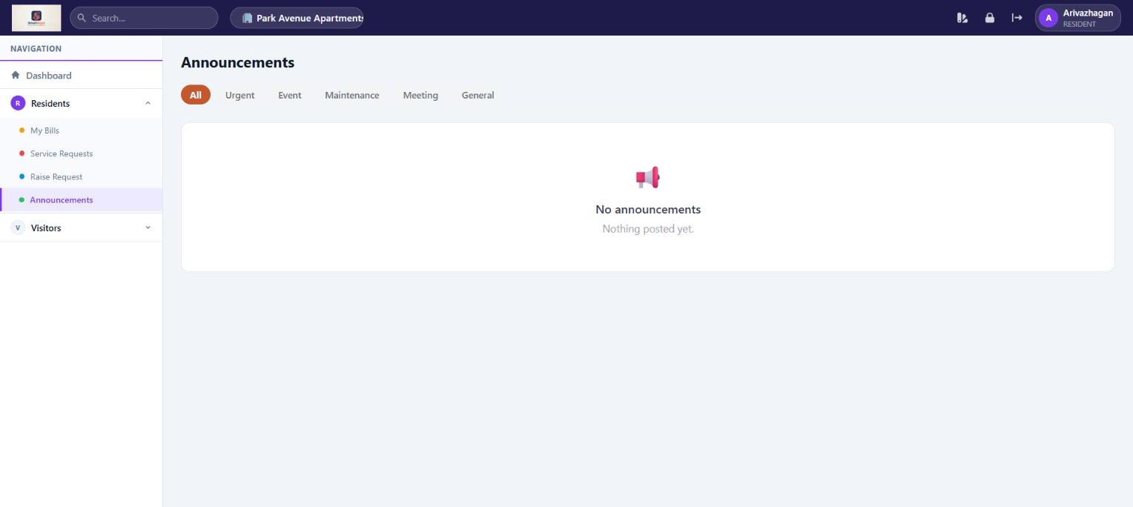
Announcements — filterable by category; residents can read but not post

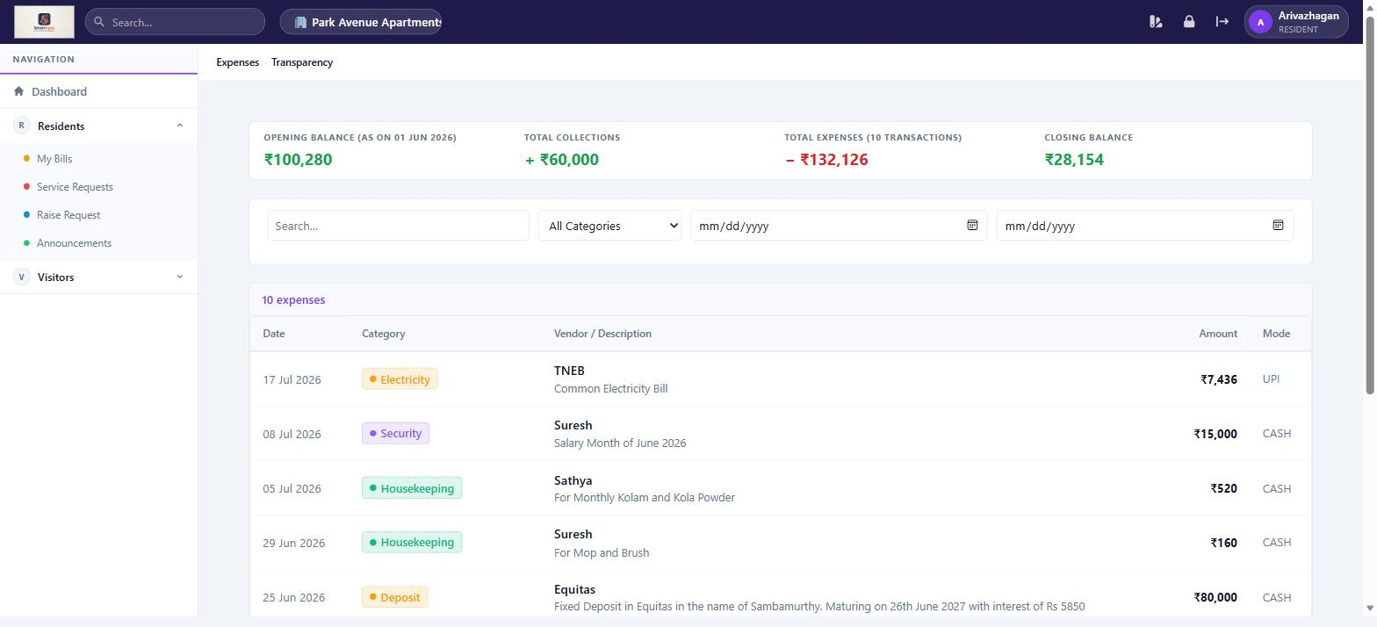
Expense Transparency — full financial summary visible to all residents (read-only)

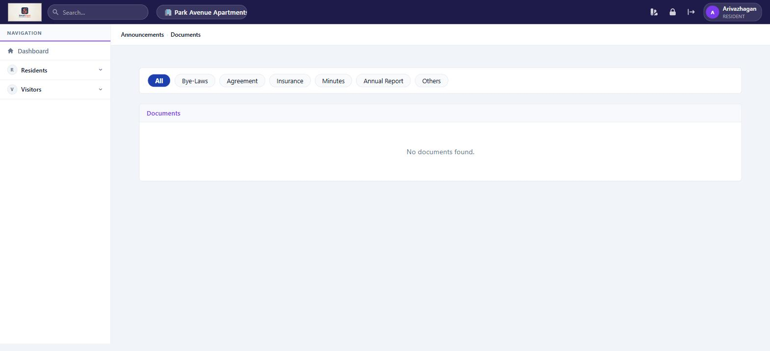
Documents — categorised repository: Bye-Laws, Agreement, Insurance, Minutes, Annual Report, Others

Mobile Application
The SmartAppt mobile app is designed for quick, on-the-go access to the most important resident features.

Screen | What You Can Do
Home | Personalised greeting with your name, association name, and unit number. Shows pending bill amount (if any). Quick-action cards for Bills, Service, Announcements, and Visitors. Recent announcements listed below.
Bills | View all your bills — Pending section shows unpaid/partial bills with Pay Now button. History section shows paid and waived bills.
Feed | Browse all community announcements in a timeline. Vote on active polls.
Service | View the maintenance requests you have raised. Tap a ticket to see status history and submit feedback (if Resolved). Use the + Raise Request button to report a new issue with photos.
Visitors | Choose Visitor Dashboard to see recent gate activity, or Pre-Approvals to pre-approve an expected visitor and manage your frequent visitors list.
More | View your profile: name, association, unit, and role. Change M-PIN (4-digit security PIN). Quick links to all features. Tap Logout at the top to sign out.

Login Options
Feature | What You Can Do
OTP Login | Enter your registered mobile number and verify with a one-time password sent via SMS.
M-PIN Login | If M-PIN is enabled, log in with your mobile number and 4-digit M-PIN for faster access. Set your M-PIN from the More screen after your first OTP login.

Gate Staff
Visitor management and gate operations

Gate Staff are responsible for managing visitor entry and exit at the main gate. SmartAppt gives Gate Staff the tools to verify pre-approved visitors, record walk-ins, and maintain a full visitor log.

Web Application

Gate Dashboard
Feature | What You Can Do
Scan QR / Verify OTP | Scan the QR code or enter the OTP that a resident shared with their pre-approved visitor to grant entry.
Record Entry | Mark a pre-approved visitor as Entered when they arrive at the gate.
Record Exit | Mark a visitor as Exited when they leave the premises.
Walk-In Entry | Record an unannounced visitor: enter their name, contact, and unit they are visiting. The resident receives a notification to approve or deny.
Emergency Alert | Trigger an emergency alert that notifies all managers and committee members immediately.

Visitor Log
Feature | What You Can Do
View All Visits | See the complete visitor history for the association: visitor name, unit visited, type (Pre-Approved, Walk-In), entry time, exit time, and current status.
Filter by Unit/Date | Narrow down the log by unit number or date to find a specific visit record quickly.

Residents Section
Feature | What You Can Do
Service Requests | View and update the status of maintenance tickets assigned to Gate Staff.
Announcements | Read community announcements.
Documents | View uploaded community documents.

Mobile Application
Gate Staff do not currently have a dedicated mobile experience in SmartAppt. Gate operations are best performed using the web application on a tablet or computer stationed at the gate.

Tip: The web application works on any mobile browser. Gate Staff can bookmark the SmartAppt URL on their phone or tablet for convenient access at the gate.

Quick Reference

Who Can Do What — Feature Matrix

Feature | Manager | Treasurer | Committee | Resident | Gate Staff
Pay Own Bills | ✓ | ✓ | ✓ | ✓
View All Bills | ✓ | ✓ | ✓
Generate / Rollback Bills |  | ✓
Configure Fees & Razorpay |  | ✓
Raise Service Request | ✓ | ✓ | ✓ | ✓
View All Service Requests | ✓
Update Ticket Status | ✓ |  |  |  | ✓
Pre-Approve Visitors | ✓ | ✓ | ✓ | ✓
View Visitor Log | ✓ |  |  |  | ✓
Gate Entry / Exit |  |  |  |  | ✓
Post Announcements | ✓ |  | ✓
View Announcements | ✓ | ✓ | ✓ | ✓ | ✓
Manage Users & Units | ✓
Manage Expenses |  | ✓
View Expense Reports | ✓ | ✓ | ✓ | ✓
Full Accounting Access | ✓ | ✓
View Accounting Reports | ✓ | ✓ | ✓
Receipts | ✓ | ✓ | ✓
One-Time Dues | ✓ | ✓ | ✓
Expense Transparency | ✓ | ✓ | ✓ | ✓
Documents | ✓ | ✓ | ✓ | ✓ | ✓

