2018 Sheet Screen Shot

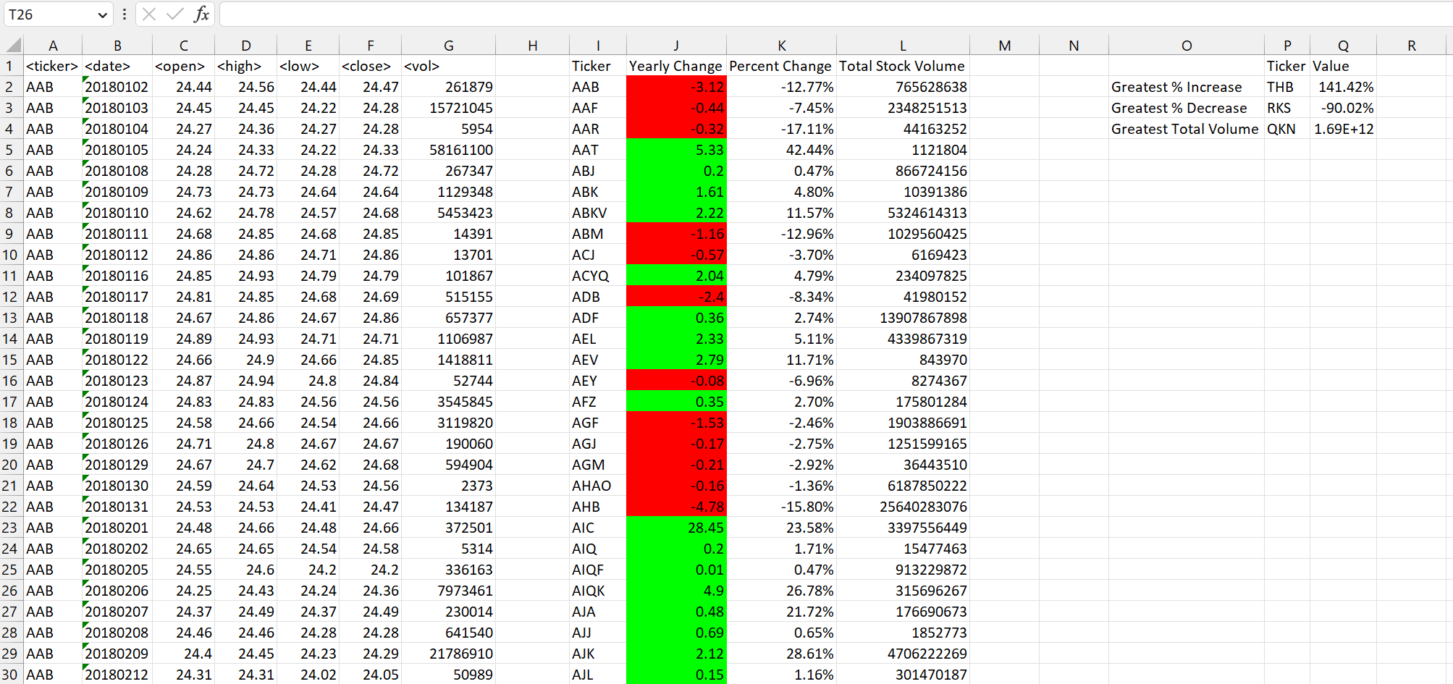

2019 Sheet Screen Shot

2020 Sheet Screen Shot

