**Rhythm Game Using LCDs**

ECE230 Final Project

Spring 2024

Rowan Sammon

Mateo Olson

Contents

Introduction 3

User Manual 3

Hardware Design 3

Software Design 3

Verification of Function 3

Bill of Materials 3

References 4

# Introduction

We have designed a rhythm game system utilizing the MSP432 board connected to two 2x16 LCDs, one that displays the scrolling notes and one that displays the current score. The two lines of the LCD (which is rotated) form the two lanes of the game. Two buttons correspond to each of the lanes. If the button is pressed when a note is at the bottom of the LCD of the respective lane, the score is increased. This score is displayed on a second LCD. Two buzzers play a song created using a MIDI interpreter. The same MIDI interpreter is used to generate the map that is displayed on the LCD.

An LCD driver utilizes structs containing information about the LCD to perform operations through the LCD. The note display LCD is configured in 8 bit mode, while the score display is configured in 4 bit mode, and both are controlled with the LCD driver. A Timer A module of the MSP board controls the timing of the note scrolling using interrupts to rewrite the. The two buttons trigger interrupts that check the current note.

TODO mateo write about midi interpreter and buzzers

# User Manual

# Hardware Design

# Software Design

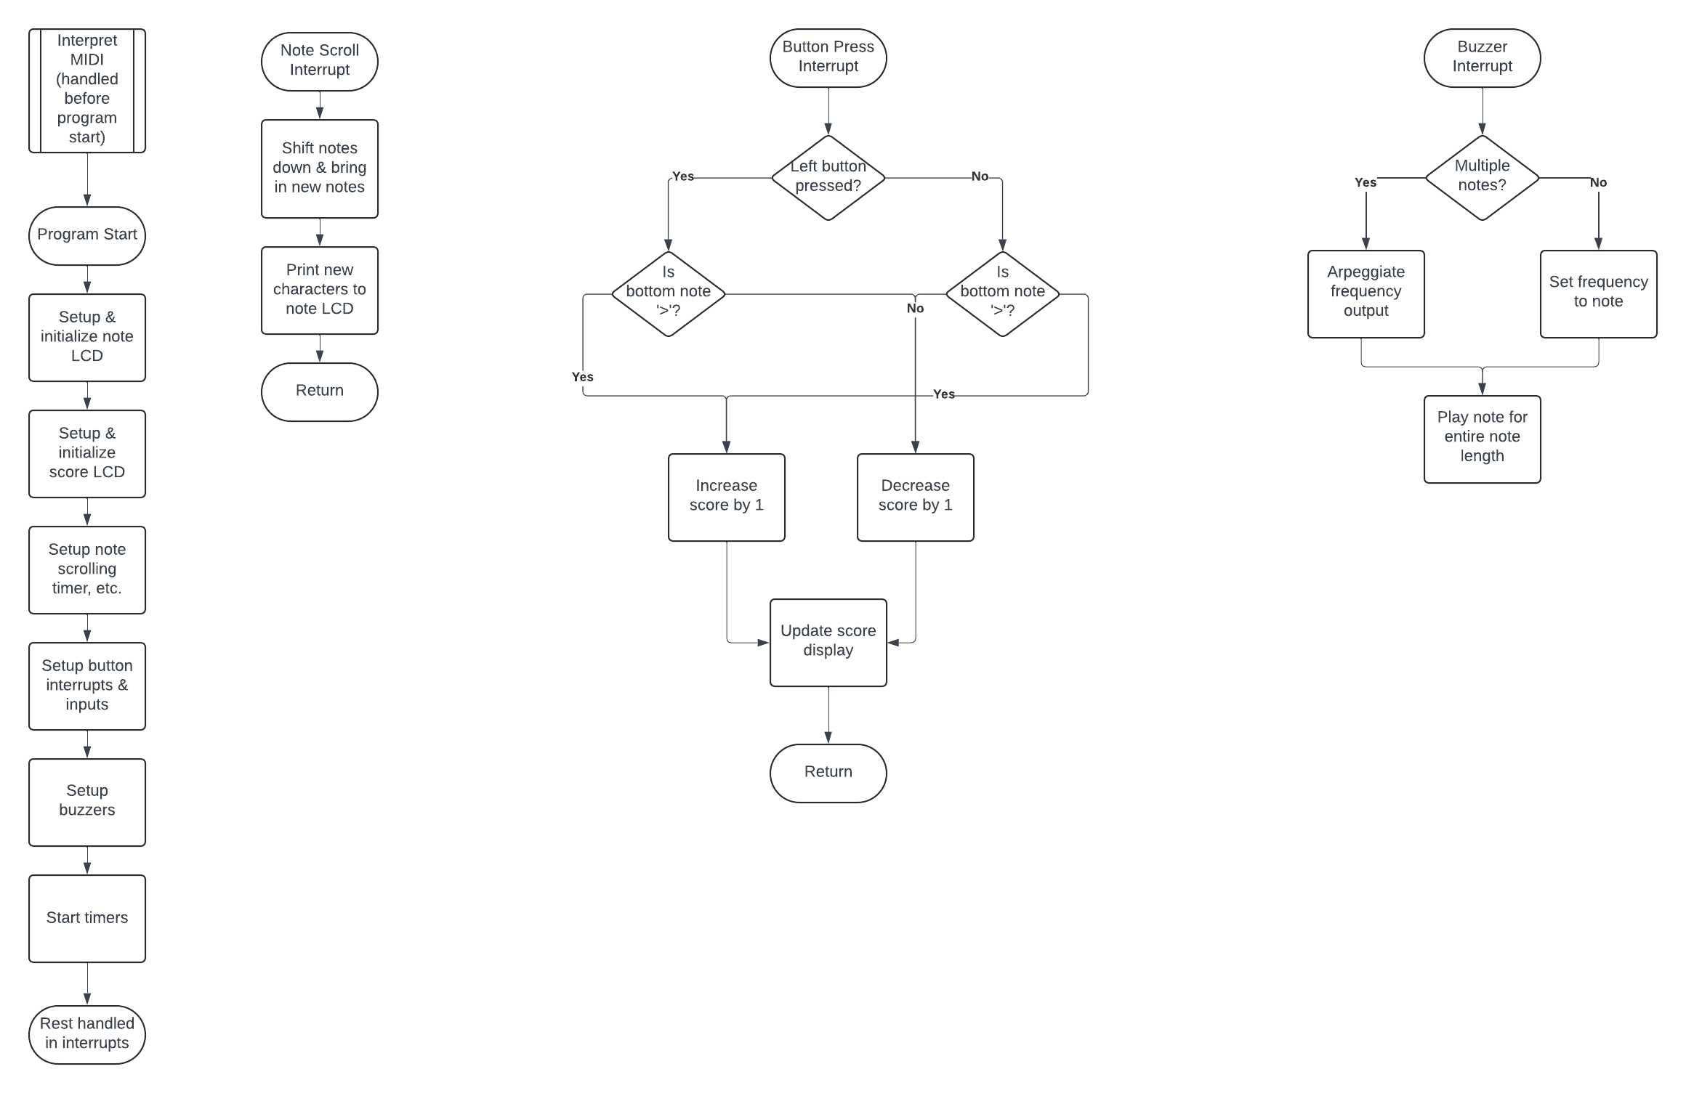

# Verification of Function

# Bill of Materials

|  |  |  |  |
| --- | --- | --- | --- |
| **Part** | **Quantity** | **Source** | **Cost** |
| LCD1602 Module | 2 | Lab kit | $0.00 |
| Buzzer | 2 | Lab kit | $0.00 |
| MSP432P4111 Board | 1 | Lab kit | $0.00 |
| Wires | - | Lab kit | $0.00 |
|  |  |  |  |
|  |  |  |  |
|  |  |  |  |
|  |  |  |  |

# References